## ASSIGNMENT - IV

## NAME : PARISHKAR SINGH

## USN : 2GI20CS081

## DATE - 17- June-2022

## DIV: 4-B

## *Q1. Write a python program to read Customer data that’s stored in CSV file format, into in array of*

## *dictionary objects and write functions to*

## *1. Find the customer who has spent maximum*

## *2. Count the total Customers who have spent through Wallet, Cash and Credit Card*

## *3. Count How many Female customers who have spent more than 5 items and spent more*

## *than 200 rupees*

## *4. Graphically display using Bar chart how the men and women have spent.*

CODE:  
*import* csv  
*from* tabulate *import* tabulate  
*from* natsort *import* natsorted  
*import* matplotlib.pyplot *as* plt  
*import* numpy *as* np  
  
*if* __name__ == '__main__':  
 *with* open("X:\\Python\\src\\Assignments\\4_16June\\supermarket.csv") *as* f:  
 rs = csv.reader(f)  
 header = next(rs)  
 record = list(rs)  
 *# the array of dict objects where key is the invoice id and value is the customer detail row* array = [{x[0]:x} *for* x *in* record]  
 *while True*:  
 x = input("\nEnter Choice\n1.Maximum Spent\n2.Count Customers(Payment method:- Wallet, Cash, Credit Card)\n3.Female Customers (Brought More than 5 items and spent>200)\n -->")  
 *if* x == '1':  
 spent = natsorted(  
 array, key=*lambda* x: list(x.values())[0][9])[-1]  
 print(tabulate(spent.values(), headers=header))  
 *elif* x == '2':  
 cc = 0  
 c = 0  
 w = 0  
 *for* i *in* array:  
 *for* key, value *in* i.items():  
 *if* value[12] == 'Credit card':  
 cc += 1  
 *elif* value[12] == 'Cash':  
 c += 1  
 *elif* value[12] == 'Ewallet':  
 w += 1  
 print(  
 f"The Payment Statistics :- \n1.Credit Card->{cc}\n2.Card->{c}\n3.Wallet->{w}\nTotal Count{cc+c+w}")  
 *elif* x == '3':  
 m = 0  
 *for* i *in* array:  
 *for* key, value *in* i.items():  
 *# converting base 10 to base 2   
 if* value[4] == 'Female' *and* int(float(value[7])) > 5 *and* int(float(value[9])) > 200:  
 m += 1  
 print(  
 f'Total Females who brought more than 5 items and spent more than 200 are:- {m} ')  
 *elif* x == '4':  
 *# 0 index is male and 1 index is female* food = [0, 0]  
 health = [0, 0]  
 sports = [0, 0]  
 fashion = [0, 0]  
 electronics = [0, 0]  
 home = [0, 0]  
 barWidth = .125  
 fig = plt.subplots(figsize=(12, 8))  
 *for* i *in* array:  
 *for* key, value *in* i.items():  
 *if* value[4] == 'Male':  
 *if* value[5] == 'Health and beauty':  
 health[0] += 1  
 *elif* value[5] == 'Sports and travel':  
 sports[0] += 1  
 *elif* value[5] == 'Fashion accessories':  
 fashion[0] += 1  
 *elif* value[5] == 'Electronic accessories':  
 electronics[0] += 1  
 *elif* value[5] == 'Food and beverages':  
 food[0] += 1  
 *elif* value[5] == 'Home and lifestyle':  
 home[0] += 1  
 *else*:  
 *if* value[5] == 'Health and beauty':  
 health[1] += 1  
 *elif* value[5] == 'Sports and travel':  
 sports[1] += 1  
 *elif* value[5] == 'Fashion accessories':  
 fashion[1] += 1  
 *elif* value[5] == 'Electronic accessories':  
 electronics[1] += 1  
 *elif* value[5] == 'Food and beverages':  
 food[1] += 1  
 *elif* value[5] == 'Home and lifestyle':  
 home[1] += 1  
  
 br1 = np.arange(len(food))  
 br2 = [x + barWidth *for* x *in* br1]  
 br3 = [x + barWidth *for* x *in* br2]  
 br4 = [x + barWidth *for* x *in* br3]  
 br5 = [x + barWidth *for* x *in* br4]  
 br6 = [x + barWidth *for* x *in* br5]  
  
 plt.bar(br1, sports, color='red', width=barWidth,  
 edgecolor='grey', label='Sports and travel')  
  
 plt.bar(br2, food, color='green', width=barWidth,  
 edgecolor='grey', label='food and beverages')  
  
 plt.bar(br3, fashion, color='blue', width=barWidth,  
 edgecolor='grey', label='fashion accessories')  
  
 plt.bar(br4, health, color='cyan', width=barWidth,  
 edgecolor='grey', label='Health and Beauty')  
  
 plt.bar(br5, electronics, color='black', width=barWidth,  
 edgecolor='grey', label='Electronics')  
  
 plt.bar(br6, home, color='yellow', width=barWidth,  
 edgecolor='grey', label='Home and lifeStyle')  
 *# for checking data accuracy* totalFemale = sports[1]+home[1] + \  
 electronics[1]+food[1]+health[1]+fashion[1]  
 totalMale = sports[0]+electronics[0] + \  
 food[0]+health[0]+home[0]+fashion[0]  
 print(  
 f'males buys:\nSports and travel--{sports[0]}\nElectronics--{electronics[0]}\nFood and beverages--{food[0]}\nhealth--{health[0]}\nfashion--{fashion[0]}\nHome--{home[0]}\ntotal is {totalMale}')  
 print('\n\n')  
 print(  
 f'Females buys:\nSports and travel--{sports[1]}\nElectronics--{electronics[1]}\nFood and beverages--{food[1]}\nhealth--{health[1]}\nfashion--{fashion[1]}\nHome--{home[1]}\ntotal is --{totalFemale}')  
 plt.xlabel('Gender')  
 plt.ylabel(f'Number of people-- {totalFemale+totalMale}')  
 plt.xticks([r + barWidth *for* r *in* range(len(food))],  
 [f'male-{totalMale}', f'female-{totalFemale}'])  
 plt.legend()  
 plt.show()

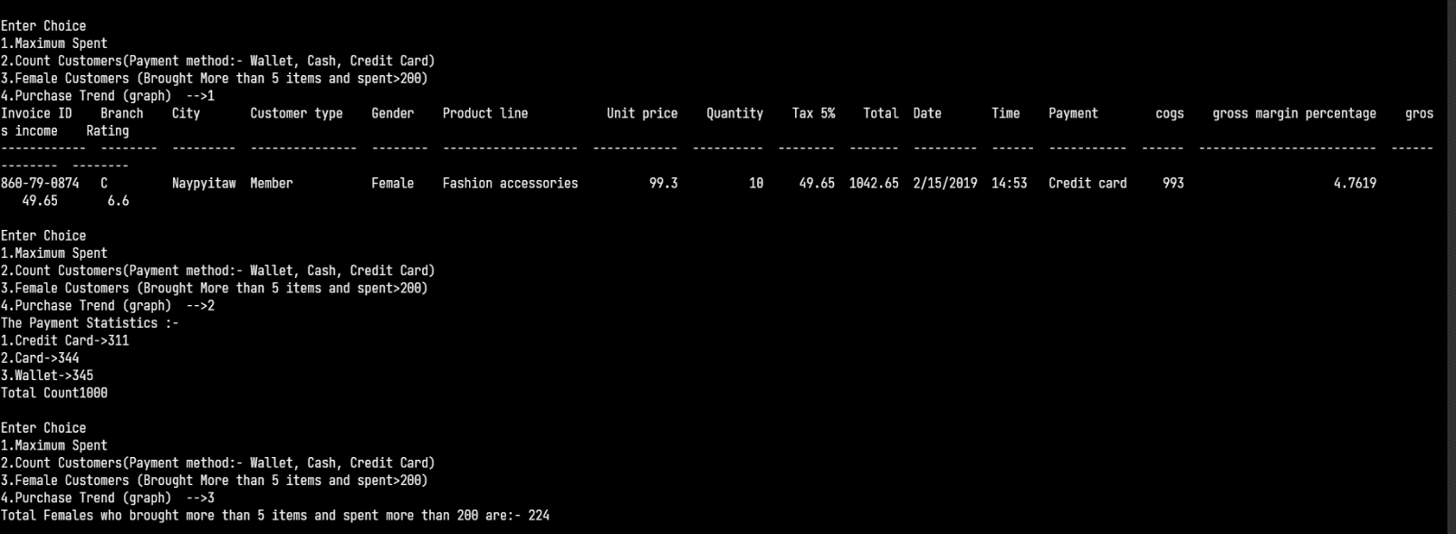

in terminal, stats for the graphs are given

in terminal, stats for the graphs are given

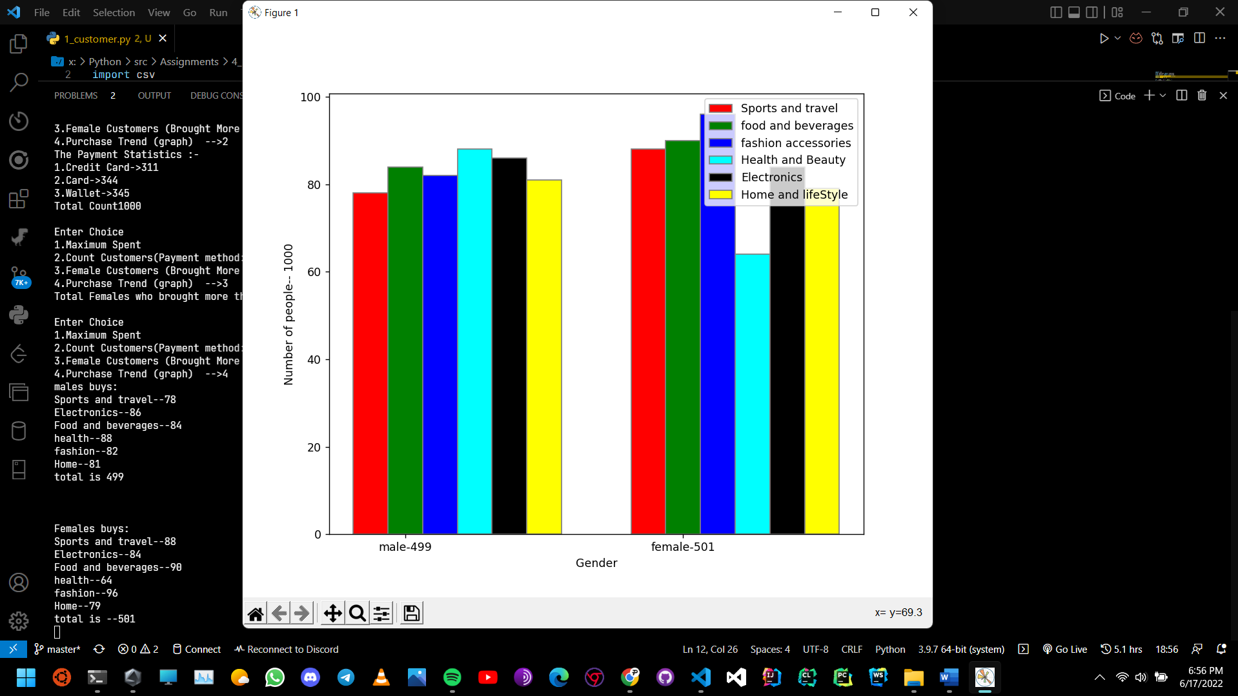*in terminal stats are of male and female buying trends are given and verified through excel

## *Q2. Write a python program to read data from JSON file that has following data*

### {

### "empDetails": [

### {

### "eid": 100,

### "ename": "sfr",

### "age": 25

### },

### {

### "eid": 101,

### "ename": "Vijay",

### "age": 17

### },

### {

### "eid": 102,

### "ename": "Karan",

### "age": 28

### }

### ]

### }

## *Store this in Employee.json and using json package read the file and process it to find*

## *Child labors if any ( Store 6 records) if found display their details*

## *Also write a function to display all employee data.*

## *import* json *def* printChild(data): print("The Found labourer's are:- ") *for* i *in* data['empDetails']: *if* int(i['age']) < 18: print(i['eid'], i['ename'], i['age']) *def* printEmps(data): *for* i *in* data['empDetails']: print(i['eid'], i['ename'], i['age']) *def* printEmp(data): x = int(input('Enter the EMP id--> ')) *for* i *in* data['empDetails']: *if* i['eid'] == x: print(i['eid'], i['ename'], i['age']) *break else*: print("Not Found") *if* __name__ == '__main__': *with* open('X:\\Python\\src\\Assignments\\4_16June\\Employee.json') *as* f: data = json.load(f) *while True*: x = input( "Enter choice 1.Found Child Labourers 2.Display Employee Data 3.Display all employees--> ") *if* x == '1': printChild(data) *elif* x == '2': printEmp(data) *elif* x == '3': printEmps(data)

