Big Mountain resort located in the state of Montana, USA should increase their weekend ticket price from $81 to $95.87. The below chart showcases where we currently are in terms of pricing in the U.S. and in the state of Montana. We can easily see that Big Mountain’s pricing is at the top of its state, but isn’t within the top 5 within the USA. Given its provided facilities, Big Mountain resort is definitely undercharging nationwide.

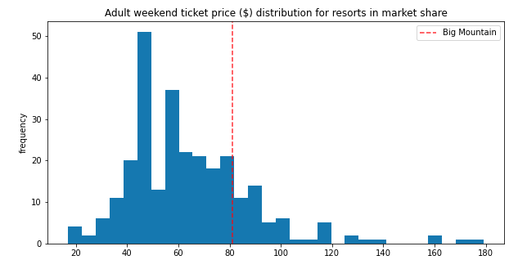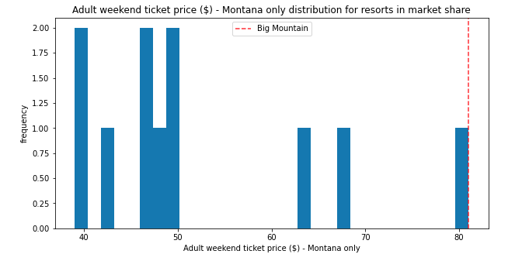Furthermore, the pricing could also increase by another $10.39 to maximize Big Mountain’s revenue. However, that number could be wrong due to multiple factors such as deficiencies within the dataset. For example, we don’t have a full complete picture of Big Mountain’s financial data as well as the other resorts. We are also not given the amount of visitors per week. Besides that, the below features show that Big Mountain is among the top resorts that provide quality services with its facilities.

* vertical_drop
* Snow Making_ac
* total_chairs
* fastQuads
* Runs
* LongestRun_mi
* trams
* SkiableTerrain_ac

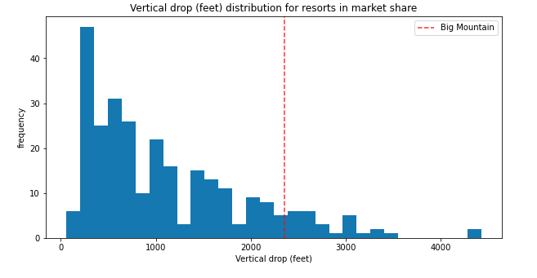

Big Mountain is doing well for vertical drop, but there are still quite a few resorts with a greater drop.

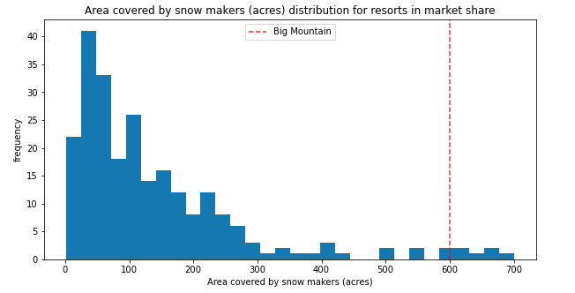

Big Mountain is very high up the league table of snowmaking-area.

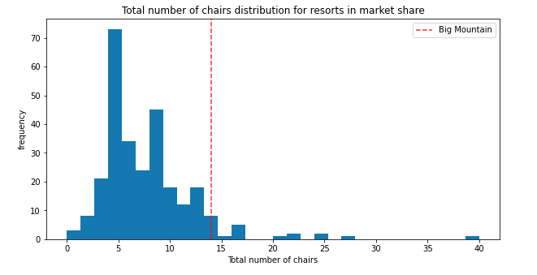

Big Mountain has amongst the highest number of total chairs, resorts with more appear to be outliers. With the initial question of whether or not to install another chairlift, Big Mountain will only have to raise the price by $1.99 per ticket to cover the additional cost, given that their revenue will increase by $3,474,638. With the mentioned, suggested pricing of $95.87, Big Mountain has plenty of room to consider this installation. 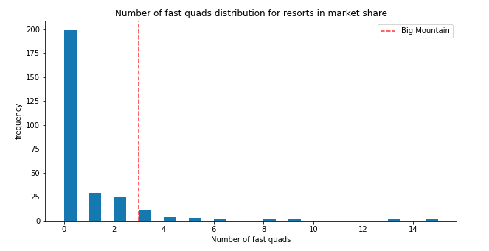

Most resorts have no fast quads. Big Mountain has 3, which puts it high up that league table. There are some values much higher, but they are rare.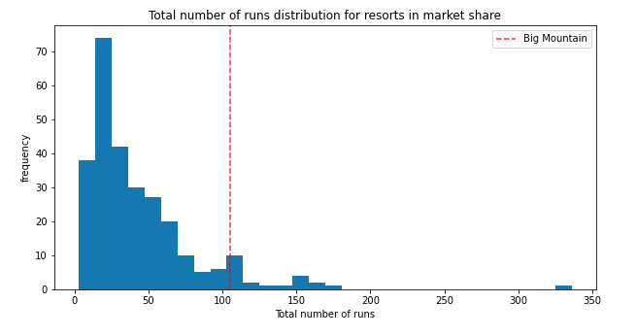

Big Mountain compares well for the number of runs. There are some resorts with more, but not many.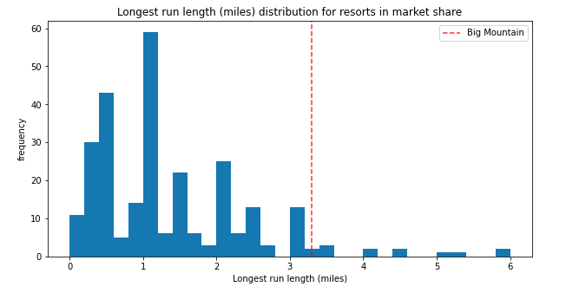

Big Mountain has one of the longest runs. Although it is just over half the length of the longest, the longer ones are rare.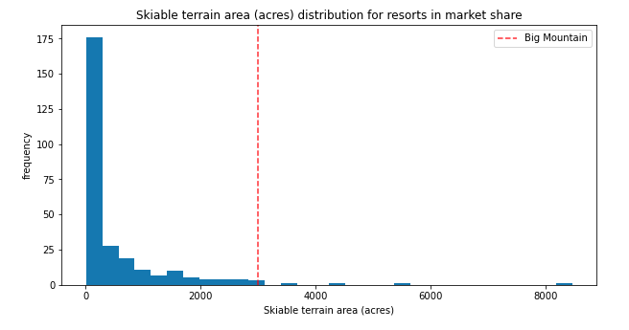

Big Mountain is amongst the resorts with the largest amount of skiable terrain.

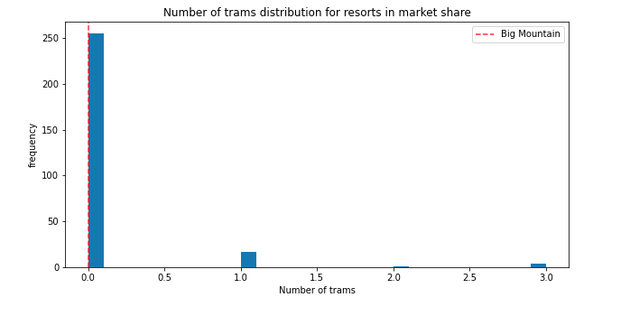

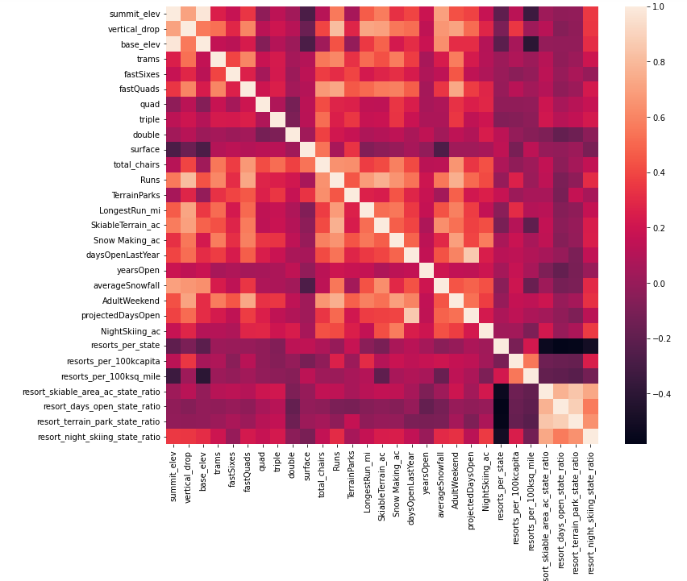

Although having no trams like most resorts, Big Mountain should consider installing one due to its positive correlation with the weekend ticket pricing shown in the heat map.