Online passport processing System

Software Requirements Specification

1. Introduction
Registering for passports is currently done manually in which all the required details are taken manually in the form of documents. In this system every individual has to stand in a queue which involves individuals in huge numbers. Hence maintaining of documents submitted for passport registration is a tedious work as many no of individual apply for registration. In this the individual has to go through the passport office foe registering of a passport through a govt. Agent. The Govt. agent who is the mediator, is responsible for registration of passport and any mistake made by the agent makes it a major concern for the individual. These agents demanded a huge amount of money and are not mainly concerned about maintaining the details of every individual in a confidential and secured. Hence the existing system is more time consuming and involves more manpower. This existing system is also not providing secure registration and profile management of all the users properly.
We have decided to investigate the use of an Online passport processing System. This system would be used by users to register for the passport and by the administrators (govt officials) to look into users requests and update the database accordingly. In this system the individual fills all the information or details required for passport registration through online. The purpose of this document is to analyze and elaborate on the high-level needs and features of the Online passport processing System. The details of what all are the needs of the Online passport processing system and if it fulfils these needs are detailed in the use-case and supplementary specifications.

1.1 Purpose
The main idea of providing Software Requirements Specification (SRS) document is to describe the external behavior of the Online passport processing System. Requirements Specification describes the functionality (what is software suppose to do ) ,attributes and performance of the Online passport System. The document also describes the nonfunctional requirements such as the user interfaces. It also describes the design constraints that are to be considered when the system is to be designed, and other factors necessary to provide a complete and comprehensive description of the requirements for the software.

1.2 Scope
The Software Requirements Specification aggregates all the requirements in a single document. The Online passport System that is to be developed provides a user to register for a passport by filling all the information or details required for passport reservation through online. The Online passport processing System shall have the following features.

- The product provides the users with online registering for passport and the Online passport processing System is up and running all day from 9:00 am in morning till 12:00 in night.
- The individual registering for passport has to fill all the details required in passport registration application and can’t leave any field as blank.
- The user can also view the status of his/her application for passport.
- The system provides log on facility to the users.
- Authentication is provided for this application only registered users can access ie the user details should be verified against the details in the user tables and if it is valid user, then only should be entered into the system
- User friendliness is provided in the application with various controls provided by user interface.
- The system provides user with the option to change the password of their account whenever user fell its necessity.
- This system makes the overall management of data for passport office much easier and flexible by using database approach.
- Report generation features is provided using to generate different kind of reports.

2. References
The SRS document uses the following documents as references:
2.1. IEEE Std 830™-1998(R2009), IEEE Recommended Practice for Software Requirements

3. Overall description

3.1 Product Perspective

The Online passport processing System is a system to be used by users and govt officials(administrators) to improve the efficiency. The Online passport System to be developed benefits greatly the users who want to apply for the passport . The system provides a help menu to tell the user about the procedure for applying for the passport and various necessary details required to register for the passport.The administrator process user application and keeps the database updated all the time. The product to be developed has interactions with the users and govt officials(administrator).The product has to interact with other systems like Internet.

3.2 Product Function
The Product functions are more or less the same as described in the product perspective. The functions of the system include the system providing different type of services based on the type of users [user or administrator].

- Provisions for the users to fill the details in passport registration application.
- The user is given a provision to check his application status.
- The administror can get the information about the users who have applied for the passport.
- Provision of changing account password is provided to user whenever they fell its necessity.

3.3 User characteristics

The users of the system are users, administrators (govt agents) who maintain and the system. The user and the administrator are assumed to have basic knowledge of the computers and Internet browsing. The administrators of the system to have more knowledge of the internals of the system and is able to rectify the small problems that may arise due to disk crashes, power failures and other catastrophes to maintain the system. The proper user interface users manual, online help and the guide to install and maintain the system must be sufficient to educate the users on how to use the system without any problems.
3.4 Constraints
- The information of all the users must be stored in a database that is accessible by the Online passport System.
- The Online passport System is connected to goverment passport office computer and is running all 15 hours a day.
- The users access the Online passport System from any computer that has Internet browsing capabilities and an Internet connection.
- All the details filled by the user in the application form should be valid and authentic otherwise invalid details will lead to rejection of application.
- The users must have their correct usernames and passwords to enter into the Online passport System if a user is a new user then he/she will be provided a username and password by the administrator for authentication purpose which can be changed later by the user accordingly.

3.5 Assumptions and dependencies

- The users have sufficient knowledge of computers.
- The computer should have Internet connection and Internet server capabilities.
- The users know the English language, as the user interface will be provided in English

4. Requirements

The requirements may be functional or non functional requirements.

4.1 Functional requirements

The functional requirements basically describes the functionality of the system. The following point shall be the functionality of proposed online passport processing system.
4.1.1 Userlogin
The Online passport processing System shall provide authentication feature such that only registered users can access.
4.1.1.1 Introduction
If the user(applicant) is an existing user then the user enters the username and password on the login page and the enters into the system
However if the user is a new user then he/she clicks on the signup option and then the user enters the necessary details for registering.
4.1.1.2 Inputs
The end user Enters the following fields in the entry screen
- Name
- Age
- Date of birth
- Nationality
- Sex
- Email Address
- Security Question
- Date of birth

4.1.1.3 Processing
The user clicks on submit on the signup Screen
    - The user selects the date of birth from the calendar provided.
    - The user then selects nationality from the drop down list
    - The user select the sex from from the dropdown list
    - The user select the security question from the dropdown list
    - The answer is provided in the answer box for security question.
    - The username and password is generated automatically by the system
    - The generated username and password is sent to email id provided by the user while signing up. The email sent is system generated email.
    - The user uses this username and password to enter into the software
    - When the user enter the user name and password he/she enters in the software .

4.1.1.4 Outputs
The successful registration message is displayed

4.1.1.5 Error Handling
- If the email address entered by the user is not the valid one then an invalid address error message is thrown to user
- If the current date minus date of birth is not equal to age entered by the user the an incorrect age error message is thrown to user
- If the birth date is greater than the current date then Check birthdate Status error message is thrown to the user

4.1.2 Applying for passport

4.1.2.1 Introduction
The End user selects the Apply for passport option in the software and enters the details in the application form

4.1.2.2 Inputs
The end user Enters the following fields in the entry screen.
- Name
- Surname
- Fathers name
- Mothers name
Date of birth
- Nationality
- Sex
- Place of Birth
- Permanent address
- Upload Recent Photograph

4.1.2.3 Processing
    - The user enters the name, surname ,father name and mother name in the respective box
    - The user selects the date of birth from the calendar provided.
    - The user then selects country code from the drop down list.
    - The user then selects nationality from the drop down list.
    - The user select the sex from from the dropdown list.
    - The user then selects place of birth from the drop down list.
    - The user enters the permanent address in corresponding text box
    - After filling all the necessary details the user clicks on the submit button.

4.1.2.4 Outputs
The Message showing successful registration is displayed along with the application no.

4.1.2.5 Error Handling
- If the current date minus date of birth is not equal to age entered by the user the an incorrect age error message is thrown to user
- If the birth date is greater than the current date then Check birthdate Status error message is thrown to the user

4.1.3 Application status enquiry

4.1.3.1 Introduction
The End user selects the checks Application status option in the software and enters the details in the checks Application status form

4.1.3.2 Inputs
The end user Enters the following fields in the entry screen.
- Name
- Application no
- Regional passport office

4.1.3.3 Processing
    - The user enters the name respective text box
    - The user enters the application no in the respective text box
    - The user then selects Regional passport office from the drop down list
    - After filling all the necessary details the user clicks on the submit button.

4.1.3.4 Outputs
The application status is displayed .

4.1.3.5 Error Handling
- If the name and application no in the database doesn’t match with the name and application no entered by the user then an incorrect details error message is thrown to user

4.1.4 Change password

4.1.4.1 Introduction
The End user selects the change password option in the software and enters the details in the change password form

4.1.4.2 Inputs
The end user Enter the following fields in the entry screen.
- Old username
- New username
- Reenter new username
- Old password
- New password
- Reenter new password

4.1.4.3 Processing
    - The user enters the old username name in the respective text box
    - The user enters the new username name in the respective text box
    - The user Reenters the new username name in the respective text box
    - The user enters the old password in the respective text box
    - The user enters the new password in the respective text box
    - The user Re-enters the new password in the respective text box
    - After filling all the necessary details the user clicks on the submit button.

4.1.4.4 Outputs
The Message showing successful change of password is displayed.

4.1.2.5 Error Handling
- If the old username stored in database doesn’t match with the old username entered by the user then an error message showing incorrect user name is thrown to the user.
- If the old password stored in database doesn’t match with the old password entered by the user then an error message showing incorrect user name is thrown to the user.

4.1.5 Help

4.1.5.1 Introduction
The End user selects the change password option in the software and enters the details in the change password form

4.1.5.2 Inputs
The end user Enter the following fields in the entry screen.
- Old username
- New username
- Reenter new username
- Old password
- New password
- Reenter new password

4.1.5.3 Processing
    - The user enters the old username name in the respective text box
    - The user enters the new username name in the respective text box
    - The user Reenters the new username name in the respective text box
    - The user enters the old password in the respective text box
    - The user enters the new password in the respective text box
    - The user Re-enters the new password in the respective text box
    - After filling all the necessary details the user clicks on the submit button.

4.1.5.4 Outputs
The Message showing successful change of password is displayed.

4.1.5.5 Error Handling
- If the old username stored in database doesn’t match with the old username entered by the user then an error message showing incorrect user name is thrown to the user.
- If the old password stored in database doesn’t match with the old password entered by the user then an error message showing incorrect user name is thrown to the user.

4.1.6 Administrator login

4.1.6.1 Introduction
The Online passport processing System shall provide authentication feature such that only registered users can access. The administrator enters the username and password on the admin login page and the enters into the system

4.1.6.2 Inputs
The Administrator Enter the following fields in the entry screen.
- username
- password
4.1.6.3 Processing
    - The administrator enters username in the respective text box
    - The administrator enters password in the respective text box
    - After filling all the necessary details the user clicks on the submit button.

4.1.6.4 Outputs
The Message showing successful login is displayed.

4.1.6.5 Error Handling
- If the username stored in database doesn’t match with the username entered by the administrator then an error message showing incorrect user name is thrown to the user.
- If the password stored in database doesn’t match with the username entered by the administrator then an error message showing incorrect password is thrown to the user.
4.1.7 Administrator Homepage:

4.1.7.1 Introduction
The Online passport processing System shall provide authentication feature such that only registered users can access. The administrator enters the username and password on the admin login page and the enters into the system and then the corresponding page for administrator is shown

4.1.7.2 Processing
    - If the administrator clicks on update application status link then the update application status page is displayed
    - If the administrator clicks on check new applications link then the check new applications page is displayed
    - If the administrator clicks on change password link then the change password page is displayed
    - If the administrator clicks on view applicant profile link then the applicant profile page is displayed
    - If the administrator clicks on view complaints link then the complaints page is displayed

4.1.7.3 Outputs
The Message showing successful logout is displayed when logout link is clicked.

4.2 Non Functional requirements

4.2.1 Usability
- The system shall allow the users to access the system from the Internet using HTML or it’s derivative technologies. The system uses a web browser as an interface.
- Since all users are familiar with the general usage of browsers, no specific training is required.
- The system is user friendly and self-explanatory.

4.2.2 Reliability

4.2.2.1 Availability
The system is available 100% for the user and is used 365 days a year. The system shall be operational 15 hours a day and 7 days a week.

4.2.2.2 Accuracy
The accuracy of the system is limited by the accuracy of the speed at which the users of the system use the system.

4.2.2.3 Access Reliability
The system shall provide 90% access reliability.

4.2.3 Performance

4.2.3.1 Response Time
The Information page should be able to be downloaded within a minute using a 56K modem. The system shall respond to the member in not less than two seconds from the time of the request submittal. The system shall be allowed to take more time when doing large processing jobs.

4.2.3.2 Administrator Response
The system shall take as less time as possible to provide service to the administrator.

4.2.3.3 Capacity
The system is capable of handling many users at a time.

4.2.3.4 Resource Utilization
The resources are modified according the user requirements and also according to the books requested by the users.

4.2.4 Supportability
The system designers shall take in to considerations the following supportability and technical limitations.

4.2.4.1 Internet Protocols
The system shall be comply with the TCP/IP protocol standards and shall be designed accordingly.

4.2.4.2 Maintenance
The maintenance of the system shall be done as per the maintenance contract.

4.2.4.3 Standards
The coding standards and naming conventions will be as per the American standards
4.2.5 Design constraints

4.2.5.1 Software Language Used
The languages that shall be used for coding the Online passport processing System are Asp.net, HTML, CSS and JavaScript shall be used as client side script. For web application servlets, JSP shall be used.
4.2.5.2 Development tools
Will make use of the available Development Tool kits for working with Microsoft visual studio,netbeans. Also will make use of the online references available for developing programs in ASP, HTML and the scripting language JavaScript. Database will be developed using My sql server or oracle .

.

4.2.6 Graphical user interfaces:
Homepage:


User login:
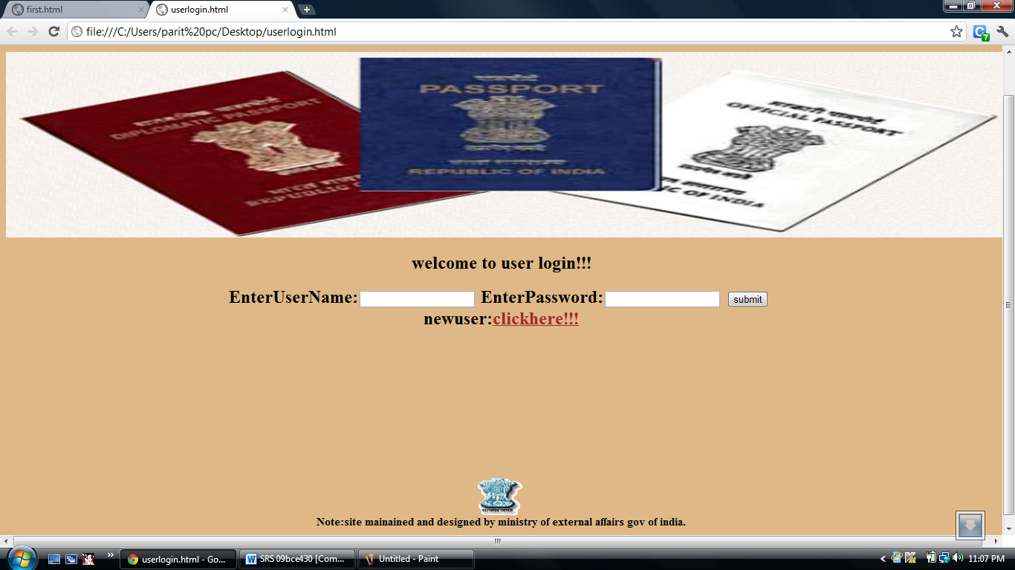

New user registration:
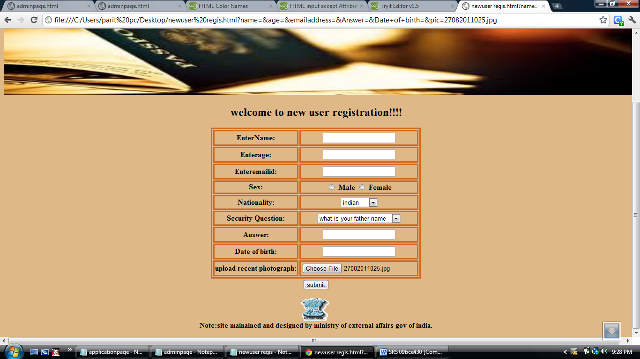

Adminintrator login:
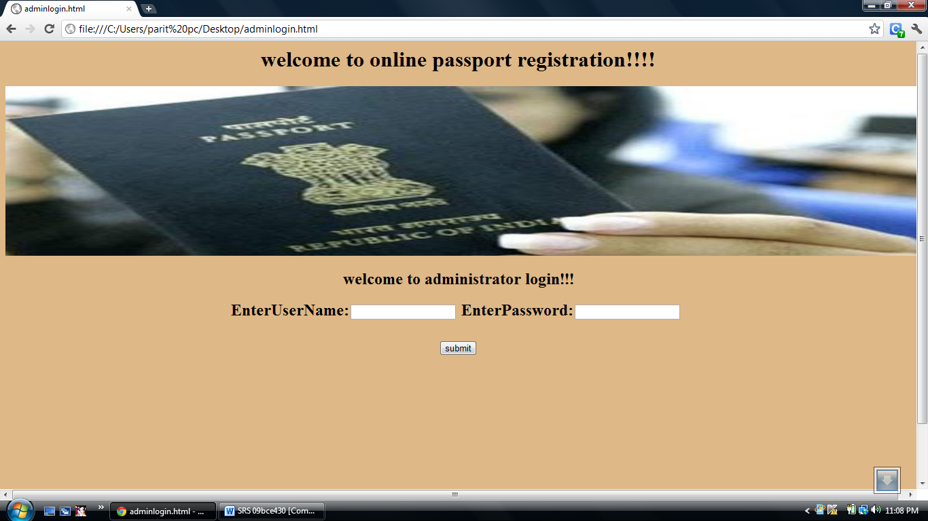

User Homepage:
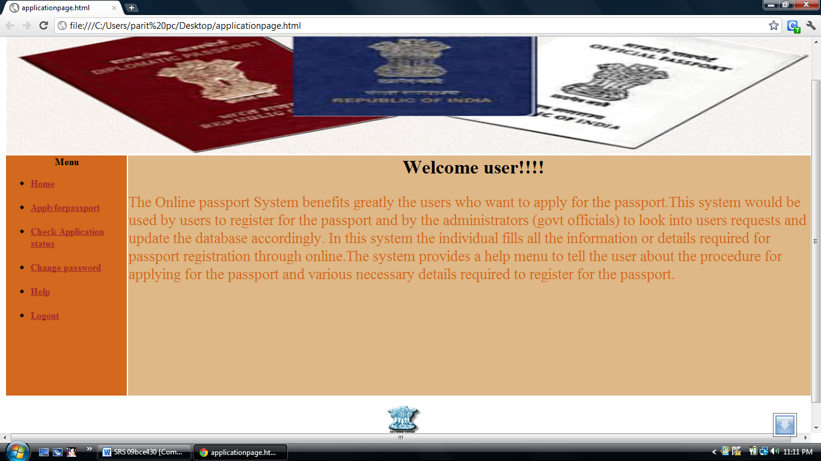

Passport Registration:
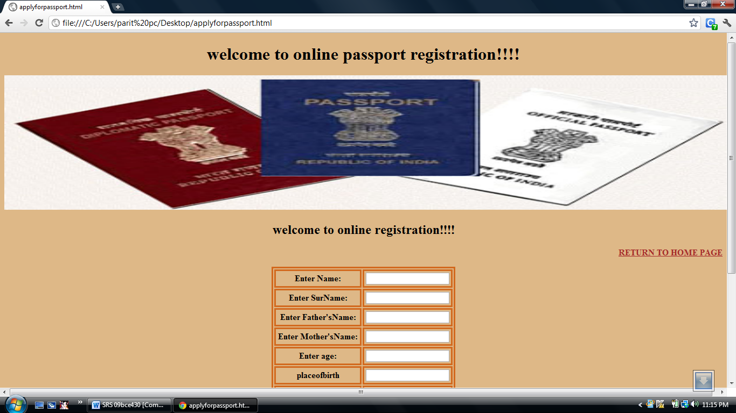

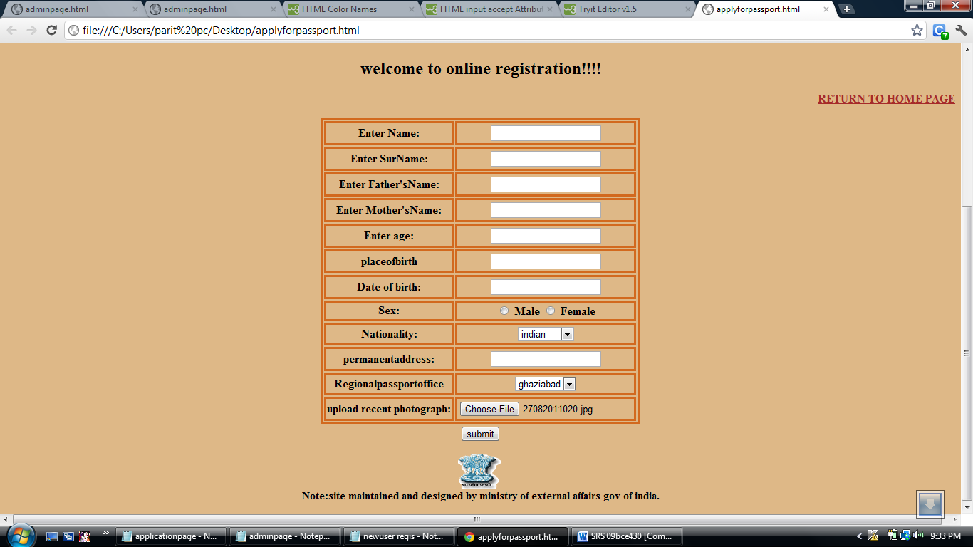

Check Application status:
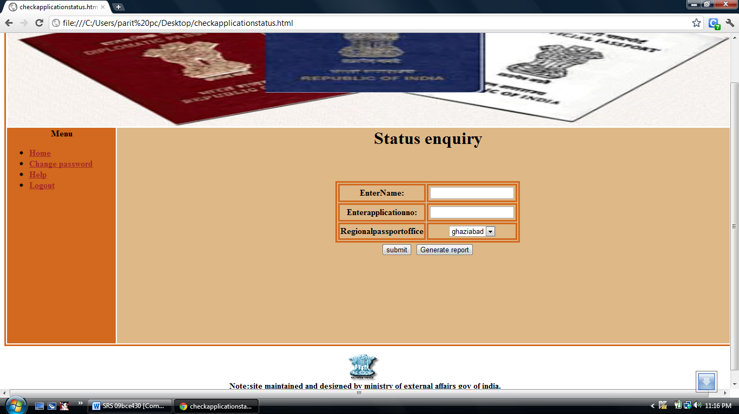

Change password:
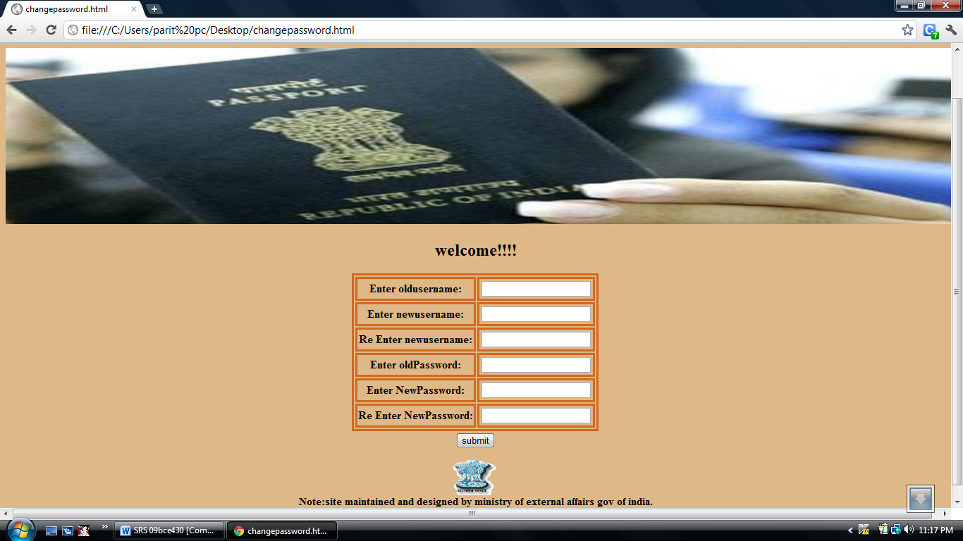

Administrator Homepage:
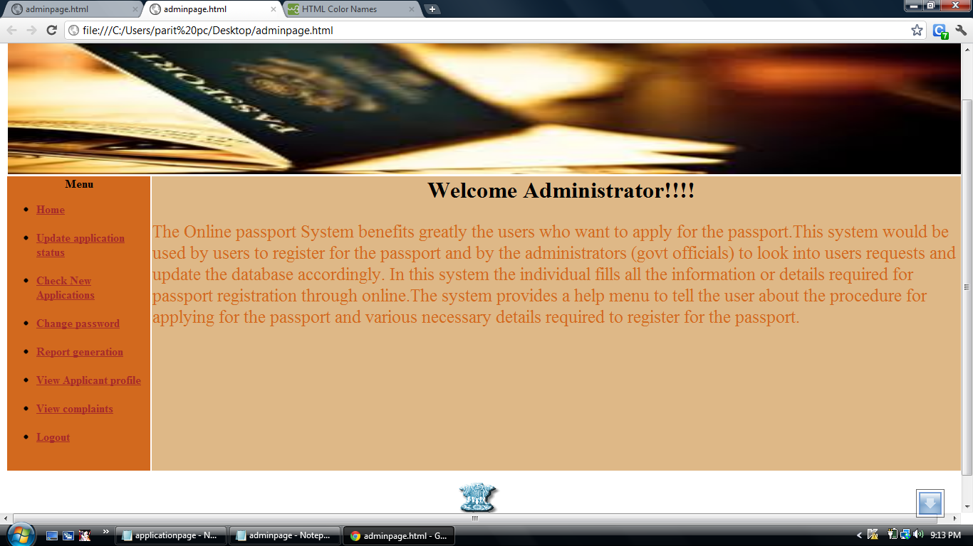

4.2.7 Communications Interfaces
The Online Library System will be connected to the World Wide Web.

4.2.8 Licensing Requirements
The usage is restricted to only University of Houston-Clearlake Library who is purchasing the Online Library System from Library InfoSys and signs the maintenance contract.

4.2.9 Legal, Copyright, and Other Notices
Online Library System is a trademark of Library InfoSys and cannot be used without its consent.
4.2.10 Applicable Standards
The ISO/IEC 6592 guidelines for the documentation of computer based application systems will be followed.

