Date : 04/08/2021

Session: Basic html command and brief about github.

Task : 1) Github account and upload code with various version.

2) Basic html controls.

Description : 1) Today I completed to create my github account ,download github desktop and add repository to my github account. Also try to add repository using command prompt.

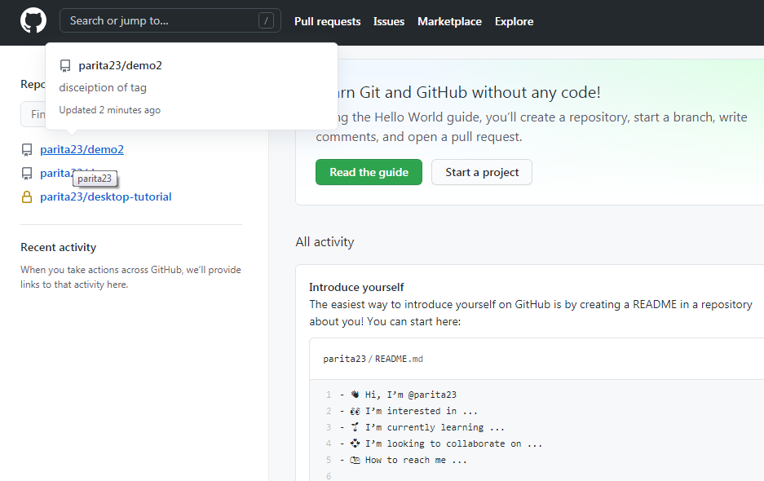

2) today I completed my second task html mostly used tag like formatting ,heading, table, link and form. so output is below.

