Date : 19/08/2021

Session: today session on eventListener and timer in javascript.

Task :

1-Image

Image1

Image2

Image3

Image4

2-Div Simple Text Event

Content 1 Style Text

Content 2

Conetnt 3

3-Color Picker value will be apply to Div Style

4- Textbox Form 10 Textbox Mouse Design   
5-CountDown Start Stop 20.19.18 Stop

5.1- Event Stop Bubbling

6-Jquery Read <https://jquery.com/>

Description : Today I have done practical on above 5 task .below are some ss.

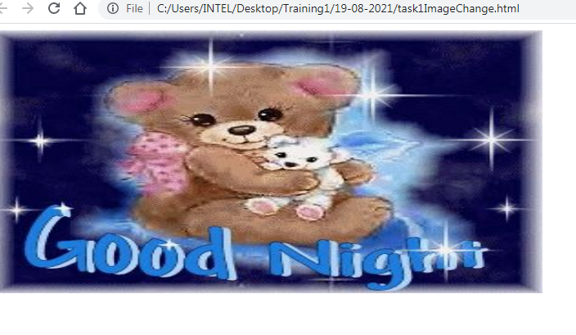

When we hover the mouse then it will change and its up to 5 photos

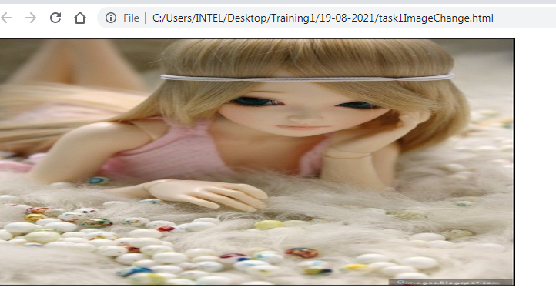

=>when perform single click.

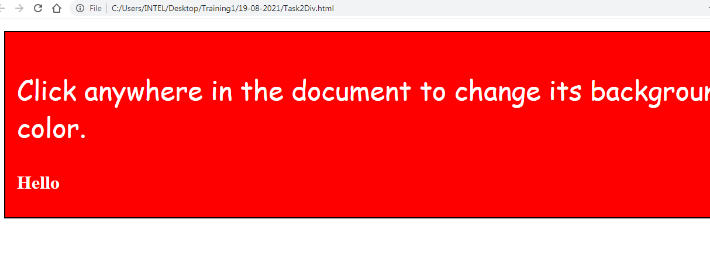

=>when perform double click.

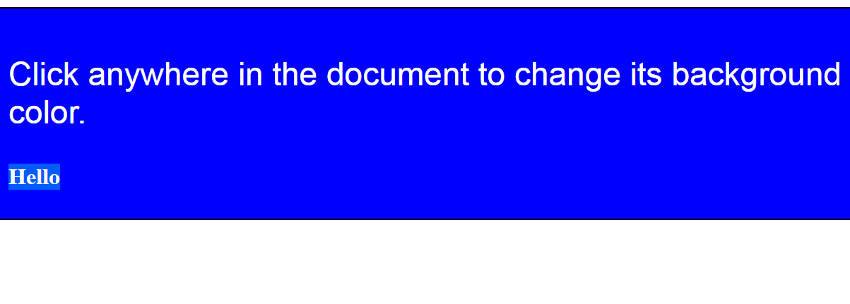

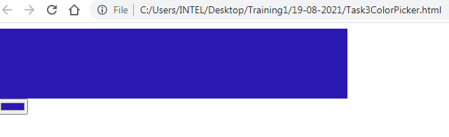

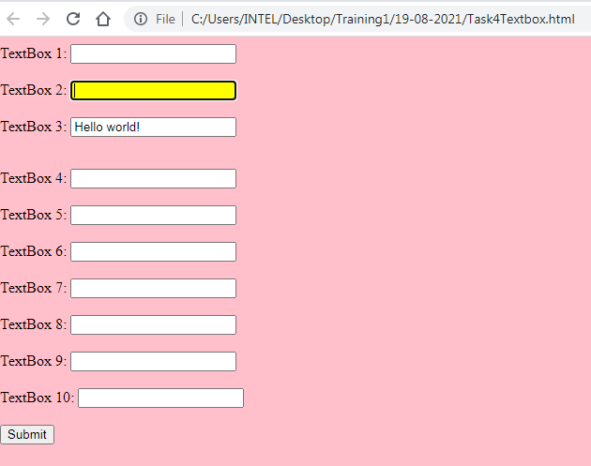

=>enter second 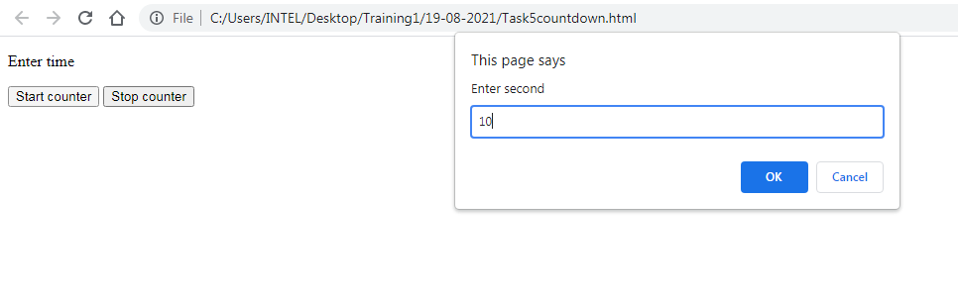

=>start timer and you can also stop it using stop button.

=>stop the timer at 3 when we pressed button.

