Date : 24/09/2021

Session:doing crud operation

Task: perform crud operation

Description : Today i have done crud operation and solve to install mongodb.

|  |  |  |  |
| --- | --- | --- | --- |
| **No** | **Tast Details** | **StartTime** | **EndTime** |
| 1 | Attend Meeting | 09:30 AM | 11:15 PM |
| 2 | Solve mongodb | 11:15AM | 03:00PM |
|  | **LUNCH** | 03:00PM | 04:00PM |
| 5 | Crud operation perform | 04:00PM | 05:30PM |
| 6 | Try another table but not done and give reporting | 05:30PM | 07:00PM |

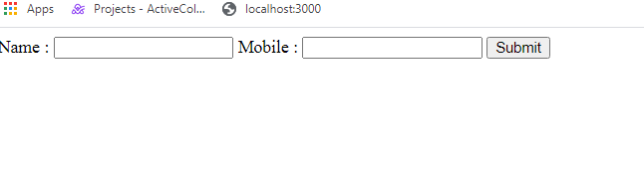

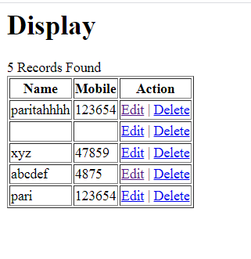

Edit

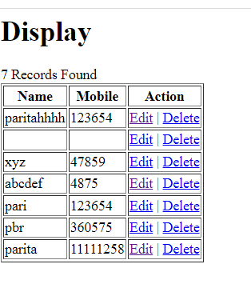

Delete last coloumn

