Parita Gala
December 14, 2024

Final Project – Quickbooks Laundry
ITC 6000

Introduction
In today's fast-paced society, managing daily chores can be a significant burden, particularly for tasks like laundry that require time and effort. QuickBooks Laundry offers a digital solution designed to alleviate this burden, catering primarily to busy professionals, families, and individuals with limited time. This service simplifies the laundry process through an easy-to-use app that allows users to book, schedule, and manage laundry and ironing services with convenient pick-up and delivery options. By integrating seamlessly into the user's lifestyle, QuickBooks Laundry not only helps manage a necessary household task but also saves precious time, making it particularly appealing to its target users.
QuickBooks Laundry adopts a transparent pay-per-service model, where customers are charged based on the specific services they use, such as washing, drying, and ironing, without any hidden costs or subscription fees. This pricing strategy is particularly advantageous for users who prefer flexibility and are wary of monthly commitments. Our personal connection to QuickBooks Laundry stems from our own experiences with the hassle of managing laundry amidst a busy schedule. The service could potentially significantly simplify this aspect of our daily routine, providing a practical solution that emphasizes efficiency and customer satisfaction. This report will explore how QuickBooks Laundry addresses these user needs while also tackling broader business challenges through innovative, technology-driven solutions.

Business Analysis
User Personas
The Over Extended Parent - Juggling a full-time job and a busy household, this parent relies on QuickBooks Laundry for managing laundry efficiently. The service's pick-up and delivery options seamlessly integrate into their tight schedule, offering convenience and ensuring their family always has clean, neatly pressed clothes.
The Professional - This young professional, with a demanding job and vibrant social life, values efficiency. They use QuickBooks Laundry for both laundry and ironing services, appreciating its ease of scheduling and the ability to have clothes ready to wear, enhancing their professional and social presentation.
The QuickBooks Laundry Employee - An integral part of the operational team, this employee manages daily logistics, benefiting from the app's route optimization and customer communication tools. They focus on delivering timely services, directly contributing to customer satisfaction and loyalty through efficient task management.
Business Rules
- Customer Management: Each customer has a unique ID and can register with personal details such as name, email, phone number, and registered date.
- Order Placement: Every order has a unique OrderID, Customer ID and SerciveID, meaning different customers can place different orders for the same location and alternatively the same customer can place different orders for different locations. Orders include details such as the type of service requested, Location ID, pick-up and delivery times, and order status.
- Service Types: Quickbook Laundry offers various services (e.g., laundry, ironing, dry cleaning), each with a unique ServiceID and a description, base price, and estimated duration.
- Location Tracking: Every order has a unique location, and every location can have multiple orders associated with it.
- Payment Processing: Every order has one or more payments associated with it, which may indicate completed or refunded status. Each payment includes details like payment method, amount, and status.
- Employee Assignments: Orders are assigned to employees for pick-up and delivery tasks, tracked with assignment details such as type (e.g., pick-up or delivery) and completion time. Every order can have one or more employees associated with it.

Table Design (ER Design)
Major Data Entities
Orders
- This table records details of each order placed by a customer.
- Attributes:
  - OrderID (PK): Unique identifier for each order.
  - CustomerID (FK): References the Customers table to link the order to a customer.
  - ServiceID (FK): References the Services table to specify the type of service ordered.
  - PickupDateTime (DateTime): Date and time for picking up laundry.
  - DeliveryDateTime (DateTime): Scheduled date and time for delivery.
  - OrderStatus (Category): Status of the order (e.g., Pending, In Progress, Completed, Delivered).
  - TotalAmount (Numeric): Total cost of the service.
2. Services
- This table defines the various services offered (e.g., laundry, ironing, dry cleaning).
- Attributes:
  - ServiceID (PK): Unique identifier for each service type.
  - ServiceName (Category): Name of the service (e.g., Laundry, Ironing, Dry Cleaning).
  - ServiceDescription (Text): Brief description of the service.
  - BasePrice (Numeric): Base price for the service.
  - ServiceDuration (Numeric): Estimated time for completing the service (in hours).
3. Customers (PII Information)
- This table stores personal information for customers.
- Attributes:
  - CustomerID (PK): Unique identifier for each customer.
  - FirstName (Text): Customer’s first name.
  - LastName (Text): Customer’s last name.
  - Email (Text): Customer’s email address (unique).
  - Phone (Text): Customer’s phone number.
  - RegisteredDate (DateTime): Date and time when the customer registered.

4. Locations
- This table stores information about pickup and delivery locations.
- Attributes:
  - LocationID (PK): Unique identifier for each location.
  - CustomerID (FK): References the Customers table.
  - AddressLine1 (Text): Primary address line.
  - AddressLine2 (Text): Secondary address line (optional).
  - City (Category): City of the location.
  - PostalCode (Text): Postal code for the location.
  - Latitude (Numeric): GPS latitude of the location.
  - Longitude (Numeric): GPS longitude of the location.
5. Payments
- This table manages payment information for each order.
- Attributes:
  - PaymentID (PK): Unique identifier for each payment.
  - OrderID (FK): References the Orders table to link the payment to an order.
  - PaymentDateTime (DateTime): Date and time the payment was made.
  - AmountPaid (Numeric): Total amount paid for the order.
  - PaymentMethod (Category): Payment method used (e.g., Credit Card, Debit Card, Cash).
  - PaymentStatus (Category): Status of the payment (e.g., Paid, Pending, Failed).
6. EmployeeAssignments
- This table assigns employees to specific orders for pickups or deliveries.
- Attributes:
  - AssignmentID (PK): Unique identifier for each assignment.
  - OrderID (FK): References the Orders table.
  - EmployeeID (FK): References an Employees table (not detailed here but would contain employee info).
  - AssignmentType (Category): Type of assignment (e.g., Pickup, Delivery).
  - AssignedDateTime (DateTime): Date and time the assignment was made.
  - CompletionDateTime (DateTime): Date and time the assignment was completed.

ER Diagram
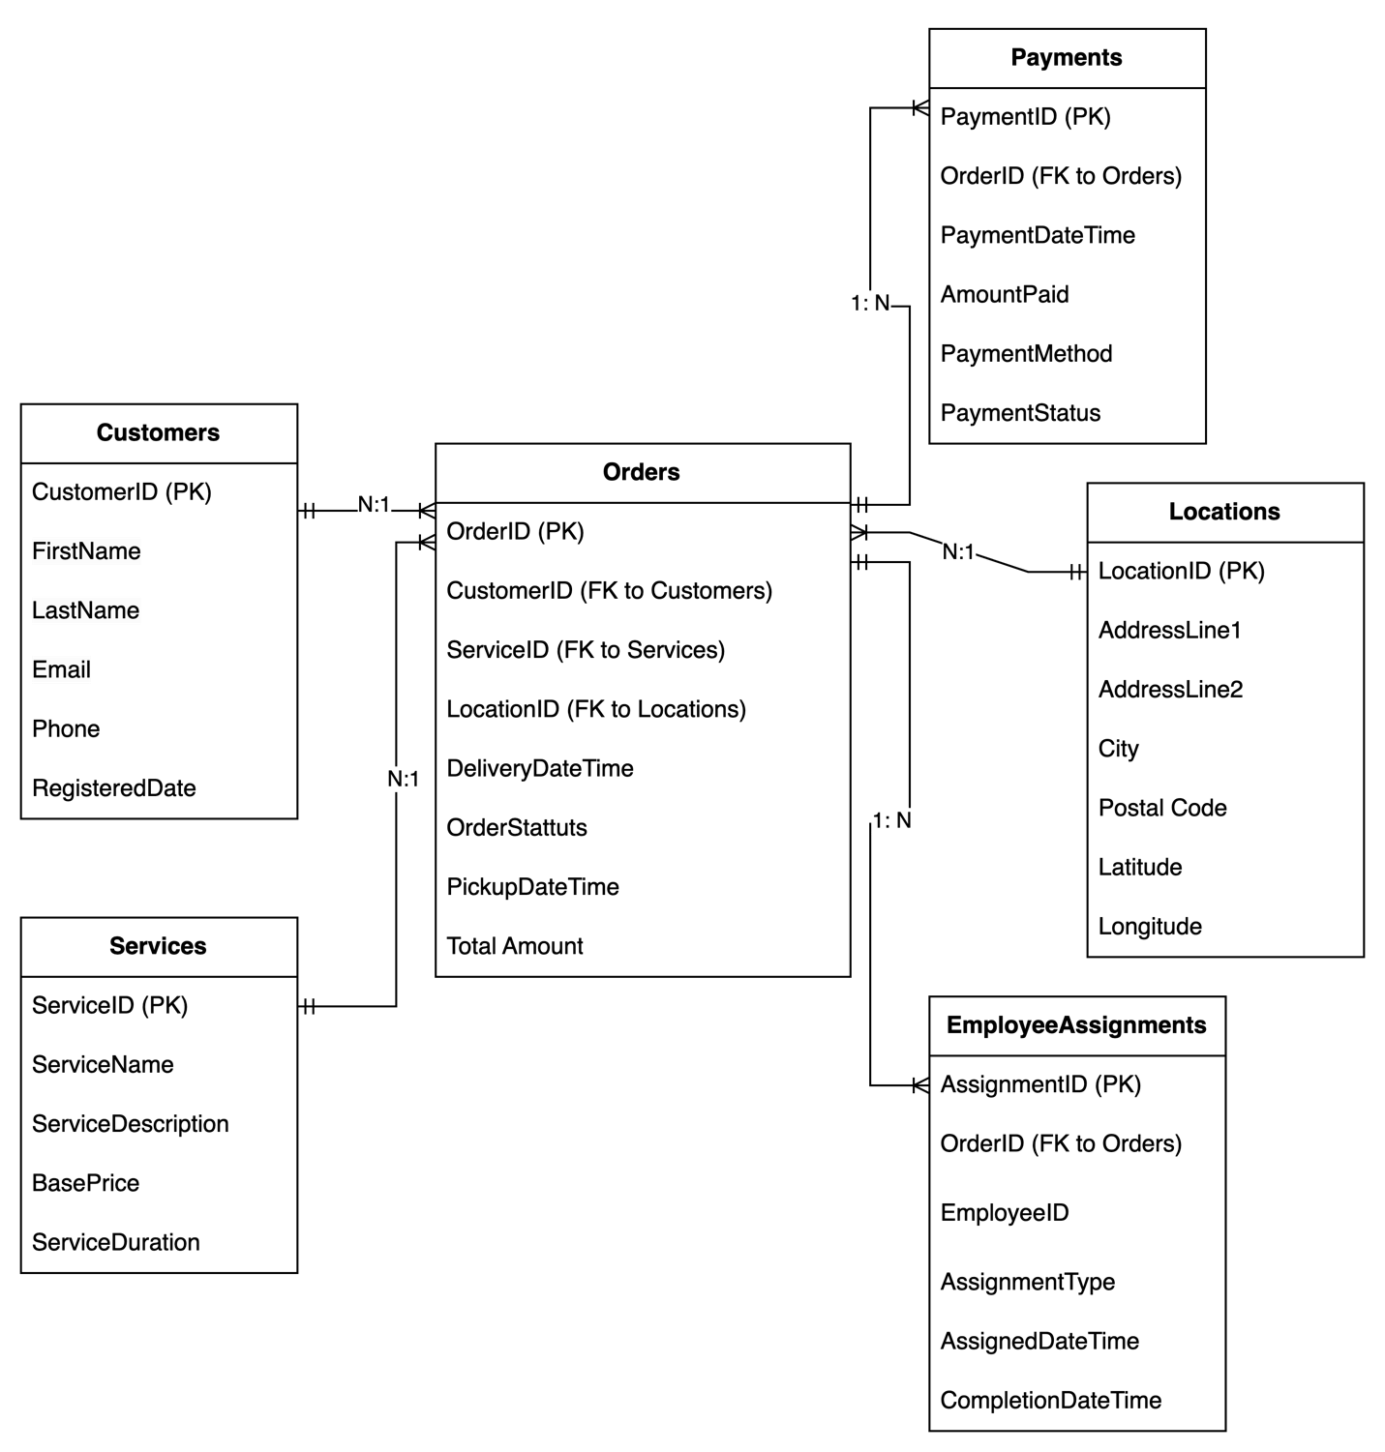

Database Implementations
For the creation of entitles and insertion of data please refer to the following two files.
    - DDL_Quickbooks_Laundry.sql
    - DML_Data_Quickbooks_Laundry.sql
As an example,
Registration and Order Placement: Emma registers on the QuickBooks Laundry app, entering her personal details which are saved in the Customers table. She places an order for laundry and ironing, selecting service types and scheduling pick-up and delivery times. Her order, including service and location details, is logged in the Orders and Locations tables.
Payment and Fulfillment: Emma makes a payment, recorded in the Payments table, linking the transaction to her order. QuickBooks Laundry assigns an employee for her order, with details stored in the EmployeeAssignments table. After service completion, the order status updates to "Delivered," and Emma receives a notification of the successful delivery.

Analytics, Reports, and Metrics
The detailed sql is available in the file
    - DML_Analysis_Quickbooks_Laundry.sql
Some of the questions addressed in our analysis are listed below:
- What is the average number of orders placed by customers per month?
- Which service type (e.g., laundry, ironing, dry cleaning) is most frequently requested?
- Which locations generate the highest number of orders?
- What is the total revenue generated by services within a specific time period?
- Which employees have completed the most assignments (e.g., pick-ups or deliveries) in the last month?
- What is the average delivery time for completed orders by location?
- What is the distribution of payment methods (e.g., credit card, cash) used by customers?
- How many customers placed repeat orders within a specified time frame?
- What percentage of orders were delivered on time versus delayed?
- Are there underserved locations (low number of orders) where marketing efforts should be targeted?

Security Concerns
The database for QuickBooks Laundry includes several categories of sensitive information that require careful handling to ensure privacy and security compliance. Primarily, the Customers table stores personal data such as names, email addresses, phone numbers, and registration dates. This data is classified as personally identifiable information (PII), which is subject to various data protection regulations like GDPR or CCPA, depending on the geographic location of the users and the operations of the business. Ensuring the security of this data is crucial to protecting customer privacy and maintaining trust.
Additionally, the Payments table processes and stores details like payment amounts, methods, and transaction statuses, which, while not directly including financial data like credit card numbers, still relate to financial transactions that could be sensitive if associated with customer identities. The linkage of orders to customers through the Orders table and the recording of payment transactions highlight the need for robust access controls and data encryption to protect against unauthorized access and data breaches. It is essential for the security, legal, and privacy teams to work closely to implement policies that comply with relevant laws and regulations regarding data handling and security.

Architecture
For QuickBooks Laundry, a cloud-based architecture is recommended to efficiently handle a high volume of transactions. This scalable solution leverages services such as Amazon Web Services (AWS) or Microsoft Azure, which provide automated scaling, data redundancy, and high availability (Amazon Web Services, n.d.; Microsoft, n.d.).
The architecture includes:
- Presentation Layer: Accessible via mobile and web platforms for customer interactions.
- Application Layer: Utilizes cloud-native services like AWS Lambda or Azure Functions to manage business logic and automatically adjust compute resources.
- Data Layer: Managed database services like Amazon RDS or Azure SQL Database ensure secure, scalable data management.
- Security and Compliance: Tools such as AWS Shield and AWS IAM, or Azure Active Directory help meet rigorous security and compliance standards.
This approach not only supports scalability but also minimizes maintenance overhead, allowing QuickBooks Laundry to focus on customer service enhancements.

Summary
Through this project, we have gained a deeper understanding of designing and implementing a scalable database architecture for a service-based application like QuickBooks Laundry. Key takeaways include the importance of designing a system that can handle varying loads efficiently through cloud-based solutions such as AWS or Azure, ensuring data security and compliance with regulations such as GDPR and CCPA, and the significance of having a robust, flexible infrastructure that can adapt to changing business needs. These insights will be invaluable in future projects, especially those requiring high availability, security, and scalability to ensure seamless user experiences and operational efficiency.

References
- Elmasri, R., & Navathe, S. B. (2016). Fundamentals of Database Systems (7th ed.). Pearson Education.
- Hoffer, J. A., Ramesh, V., & Topi, H. (2016). Modern Database Management (12th ed.). Pearson Education.
- Connolly, T., & Begg, C. (2015). Database Systems: A Practical Approach to Design, Implementation, and Management (6th ed.). Pearson.
- Silberschatz, A., Korth, H. F., & Sudarshan, S. (2019). Database System Concepts (7th ed.). McGraw-Hill Education.
- Amazon Web Services. (n.d.). AWS Well-Architected Framework. Retrieved from https://aws.amazon.com/architecture/well-architected/
- Microsoft. (n.d.). Azure Architecture Center. Retrieved from https://docs.microsoft.com/en-us/azure/architecture/

