**Hands on 1**

**Create a Spring Web Project using Maven**

package com.cognizant.springlearn;

import org.slf4j.Logger;

import org.slf4j.LoggerFactory;

import org.springframework.boot.SpringApplication;

import org.springframework.boot.autoconfigure.SpringBootApplication;

*@SpringBootApplication*

public class SpringLearnApplication {

private static final Logger ***LOGGER*** = LoggerFactory.*getLogger*(SpringLearnApplication.class);

public static void main(String[] args) {

***LOGGER***.info("START");

SpringApplication.*run*(SpringLearnApplication.class, args);

***LOGGER***.info("END");

}

}

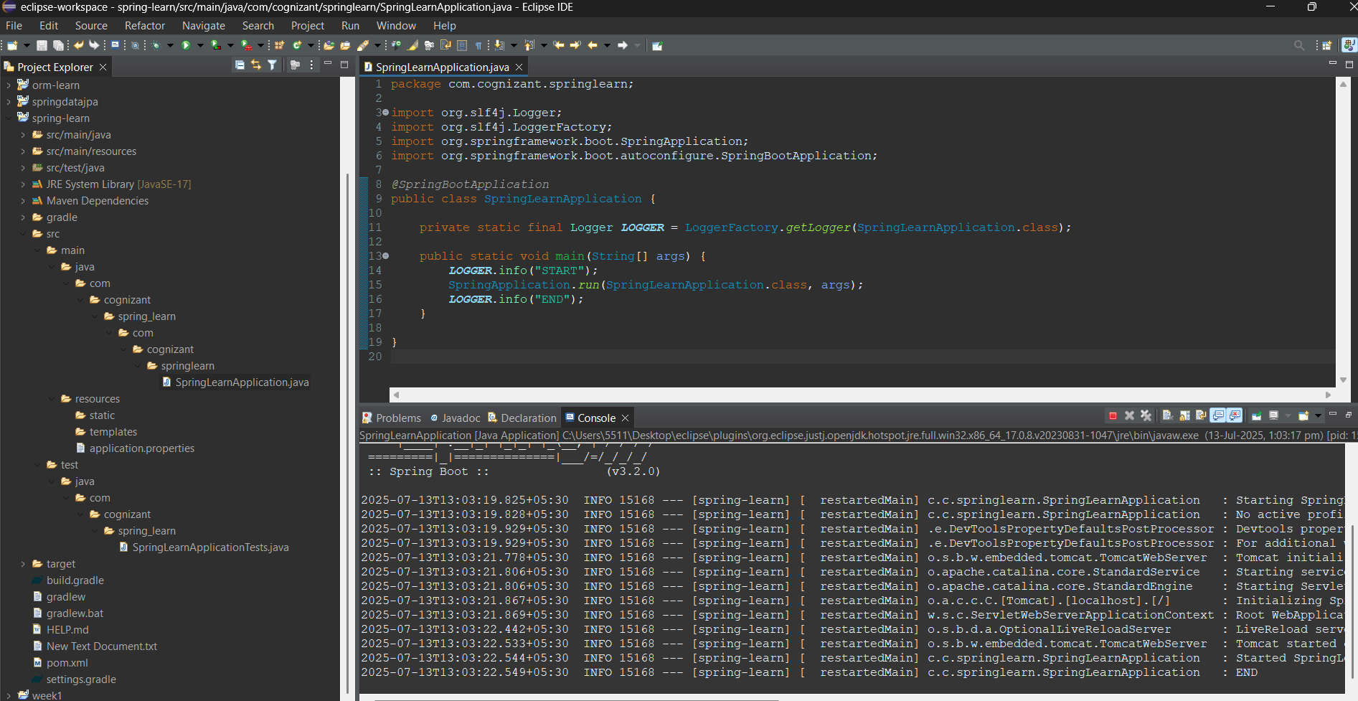

**2)Spring Core – Load Country from Spring Configuration XML**

package com.cognizant.springlearn;

import org.slf4j.Logger;

import org.slf4j.LoggerFactory;

import org.springframework.boot.SpringApplication;

import org.springframework.boot.autoconfigure.SpringBootApplication;

import org.springframework.context.ApplicationContext;

import org.springframework.context.support.ClassPathXmlApplicationContext;

@SpringBootApplication

public class SpringLearnApplication {

private static final Logger LOGGER = LoggerFactory.getLogger(SpringLearnApplication.class);

public static void main(String[] args) {

LOGGER.info("START");

SpringApplication.run(SpringLearnApplication.class, args);

displayCountry();

LOGGER.info("END");

}

public static void displayCountry() {

ApplicationContext context = new ClassPathXmlApplicationContext("country.xml");

Country country = (Country) context.getBean("country", Country.class);

LOGGER.debug("Country : {}", country.toString());

}

}

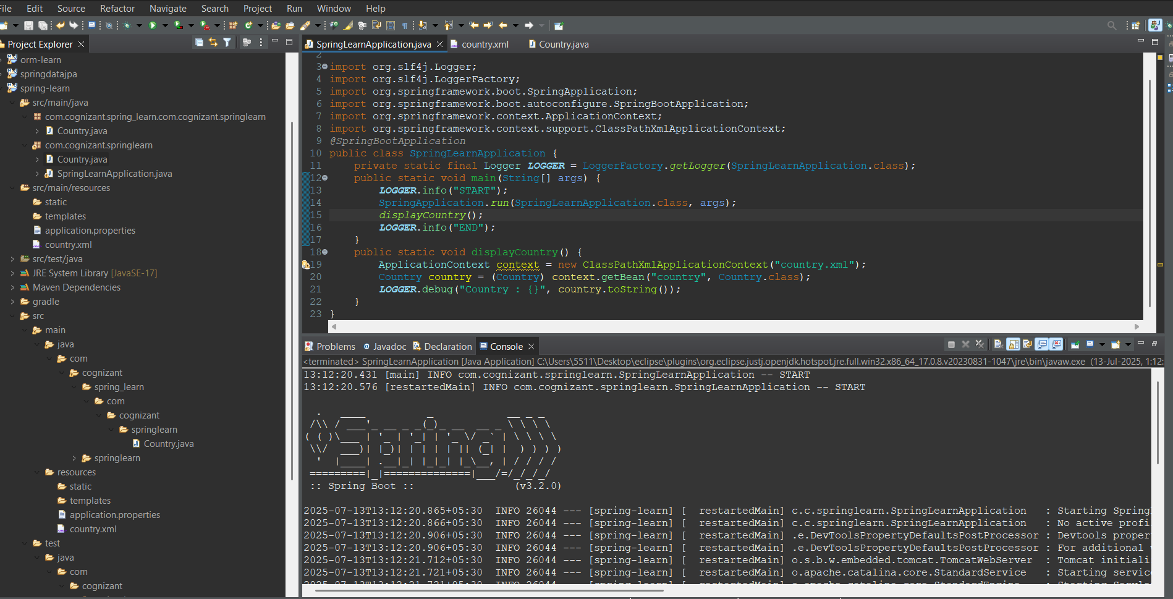

**Hello World RESTful Web Service**

package com.cognizant.springlearn;

import org.slf4j.Logger;

import org.slf4j.LoggerFactory;

import org.springframework.boot.SpringApplication;

import org.springframework.boot.autoconfigure.SpringBootApplication;

import org.springframework.context.ApplicationContext;

import org.springframework.context.support.ClassPathXmlApplicationContext;

@SpringBootApplication

public class SpringLearnApplication {

private static final Logger LOGGER = LoggerFactory.getLogger(SpringLearnApplication.class);

public static void main(String[] args) {

LOGGER.info("START");

SpringApplication.run(SpringLearnApplication.class, args);

displayCountry();

LOGGER.info("END");

}

public static void displayCountry() {

ApplicationContext context = new ClassPathXmlApplicationContext("country.xml");

Country country = (Country) context.getBean("country", Country.class);

LOGGER.debug("Country : {}", country.toString());

}

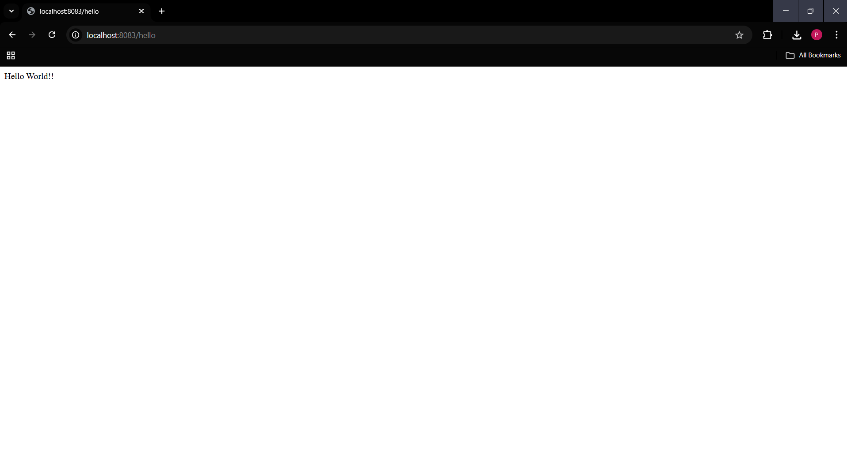

**REST - Country Web Service**

package com.cognizant.springlearn.controller;

import com.cognizant.springlearn.Country;

import org.slf4j.Logger;

import org.slf4j.LoggerFactory;

import org.springframework.context.ApplicationContext;

import org.springframework.context.support.ClassPathXmlApplicationContext;

import org.springframework.web.bind.annotation.RequestMapping;

import org.springframework.web.bind.annotation.RestController;

*@RestController*

public class CountryController {

private static final Logger ***LOGGER*** = LoggerFactory.*getLogger*(CountryController.class);

*@RequestMapping*("/country")

public Country getCountryIndia() {

***LOGGER***.info("START");

ApplicationContext context = new ClassPathXmlApplicationContext("country.xml");

Country country = (Country) context.getBean("country", Country.class);

***LOGGER***.debug("Country : {}", country.toString());

***LOGGER***.info("END");

return country;

}

}

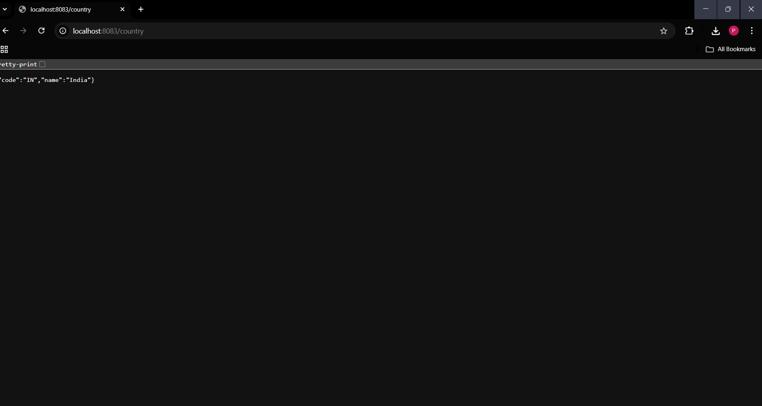

**REST - Get country based on country code** 

package com.cognizant.springlearn.service;

import com.cognizant.springlearn.Country;

import org.slf4j.Logger;

import org.slf4j.LoggerFactory;

import org.springframework.context.ApplicationContext;

import org.springframework.context.support.ClassPathXmlApplicationContext;

import org.springframework.stereotype.Service;

import java.util.List;

*@Service*

public class CountryService {

private static final Logger ***LOGGER*** = LoggerFactory.*getLogger*(CountryService.class);

public Country getCountry(String code) {

***LOGGER***.info("START");

ApplicationContext context = new ClassPathXmlApplicationContext("country.xml");

List<Country> countries = (List<Country>) context.getBean("countryList");

// Using Lambda Expression for case-insensitive matching

Country country = countries.stream()

.filter(c -> c.getCode().equalsIgnoreCase(code))

.findFirst()

.orElse(null);

***LOGGER***.debug("Country : {}", country);

***LOGGER***.info("END");

return country;

}

}

