1. Singleton Pattern

package week1;

class Logger {

private static Logger instance;

private Logger() {

System.out.println("instance created");

}

public static Logger getInstance() {

if(instance == null) {

instance = new Logger();

}

return instance;

}

public void log(String message) {

System.out.print("message: "+message);

}

}

public class Singleton {

public static void main(String[] args) {

// TODO Auto-generated method stub

Logger logger1 = Logger.getInstance();

Logger logger2 = Logger.getInstance();

logger1.log("First log");

logger2.log("Second log");

if (logger1 == logger2) {

System.out.println("logger1 and logger2 are the same instance.");

} else {

System.out.println("logger1 and logger2 are Different instances");

}

}

}

Output: 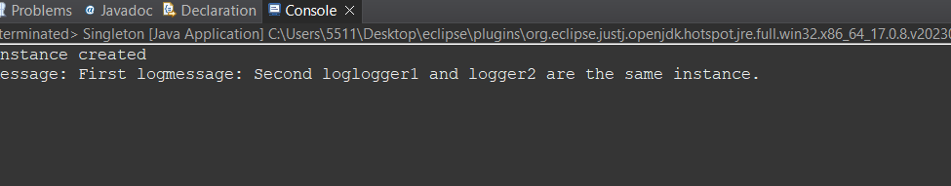

1. Factory Method Pattern

package week1;

public class FactoryMethodPattern {

interface Document{

void open();

}

static class WordDocument implements Document{

public void open() {

System.out.println("Word doc");

}

}

static class PdfDocument implements Document{

public void open() {

System.out.println("Pdf doc");

}

}

static class ExcelDocument implements Document{

public void open() {

System.out.println("Excel doc");

}

}

static abstract class DocumentFactory{

public abstract Document createDocument();

}

static class WordDocumentFactory extends DocumentFactory {

@Override

public Document createDocument() {

return new WordDocument();

}

}

static class PdfDocumentFactory extends DocumentFactory {

@Override

public Document createDocument() {

return new PdfDocument();

}

}

static class ExcelDocumentFactory extends DocumentFactory {

@Override

public Document createDocument() {

return new ExcelDocument();

}

}

public static void main(String[] args) {

DocumentFactory wordFactory = new WordDocumentFactory();

Document wordDoc = wordFactory.createDocument();

wordDoc.open();

DocumentFactory pdfFactory = new PdfDocumentFactory();

Document pdfDoc = pdfFactory.createDocument();

pdfDoc.open();

DocumentFactory excelFactory = new ExcelDocumentFactory();

Document excelDoc = excelFactory.createDocument();

excelDoc.open();

}

}

Output:

