Exercise 1: Setting Up Junit

package com.example;

import static org.junit.Assert.*;

import org.junit.Test;

public class CalculatorTest {

*@Test*

public void testAddition() {

Calculator calc = new Calculator();

int result = calc.add(2, 3);

*assertEquals*(5, result);

}

}

Output:

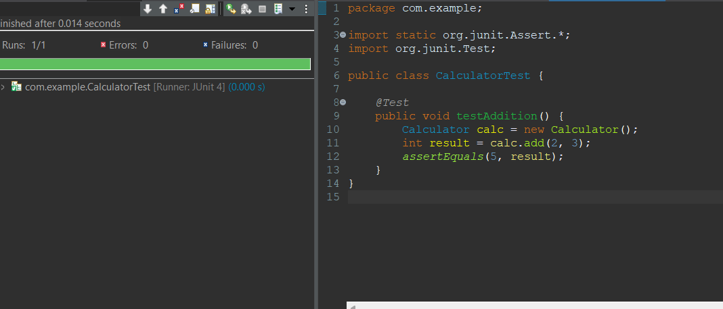

Exercise 3: Assertions in Junit

package com.example;

import static org.junit.Assert.*;

import org.junit.Test;

public class AssertionsTest {

*@Test*

public void testAssertions() {

// Assert equals

*assertEquals*(5, 2 + 3);

// Assert true

*assertTrue*(5 > 3);

// Assert false

*assertFalse*(5 < 3);

// Assert null

*assertNull*(null);

// Assert not null

*assertNotNull*(new Object());

}

}

Output:

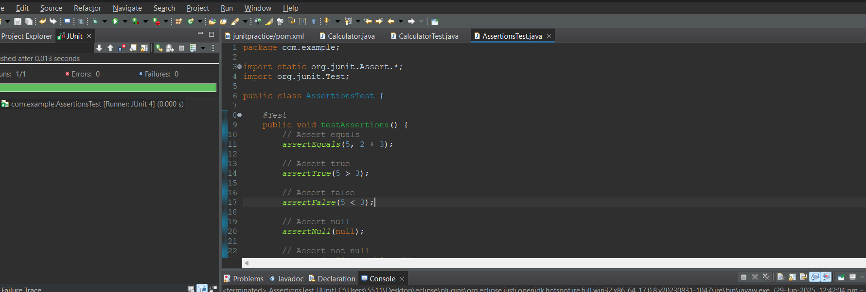

Exercise 4: Arrange-Act-Assert (AAA) Pattern, Test Fixtures, Setup and Teardown Methods in Junit

package com.example;

import static org.junit.Assert.*;

import org.junit.Before;

import org.junit.After;

import org.junit.Test;

public class CalculatorAAATest {

private Calculator calc;

*@Before*

public void setUp() {

calc = new Calculator();

System.***out***.println("Setup: Calculator instance created.");

}

*@After*

public void tearDown() {

calc = null;

System.***out***.println("Teardown: Calculator instance set to null.");

}

*@Test*

public void testAddition() {

int result = calc.add(10, 5);

*assertEquals*(15, result);

}

*@Test*

public void testAdditionNegative() {

int result = calc.add(-2, -3);

*assertEquals*(-5, result);

}

}

Output:

