Exercise 1: Mocking and Stubbing

import static org.mockito.Mockito.\*;

import org.junit.jupiter.api.Test;

import org.mockito.Mockito;

public class MyServiceTest {

@Test

public void testExternalApi() {

ExternalApi mockApi = Mockito.mock(ExternalApi.class);

when(mockApi.getData()).thenReturn("Mock Data");

MyService service = new MyService(mockApi);

String result = service.fetchData();

assertEquals("Mock Data", result);

}

}

Output: 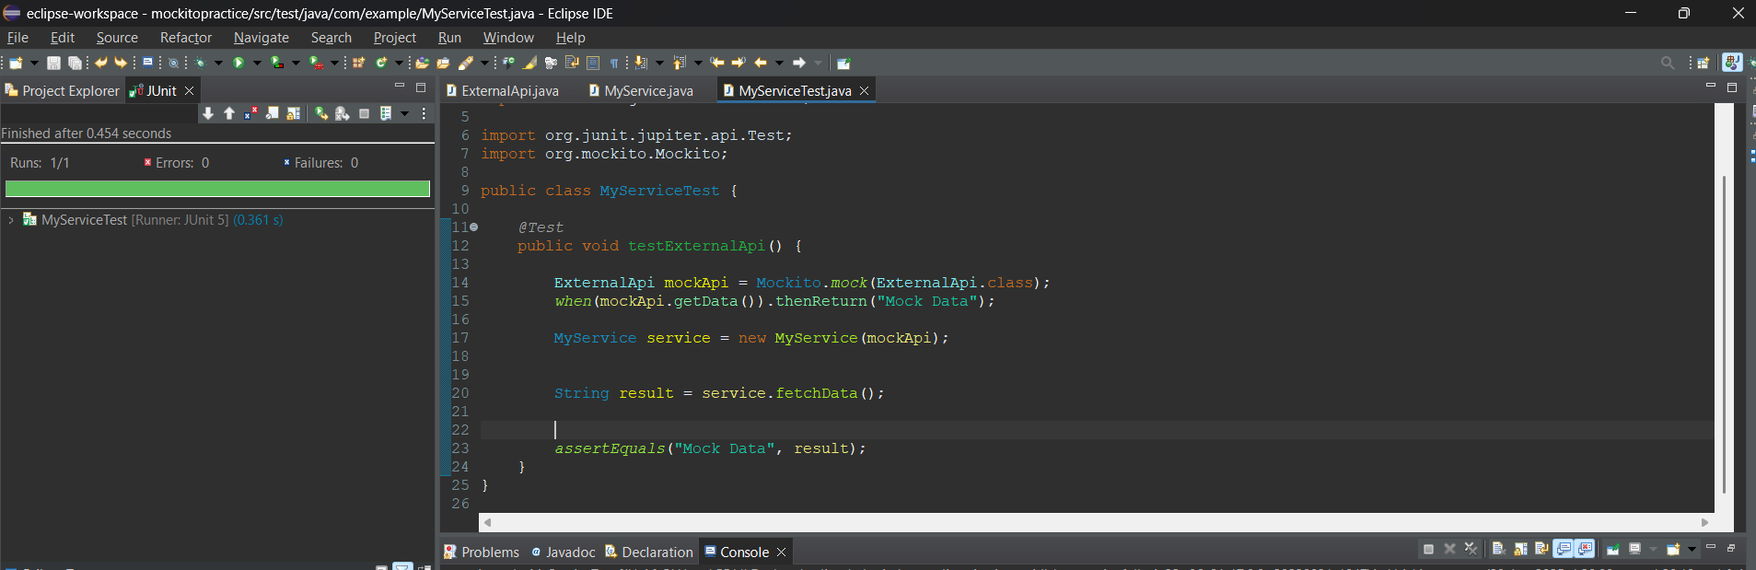

Exercise 2: Verifying Interactions

import static org.mockito.Mockito.\*;

import org.junit.jupiter.api.Test;

import org.mockito.Mockito;

public class MyServiceTest {

@Test

public void testVerifyInteraction() {

ExternalApi mockApi = Mockito.mock(ExternalApi.class);

MyService service = new MyService(mockApi);

service.fetchData();

verify(mockApi).getData();

}

}

Output:

