**Exercise 1: Control Structures**

**Scenario 1:** The bank wants to apply a discount to loan interest rates for customers above 60 years old

SET SERVEROUTPUT ON;

DECLARE

    v_age NUMBER;

    v_discount NUMBER := 1;

BEGIN

    FOR cust_rec IN (SELECT CustomerID, DOB FROM Customers) LOOP

        v_age := FLOOR(MONTHS_BETWEEN(SYSDATE, cust_rec.DOB)/12)

        IF v_age > 60 THEN

            UPDATE Loans

            SET InterestRate = InterestRate - v_discount

            WHERE CustomerID = cust_rec.CustomerID;

            DBMS_OUTPUT.PUT_LINE('Applied discount for CustomerID: ' || cust_rec.CustomerID);

        END IF;

    END LOOP;

END;

Output: 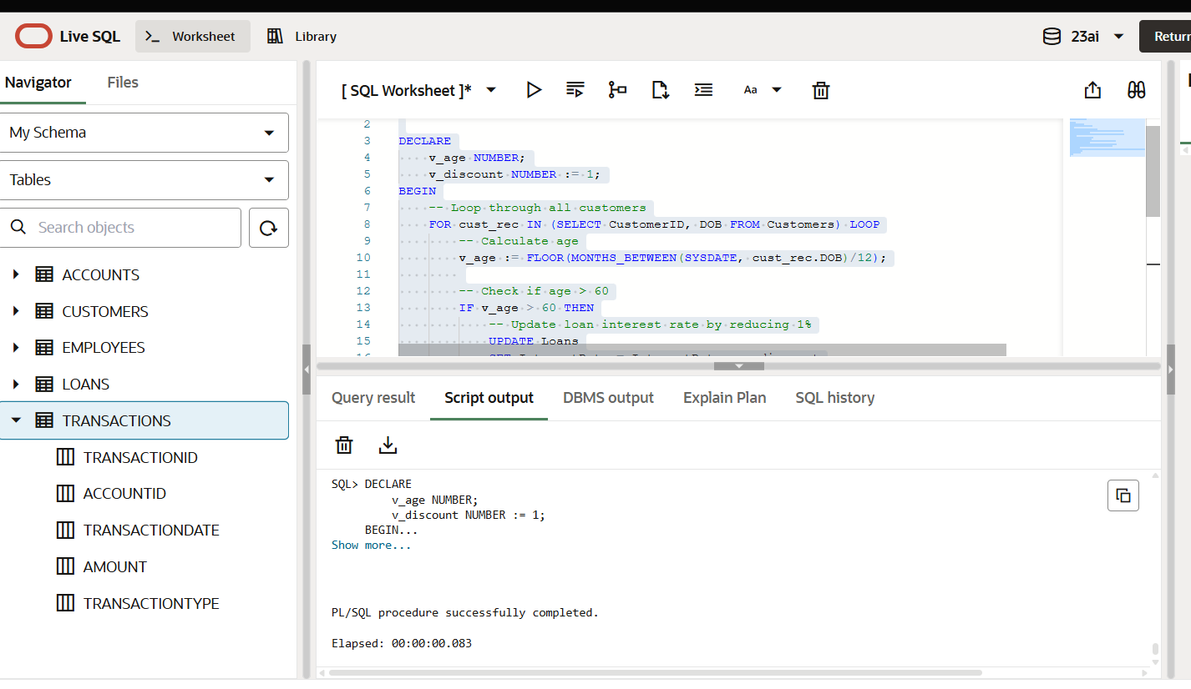

**Scenario 2:** A customer can be promoted to VIP status based on their balance

ALTER TABLE Customers ADD (IsVIP VARCHAR2(5));

SET SERVEROUTPUT ON;

BEGIN

FOR cust_rec IN (SELECT CustomerID, Balance FROM Customers) LOOP

IF cust_rec.Balance > 10000 THEN

UPDATE Customers

SET IsVIP = 'TRUE'

WHERE CustomerID = cust_rec.CustomerID;

DBMS_OUTPUT.PUT_LINE('CustomerID ' || cust_rec.CustomerID || ' promoted to VIP.');

END IF;

END LOOP;

END;

Output:

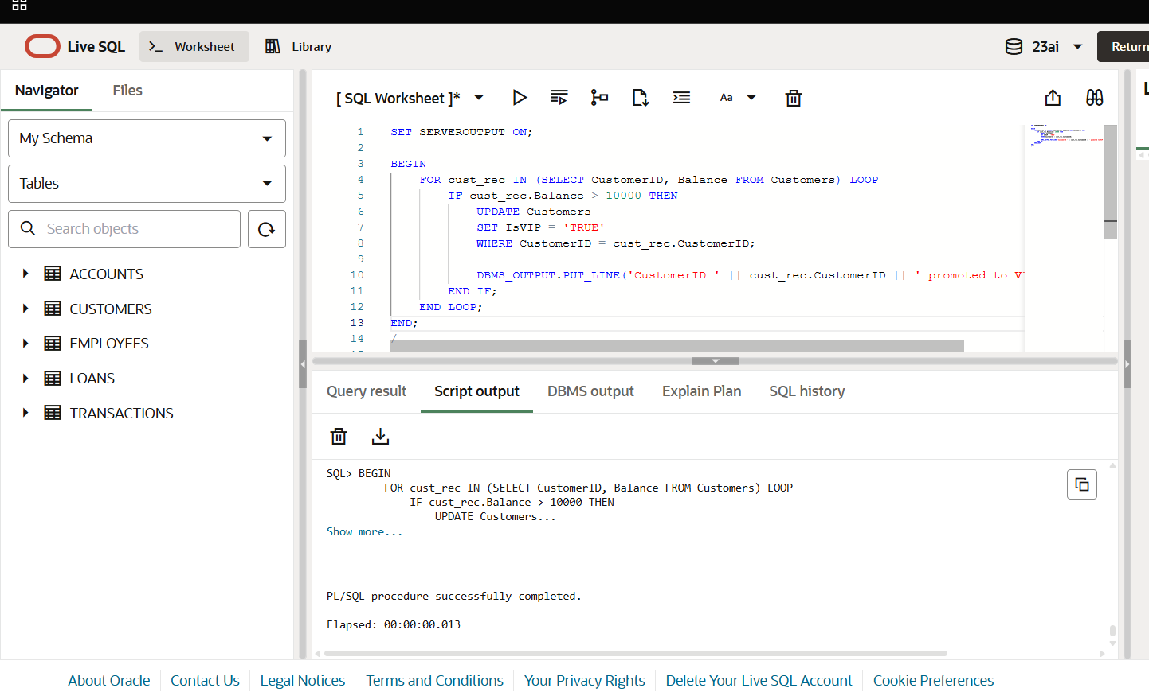

**Scenario 3:** The bank wants to send reminders to customers whose loans are due within the next 30 days.

SET SERVEROUTPUT ON;

BEGIN

FOR loan_rec IN (

SELECT l.LoanID, l.CustomerID, l.EndDate, c.Name

FROM Loans l

JOIN Customers c ON l.CustomerID = c.CustomerID

WHERE l.EndDate BETWEEN SYSDATE AND SYSDATE + 30

) LOOP

DBMS_OUTPUT.PUT_LINE('Reminder: LoanID ' || loan_rec.LoanID ||

' for customer ' || loan_rec.Name ||

' is due on ' || TO_CHAR(loan_rec.EndDate, 'YYYY-MM-DD'));

END LOOP;

END;

Output:

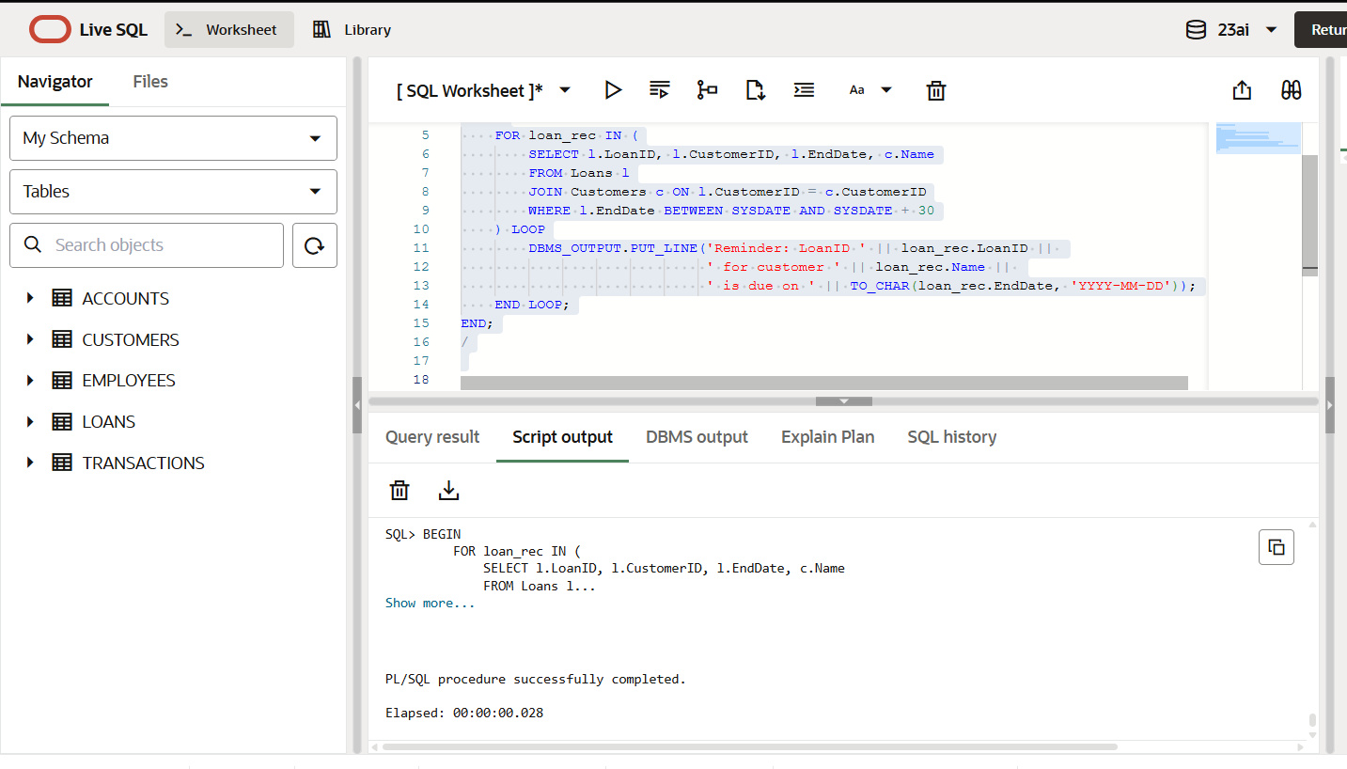

**Exercise 3: Stored Procedures**

**Scenario 1:** The bank needs to process monthly interest for all savings accounts.

CREATE OR REPLACE PROCEDURE ProcessMonthlyInterest

IS

v_interest_rate NUMBER := 0.01; -- 1% interest

BEGIN

UPDATE Accounts

SET Balance = Balance + (Balance * v_interest_rate)

WHERE AccountType = 'Savings';

DBMS_OUTPUT.PUT_LINE('Monthly interest processed for all savings accounts.');

END;

Output:

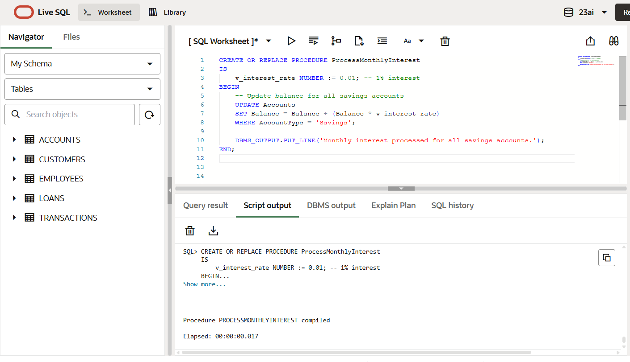

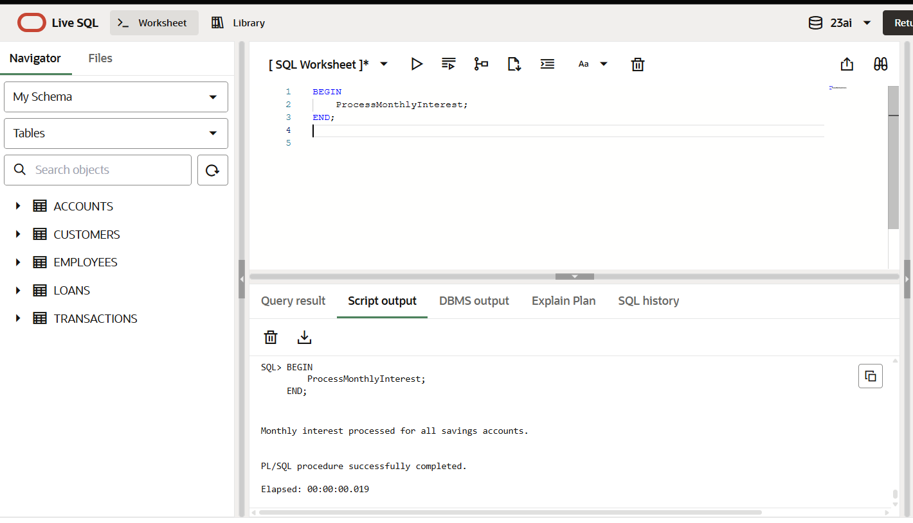

**Scenario 2:** The bank wants to implement a bonus scheme for employees based on their performance

CREATE OR REPLACE PROCEDURE UpdateEmployeeBonus(

p_department IN VARCHAR2,

p_bonus_pct IN NUMBER

)

IS

BEGIN

UPDATE Employees

SET Salary = Salary + (Salary * (p_bonus_pct / 100))

WHERE Department = p_department;

DBMS_OUTPUT.PUT_LINE('Bonus applied to department: ' || p_department);

END;

Output:

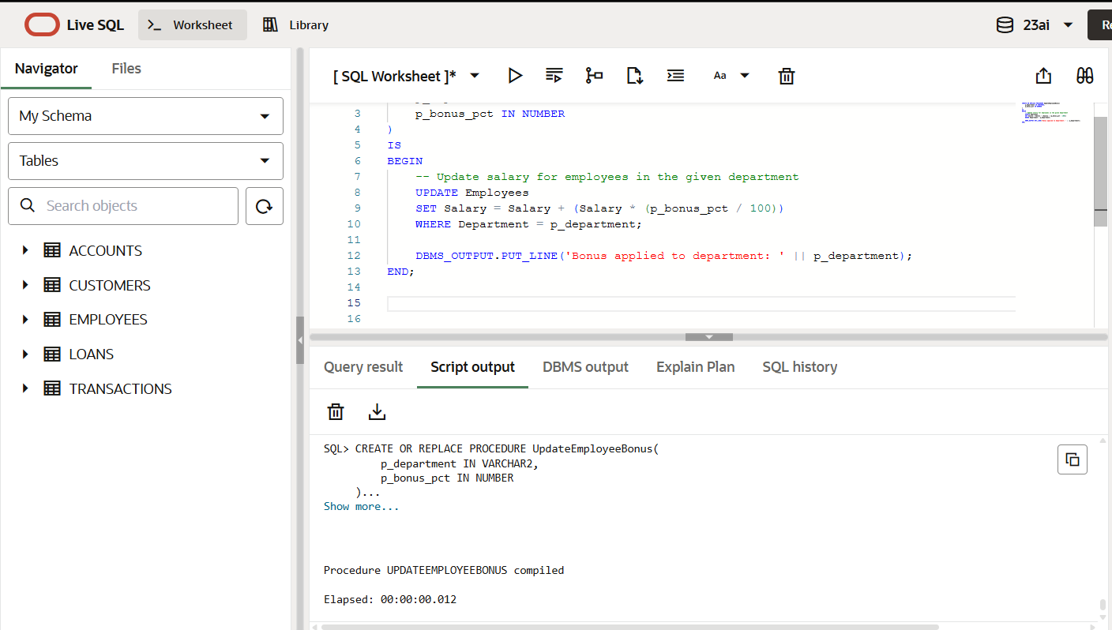

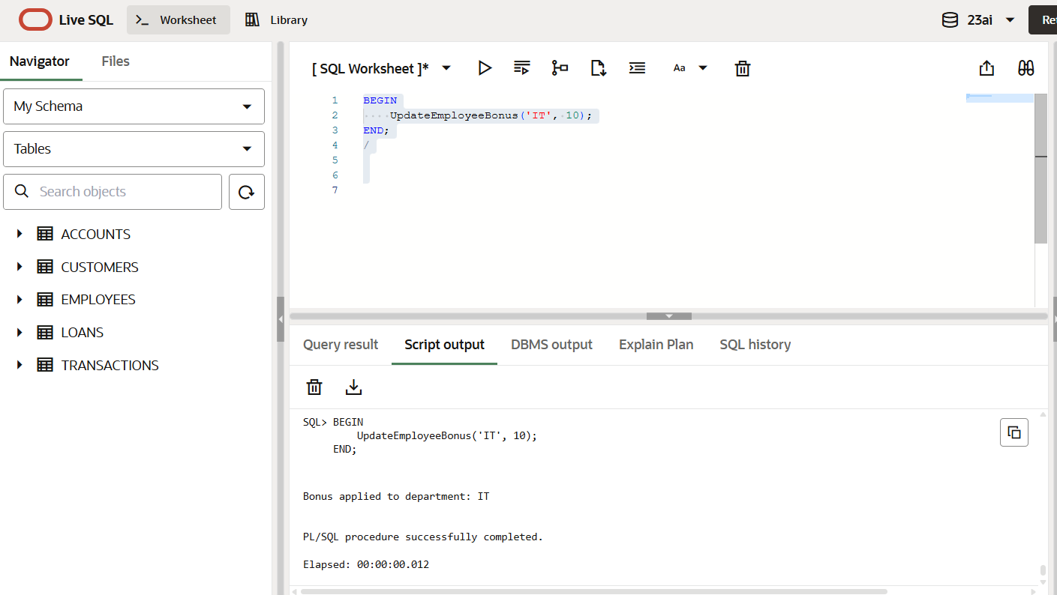

**Scenario 3:** Customers should be able to transfer funds between their accounts.

CREATE OR REPLACE PROCEDURE TransferFunds(

    p_source_account IN NUMBER,

    p_target_account IN NUMBER,

    p_amount IN NUMBER

)

IS

    v_source_balance NUMBER;

BEGIN

    SELECT Balance INTO v_source_balance

    FROM Accounts

    WHERE AccountID = p_source_account;

    IF v_source_balance >= p_amount THEN

        UPDATE Accounts

        SET Balance = Balance - p_amount

        WHERE AccountID = p_source_account;

        UPDATE Accounts

        SET Balance = Balance + p_amount

        WHERE AccountID = p_target_account;

        DBMS_OUTPUT.PUT_LINE('Transfer of ' || p_amount || ' completed from AccountID ' || p_source_account || ' to AccountID ' || p_target_account);

    ELSE

        DBMS_OUTPUT.PUT_LINE('Insufficient balance in AccountID ' || p_source_account);

    END IF;

END;

Output:

