**Exercise 1: Configuring a Basic Spring Application**

package com.library;

import org.springframework.context.support.ClassPathXmlApplicationContext;

import com.library.service.BookService;

public class MainApp {

public static void main(String[] args) {

ClassPathXmlApplicationContext context = new ClassPathXmlApplicationContext("applicationContext.xml");

BookService bookService = context.getBean("bookService", BookService.class);

bookService.addBook("Spring in Action");

context.close();

}

}

Output:

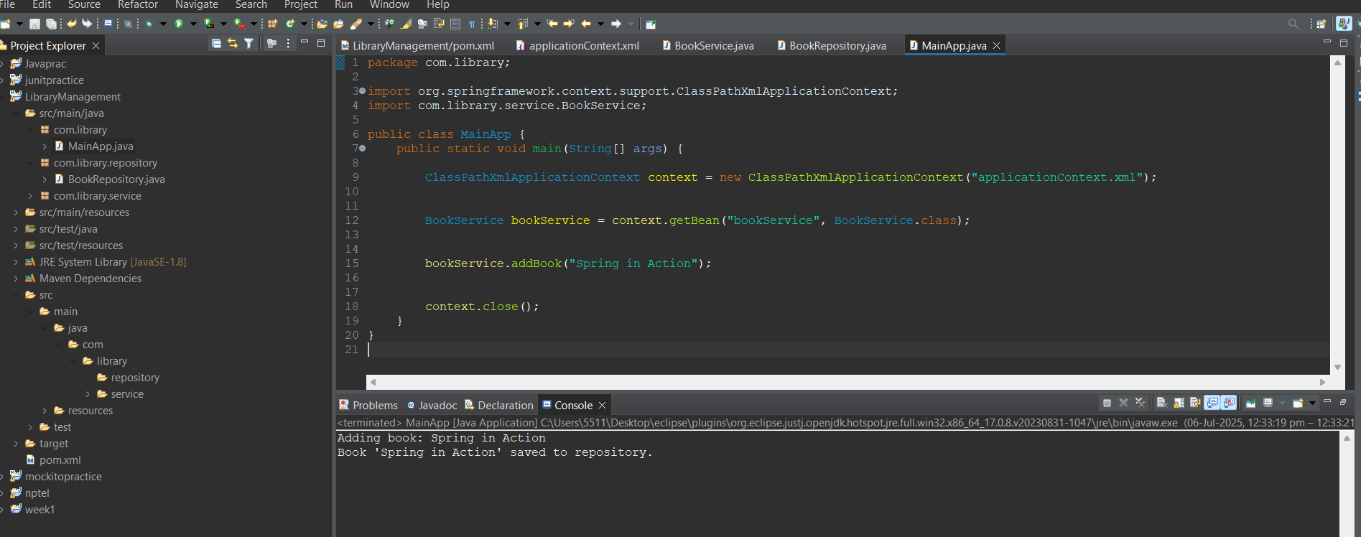

**Exercise 2: Implementing Dependency Injection**

package com.library;

import org.springframework.context.support.ClassPathXmlApplicationContext;

import com.library.service.BookService;

public class MainApp {

public static void main(String[] args) {

ClassPathXmlApplicationContext context = new ClassPathXmlApplicationContext("applicationContext.xml");

BookService bookService = context.getBean("bookService", BookService.class);

System.***out***.println("Dependency Injection example:");

bookService.addBook("Spring in Action");

}

}

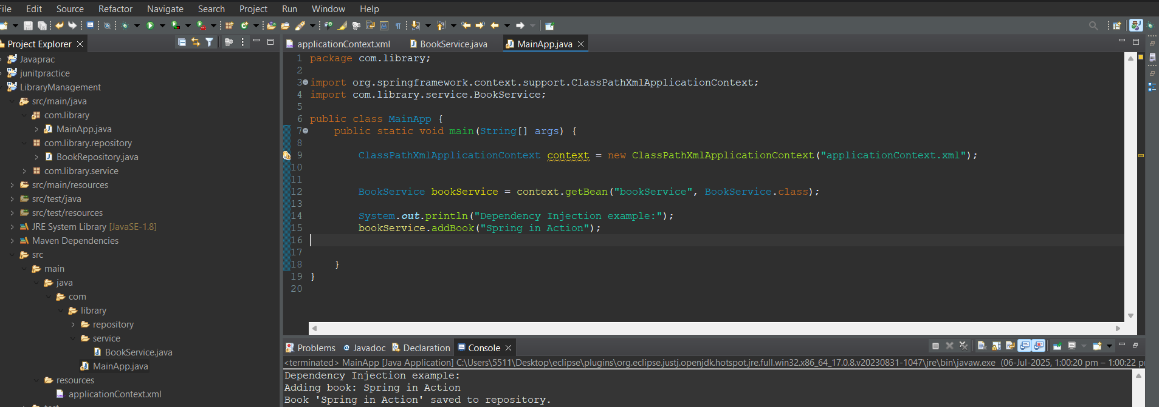

**Exercise 4: Creating and Configuring a Maven Project**

<project xmlns="http://maven.apache.org/POM/4.0.0"

xmlns:xsi="http://www.w3.org/2001/XMLSchema-instance"

xsi:schemaLocation="http://maven.apache.org/POM/4.0.0

http://maven.apache.org/xsd/maven-4.0.0.xsd">

<modelVersion>4.0.0</modelVersion>

<groupId>com.library</groupId>

<artifactId>LibraryManagement</artifactId>

<version>1.0-SNAPSHOT</version>

<dependencies>

<dependency>

<groupId>org.springframework</groupId>

<artifactId>spring-context</artifactId>

<version>5.3.29</version>

</dependency>

<dependency>

<groupId>org.springframework</groupId>

<artifactId>spring-aop</artifactId>

<version>5.3.29</version>

</dependency>

<dependency>

<groupId>org.springframework</groupId>

<artifactId>spring-webmvc</artifactId>

<version>5.3.29</version>

</dependency>

</dependencies>

<build>

<plugins>

<plugin>

<groupId>org.apache.maven.plugins</groupId>

<artifactId>maven-compiler-plugin</artifactId>

<version>3.8.1</version>

<configuration>

<source>1.8</source>

<target>1.8</target>

</configuration>

</plugin>

</plugins>

</build>

</project>