**Capstone Project Proposal Report**

|  |  |  |
| --- | --- | --- |
| Guide Approval (initials/date) | Suseela Vappangi | 12.08.2020 |

**CAP4001– Capstone Project Proposal Report**

|  |  |  |  |  |
| --- | --- | --- | --- | --- |
| **Student Name** | | Parithosh Dinesh Poojary | | |
| **Student Register Number** | | 17BEC7050 | | |
| **Programme** | | Electronics and Communications - Core | | |
| **Semester/Year** | | 7th Sem – (4th year) | | |
| **Guide(s)** | | Suseela Vappangi | | |
| **Project Title** | | **Soldier’s Health monitoring and position tracking system.** | | |
| **Team Composition:** Provide the information below for each member of the **project team**. Include **all** project team members, not just those in your discipline or those enrolled for Capstone project. Please also include yourself! | | | | |
| **Reg. No** | **Name** | | **Major** | **Specialization** |
| NA | NA | | NA | NA |
| NA | NA | | NA | NA |

**Project and Task Description**:

In today’s era, enemy warfare is an important factor in any nation’s security. The national security mainly depends on army, navy and air-force. The important and vital role is played by the soldiers. As soon as any soldier enters the enemy lines it is very difficult for the army base station to know about the location as well as the health status of all soldiers. So, in order to obtain this crucial information about the soldier’s, who protect our nation, there should be some technology to protect them too. So, to support this new technological idea, in this project I have come up with an idea of tracking soldier as well as to give the health status of the soldier during the war/operation. This system in particular will be useful for soldiers, who involve in missions or in special operations.

This system enables GPS (Global positioning systems) tracking of these soldiers. It is possible by S-Health. The S-Health can be defined as mobile computing, medical sensors and communication technologies for health care. In this system, smart sensors such as (Temperature sensor, Heartbeat sensor, Pulse sensor, Wireless comm. sensor) are attached to the body of the soldiers.

The hierarchy of obtaining data from the soldier is divided into three segments.

Soldier (data of individual soldier) Squadron Leader (data of the individual soldier + data of the Squadron leader) Control Room

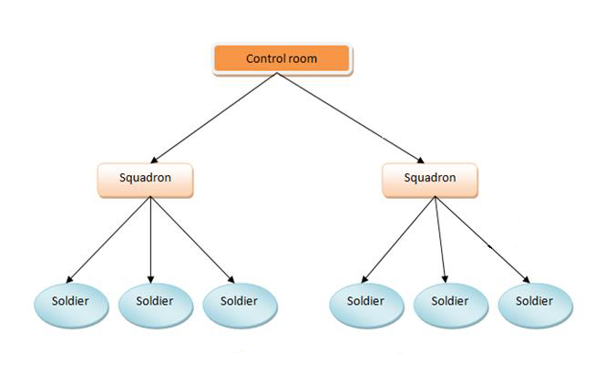

All the data collected form the S-Health system (of each individual soldier) is sent to the Squadron leader of the second unit via a wireless sensor module. The same procedure is repeated and the data from the second unit (including the data of the each soldiers and the squadron leader) is sent to the third unit...i.e. Control Room, where it is all about collecting all the data at one place so if any soldier is in trouble then he/she can be tracked down and help can be sent for the individual.

**Project Schedule:**

WEEK 10

WEEK 9

WEEK 8

WEEK 7

WEEK 6

WEEK 5

WEEK 4

WEEK 3

WEEK 2

WEEK 1

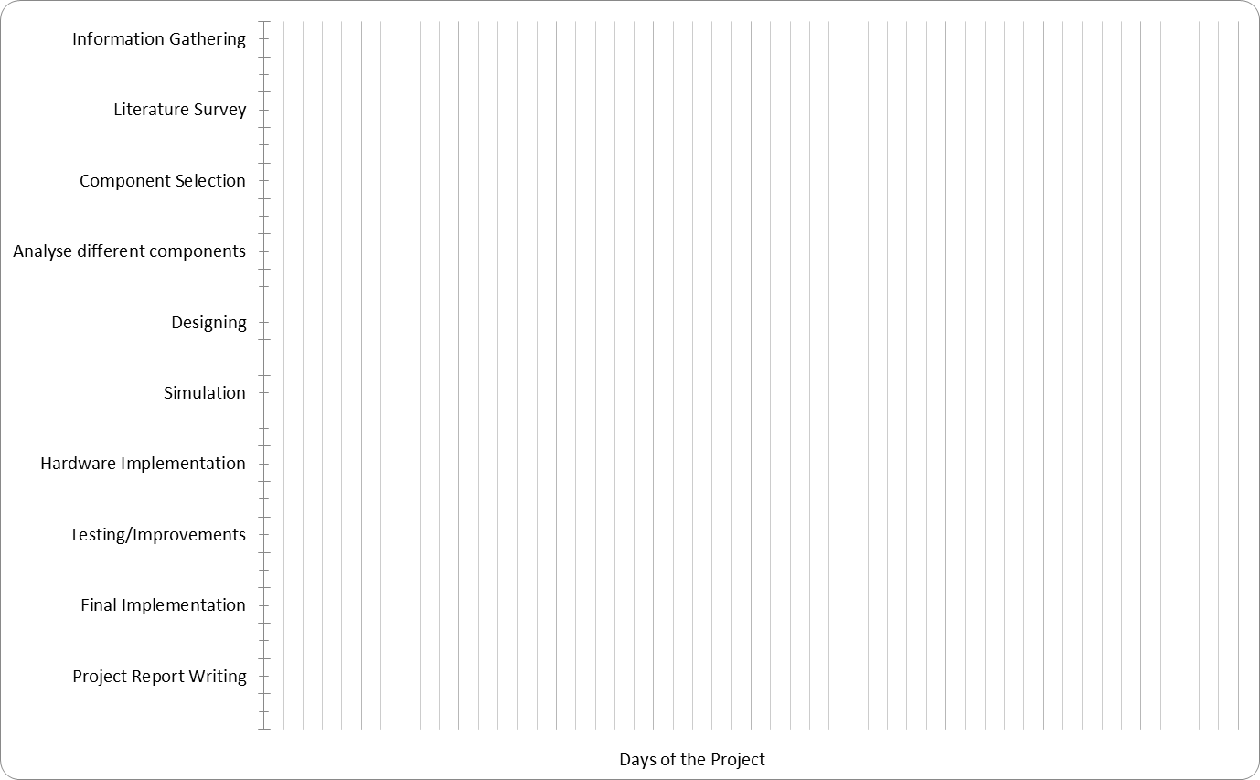

Fig: Gant chart for Capstone

**Outcome Matrix:**

|  |  |
| --- | --- |
| **Outcomes** | **Plan for demonstrating outcome** |
| a) an ability to apply knowledge of mathematics, science, and engineering |  |
| b) an ability to design a system, component, or process to meet desired needs within realistic constraints such as economic, environmental, social, political, ethical, health and safety, manufacturability, and sustainability |  |
| c) an ability to function on multidisciplinary teams |  |
| d) an ability to identify, formulate, and solve engineering problems | In order to obtain an information about the soldier’s health and position in an ongoing operation/warzone, it is quite difficult for the army base station. So, in order achieve that, this project uses a (heartbeat sensor, temperature sensor) to monitor the health of the soldier and a (GPS sensor) to locate the soldier’s position in the warzone, and all the information is transmitted over a wireless sensor. |
| e) an ability to communicate effectively | For communicating effectively, I have used some wireless sensors...i.e.     1. HC-12 wireless communication module. 2. LoRA WAN module.   HC-12 sensor enables the communication b/w the soldier and the squadron leader, whereas the LoRA WAN enables the comm. b/w the squadron leader and the control room. |
| f) an ability to use the techniques, skills, and modern engineering tools necessary for engineering practice |  |

**Realistic Constraints:**

The Realistic Constraints taken in to account for the project are the following:

1. The environmental conditions...i.e. {heights (geographic location), climatic conditions} the soldier would face as in person.
2. Power consumption of the whole system.
3. Size and Weight of the whole system.
4. Range of the wireless communication b/w (Soldier and Squadron) and (Squadron and the Control Room).

**Engineering Standards:**

The Engineering Standards that will be followed and maintained in the Project: