Vodafone Qatar DXP
Technical & Information Architecture
Front-end-only reconstruction of the Vodafone Qatar CRM/CVM Digital Experience Platform

Repository: local blueprint (blueprint/reconstruction-package/) — no live codebase exists yet
Version: Blueprint v1.0 (Stage D/E)
Date: 23 August 2026

Table of Contents
Right-click and choose 'Update Field' to build the table of contents.

1. Executive Summary
The Vodafone Qatar DXP is a planned replacement for the legacy Siebel/ECR/VSA CRM stack, rebuilt here as a production-ready, front-end-only React application: no APIs, backend services, databases, or third-party integrations. Every workflow, business rule, validation, permission, calculation, approval, and state transition is simulated entirely in front-end logic.
The platform serves 66 evidenced personas (retail sales agents, fulfilment agents, managers/approvers, credit control, back office, and more) across 16 functional modules — Lead Management, Mobile Postpaid/Prepaid, Fixed Line/Fibre, FWA/5G Home, MNP/FNP Porting, Enterprise/IoT/B2B, Billing & Adjustments, Order Management, Identity & Customer Management, SIM & Number Management, Trouble Ticketing, Access/Roles/Approval Governance, CAF/Attachments & Forms, and Platform Governance — comprising 213 screens built from 111 end-to-end user journeys.
This document's two diagrams are synthesized from a 4-stage evidence-backed reconstruction blueprint (`blueprint/`), not from a scan of existing code — no implementation exists yet. The Technical Architecture diagram shows the recommended system shape (5 simulation engines standing in for what a real backend/auth-server/rules-engine would normally provide). The Information Architecture diagram shows the navigation hierarchy (16 modules → sub-modules → screens) and the core entity relationships underlying the domain model.

2. Technology & Tooling Inventory
No target tech stack is evidenced anywhere in the 83-document source corpus (the corpus's only UI evidence is screenshots of the legacy Siebel/Open UI system being replaced). Every technology below is therefore a recommended default from the Stage D architecture blueprint (`blueprint/reconstruction-package/docs/frontend-architecture.md`), not a confirmed fact — see `assumptions`.

Languages
Component | Version | Purpose / Notes
TypeScript | 5.x | Primary application language — compile-time safety across the ~1,700 generated config/data records

Frameworks & Runtimes
Component | Version | Purpose / Notes
React | 18 | Component-based SPA UI
React Router | 6 | Client-side routing (213 routes, one per catalogued screen)

Key Libraries
Component | Version | Purpose / Notes
Zustand | — | State management (one store per bounded context: persona, entity, workflow, notification, config)
React Hook Form | — | Schema-driven form handling for the 970-field inventory
Tailwind CSS | — | Utility styling; no design system was evidenced in the source corpus

Data Stores
Component | Version | Purpose / Notes
IndexedDB | — | Mock Data Engine's persisted ‘database’ (customers, accounts, orders, etc.) — simulates a backend entirely client-side
localStorage | — | Persona selection + config persistence across reloads
sessionStorage | — | In-progress wizard/journey draft state (matches evidenced ‘resume from last milestone’ behavior)

Infrastructure & Hosting
Component | Version | Purpose / Notes
Vite | 5 | Build tool — static SPA bundle, no server runtime required

Build & Dev Tooling
Component | Version | Purpose / Notes
Vite dev server | — | Local development / HMR

3. Technical Architecture
There is no backend by design (per the project's front-end-only constraint). Five simulation engines take the place of what a real backend/rules-engine/auth-server would normally provide, each reading from generated, evidence-backed configuration JSON rather than hardcoded logic: the Configuration Engine loads all config at boot; the Persona Engine simulates authentication/authorization by filtering navigation and screen/action visibility against the RBAC Matrix (145 evidenced entries); the Rule Engine evaluates the 346-entry Business Rule catalogue (eligibility, thresholds, calculations); the Validation Engine evaluates the 418-entry Validation catalogue at the field level; and the Mock Data Engine simulates CRUD persistence (with artificial latency and referential-integrity checks) against IndexedDB, standing in for a real database. Screen components (organized into 16 modules) compose a small set of shared UI patterns rather than being built bespoke — see `blueprint/reconstruction-package/docs/reusable-patterns.md`'s 18 evidence-backed patterns.

3.1 Architecture Diagram
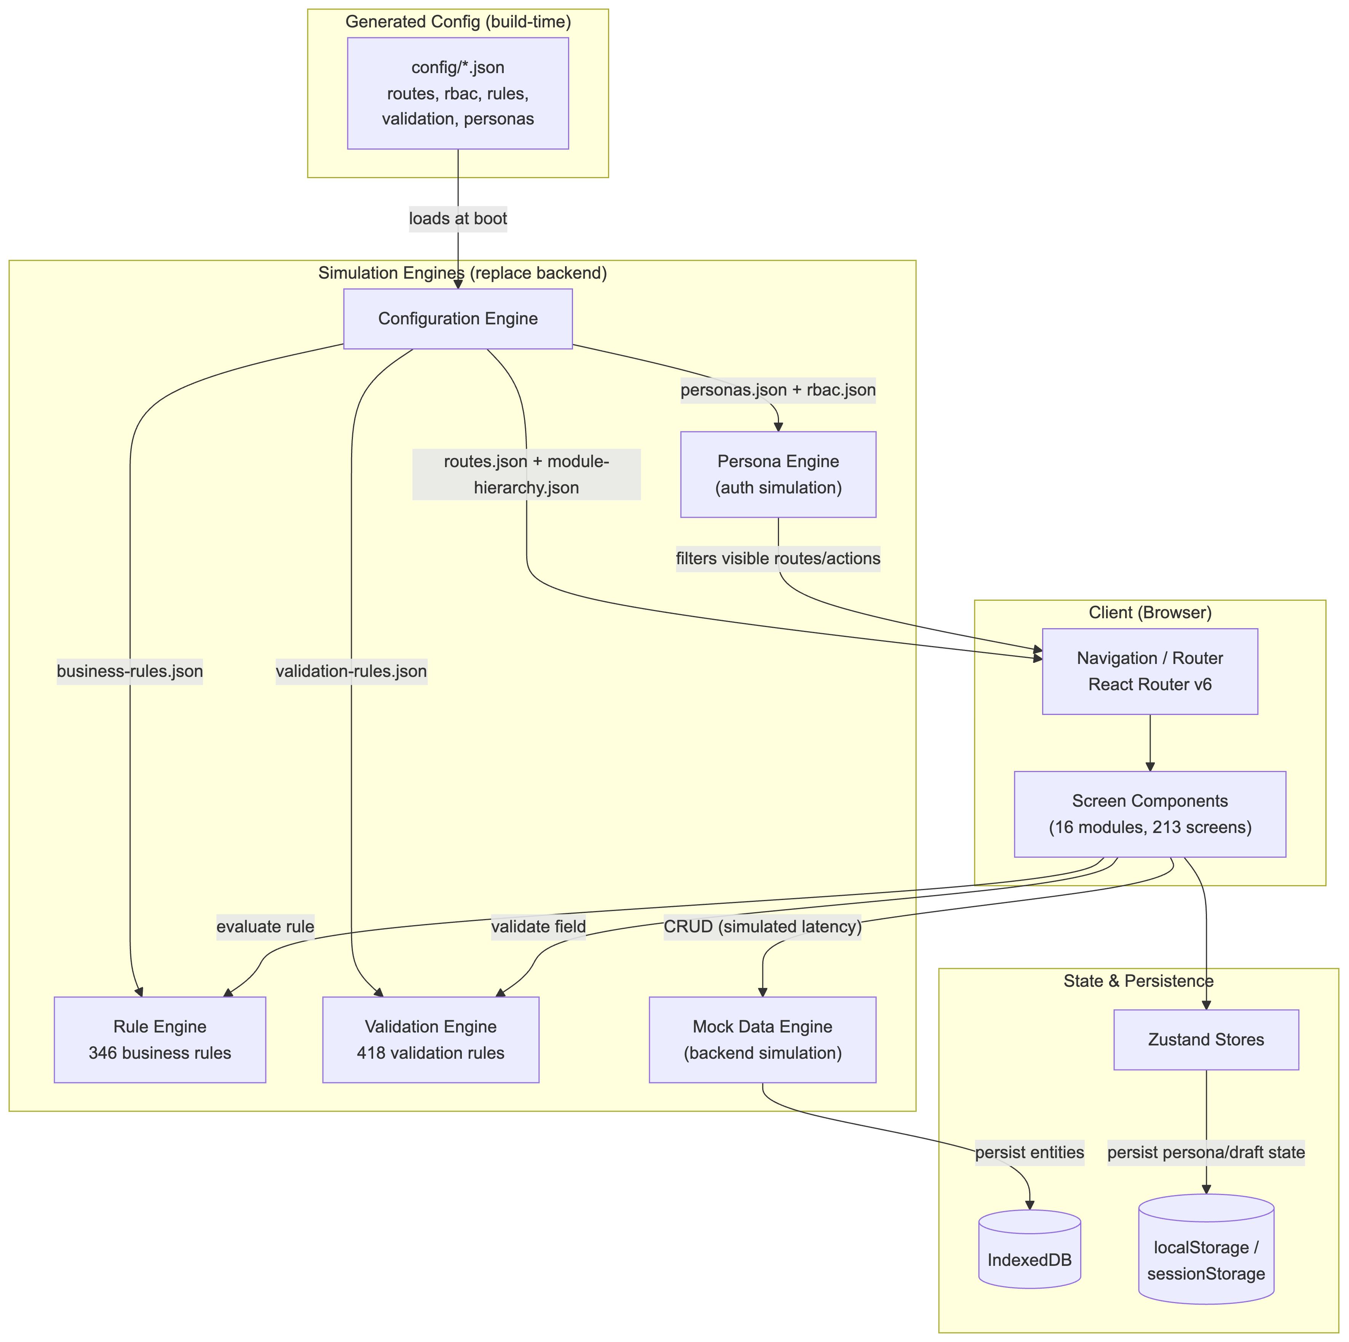
Figure: Technical Architecture

3.2 Components
Component | Layer | Technology | Responsibility
Screen Components (16 modules, 213 screens) | frontend | React + TypeScript | Compose shared UI patterns into the catalogued screens; no bespoke business logic — delegates to the engines below
Navigation / Router | frontend | React Router v6 | Client-side routing generated from routes.json; sidebar/breadcrumb navigation filtered by the active persona
Persona Engine | service | TypeScript module | Simulates authentication/authorization: tracks the active persona and filters visible routes/actions via the RBAC Matrix (no real login exists)
Rule Engine | service | TypeScript module + JSON rule catalogue | Evaluates business rules (eligibility, thresholds, calculations) from business-rules.json; falls back to a visible dev-mode warning for any rule without a registered implementation
Validation Engine | service | TypeScript module + React Hook Form resolvers | Evaluates field-level validation rules from validation-rules.json against the 970-entry Field Inventory
Mock Data Engine | service | TypeScript module | Simulates a backend: CRUD operations with artificial latency, referential-integrity checks, and entity lifecycle-state transitions, entirely in-browser
Configuration Engine | service | TypeScript module | Boot-time loader exposing typed accessors over all config/*.json — no screen imports config JSON directly
Zustand Stores | datastore | Zustand | In-memory application state, one store per bounded context (persona, entity, workflow, notification, config)
Browser Persistence (IndexedDB / localStorage / sessionStorage) | datastore | Web Storage APIs | Durability layer standing in for a real database — survives reloads within a session

3.3 Data Flows
From | To | Protocol | Description
Persona Engine | Navigation / Router | in-memory call | Filters visible modules/routes/actions by the active persona's RBAC entries
Screen Components | Validation Engine | in-memory call | Resolves field-level validation rules per screen/field before submit
Screen Components | Rule Engine | in-memory call | Evaluates eligibility/threshold/calculation business rules (e.g. Bill Limit Agent Minimum) during a guided journey
Screen Components | Mock Data Engine | in-memory async (simulated latency) | CRUD reads/writes against the simulated backend (customers, accounts, orders, tickets, leads)
Mock Data Engine | Browser Persistence (IndexedDB) | IndexedDB API | Persists entity records; enforces evidenced lifecycle-state transitions (e.g. Billing Profile: good standing → overdue → in collection → blacklisted)
Zustand Stores | Browser Persistence (localStorage/sessionStorage) | Web Storage API | Persists active persona and in-progress wizard/journey draft state
Configuration Engine | Persona Engine | in-memory call | Supplies personas.json + rbac.json at boot
Configuration Engine | Rule Engine | in-memory call | Supplies business-rules.json at boot
Configuration Engine | Validation Engine | in-memory call | Supplies validation-rules.json at boot
Configuration Engine | Navigation / Router | in-memory call | Supplies routes.json + module-hierarchy.json at boot

3.4 Deployment & Runtime
Static single-page application, built with Vite, deployable to any static host or CDN (e.g. object storage + CDN) — no server runtime, container, or database is required at any environment tier. This is an architectural consequence of the project's explicit front-end-only constraint, not evidenced by the source corpus (which describes the legacy Siebel/ECR/VSA deployment, being replaced, not the new DXP's deployment target). CI/CD would be a standard static-build-and-deploy pipeline.

4. Information Architecture
The application's information architecture is Platform → Module → Sub-Module → Screen → Component → Action, derived from the 16-module hierarchy synthesized from 111 journeys, 308 requirements, and 83 entities (`blueprint/module-hierarchy.md`). Primary navigation is the 16 modules (sidebar, filtered by the active persona's RBAC entries); secondary navigation is a module's sub-modules and screens. Screen-to-module assignment (`blueprint/reconstruction-package/config/routes.json`) is a deterministic keyword match against each module's capability list — a strong starting point, not a confirmed final IA. Full screen-by-screen detail (213 entries) lives in `blueprint/screens.md`; this diagram shows the module/sub-module tier with representative screen counts rather than all 213 leaf nodes, which would not be legible in a single diagram. (The diagram below shows the Platform → Module tier only, for legibility; the Module → Sub-Module → Screen tier is detailed in the navigation table above and in full in `blueprint/module-hierarchy.md` and `blueprint/screens.md`.)

4.1 Information Architecture Diagram
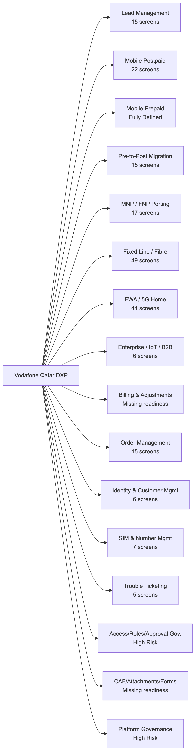
Figure: Information Architecture

4.2 Navigation & Screen Hierarchy
- Lead Management (/lead-management) — 15 screens
- Lead Creation & Qualification (/lead-management/lead-creation) — Create/edit/reassign leads across 4 personas
- Cross Sales Conversion (/lead-management/cross-sales) — Campaign offer acceptance → guided journey handoff
- Mobile Postpaid (/mobile-postpaid) — 22 screens
- New Postpaid Activation (/mobile-postpaid/new-activation) — Guided wizard: Contact→Plan→Number→SIM→CAF
- Postpaid Service Management (/mobile-postpaid/service-management) — Plan changes, add-ons, credit limit edits
- Device Installment (/mobile-postpaid/device-installment) — DOI plan management
- Mobile Prepaid (/mobile-prepaid) — Fully Defined module (build-readiness.md)
- Prepaid Activation (/mobile-prepaid/activation) — New Prepaid guided wizard
- Pre-to-Post Migration (/pre-to-post-migration) — 15 screens
- Prepaid to Postpaid Conversion (/pre-to-post-migration/pre-to-post) — Manual + Autobase (Unica-sourced) migration
- Postpaid to Prepaid Conversion (/pre-to-post-migration/post-to-pre) — Reverse migration flow
- Connection Count Validation (/pre-to-post-migration/connection-count) — Multi-connection eligibility checks
- MNP / FNP Porting (/mnp-fnp-porting) — 17 screens
- MNP Port-In (/mnp-fnp-porting/mnp-port-in) — Mobile number port-in (postpaid/prepaid)
- FNP Port-In (/mnp-fnp-porting/fnp-port-in) — Fixed number port-in
- Post-Port Billing (/mnp-fnp-porting/post-port-billing) — Dunning ladder after port-in
- Port-Out Handling (/mnp-fnp-porting/port-out) — Outbound porting
- Fixed Line / Fibre (/fixed-line-fibre) — 49 screens — largest module
- Fixed Line Activation (/fixed-line-fibre/activation) — Triple Play, KID lookup, WFM appointment
- Digital Self-Service Fiber (/fixed-line-fibre/digital-self-service) — Instant activation, eKYC
- Fixed Line Migration & Termination (/fixed-line-fibre/migration-termination)
- GigaHome / OSNtv Subscription (/fixed-line-fibre/gigahome-osntv) — Subscription Acceptance Form flows
- Home Move (/fixed-line-fibre/home-move) — Fixed-to-Fixed relocation
- FWA / 5G Home (/fwa-5g-home) — 44 screens
- FWA Indoor/Outdoor Activation (/fwa-5g-home/activation) — Desktop Vanilla + Open UI variants
- FWA Tablet Channel (/fwa-5g-home/tablet) — B2B2C, With/Without Approval variants
- CPE Configuration & Field Fulfilment (/fwa-5g-home/cpe-fulfilment) — WFM/Oracle Field Service installation
- Enterprise / IoT / B2B (/enterprise-iot-b2b) — 6 screens
- Enterprise Account Management (/enterprise-iot-b2b/account-management) — Parent/sub-account, choosers
- Bulk Operations (/enterprise-iot-b2b/bulk-operations) — Bulk SMS, DAPN, PTT provisioning
- B2B2C Employer Association (/enterprise-iot-b2b/b2b2c) — Employer-sponsored consumer plans
- Billing & Adjustments (/billing-adjustments) — 3 screens — Missing readiness (zero linked journeys)
- Billing Profile Management (/billing-adjustments/billing-profile)
- Bill Viewing & Simulation (/billing-adjustments/bill-viewing)
- Deposit & Credit Management (/billing-adjustments/deposit-credit)
- Order Management (/order-management) — 15 screens
- Order Approval Workflow (/order-management/approval) — Approve / Reject-Correction / Reject-Drop
- Order Lifecycle & Status (/order-management/lifecycle)
- Future Dated Orders (/order-management/future-dated) — 30-day max, status model
- Identity & Customer Management (/identity-customer-management) — 6 screens
- Identity Validation (/identity-customer-management/identity-validation) — QID/MOI validation
- Passport to QID Update (/identity-customer-management/passport-to-qid)
- Customer 360 (/identity-customer-management/customer-360)
- SIM & Number Management (/sim-number-management) — 7 screens
- SIM Swap (/sim-number-management/sim-swap) — OCR→barcode→MOI→CBS chain
- Number Management (/sim-number-management/number-management)
- Transfer of Ownership / Number (/sim-number-management/ton)
- Trouble Ticketing & Complaints (/trouble-ticketing-complaints) — 5 screens
- Ticket Creation & Handling (/trouble-ticketing-complaints/ticket-handling)
- Disconnection (/trouble-ticketing-complaints/disconnection)
- Access, Roles & Approval Governance (/access-roles-approval-governance) — 3 screens — High Risk readiness
- Role-Based Access Control (/access-roles-approval-governance/rbac)
- CAF, Attachments & Forms (/caf-attachments-forms) — 5 screens — Missing readiness (zero linked journeys)
- CAF Lifecycle (/caf-attachments-forms/caf-lifecycle) — Digital/Manual/Touch Screen signature
- Platform Governance & Architecture (/platform-governance-architecture) — 1 screen — High Risk readiness
- Delivery & Traceability Governance (/platform-governance-architecture/governance)

4.3 Data Models

Customer / Contact
The person transacting (consumer or B2B2C sponsored employee). Corpus has two closely related legacy variants (ENT-023 Customer, ENT-037 Customer/Contact), merged here for clarity.
Field | Type | Notes
qid / idNumber | string | QID / Passport / GCC / Diplomatic ID
name, dob, nationality | string/date | MOI-validated fields
moiValidationStatus | enum
blacklisted | boolean

Relationships: Owns one or more Accounts; linked to Employer for B2B2C; owned by a User as Lead Owner before conversion.

Account
Service/legal-entity container (ENT-024 Service Account).
Field | Type | Notes
accountType | enum | Consumer / Enterprise parent / Enterprise sub-account
status | enum

Relationships: Belongs to Customer; has one or more Billing Profiles; places Orders; may have a parent Account (enterprise hierarchy).

Billing Profile
ENT-001 — drives billing, barring, and payment posting.
Field | Type | Notes
billingCycle, billingType | string/enum | PIA / Arrears / Hybrid
creditLimit | number | QAR
collectionStatus | enum | Good standing → Overdue → In collection → Blacklisted

Relationships: Belongs to Account; referenced by Orders and Line Items.

Order
ENT-006 — the central transactional entity.
Field | Type | Notes
orderType, orderSubType, status | enum
approvalStatus, holdFlag/Reason | enum/string
totalQAR, mrcTotalQAR, nrcTotalQAR | number

Relationships: Belongs to Account; billed to a Billing Profile; contains Line Items; produces a CAF; may incur a Commitment/Penalty.

Line Item
ENT-039 — hierarchical parent/child structure under an Order.
Field | Type | Notes
lineItemType | enum

Relationships: Child of Order; references a Product; may provision a SIM, MSISDN, or CPE.

Product / Plan / Promotion
ENT-028 — bundled plan/discount/add-on, deliberately bundled into named promotions to prevent agent-side discount misuse.
Field | Type | Notes
mrcQAR, lockInMonths | number

Relationships: Referenced by Line Items; determines Addon & Discount eligibility.

SIM
ENT-026
Field | Type | Notes
iccid, type, stockStatus | string/enum | Physical / Printed eSIM / Virtual eSIM

Relationships: Linked to CPE and Order; paired with an MSISDN; becomes part of an Installed Asset.

MSISDN / Number
ENT-015
Field | Type | Notes
msisdn, category, status | string/enum | Free / Star / Reserved; AVAILABLE / BLOCKED

Relationships: Reserved to a Contact/Order; tied to Account/Service; subject to porting window after MNP port-in.

CPE / ONT / Combo Box
ENT-035 — Customer Premises Equipment for fixed/FWA.
Field | Type | Notes
serial | string

Relationships: Linked to SIM, Order, and a KID/Service Point.

KID / Service Point
ENT-032 — Kahramaa ID / Karama ID address record.
Field | Type | Notes
kid | string | One government KID may map to multiple Vodafone service points/VFIDs

Relationships: Linked to Address, Contact, and installed CPE.

CAF (Customer Application Form)
ENT-025
Field | Type | Notes
formId, signatureMethod | string/enum | Digital / Manual / Touch Screen

Relationships: Produced per Order; distinct Consumer vs. Enterprise/SME-SOHO sub-types.

Trouble Ticket
ENT-020
Field | Type | Notes
status, category, hashtags | enum/string[] | VFQA_TT_HASHTAGS / VFQA_TT_ACTUAL_ISSUE taxonomies

Relationships: Linked to Account, Customer, MSISDN, Order; closure by Retention Team can auto-create a Disconnection Order.

Employer / Company (B2B2C)
ENT-047
Field | Type | Notes
companyName | string

Relationships: Sponsors a Contact/Account under B2B2C.

Commitment / Penalty
ENT-005 — calculated on-demand from guided journeys (e.g. Fibre lock-in disconnection fee).
Field | Type | Notes
amountQAR | number

Relationships: Calculated against an Order/Billing Profile at disconnection or plan-change time.

5. Supplementary Diagrams

Entity Relationship Diagram (core domain entities)
The full domain model has 83 entities (`blueprint/domain-model.md`); this diagram shows the 14 most-referenced entities (by module-hierarchy feature co-occurrence) with their evidenced relationships, kept to a legible node count per diagramming best practice. See `domain-model.md` for the remaining 69 entities (e.g. Commitment/Penalty sub-types, IMS Site/ZSB, Functional Cluster, Authorised Person/Chooser) and their full evidenced attributes.
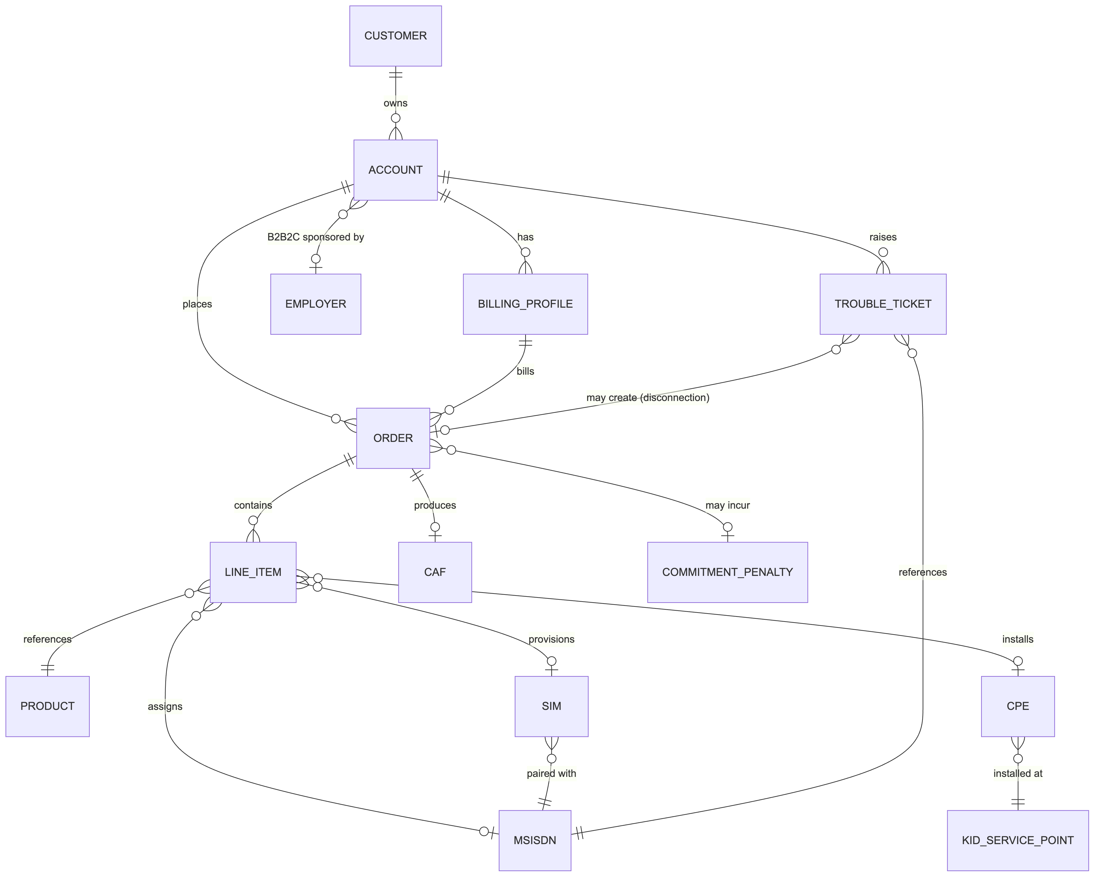
Figure: Entity Relationship Diagram (core domain entities)

6. Assumptions & Confidence
The following assumptions were made during analysis. Confirm or correct them before treating this document as authoritative.
- No live codebase exists yet — both diagrams are synthesized from the Stage A-D evidence-backed reconstruction blueprint (`blueprint/`), not from static analysis of a repository. Treat this document as a design specification, not an as-built record.
- The entire technology_inventory (React, TypeScript, Vite, Zustand, React Hook Form, Tailwind CSS) is a recommended default from `blueprint/reconstruction-package/docs/frontend-architecture.md` §1 — no source document specifies a target tech stack.
- Screen-to-module assignment in the Information Architecture navigation tree is a deterministic keyword match (`config/routes.json`), not a confirmed final IA — expect some screens to need manual re-bucketing.
- The Entity Relationship Diagram shows 14 of 83 evidenced entities, curated for diagram legibility (8-20 node guidance) by module-hierarchy reference frequency — not the full domain model.
- The 'Customer' node in the ERD merges two closely related legacy entity variants (ENT-023 Customer, ENT-037 Customer/Contact) found in the source corpus — see `domain-model.md` for the distinction.
- Deployment description (static SPA, no server) is an architectural consequence of the explicit front-end-only project constraint, not evidenced by the source corpus, which only describes the legacy system being replaced.

Confidence Notes
High confidence on the module/screen/entity counts and relationships (all evidence-cited in blueprint/*.md, traceable to specific source documents). Low-to-no confidence on the specific technology choices and deployment target (Assumed defaults, explicitly flagged, since the source corpus contains no target-state technical specification — only legacy-system screenshots and business/functional requirements).

