**1.CUSTOMER**

1.1 Abstract-------------------------------------------------------------------04

1.2 Project Scope-------------------------------------------------------------04

1.3 Process Work Flow------------------------------------------------------04

1.4 Registration Form--------------------------------------------------------05

1.5 Book My Trip------------------------------------------------------------07

1.6 My Trips------------------------------------------------------------------10

1.7 Payment-------------------------------------------------------------------11

1.7.1credit/Debit Card Payment----------------------------------------11

1.7.2 Mobile Wallets------------------------------------------------------12

1.7.3 Net Banking---------------------------------------------------------13

1.8 Modify My Trip----------------------------------------------------------14

1.9 Cancel Trip----------------------------------------------------------------15

2.0 Customer Feedback------------------------------------------------------17

**2 AGENT**

2.1 Abstract-------------------------------------------------------------------19

2.2 Objectives----------------------------------------------------------------19

2.3 Scope----------------------------------------------------------------------19

2.4 Agent Details-------------------------------------------------------------20

2.4.1 Login-------------------------------------------------------------------21

2.4.2 Payment Details-------------------------------------------------------22

2.4.3 Customer Details------------------------------------------------------22

2.5 Process Flow Chart. ----------------------------------------------------23

2.6 Use-Case Diagram------------------------------------------------------23

2.7 Dash Board----------------------------------------------------------------24

**3. ADMIN**

3.1 Abstract-------------------------------------------------------28

3.2 Objective------------------------------------------------------28

3.3 Package Creation--------------------------------------------29

3.4 Process Work Flow------------------------------------------30

3.5 Dash Board----------------------------------------------------31

3.6 Admin Management-----------------------------------------33

3.7 Data Flow Diagrams-----------------------------------------37

3.8 Registration Form Of Agent--------------------------------38

3.9 Use case -------------------------------------------------------39

3.10 Overview-----------------------------------------------------39

**4. SUPPORT CENTER**

4.1 Abstract---------------------------------------------------------41

4.2 Introduction-----------------------------------------------------41

4.3 Purpose----------------------------------------------------------41

4.4 Objective--------------------------------------------------------41

4.5 Scope of the project--------------------------------------------42

4.6 Process work flow----------------------------------------------42

4.7 Login--------------------------------------------------------------42

4.7.1 FAQ----------------------------------------------------------43

4.7.2 Technical issues--------------------------------------------44

4.7.2.1 Money Transfer Issue-------------------------------44

4.7.2.2 Refund Issue------------------------------------------45

4.7.2.3 Booking Confirmation Issue-----------------------46

4.7.3 Emergency Contact-----------------------------------------47

**1.CUSTOMER PROCESS**

## 1.1ABSTRACT

The aim of this application is to provide service for the customer to complete the process of booking their holiday trip through various packages with offers and EMI facility.

## 

## 1.2PROJECT SCOPE

1. Customer can communicate with agent or with support center..
2. Easy interface for booking.

## 1.3PROCESS WORK FLOW

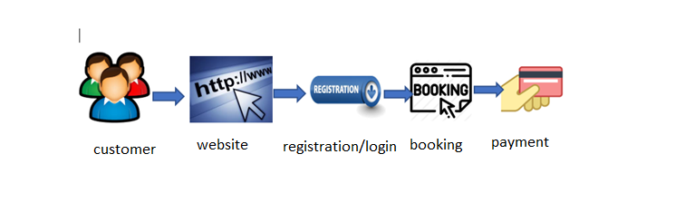

## **1.4 REGISTRATION FORM**

The customer has to register before login to the web-site plan my trip.

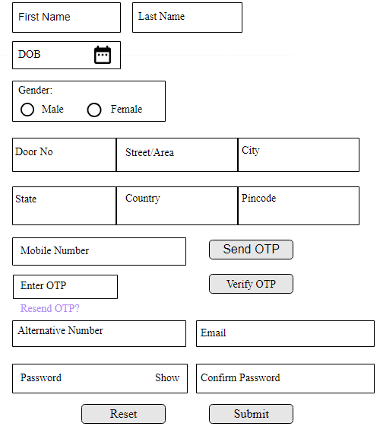

**Business Rules**

* The customer has to register first to login to plan my trip web-site.
* Customer will fill all the details in the registration form.
* And then click on “SUBMIT” button.
* If any modifications/changes then click on “RESET” button.

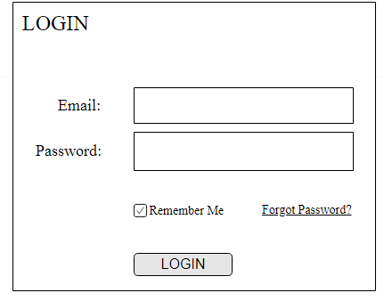

* Enter your Email and Password and click on “LOGIN” option.

## 1.5 BOOK MY TRIP

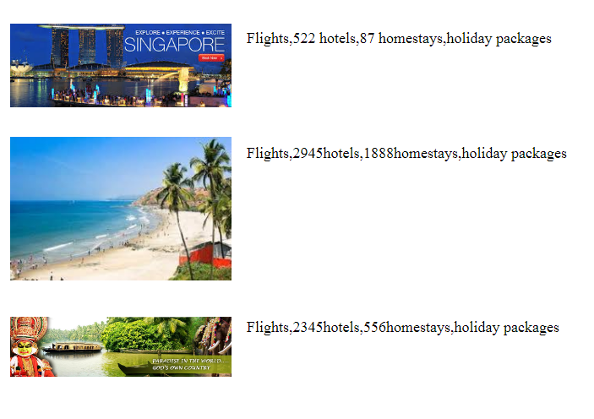

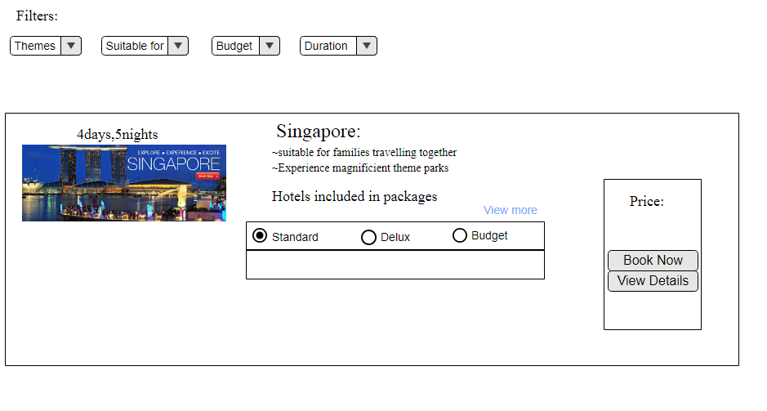

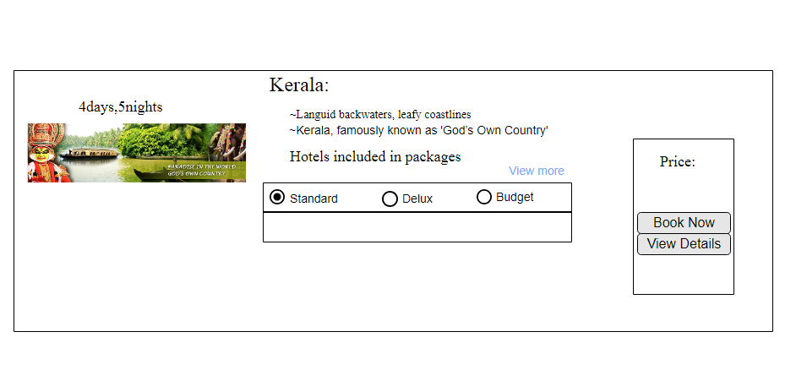

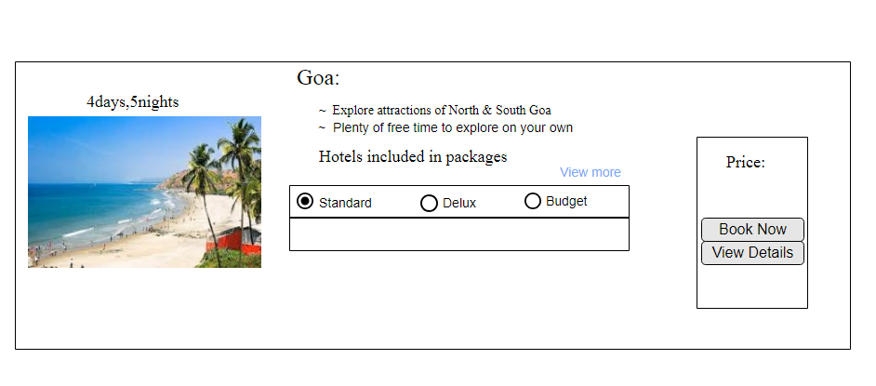

**Business Rules**

1. Navigate to Home Page.
2. In home page,the packages will be displayed.
3. Customer can select the packages on his preferences.
4. After selecting the package,the details of packages will be displayed.
5. The total price will be displayed and click on “Book Now”.
6. Display the confirmation message 🡪“Are sure to Book the Trip” <Yes / No>

* If Yes –>
* Select the Payment Mode
* Click on the button “Confirm Booking”
* Book the Trip by Generating Confirmation Number
* Generate the Initial Invoice.
* Email / SMS the Booking confirmation number

## 1.6MY TRIP

## As a customer I want to view all my trips

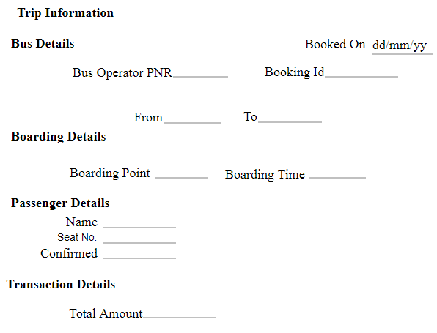

## 1.7 PAYMENT

**Business Rules**

* Customer is allowed to select the Payment modes. After selecting any one of the above options, the customer can pay via credit/debit cards,Net Banking.

**1.7.1CREDIT/DEBIT CARD PAYMENT**

Credit/debit card

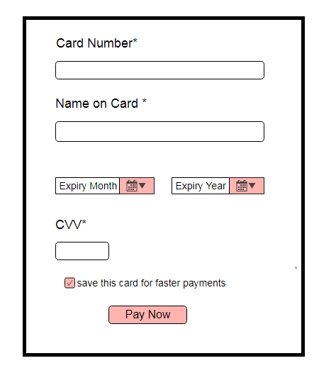

* + - Enter Card Number, Card Name, Expiry Date, Expiry Year, CVV*.
    - Click on Pay Now.
    - Card Validity to be verified at the back end
    - Display a message “Payment mode added successfully”. If failed, display Failure message and take back to the Card Registration screen

## 1.7.2MOBILE WALLETS

PAYTM

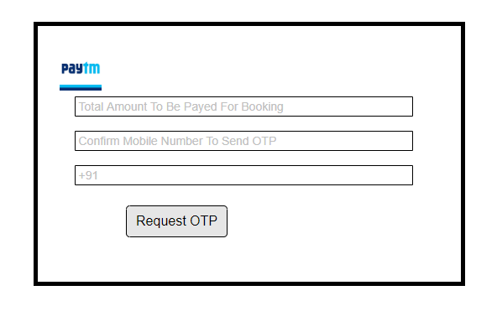

* Customer has to enter the paytm registered mobile number to receive the OTP to login to paytm.
* Request OTP- it will send request OTP to mobile number.
* After login to paytm customer will make the payment.

## 1.7.3 NET BANKING

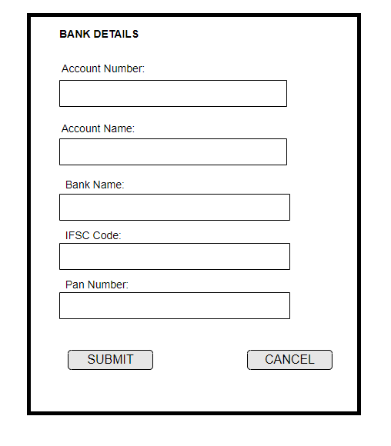

Business Rules

* Bank details of customer will be displayed and filled in this screen.
* The account number, account name, bank name, IFSC code, PAN no should be entered by the customer.
* By clicking on SUBMIT button, account details will be updated in the
* database.
* By clicking on CANCEL button, all fields will be cleared.
* Account need to be authenticated with the Bank through Payment gateway
* Display /Alert on Successful / failed authentication of the Bank account

## 1.8 MODIFY MY TRIP

* Modify the Trip Before Start:
* Allow Customer to modify the below fields and re - Book the Trip:
* Destination, Start, End and no of travellers.

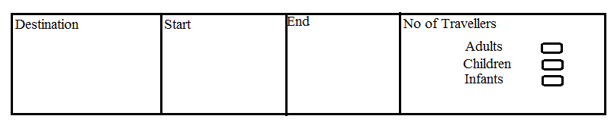

**Business Rules**

1. Navigate to Modify My Trip Page
2. Enter the field - Destination.
3. Enter no of travelers

* Adults
* Children
* Infants

1. Price will be calculated based on Destination and no of travelers.

## **1.9 CANCEL TRIP**

Comment the reason below for canceling the trip:



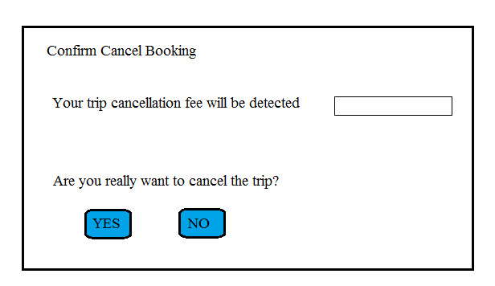

**Business Rules**

1. User should navigate to the scheduled Trip

2. Click on “Cancel” button

3. Comment the reason for canceling the trip

4. Based on reason, “Cancellation Fee --- will be charged”. YES and No buttons will be displayed

5. If Customer clicks on “YES”, the Trip will be cancelled. The customer will receive an EMAIL/ SMS with the cancellation details

6. If Customer clicks on “No”, the trip will not be cancelled

2.0CUSTOMER FEEDBACK

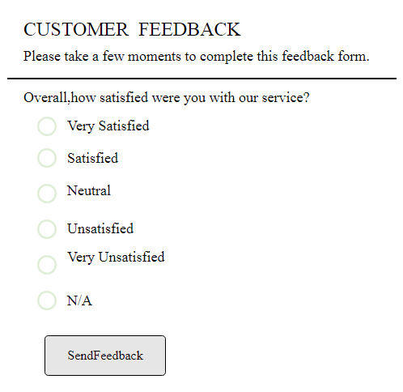

Business Rules

Customer will be given a feedback form – wherein, the customer has to share his experience in regard with the over-all trip.

# 2. Agent Process

**2.1Abstract:**

Agent management system provides the details customer and their payment.

A customer can select the appropriate agency depending on convenience and accessibility.

Agent’s role is to collect payments and maintain records.

**2.2 Objective:**

* Agent is responsible for maintaining the customer records regarding their payment details and booking details.
* Agent also responsible for collect payment/fees
* Agent also responsible for provide relevant information about EMI payment

## 2.3 Scope:

* We provide payment through EMI , Net banking, and by Cash.
* Agent maintains a customer details and payment details.

2.4 Agent Details:

**Registration for Agent:**

**Business Rule**: Agents have to register by filling all details below

1. Agent have to Enter their details like:

Name, Email id, Mobile number, Enter the Password for sing up and again enter the same password to confirm the password.

1. And Enter the details like:

Country, State, City, Landmark, Pin code, Address, Pan card. after entering the details You can click on register button to register

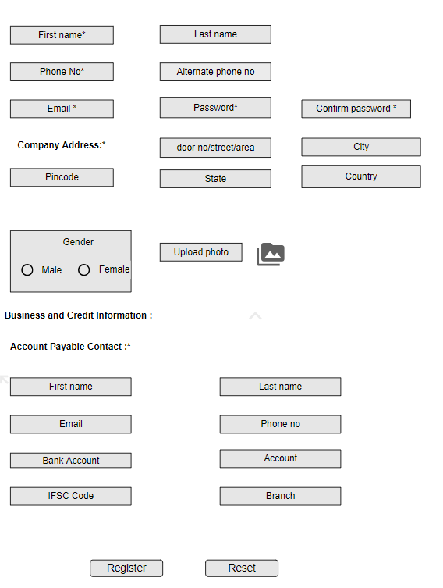

**Registration form**

**2.4.1Sign in Authentication for agent:**

* After Register agent have to enter the username or email and Password for Sign authentication.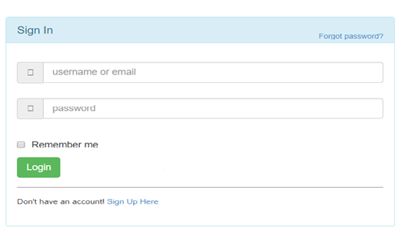

**Business Rule** :

* Agent collects the payment by customer.
* Agent confirms the booking details through email and by giving receipt to customer
* Agent provides specific id to the customer.
* Agent confirms the payment through sending invoice or by giving receipt to the customer
* Agent maintains the account details who pay through EMI.
* Agent maintains the customer details.

**2.4.2 Payment Details**

**EMI Details**

|  |  |  |  |  |  |
| --- | --- | --- | --- | --- | --- |
| Booking Id | Total amount | Paid amount | Balance amount | Date | Payment due date |
|  |  |  |  |  |  |
|  |  |  |  |  |  |
|  |  |  |  |  |  |

**EMI Plans**

|  |  |  |  |
| --- | --- | --- | --- |
| EMI Tenure | Bank interest Rate | Monthly Installment | Interest paid to Bank |
| 3 months | 15% | 12,350 | 3,764 |
|  |  | 6,750 | 7,100 |
| 9 months | 15% | 3,900 | 10,500 |
| 12 months | 15% | 1,500 | 12.750 |

**2.4.3 Customer Details**

|  |  |  |  |  |  |  |  |
| --- | --- | --- | --- | --- | --- | --- | --- |
| Customer name | Booking Id | Package id | Booking date | Contact no | Email id | Paid amt | Balance amt |
|  |  |  |  |  |  |  |  |
|  |  |  |  |  |  |  |  |
|  |  |  |  |  |  |  |  |

**2.5 Process flow**

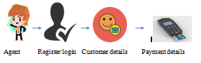

**2.6 Use Case Diagram for Agent:**

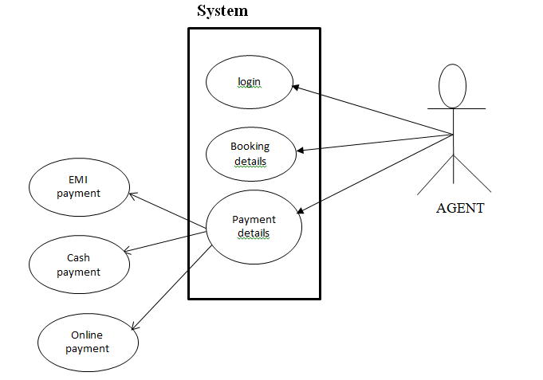

**2.7 Dash Board**

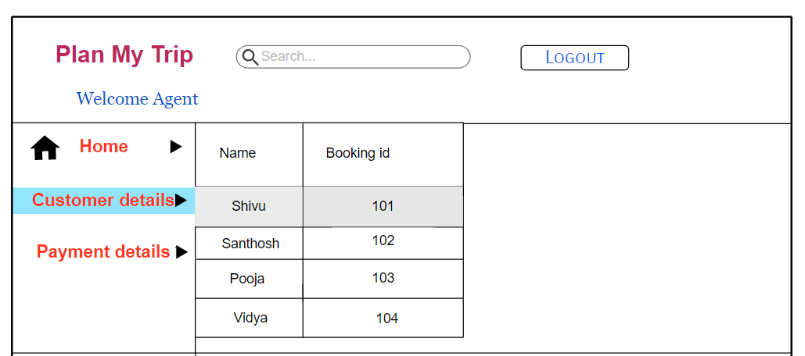

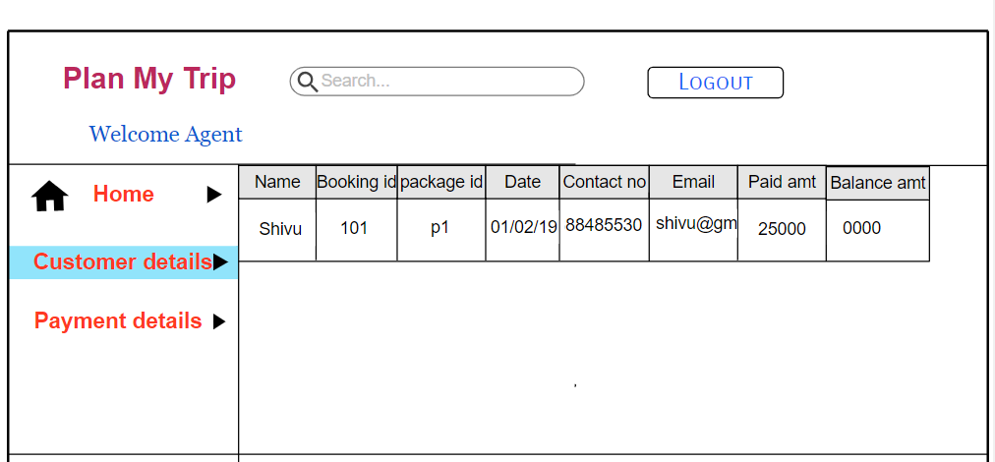

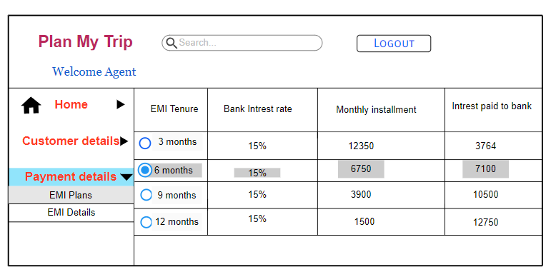

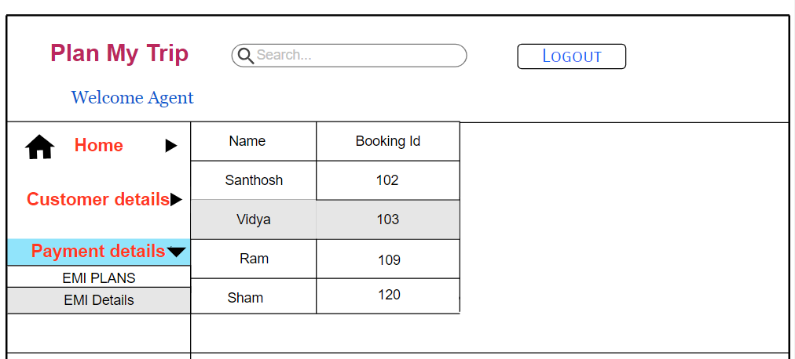

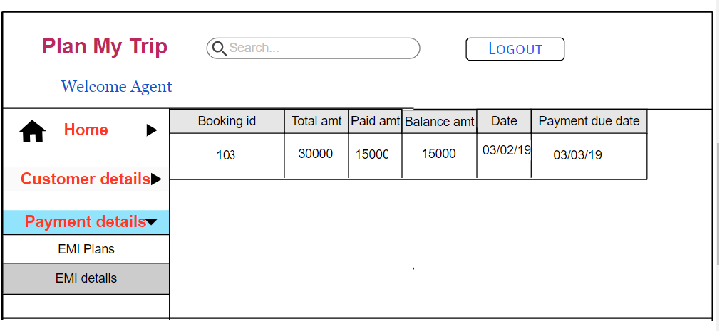

**3.ADMIN PROCESS**

**Plan My Travel**

**Plan My Travel**

**3.1Abstract**

#### Here admin can access the overall control in working process of an office. He should share the different task to different type of employees. Admin can manage the Agent registered on the System and admin can manage the Vehicles added by the Drivers, Customer’s Details and Support System. Admin can add and delete any agents. He can click on any Driver can see his details. He should get reports based on performance of Travels. Admin can see various reports like payment, driver details, Travelers trips, trip plans and duration of travel, hotel management. He can review the documents and drivers registered under any company. In his work management agents, support systems, customers, vehicles and drivers, everyone works should be supervised by Admin.

## 3.2Objective

* The overall process of the office can be maintained and controlled very effectively.
* If any problems occurred during Travel time or any problem happened to the vehicles it will tracked and can be solved easily.
* Very easily book my Travelso Time saving.

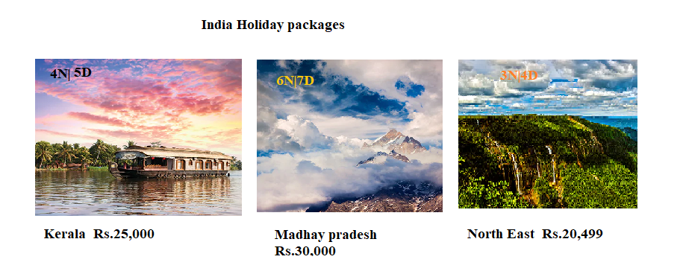

**3.3 Package Creation:**

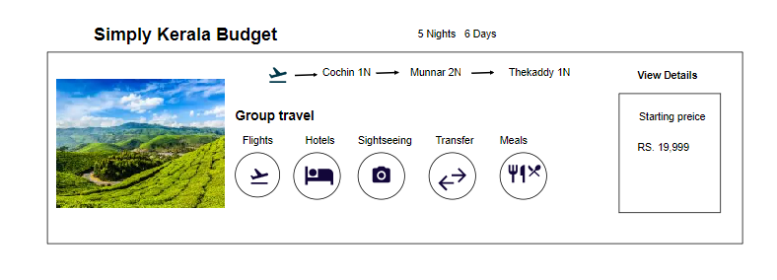

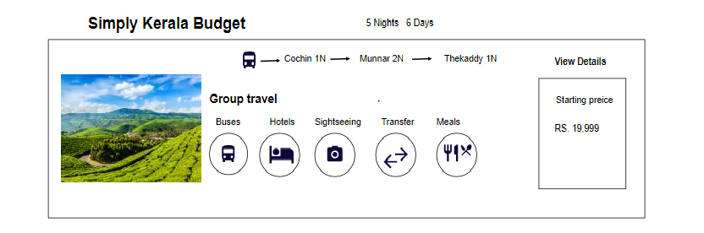

## 

## 3.4 Process Work Flow:

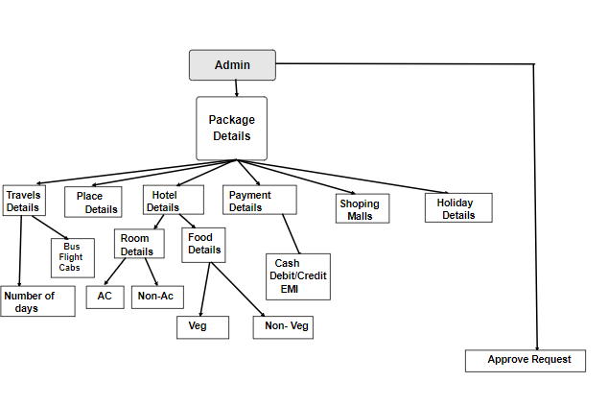

**Admin:**

* In this system admin can maintain all Travels Information and maintain bus category, Plan facility, comments etc.
* This System admin can maintain the registered Agent, manage news and also admin can generate reports and manage whole system.
* Admin can approve/reject any Driver’s account.

**3.5 DASH BOARD:**

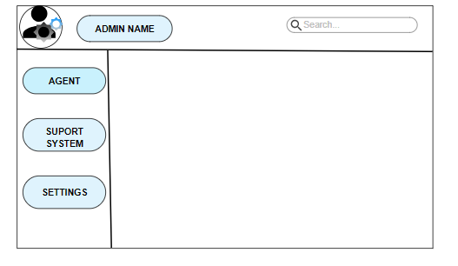

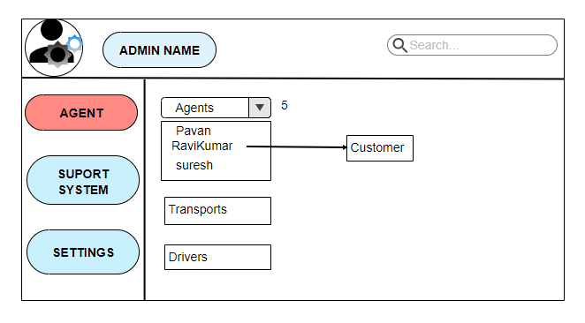

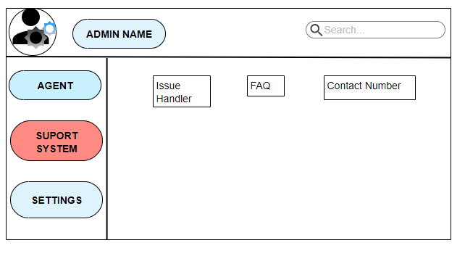

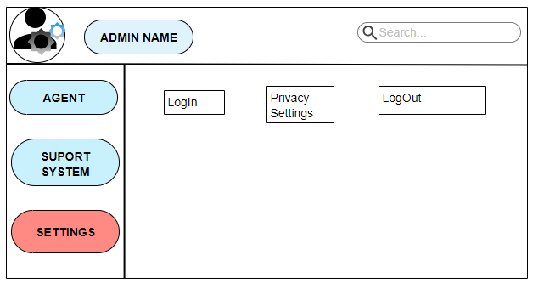

**Business Rules:**

* Admin can manage the Drivers registered on the System by Agent.
* Admin can review the documents and Vehicles added by Agent.
* Admin can add, modify and delete any Agents.

**3.6 Admin Management:**

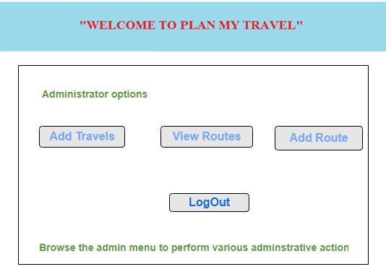

**Business Rules:**

* Admin can manage the Agent registered on the System.
* They can review the document and drivers registered under any Agents.
* Admin can add, modify and delete any Agents.

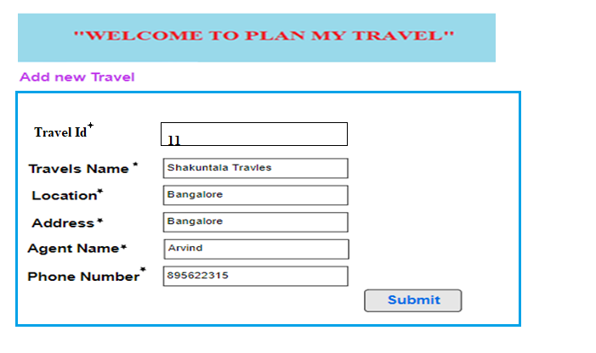

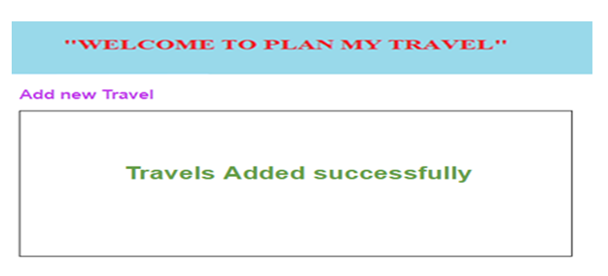

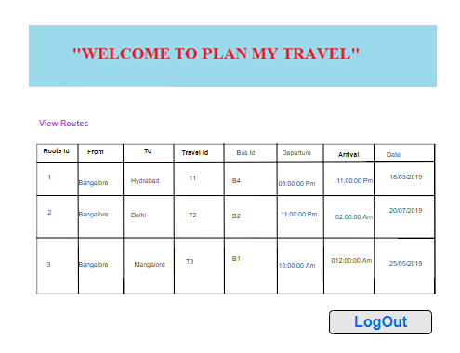

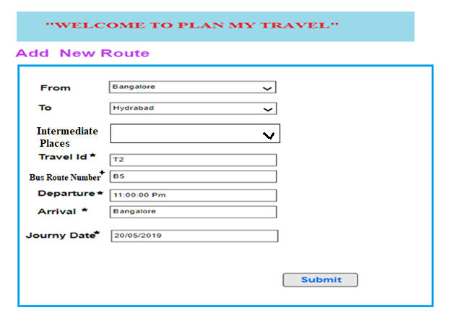

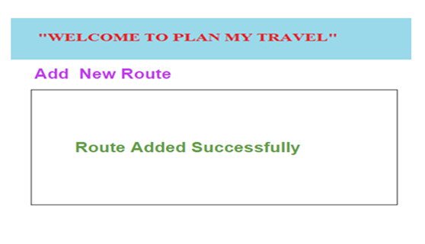

**Business Rules:**

* Admin can manage the Agent registered on the System.
* Admin can add Travels, add new Routes and he can view the Routes.
* They can review the document and drivers registered under any Agents.
* Admin can add, modify and delete any Agents.

**3.7Data Flow of Diagram1:**

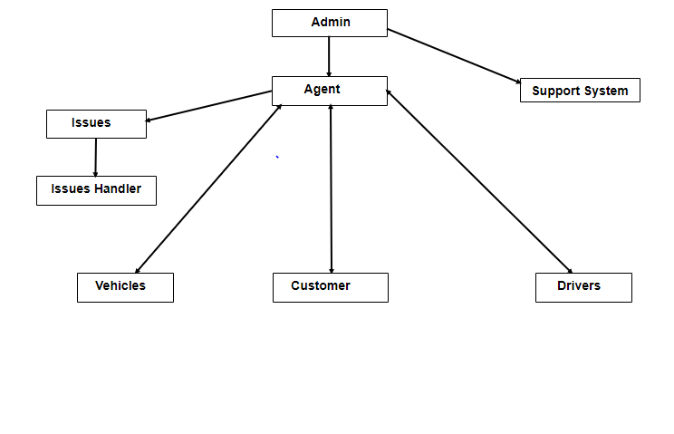

**1Data Flow of Diagram2:**

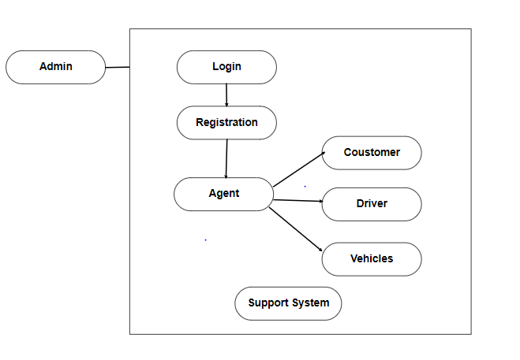

Business Rules:

* Super Admin can Register Agent from here.
* Admin can handle all issues also add, modify, and delete Admin and their rights.

**3.8 Registration Form of Agent:**

* Whoever wants to be associate with our Business Model, they can visit our Portal and Register themselves by providing their details.
* Agent as to Enter the Registration Details:

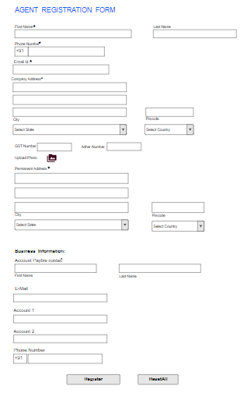

**3.9Use case Diagram:**

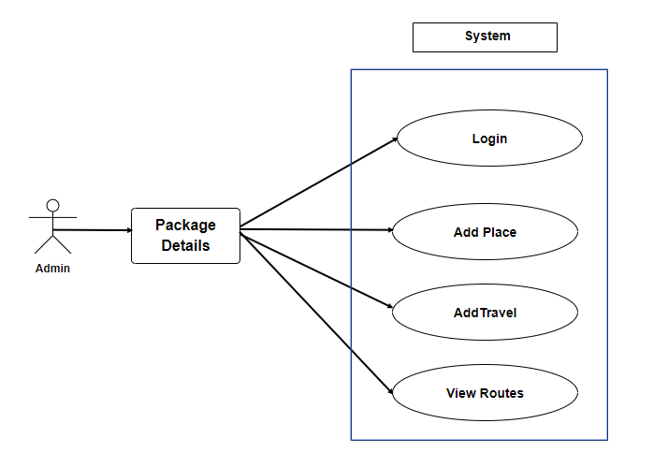**3.10Overview:**

The rest of the document is composed of the Overall Admin Requirement Specification. The Overall Description section presents the flow of the admin. The Requirement Specification section defines and describes the system functional requirements in enough detail to view and manage the process which is under admin control.

**4.SUPPORT CENTER**

* 1. **Abstract**

The aim of this application is to help the customer if they faces any issues while booking the places to travel.

* 1. **Introduction**

Support center provides 24/7 services, connecting customers to solve their problems, In case any problems occur during Refund,ticket confirmation etc. In such a cases use the Help center application, give a certain information about the problem, based on that information,solution provided for the customer. In Emergency case, call to customer care center and resolve their particular problem and also track their complaint status.

* 1. **Purpose**
* Customers can report their problems/Issues easily to the customer care.
* Any Issues occur to the Customers, they can raise the issue using their Help Center Application by given certain information about the Problem.
  1. **Objective**
* Provide solutions for Customers for their issues.
* By solving the issues that makes Organization growth.
* Increase the customers to the Organization by solving the issues.
* We can easily solve issues for customers because they give us exact information about problem using their Help Center Application.

**4.5Scope of the project**

* To interact with the customers in order to answer questions.
* Resolve the issues.
  1. **Process work flow**

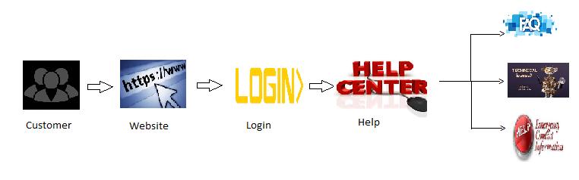 **4.7 Login**

Registered customer can click on sign in page option to ask any queries.

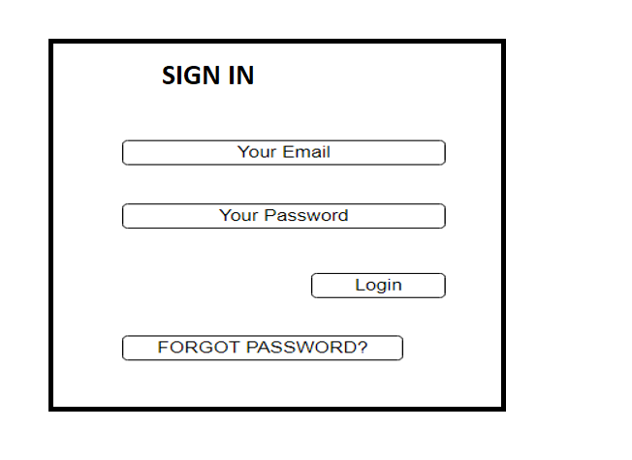

* Enter your Email and Password and click on Login option.
* After login If the customer faces any issues then click on Help centre option.
* Help centre contains three options

1. FAQ(Frequently asked questions)
2. Technical issues(Major issues)
3. Emergency contact

**4.7.1 FAQ:**

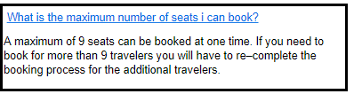

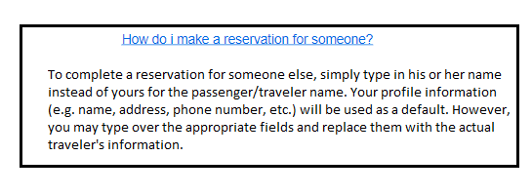

* When the customer click on the link then will get the solution below of that particular question.

**4.7.2 TECHNICAL ISSUES:**



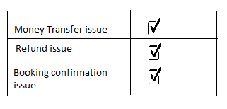

**4.7.2.1 Money Transfer issue:**

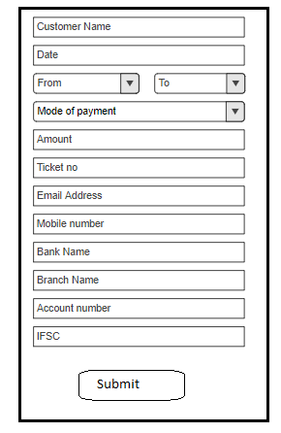

* If customer faces any issues during payment then customer has to fill “Money transfer form” then click on submit.
* Customer will get one alert popup message “We have received your request”

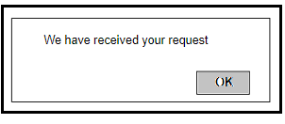

* Support centre will contact to the customer through mobile number or email id.

**4.7** .**2.2 Refund issue:**

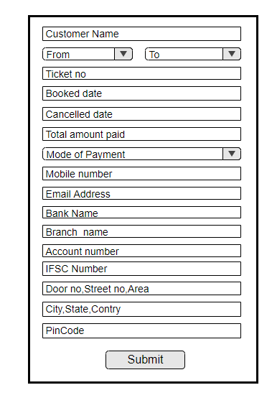

* Enter your Name, Ticket number, Date when you have booked the tickets, Cancelled date when you have cancelled the booked tickets, Amount how much you have paid while booking the tickets, Mode of transaction( Net Banking, Debit card, Credit card),places ,Total members(how many members tickets has cancelled) ,Bank details(Bank name, Branch, account no, IFSC code),Mobile Number and click on submit option.
* Support centre will receive all the details then customer will get one popup alert box “All the details are submitted successfully”.

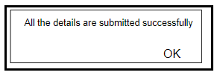

* Once the support centre gets solution will contact to the customer through mobile number or email id.

**4.7.2.3 Booking confirmation issue:**

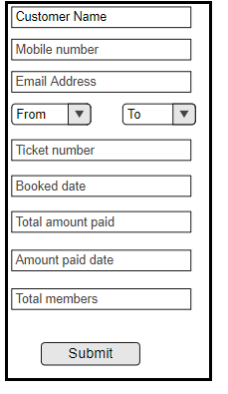

* Enter your name, places name, email id, Mobile number, Ticket booked date, total amount paid, amount paid date and total members travelling and click on Submit button

**4.7.3.EMERGENCY CONTACT:**



* When the customer click on Contact Number link then customer will get number in another page then customer has to select the contact based on there query.

