Real-Time Lecture-to-Slide Generation from Teacher Speech with Bounded LLM Interpretation and Deterministic Slide Planning
Prachi Potdar, Paritosh Raut, Deepali Magdum, Swati Kale, and Sunita Patnaik
Department of Electronics and Telecommunication Engineering
JSPM's Rajarshi Shahu College of Engineering, Pune, Maharashtra, India – 411033
prachipotdar50@gmail.com, paritosh21raut@gmail.com, dipalimagdum@gmail.com, swatikale@gmail.com, sunitapatnaik@gmail.com

Abstract—Slides prepared before class cannot show what a teacher adds while explaining, live captions give students only verbatim text, and a large language model (LLM) that regenerates slides from a growing transcript rewrites what students are reading. This paper presents an implemented system that turns a teacher's live speech into a structured, continuity-aware slide deck on the classroom projector during the lecture. Speech is transcribed locally; a sentence-embedding concept tracker and a rule-based gate send bounded transcript units to an LLM that returns a schema-validated interpretation of topic, subtopic, discourse relation and typed content. A deterministic planner, not the LLM, decides whether to update the live slide, continue or open a new topic, transcript-grounding guards keep every taught fact on screen, and a composer renders typeset formulas, structured layouts and CLIP-ranked open images. The teacher controls the deck live, and on request the system generates summaries, notes, assignments, quizzes, tests and PPTX decks. In six live lectures (114 min) on a laptop with a 4 GB GPU and free services, it built 163 slides with median latencies of 0.66 s for speech recognition, 1.35 s per LLM call and 12.5 s from speech to slide. On the same lecture units, an LLM-controlled baseline rewrote or removed 56 % and 30 % of the statements already shown, the proposed system 3 % and 0 %. ‹Held-out accuracy and teacher ratings.›
Index Terms—Automatic slide generation, educational technology, large language models, real-time systems, speech recognition, human-in-the-loop
I. Introduction
Slides prepared before a lecture fix its order and depth in advance, so the examples, derivations and answers a teacher adds while explaining never reach the screen. Learners understand better from words with organized pictures than from words alone [1], if the visuals add no extraneous load [2], [3], but no teacher can author such visuals while teaching.
Existing tools solve only parts of this problem. Live captions show verbatim text without the structure of the lesson, which students find hard to follow [4]; slide generators work offline from a finished document or prompt [5]–[11]; and a large language model (LLM) [12], [13] applied naively to a growing transcript rewrites slides while students read them, adds untaught content [14] and exhausts free quotas. Three problems remain open: (P1) projected material does not follow what is actually taught; (P2) live speech is not turned into a structured visual lesson; and (P3) LLM output is neither stable nor faithful to the teacher's words.
This paper presents an implemented live lecture-to-slide system that addresses all three. While the teacher speaks, it transcribes locally, tracks topic and subtopic, and builds a continuity-aware deck on the projector; the LLM interprets bounded transcript units, and a deterministic planner controls the slides. The contributions are: (1) a working system that generates projected slides from live speech on a laptop with a 4 GB GPU and free services; (2) an architecture in which the LLM is a gated, bounded, schema-validated interpreter inside a deterministic event-driven core, so every slide decision is a testable rule; (3) transcript-grounding safeguards and a fallback that keep taught content on screen; (4) live teacher control and on-demand summaries, notes, assignments, quizzes, tests and PPTX decks; and (5) an evaluation on six live and ‹N› held-out lectures with end-to-end latency, an LLM-controlled baseline, annotated accuracy and ratings by three teachers.
II. Related Work
A. Multimedia Learning and Slide Design
Mayer showed that words with pictures are understood better than words alone [1]. Cognitive load theory by Sweller adds that working memory is limited [2], Mayer and Moreno listed ways to reduce extraneous load [3], and Bartsch and Cobern found that unrelated pictures lowered performance in PowerPoint lectures [15]. Hence the slides use short typed layouts and an image only for a concrete object that was taught.
B. Lecture Speech Recognition and Captioning
Radford et al. trained Whisper on 680,000 hours of weakly supervised audio [16]; faster-whisper runs it with 8-bit weights on consumer GPUs [17], and Silero VAD detects speech [18]. These form the speech front end of the system. Kushalnagar et al. showed that verbatim real-time captions are hard for students to follow [4], and Gonzalez et al. found that LLM summaries beside recorded lecture videos improved quiz scores [19]. Both produce text; neither restructures live speech into a visual lesson (P2).
C. Topic Segmentation and Semantic Similarity
TextTiling by Hearst places subtopic boundaries where the similarity of adjacent blocks drops [20]. Sentence-BERT by Reimers and Gurevych compares sentence embeddings by cosine similarity [21], and Wang et al. distilled it into MiniLM [22]. These methods segment a complete transcript offline; the system applies the similarity-drop idea online, utterance by utterance, as one signal for confirming a topic change, and is evaluated with the boundary measure of Beeferman et al. [23].
D. Automatic Slide Generation
PPSGen selects sentences of a paper for slides by integer linear programming [7], D2S summarizes document text for each slide title [6], and DOC2PPT generates slides with text and figures from scientific documents [5]. With LLMs, Xie et al. ground educational slides in retrieved sources [8], SlideBot adds multi-agent planning [9], PPTAgent edits reference slides [10], and AutoPresent writes slides as code [11]. All of them produce a whole deck offline from a finished document, prompt or topic, whereas a lecture arrives incrementally as noisy speech and its slides must stay stable while students read them (P1, P3).
E. LLMs in Education and Faithful Generation
Kasneci et al. stressed teacher oversight of LLMs in education [12], so every automatic decision can be overridden by the teacher. Ji et al. surveyed hallucination [14], and Willard and Louf constrained generation to a JSON schema [24], which fixes the format but not the facts; the output is therefore also checked against the transcript. Kurdi et al. reviewed question generation for education [25], the basis of the generated assignments, quizzes and tests.
Table I compares the systems on the properties that matter in a live classroom: input, when slides are produced, how topic structure is obtained, how content is kept faithful to its source, and what controls the slide sequence. Every prior system works offline from written input; none builds and manages a deck incrementally from live speech, which is the gap addressed here.
TABLE I
Comparison of the Proposed System With Prior Systems
System | Input | Produced | Topic structure | Faithfulness to source | Slide sequence
Live captions [4], [16] | Speech | Live | None (text stream) | Verbatim text | None
Lecture summaries [19] | Recorded lecture | Offline | None (summary) | LLM summary | None
PPSGen, D2S, DOC2PPT [5]–[7] | Paper / document | Offline | Document sections | Extracted from document | Whole deck at once
LLM slide generators [8]–[11] | Topic / document / prompt | Offline | LLM outline / planning | Retrieved sources [8], [9] or none | Whole deck at once
Proposed system | Live speech | During lecture | Online, confirmed topic / subtopic | Transcript coverage and formula guards | Deterministic planner + teacher
III. Methodology
A lecture is processed as a stream through six stages (Fig. 1): local speech capture and recognition; filtering of classroom talk and concept tracking; a gate that groups finished sentences into units; bounded LLM interpretation of each unit; a deterministic planner and composer that turn it into slide operations and layouts; and delivery to the projector, the teacher and students, with study material on request. Four rules guide the design: the LLM never controls the flow, it never sees the whole transcript, a new concept is not by itself a new slide, and user interfaces send commands instead of changing the state.
All components run in one Python asyncio process and communicate through typed events on an in-process bus; a single store owns the lecture state, and every event is appended to an SQLite log, so each lecture can be replayed for debugging, evaluation and materials. Models run in worker threads with bounded queues, so audio capture never blocks, and teacher commands override automatic decisions. Recognition runs on the GPU, MiniLM and CLIP on the CPU (ONNX), and the LLM on the Groq free tier (gpt-oss-120b [13], then qwen3.8-27b when its daily quota is spent), because a 7B-class local model does not fit beside the speech model in 4 GB. Only bounded transcript units leave the laptop; audio does not.
IV. Implementation Details
A. Speech Capture and Concept Tracking
Silero VAD [18] segments 16 kHz audio (utterances up to 15 s), and faster-whisper [17] with Whisper medium.en [16] (int8/float16 on CUDA, beam size 1, subject-keyword prompt) transcribes them. A deterministic filter removes classroom management ("take out your books"), meta talk and fillers. Each content utterance is embedded with MiniLM [22]; with the L2-normalized embedding eₜ and concept centroid cₜ₋₁, the shift score is the cosine distance used with Sentence-BERT [21], and the centroid an exponentially weighted mean (proposed here):
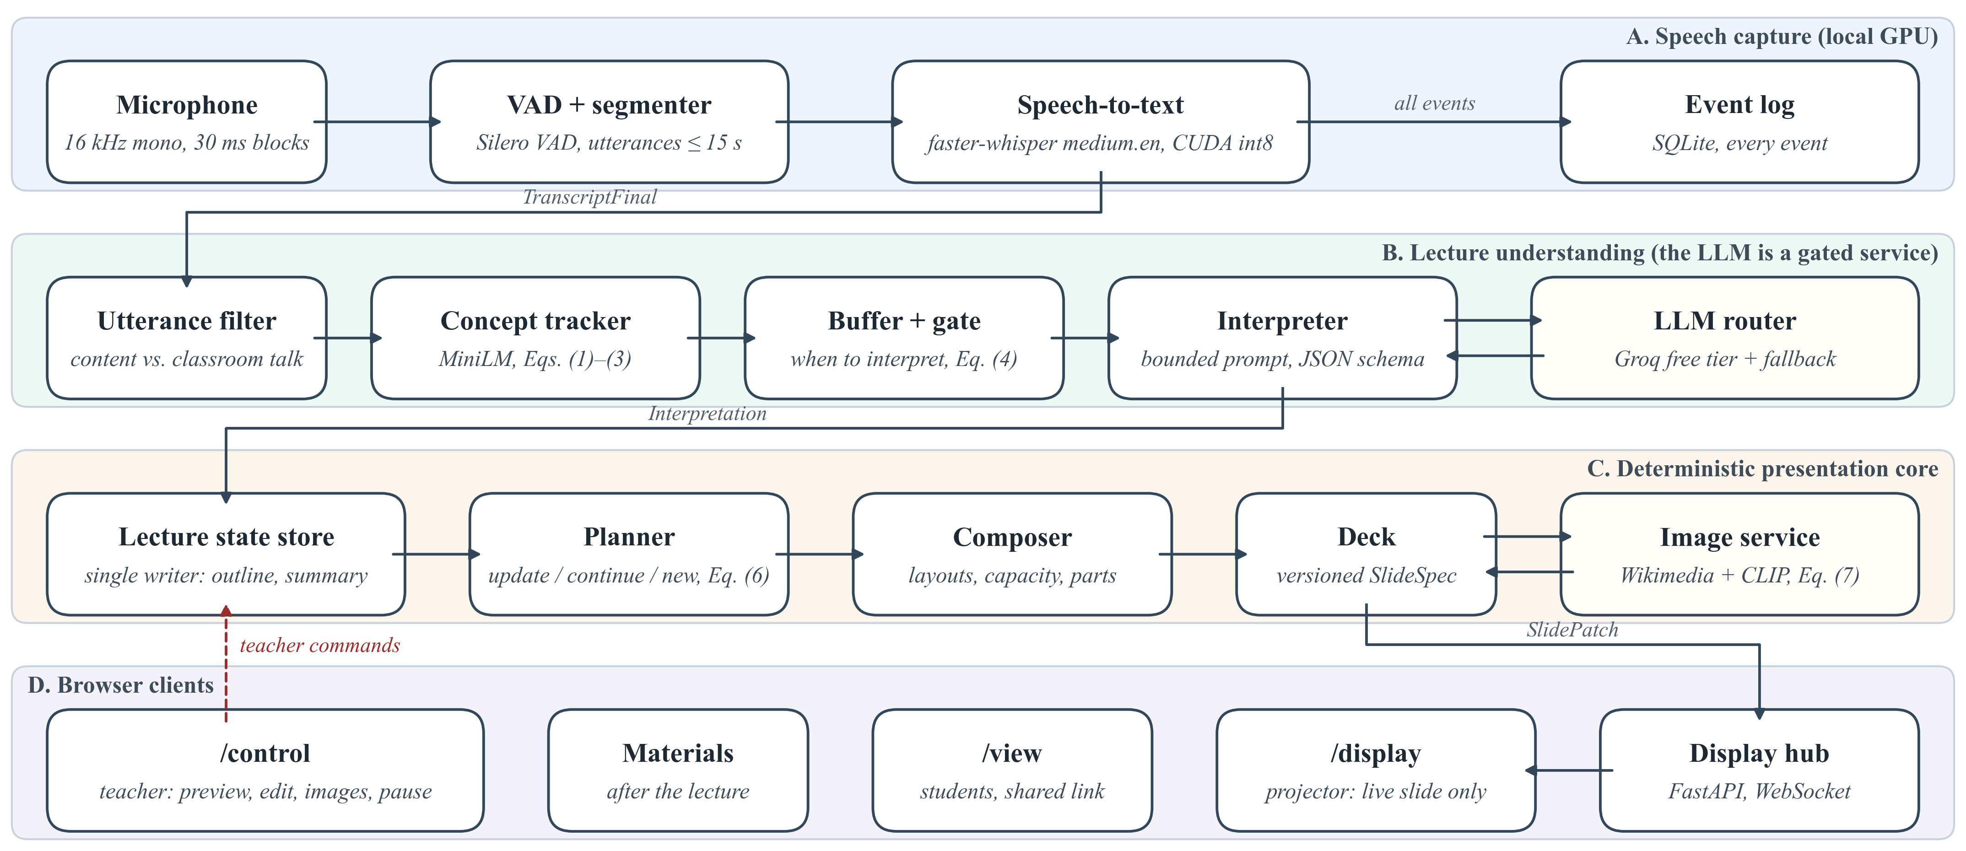
Fig. 1. Implemented architecture. Lanes A–C run in one Python process; the LLM is called only by the interpreter through the router. Browser clients receive versioned slide patches and send teacher commands back; the user interface never changes the core state directly.
$s_{t}=1−e_{t}^{⊤}c_{t−1}$ (1)
$c_{t}=norm\left((1−α_{t})c_{t−1}+α_{t}e_{t}\right)$ (2)
where norm(x) = x/‖x‖ and α = 0.35, raised to 0.6 at a boundary so the centroid re-seeds on the new concept. Following the similarity-drop criterion of TextTiling [20], a boundary is signalled when
$b_{t}=κ_{t}∨\left(s_{t} ≥ τ\right),τ=0.75$ (3)
where κₜ marks a cue phrase ("now let us", "next"). Shift scores within one facet were 0.3–0.6, so τ was set high by hand; cue words carry most boundaries and the LLM decides the final relation.
B. Gate and Token Budget
Content accumulates in a buffer until a rule-based gate (proposed here) fires. With pₜ the silence after a finished sentence, wₜ the buffered words and aₜ the age of the oldest pending line (s),
$G_{t}=(p_{t}≥1.2∧w_{t}≥6)∨w_{t}≥40∨b_{t}∨a_{t}≥12$ (4)
with an 8 s floor between calls; fragments under six words join the next unit. The floor follows from the free quota of 200,000 tokens per key and model per day: at about 2,300 tokens per call this allows 85 calls, or 15–20 lecture minutes per key.
C. Bounded Interpretation and Transcript-Grounding Safeguards
The prompt holds the subject, level, an outline (≤ 150 tokens), the current slide with numbered items, a rolling summary (≤ 120 tokens) and the new lines, within 3,000 tokens (temperature 0.2). The LLM returns JSON with topic, subtopic, a relation (same concept, elaboration, sub-concept, sibling, new topic, digression), typed content (definition, facts, classification, steps, comparison, timeline, formula, cause-effect, example), an image hint, revisions and concerns about possibly wrong statements. Pydantic validates it; after one failed repair, a deterministic fallback shows the spoken sentences as points. A coverage guard compares every content sentence u (≥ 6 words) with the output O; with W(·) the set of word stems and a recall-style overlap as in ROUGE-1 [26],
$\left|W(u)∩W(O)\right|≤\frac{1}{3}\left|W(u)\right|⇒u\text{ is shown as said}$ (5)
so a fact the model left out still reaches the slide. A formula guard flags formula tokens the model changed, and a correction is applied only above a confidence of 0.75 (factual) or 0.4 (mis-hearing); otherwise the slide shows what was said and the teacher gets a card with both versions. These checks keep slides faithful to the transcript, not proof that a statement is correct. The router adds token buckets, a usage ledger, several free keys in turn and a 15 s deadline per unit.
D. Slide Planner
The planner turns each interpretation into one operation: update the working slide, continue on a new slide of the same topic, open a new topic slide, retitle, or nothing (Fig. 2). A topic change must be confirmed (rule proposed here), because one unit can be misread:
$C_{n}=B_{n}∨\left({\overline{s}}_{n}^{max} ≥ τ\right)∨\left(T_{n} ≡ {\overset{\sim }{T}}_{n−1}\right)$ (6)
where B_{n} is true if a boundary (3) occurred in unit n, s̄_{n}^{max} is its largest shift score smoothed over two utterances, T_{n} its topic and T̃_{n−1} an unconfirmed candidate from the previous unit. Unconfirmed content is shown tentatively and moved once confirmed. A minimum dwell of 15 s (6 s for the next part of a full slide) prevents rapid changes, near-duplicates (similarity ≥ 0.85) are merged, and teacher edits are never overwritten. All thresholds were set by hand on development lectures.
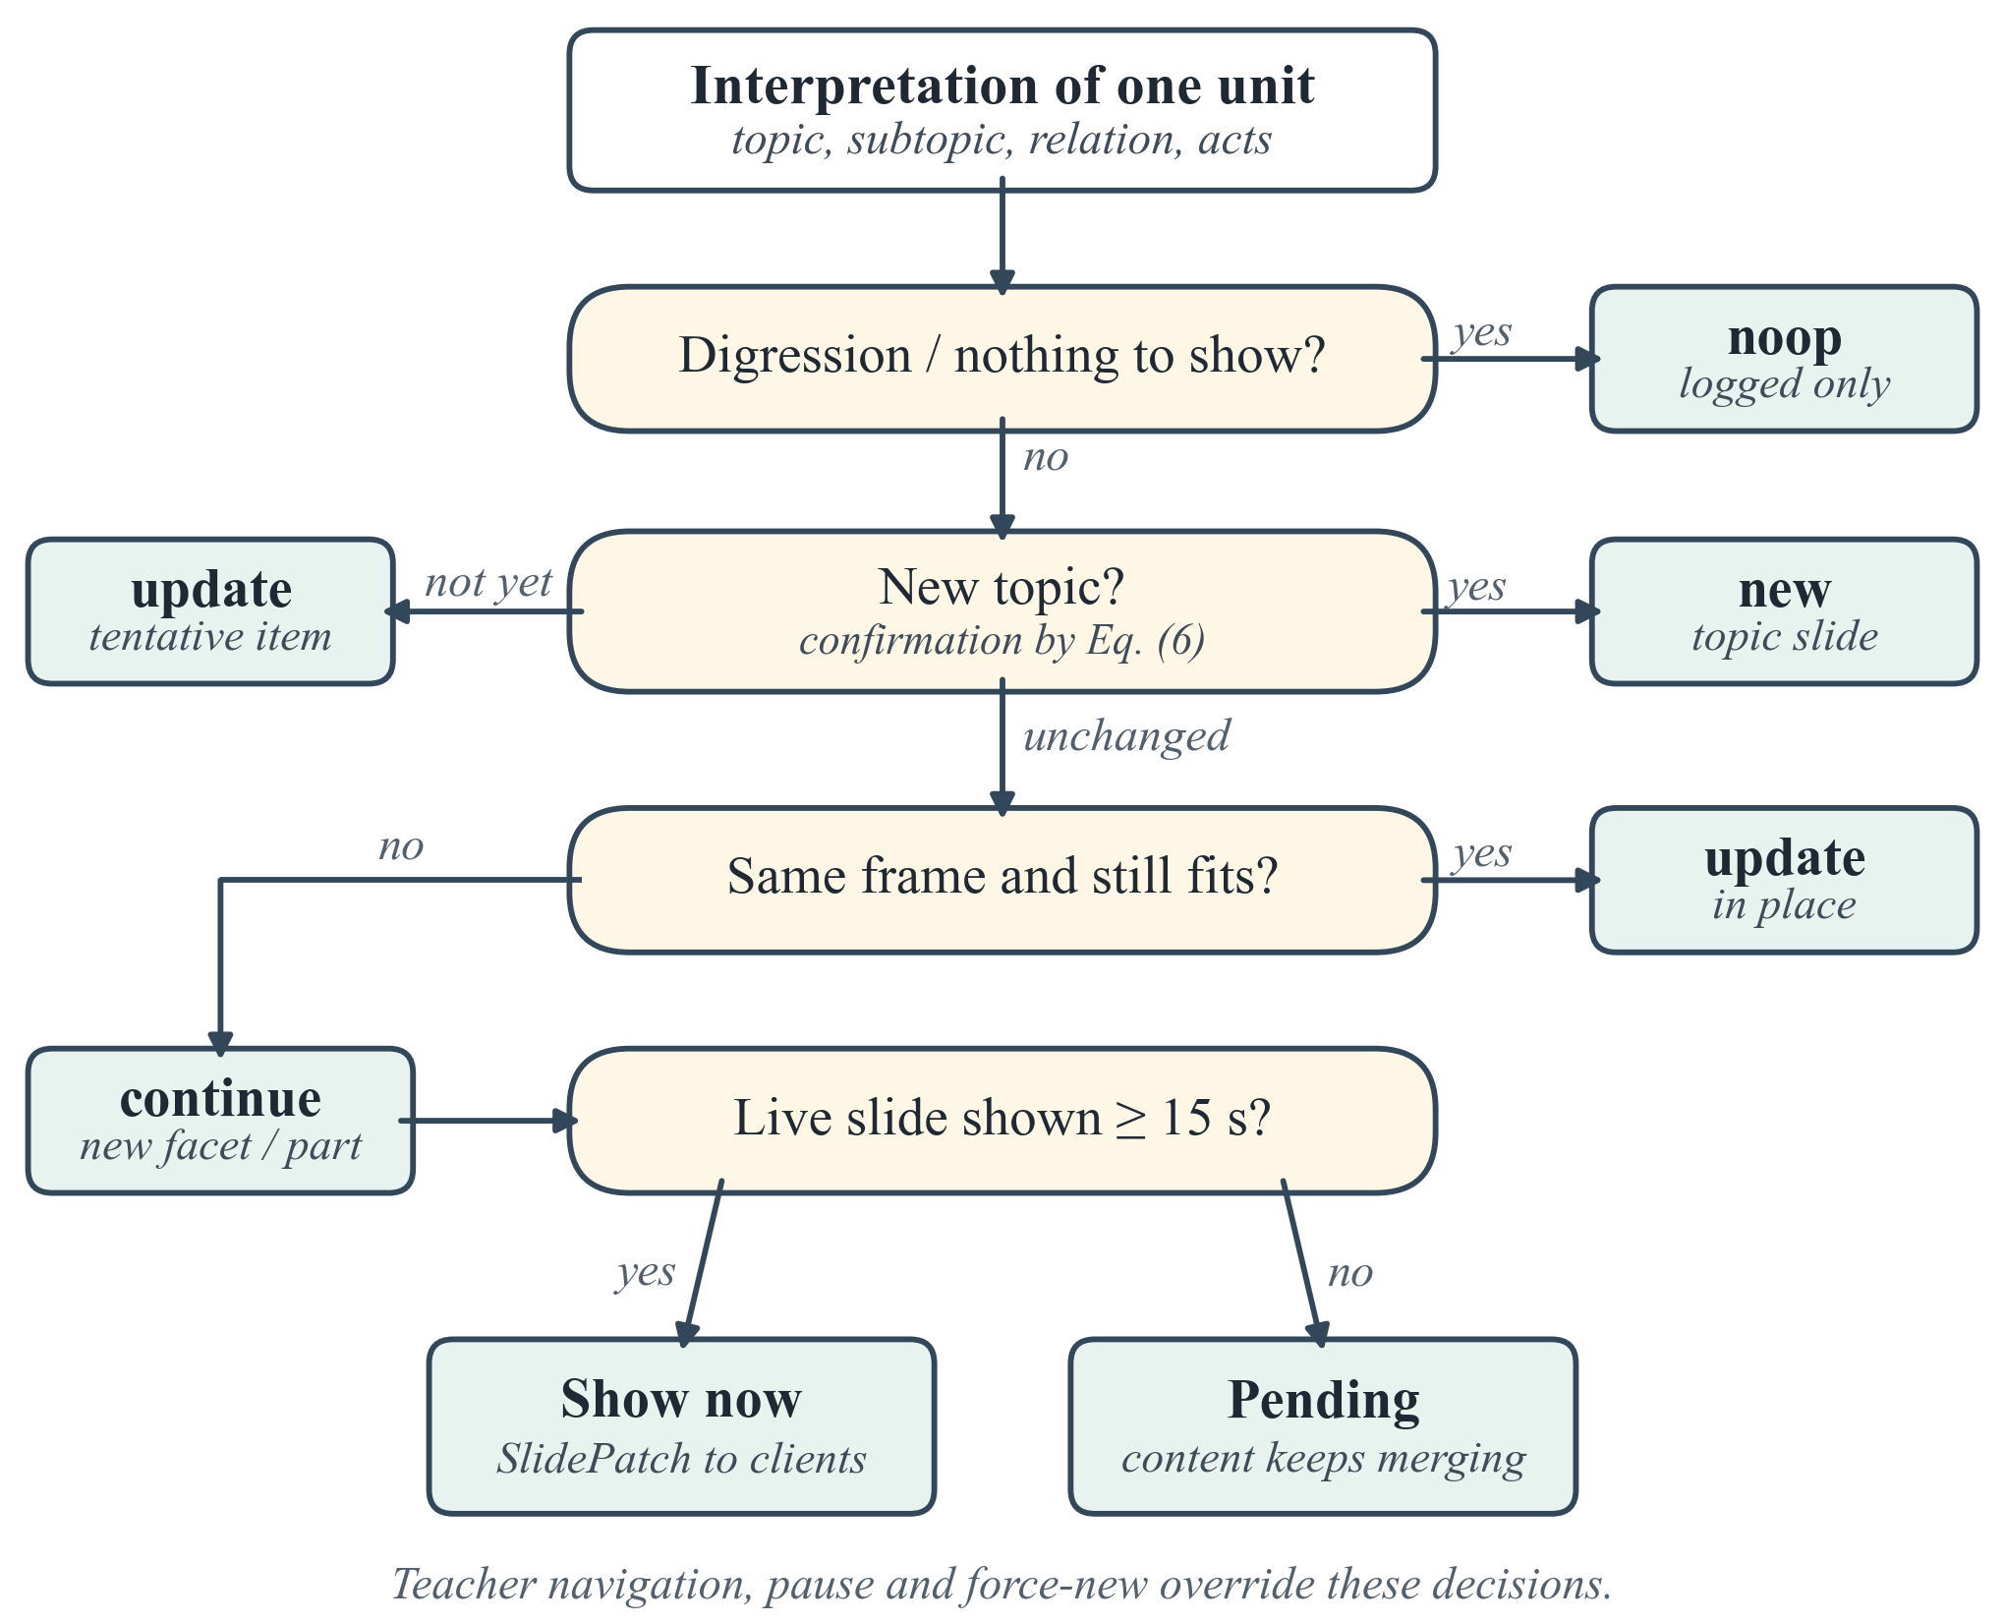
Fig. 2. Planner decision for one interpreted unit. The LLM supplies the relation and content; the decision itself is rule-based and unit-tested.
E. Composer and Image Retrieval
The composer maps items to definition cards, key points, fact tiles, process flows, comparison tables, timelines, cause-effect chains, classification trees and formulas; a pixel-level height model of the 16:9 stage moves overflow to a further part (I, II, …) instead of shrinking text. Spoken mathematics is converted to LaTeX deterministically ("v equals under root 2RT upon m") and typeset with KaTeX with a variable legend. For a concrete object, the LLM suggests a query q; Wikipedia and Wikimedia Commons are searched for openly licensed files (source, author and licence are kept), and up to eight previews are scored by CLIP's zero-shot image–text similarity σ [27]. Image I is accepted when
$σ(q,I)≥0.22∧σ(q,I)−\max_{d∈D}σ(d,I)≥0.01$ (7)
where D is a set of generic distractor prompts ("a logo", "a map"); labelled diagrams rank first, and an image is placed only if the MiniLM similarity of query and slide text is at least 0.25.
F. Live Display and Teacher Control
A FastAPI server pushes versioned slide patches over WebSocket to /display (projector), /control (teacher) and /view (students, shared link). The control view (Fig. 3) offers an editable preview, navigation, pause, blank screen, new slide, in-place editing, image search and upload, mistake cards, the lecture structure tree and light or dark themes.
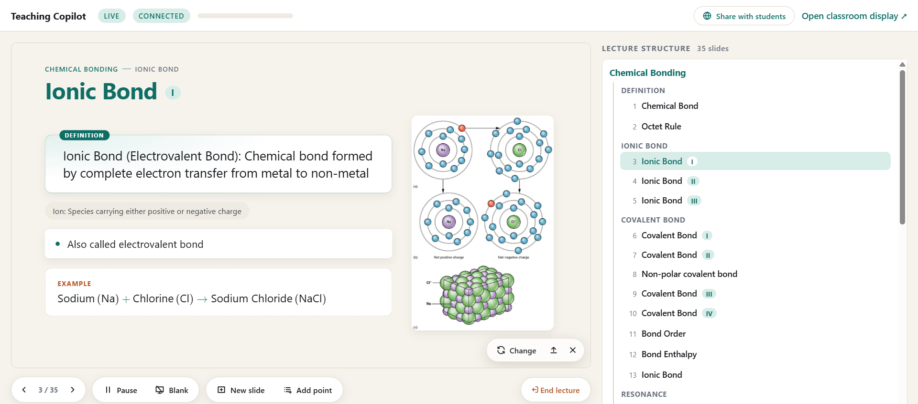
Fig. 3. Teacher control view (/control) in a live chemistry lecture. Left: editable preview of the projected slide (definition card, term chip, key point, worked example, retrieved labelled diagram) with image tools and lecture controls. Right: the lecture structure tree built by the system (topic → facet → numbered slides and parts).
G. Lecture Materials, Quizzes and Archive
On request, a lecture becomes a summary or key-concepts slide, study notes (PDF) that expand slides and transcript into explanations, an assignment (PDF) with short and long theory questions, and a PPTX deck. A quiz (timed multiple-choice questions, leaderboard on the projector) and a test (set duration, scores to the teacher) are generated, edited by the teacher and answered by students through the shared link, once per roll number. Materials can draw on past lectures or a chapter of the searchable archive (Fig. 4).
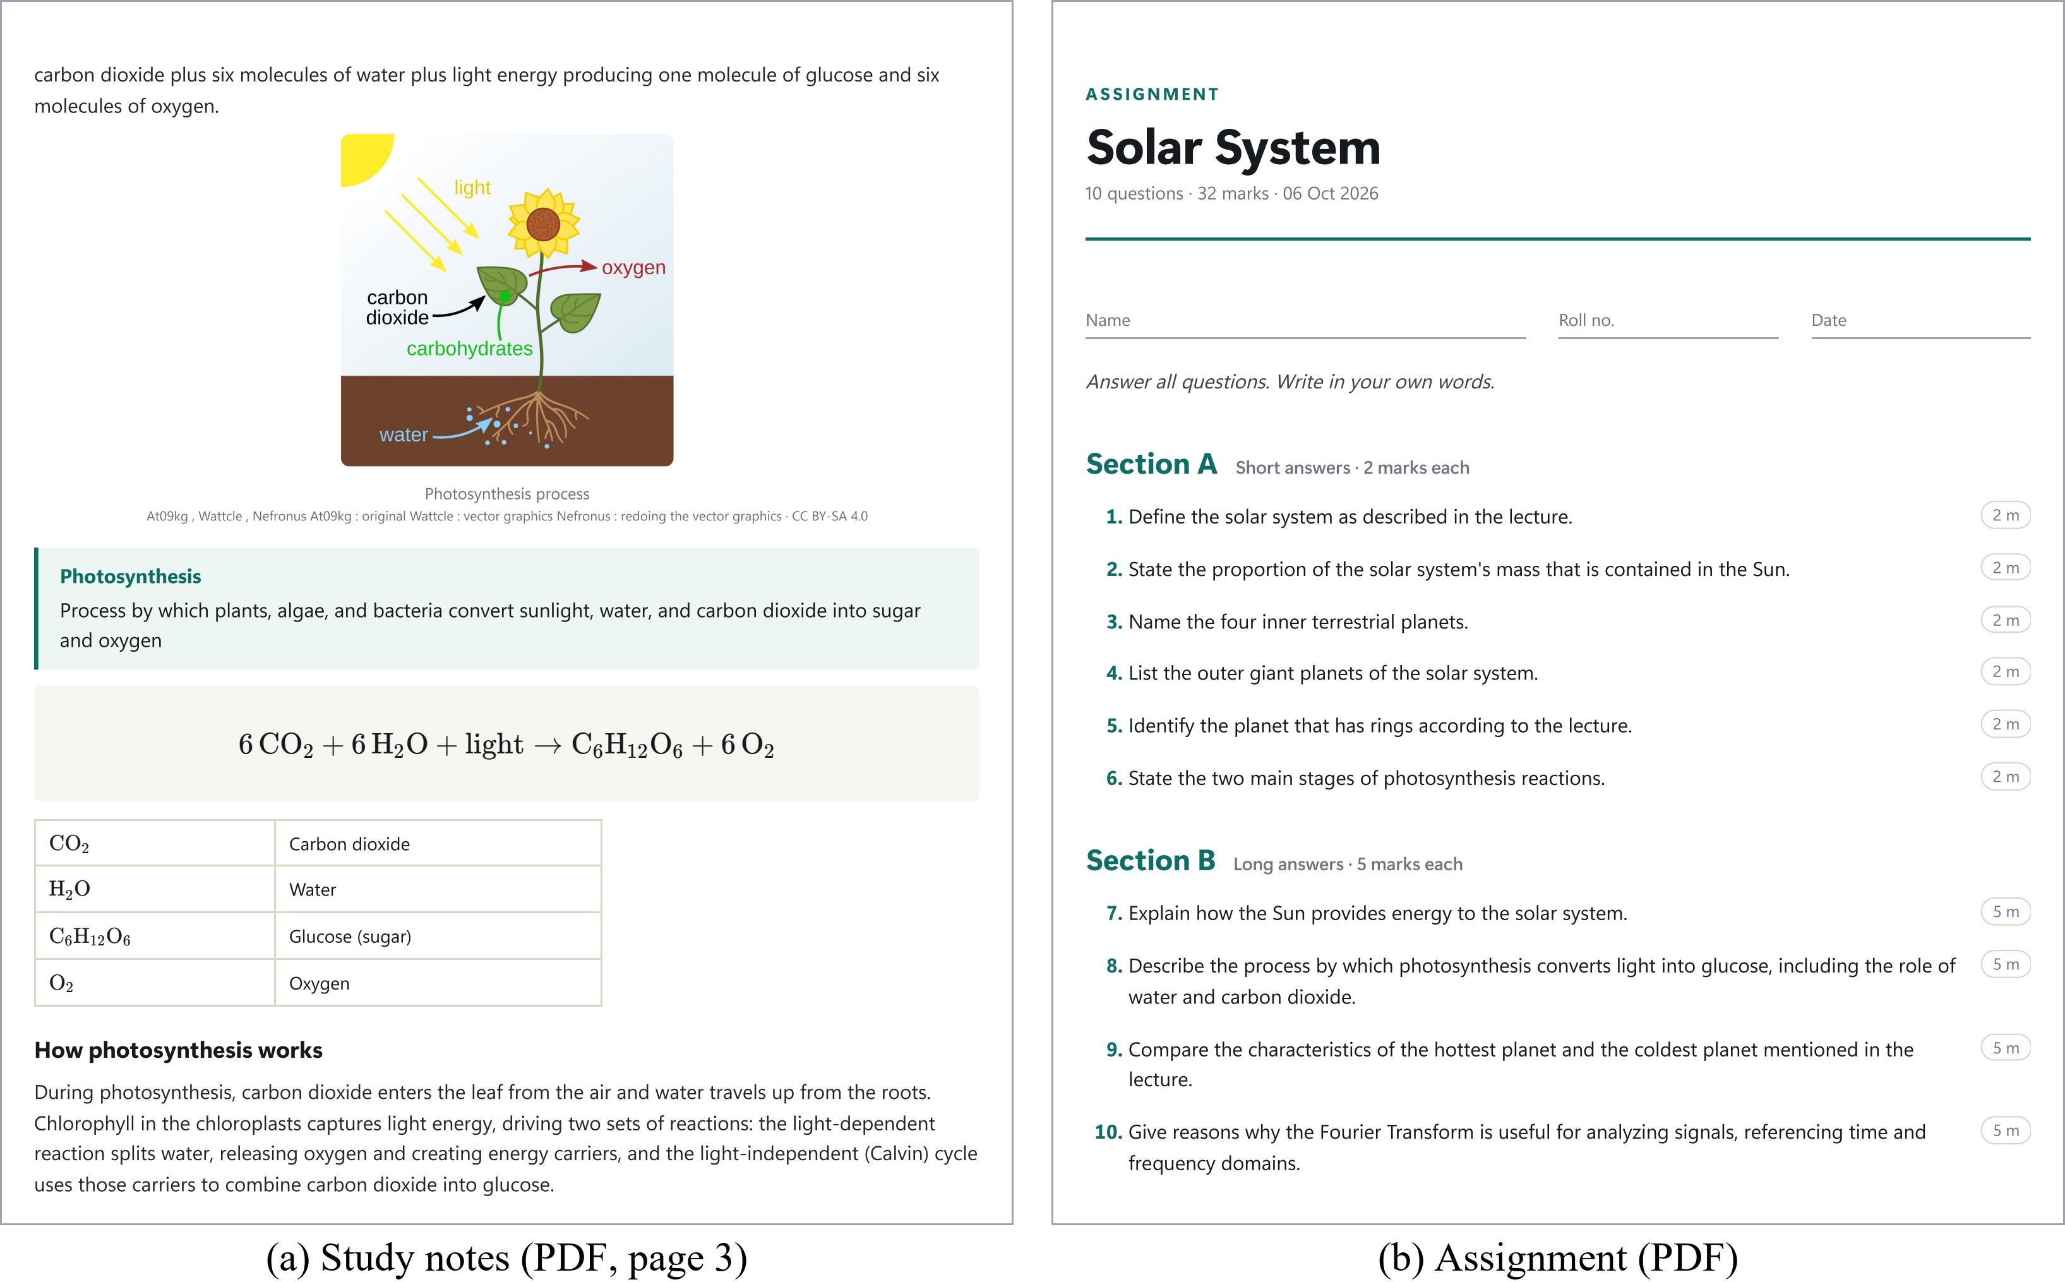
Fig. 4. Materials generated on request from a recorded lecture with the real LLM: (a) a study-notes page with a retrieved diagram, definition, typeset equation and legend; (b) an assignment with short and long theory questions grounded in what was taught.
V. Experimental Evaluation
A. Setup and Data
All runs used a laptop with an RTX 3050 Laptop GPU (4 GB) and 16 GB RAM. The development set D1 has six lectures spoken live by the authors into the laptop's microphone during development (114 min, five subject areas); of its 389 units, 79 were interpreted by gpt-oss-120b, 265 by qwen3.8-27b and 45 by the fallback while every key's quota was spent. The held-out set D2 has ‹N› lectures (‹M› min) by ‹K› other speakers from openly licensed courses and recordings made for this study, unused for any parameter and played in as audio files.
Annotation and rating. Two annotators independently marked topic boundaries and key facts in each transcript; boundaries are scored by F1 (±1 unit) and P_{k} [23], coverage is the share of key facts shown on a slide, the unsupported rate the share of slide statements not backed by the transcript, and agreement is Cohen's κ [28]. Three teachers (T1–T3), not involved in development, rated ‹30› random slides from 1 to 5. Baseline. On the same units of the D1 chemistry and biology lectures, an LLM-controlled baseline gets its last slide and the last 60 s of transcript and returns the slide to show (≤ 6 bullets) and whether it is new, with no planner, guards or composer and the same router and models.
B. Results Across Six Live Lectures
Table II summarizes D1: 765 utterances formed 389 units and the system built 163 slides (the fifth session was paused for long stretches). In Fig. 5 the layout follows the kind of content, not the subject: formulas with variable legends, a comparison table, a reaction equation, labelled diagrams, a ten-step process, type cards and a hierarchy tree.
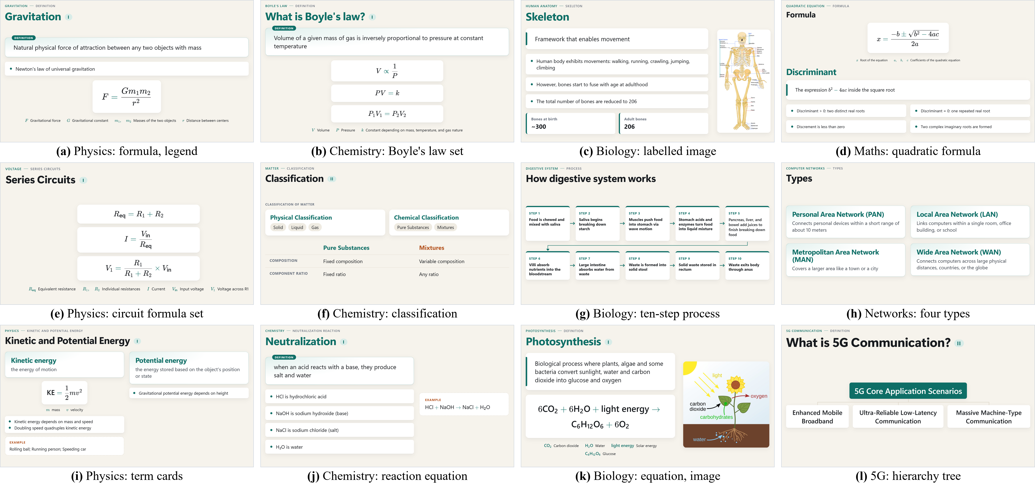
Fig. 5. Projected slides from the six live lectures (light theme), one subject per column. (c), (d), (f) and (k) are screenshots of the running application; the others are the recorded LLM interpretations of the same lectures re-rendered by the current display engine without new LLM calls. Slide text is as spoken, including the speaker's slip "Discrement" in (d).
TABLE II
Six Live Development Lectures (D1, Session Logs)
Lecture topics | Min | Utt. | Units (fb) | STT | LLM | Slides | Images
Phys., maths, chem. | 26.1 | 121 | 64 (6) | 0.73 | 1.29 | 32 | –
Biology (anatomy) | 12.5 | 67 | 45 (0) | 0.74 | 1.34 | 11 | 7 / 11
Bio., phys., engg. | 20.3 | 159 | 89 (2) | 0.62 | 1.39 | 43 | 6 / 13
CS, maths, bio. | 24.2 | 157 | 87 (30) | 0.61 | 1.20 | 32 | 10 / 12
Chem., bio., phys. | 13.3 | 119 | 16 (0) | 1.00 | 1.56 | 10 | 2 / 2
Chemistry | 17.6 | 142 | 88 (7) | 0.66 | 1.30 | 35 | 8 / 25
All six | 114.1 | 765 | 389 (45) | 0.66 | 1.35 | 163 | 33 / 63
fb: fallback units; STT, LLM: median latency (s); Images: searches with an accepted image / all searches (off in the first session).
C. End-to-End Latency
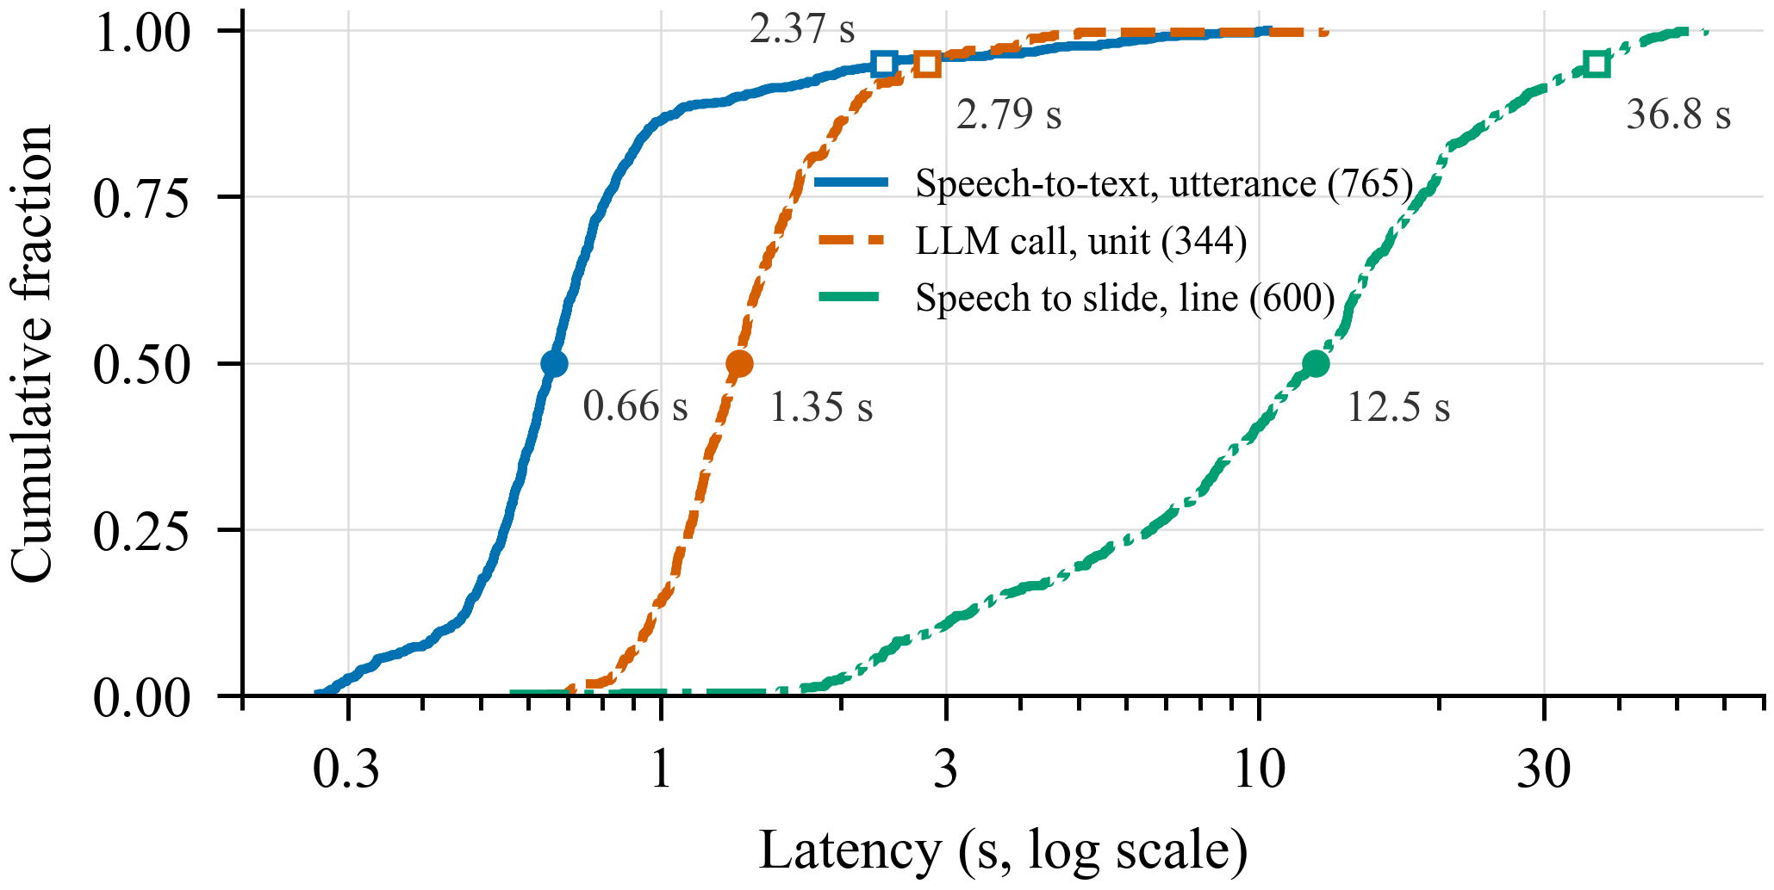
Fig. 6. Cumulative distributions over D1 (log scale): speech-to-text per utterance, LLM call per unit, and end-to-end delay from the end of a spoken line to its interpreted content on the display. Filled markers: medians; open: 95th percentiles.
Speech-to-text has a median of 0.66 s (95th percentile 2.37 s, mainly the fifth session) and an LLM call 1.35 s (2.79 s) (Fig. 6). From the end of a spoken line to its interpreted content on the display, the median is 12.5 s and the 95th percentile 36.8 s (600 lines; 12.1 s for LLM, 13.5 s for fallback units). Waiting in the gate and queue dominates (median 9.1 s), as each concept boundary made a short unit that queued behind the 8 s floor; a key-phrase teaser appeared within 0.68 s for 134 lines. Ending units only after finished sentences cut the median wait in a chemistry replay from 9.5 s to 5.3 s (not yet live).
D. Comparison With an LLM-Controlled Baseline
TABLE III
Proposed System vs. LLM-Controlled Baseline (Same Units)
Lecture / system | Slides | Rewritten | Missing | Unsupported
Chemistry: proposed | 36 | 8 / 317 (3 %) | 5 / 136 (4 %) | ‹›
Chemistry: baseline | 15 | 226 / 405 (56 %) | 220 / 293 (75 %) | ‹›
Biology: proposed | 11 | 0 / 74 (0 %) | 0 / 39 (0 %) | ‹›
Biology: baseline | 13 | 48 / 160 (30 %) | 44 / 90 (49 %) | ‹›
Rewritten: statements of a shown slide that its next version rewrote or removed; missing: distinct statements shown but absent from the final deck; unsupported: annotated.
Given the same units, the LLM-controlled baseline kept one slide for long stretches and rewrote it (Table III): in chemistry, 56 % of statements students had already seen were rewritten or removed by the next version, and 75 % of all statements it showed were absent from its final deck. The proposed system appends to the live slide and moves on instead, rewriting 3 % (mostly mis-hearing corrections) and losing 4 %; in biology the baseline rewrote 30 % and lost 49 %, the proposed system none. The baseline used 89,129 tokens for the 133 units. ‹Unsupported-rate sentence.›
E. Content and Topic Accuracy
TABLE IV
Annotated Accuracy and Teacher Ratings
Measure | D1 | D2 | All
Boundary F1 (±1 unit) / P_{k} | ‹› | ‹› | ‹›
Key-fact coverage | ‹› | ‹› | ‹›
Unsupported statements | ‹› | ‹› | ‹›
Annotator agreement κ | ‹› | ‹› | ‹›
Teacher rating (corr./rel./read./use.) | ‹› | ‹› | ‹›
Ratings: mean of T1–T3, 1–5 scale.
‹Accuracy result paragraph, with fallback units reported separately.›
F. Session Details and Components
In the chemistry lecture the planner made 55 in-place updates, 12 continuations and 7 new-topic decisions, and 23 mis-hearings were corrected silently ("world of container" → "walls of container"). Of 63 image searches, 33 found an accepted image; on a 30-concept labelled set, the first image was relevant for all 28 that received one. All 513 unit and integration, 28 browser and 8 GPU tests pass.
VI. Discussion
When the planner, not the LLM, owns the slide sequence, a stable deck can be built from live speech on modest hardware: the LLM-controlled baseline lost most of what it had shown, and every slide change of the system has a rule-based reason in the log that can be replayed at zero LLM cost. ‹Accuracy discussion.› The cost is delay, about 12 s from speech to interpreted slide, set by unit formation and the free-quota call floor rather than the models. D1 was spoken by the authors, so D2 tests other speakers; without a classroom study, no claim is made about learning outcomes. Subtopic names vary between runs, and image coverage depends on Wikimedia Commons.
VII. Conclusion
This paper presented an implemented live lecture-to-slide system that turns a teacher's speech into a structured, continuity-aware deck during the lecture, with the LLM as a bounded interpreter and a deterministic planner in control of the slides, plus summaries, notes, assignments, quizzes, tests and PPTX decks on request. On a laptop with a 4 GB GPU and free services it built 163 slides in six live lectures and rewrote 3 % instead of 56 % of the statements students had already seen, compared with an LLM that controls the slides. ‹One sentence on held-out accuracy and teacher ratings.› A classroom study is the next step.
References
[1] R. E. Mayer, Multimedia Learning, 2nd ed. Cambridge, U.K.: Cambridge Univ. Press, 2009.
[2] J. Sweller, "Cognitive load during problem solving: Effects on learning," Cognitive Sci., vol. 12, no. 2, pp. 257–285, 1988.
[3] R. E. Mayer and R. Moreno, "Nine ways to reduce cognitive load in multimedia learning," Educ. Psychologist, vol. 38, no. 1, pp. 43–52, 2003.
[4] R. S. Kushalnagar, W. S. Lasecki, and J. P. Bigham, "Accessibility evaluation of classroom captions," ACM Trans. Accessible Comput., vol. 5, no. 3, Art. no. 7, 2014.
[5] T.-J. Fu, W. Y. Wang, D. McDuff, and Y. Song, "DOC2PPT: Automatic presentation slides generation from scientific documents," in Proc. AAAI Conf. Artif. Intell., vol. 36, no. 1, 2022, pp. 634–642.
[6] E. Sun, Y. Hou, D. Wang, Y. Zhang, and N. X. R. Wang, "D2S: Document-to-slide generation via query-based text summarization," in Proc. NAACL-HLT, 2021, pp. 1405–1418.
[7] Y. Hu and X. Wan, "PPSGen: Learning-based presentation slides generation for academic papers," IEEE Trans. Knowl. Data Eng., vol. 27, no. 4, pp. 1085–1097, Apr. 2015.
[8] E. Xie, G. Xiong, H. Yang, O. Coleman, M. Kennedy, and A. Zhang, "Leveraging grounded large language models to automate educational presentation generation," in Proc. Large Found. Models Educ. Assessment, PMLR, vol. 264, 2025, pp. 207–220.
[9] E. Xie, D. Waterfield, M. Kennedy, and A. Zhang, "SlideBot: A multi-agent framework for generating informative, reliable, multi-modal presentations," in Proc. AAAI Conf. Artif. Intell., vol. 40, no. 48, 2026, pp. 40907–40915.
[10] H. Zheng et al., "PPTAgent: Generating and evaluating presentations beyond text-to-slides," in Proc. EMNLP, 2025, pp. 14402–14418.
[11] J. Ge et al., "AutoPresent: Designing structured visuals from scratch," in Proc. IEEE/CVF CVPR, 2025, pp. 2902–2911.
[12] E. Kasneci et al., "ChatGPT for good? On opportunities and challenges of large language models for education," Learn. Individual Differences, vol. 103, Art. no. 102274, 2023.
[13] OpenAI, "gpt-oss-120b & gpt-oss-20b model card," arXiv:2508.10925, 2025.
[14] Z. Ji et al., "Survey of hallucination in natural language generation," ACM Comput. Surv., vol. 55, no. 12, Art. no. 248, 2023.
[15] R. A. Bartsch and K. M. Cobern, "Effectiveness of PowerPoint presentations in lectures," Comput. Educ., vol. 41, no. 1, pp. 77–86, 2003.
[16] A. Radford, J. W. Kim, T. Xu, G. Brockman, C. McLeavey, and I. Sutskever, "Robust speech recognition via large-scale weak supervision," in Proc. ICML, 2023, pp. 28492–28518.
[17] SYSTRAN, "faster-whisper: Faster Whisper transcription with CTranslate2," GitHub. [Online]. Available: https://github.com/SYSTRAN/faster-whisper
[18] Silero Team, "Silero VAD: Pre-trained enterprise-grade voice activity detector," GitHub, 2021. [Online]. Available: https://github.com/snakers4/silero-vad
[19] H. Gonzalez et al., "Automatically generated summaries of video lectures may enhance students' learning experience," in Proc. 18th Workshop BEA, 2023, pp. 382–393.
[20] M. A. Hearst, "TextTiling: Segmenting text into multi-paragraph subtopic passages," Comput. Linguistics, vol. 23, no. 1, pp. 33–64, 1997.
[21] N. Reimers and I. Gurevych, "Sentence-BERT: Sentence embeddings using Siamese BERT-networks," in Proc. EMNLP-IJCNLP, 2019, pp. 3982–3992.
[22] W. Wang, F. Wei, L. Dong, H. Bao, N. Yang, and M. Zhou, "MiniLM: Deep self-attention distillation for task-agnostic compression of pre-trained transformers," in Proc. NeurIPS, vol. 33, 2020, pp. 5776–5788.
[23] D. Beeferman, A. Berger, and J. Lafferty, "Statistical models for text segmentation," Mach. Learn., vol. 34, no. 1–3, pp. 177–210, 1999.
[24] B. T. Willard and R. Louf, "Efficient guided generation for large language models," arXiv:2307.09702, 2023.
[25] G. Kurdi, J. Leo, B. Parsia, U. Sattler, and S. Al-Emari, "A systematic review of automatic question generation for educational purposes," Int. J. Artif. Intell. Educ., vol. 30, no. 1, pp. 121–204, 2020.
[26] C.-Y. Lin, "ROUGE: A package for automatic evaluation of summaries," in Proc. ACL Workshop Text Summarization, 2004, pp. 74–81.
[27] A. Radford et al., "Learning transferable visual models from natural language supervision," in Proc. ICML, 2021, pp. 8748–8763.
[28] J. Cohen, "A coefficient of agreement for nominal scales," Educ. Psychol. Meas., vol. 20, no. 1, pp. 37–46, 1960.

