Multimodal AI Teaching Copilot: Live Slide Generation from Lecture Speech
Prachi Potdar, Paritosh Raut, Deepali Magdum, Swati Kale, and Sunita Patnaik
Department of Electronics and Telecommunication Engineering
JSPM's Rajarshi Shahu College of Engineering, Pune, Maharashtra, India – 411033
prachipotdar50@gmail.com, paritosh21raut@gmail.com, dipalimagdum@gmail.com, swatikale@gmail.com, sunitapatnaik@gmail.com

Abstract—Prepared slides cannot show what a teacher adds while explaining, and a large language model (LLM) that regenerates slides from a growing transcript rewrites what students are reading. This paper presents a teaching copilot that builds a structured, continuity-aware slide deck on the classroom projector from the teacher's live speech. Locally transcribed speech is sent in bounded units to an LLM that only returns a schema-validated interpretation; a deterministic planner turns it into slide operations that only extend the deck, so the LLM cannot rewrite what students have read, and a transcript-coverage guard restores facts the LLM omits. Across 36 held-out lectures (409 min), run on one laptop with 4 GB of graphics memory, the median delay from speech to slide was 11.2 s. On an annotated subset of 18 lectures, slide changes matched topic boundaries with precision 0.78, 86.6 % of key facts reached a slide, 0.9 % of statements were unsupported by the speech, and five teachers gave mean ratings of 3.87–4.17 of 5 on four criteria. On the same units, an LLM-controlled baseline rewrote or removed 38.2 % of the statements students had already seen, against 2.0 % (lower in all 18 lectures, p < 0.001), and a replay ablation showed that opening a slide per concept lowers precision to 0.37.
Index Terms—Automatic slide generation, educational technology, large language models, live systems, speech recognition, human-in-the-loop
I. Introduction
Slides prepared before a lecture fix its order in advance, so the examples and answers a teacher adds while explaining never reach the screen. Narration paired with relevant pictures helps learners more than narration by itself [1], provided the visuals add no extraneous load [2], [3]; yet no teacher can draw such visuals while teaching.
Existing tools solve only parts of this problem: live captions show verbatim text without the structure of the lesson [4]; slide generators work offline from a finished document or prompt [5]–[11]; and a large language model (LLM) [12], [13] applied to a growing transcript rewrites slides while students read them and adds untaught content [14]. Three problems remain open: (P1) projected material does not follow what is taught; (P2) live speech is not turned into a structured visual lesson; and (P3) LLM output is neither stable nor faithful to the teacher's words.
This paper presents the Multimodal AI Teaching Copilot, an implemented system that addresses all three: spoken input becomes visual output (typed layouts, typeset formulas, diagrams and retrieved images) on the projector while the teacher speaks. The contributions are: (1) incremental slide generation from live speech; (2) an extend-only update policy: the LLM only labels bounded, schema-validated units, and a deterministic planner executes only operations that add to the deck, so the LLM cannot rewrite what students have read; (3) a transcript-coverage guard that restores facts the LLM omits, and a formula guard; and (4) a held-out evaluation with annotation, teacher ratings, a replay ablation and a paired comparison with an LLM-controlled baseline.
II. Related Work
A. Multimedia Learning and Lecture Speech
In Mayer's experiments, learners given text with matching pictures outperformed those given text only [1]; Sweller traces such effects to the small capacity of working memory [2], [3], and decorative pictures reduced test scores in PowerPoint lectures [15]. The system therefore uses short typed layouts and adds an image only for a concrete object that is taught.
Whisper by Radford et al. [16], run with 8-bit weights by faster-whisper [17], and Silero VAD [18] form the speech front end. Kushalnagar et al. showed that verbatim real-time captions are hard for students to follow [4], and Gonzalez et al. found that LLM summaries of recorded lectures improved quiz scores [19]; both produce text, not a structured visual lesson (P2).
B. Segmentation, Slide Generation and LLMs
TextTiling by Hearst places subtopic boundaries where the similarity of adjacent blocks drops [20]; Sentence-BERT by Reimers and Gurevych compares sentence embeddings by cosine similarity [21], and Wang et al. distilled it into MiniLM [22]. These methods segment a complete transcript offline; here the similarity drop is one online signal, evaluated with the measure of Beeferman et al. [23].
PPSGen selects sentences of a paper for slides by integer linear programming [7], D2S summarizes document text for each slide title [6], and DOC2PPT generates slides with text and figures from scientific documents [5]. With LLMs, Xie et al. ground educational slides in retrieved sources [8], SlideBot adds multi-agent planning [9], PPTAgent edits reference slides [10], and AutoPresent writes slides as code [11]. All build a whole deck offline from written input; a lecture arrives incrementally as noisy speech (P1, P3).
Kasneci et al. stressed teacher oversight of LLMs in education [12], so the teacher overrides every automatic decision. Ji et al. surveyed hallucination [14], and Willard and Louf constrained generation to a JSON schema [24], which fixes the format but not the facts, so the output is also checked against the transcript; generated quizzes follow the review of Kurdi et al. [25].
Among the systems in Table I, none combines streaming speech input with incremental decisions about which slide to change while students read; this is the gap addressed here.
TABLE I
Comparison of the Proposed System With Prior Systems
System | Input | Produced | Topic structure | Faithfulness to source | Slide sequence
Live captions [4], [16] | Speech | Live | None (text stream) | Verbatim text | None
Lecture summaries [19] | Recorded lecture | Offline | None (summary) | LLM summary | None
PPSGen, D2S, DOC2PPT [5]–[7] | Paper / document | Offline | Document sections | Extracted from document | Whole deck at once
LLM slide generators [8]–[11] | Topic, document | Offline | LLM outline / plan | Retrieved sources or none | Whole deck at once
Proposed system | Live speech | During lecture | Online topic / subtopic | Coverage + formula guards | Extend-only + teacher
III. Methodology
A. System Overview
A lecture is processed as a stream through six stages (Fig. 1): speech capture and recognition; filtering and concept tracking; a gate that groups finished sentences into units; bounded LLM interpretation of each unit; a deterministic planner and composer that turn it into slide operations and layouts; and delivery to the projector, the teacher and students. Four rules guide the design: the LLM supplies labels but never executes a slide operation, it never sees the whole transcript, a new concept is not by itself a new slide, and user interfaces send commands instead of changing the state.
All components run in one Python asyncio process and exchange typed events; every event is logged in SQLite, from which each lecture is replayed for evaluation and materials. Recognition runs on the GPU, MiniLM and CLIP on the CPU (ONNX), and the LLM on the Groq free tier (openai/gpt-oss-120b [13]; qwen/qwen3.8-27b of the Qwen3 family [26] when that quota is spent; Oct. 2026), as a 7B-class local model does not fit beside the speech model in 4 GB. Of the 1,619 held-out units, 71.6 % were interpreted by the first model, 24.0 % by the second and 4.4 % by the deterministic fallback.
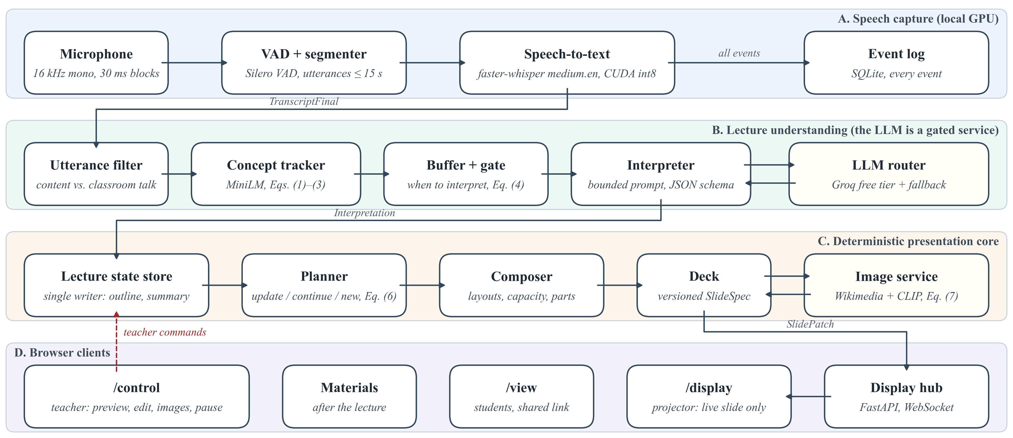
Fig. 1. Implemented architecture. Lanes A–C run in one Python process; only the interpreter calls the LLM; browsers get slide patches and send commands.
B. Speech Capture and Concept Tracking
Silero VAD [18] segments 16 kHz audio (utterances up to 15 s), and faster-whisper [17] with Whisper medium.en [16] (int8, beam size 1, keyword prompt) transcribes them. A deterministic filter removes classroom management, meta talk and fillers. Each content utterance is embedded with MiniLM [22]; with the L2-normalized embedding eₜ and concept centroid cₜ₋₁, the shift score is the cosine distance sₜ = 1 − eₜ·cₜ₋₁ used with Sentence-BERT [21], and the centroid is the exponentially weighted mean cₜ = norm((1 − α)cₜ₋₁ + αeₜ) with α = 0.35, raised to 0.6 at a boundary so it re-seeds on the new concept. Following the similarity-drop criterion of TextTiling [20], a boundary is signalled when
$b_{t}=κ_{t}∨\left(s_{t} ≥ τ\right),τ=0.75$ (1)
where κₜ marks a cue phrase ("moving on to", "next"); τ is high because shift scores within one facet were 0.3–0.6.
C. Gate and Token Budget
Content accumulates in a buffer until a rule-based gate fires. With pₜ the silence after a finished sentence, wₜ the buffered words and aₜ the age of the oldest pending line (s),
$G_{t}=(p_{t}≥1.2∧w_{t}≥6)∨w_{t}≥40∨b_{t}∨a_{t}≥12$ (2)
with an 8 s floor between calls, set by the free quota (200,000 tokens per key and model per day).
D. Bounded Interpretation and Transcript-Grounding Safeguards
The prompt holds the subject, level, an outline (≤ 150 tokens), the current slide with numbered items, a rolling summary (≤ 120 tokens) and the new lines, within 3,000 tokens (temperature 0.2). The LLM returns JSON with topic, subtopic, a relation (same concept, elaboration, sub-concept, sibling, new topic, digression), typed content, an image hint and concerns about possibly wrong statements. Pydantic validates it; after one failed repair, a deterministic fallback shows the spoken sentences as points. A coverage guard compares every content sentence u (≥ 6 words) with the output O; with W(·) the set of word stems and a recall-style overlap as in ROUGE-1 [27],
$\left|W(u)∩W(O)\right|≤\frac{1}{3}\left|W(u)\right|⇒u\text{ is shown as said}$ (3)
so a fact the model left out still reaches the slide. A formula guard flags changed formula tokens, and a correction is applied only above a confidence of 0.75 (factual) or 0.4 (mis-hearing); otherwise the slide shows what was said and the teacher gets a card with both versions. These checks keep slides faithful to the transcript; they do not prove a statement correct.
E. Slide Planner
The planner turns each interpretation into one operation: update the working slide, continue on a new slide of the same topic, open a new topic slide, retitle, or nothing. None of them lets the LLM rewrite or delete a shown item: shown text changes only when the composer merges an elaboration into the item it elaborates, a mis-hearing correction is applied, or the teacher edits it. A topic change must be confirmed, because a single unit may be misread:
$C_{n}=B_{n}∨\left({\overline{s}}_{n}^{max} ≥ τ\right)∨\left(T_{n} ≡ {\overset{\sim }{T}}_{n−1}\right)$ (4)
where B_{n} is true if a boundary (1) occurred in unit n, s̄_{n}^{max} is its largest shift score smoothed over two utterances, T_{n} its topic and T̃_{n−1} an unconfirmed candidate from the previous unit. Unconfirmed content is shown tentatively and moved once confirmed. A minimum dwell of 15 s (6 s for the next part of a full slide) prevents rapid changes, near-duplicates (similarity ≥ 0.85) are merged, and teacher edits are never overwritten. All thresholds were set by hand on D1 and are tested by ablation in Section IV.
F. Composer and Image Retrieval
The composer maps items to definition cards, key points, fact tiles, process flows, comparison tables, timelines, cause-effect chains, classification trees and formulas; overflow moves to a further part (I, II, …) instead of shrinking text, and spoken mathematics is typeset with KaTeX. For a concrete object the LLM suggests a query; an openly licensed Wikimedia image (source, author and licence kept) is placed only if CLIP's zero-shot similarity [28] ranks it above generic distractor prompts ("a logo", "a map") and the query matches the slide text.
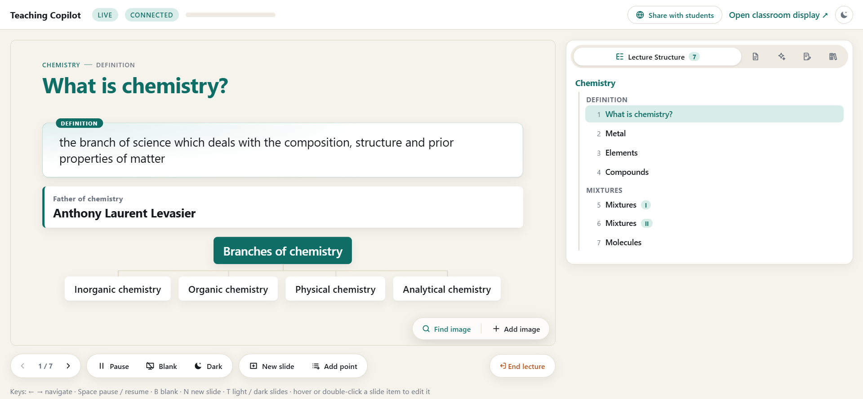
Fig. 2. Teacher control view (/control) in a live chemistry lecture: the projected slide as an editable preview with image tools and lecture controls (left) and the lecture structure tree built by the system, topic → facet → slides, with overflow parts I and II (right).
G. Live Display and Teacher Control
A FastAPI server pushes versioned slide patches over WebSocket to /display (projector), /control (teacher) and /view (students, shared link). The control view (Fig. 2) adds editing, image search and upload, pause, blank screen, mistake cards, the running transcript and the lecture structure tree.
H. Lecture Materials
After the lecture the event log is reused: on request it becomes study notes, an assignment (Fig. 3), a PPTX deck, or a live quiz or test answered through the shared link, all from the taught content and edited by the teacher. These features are not evaluated here.
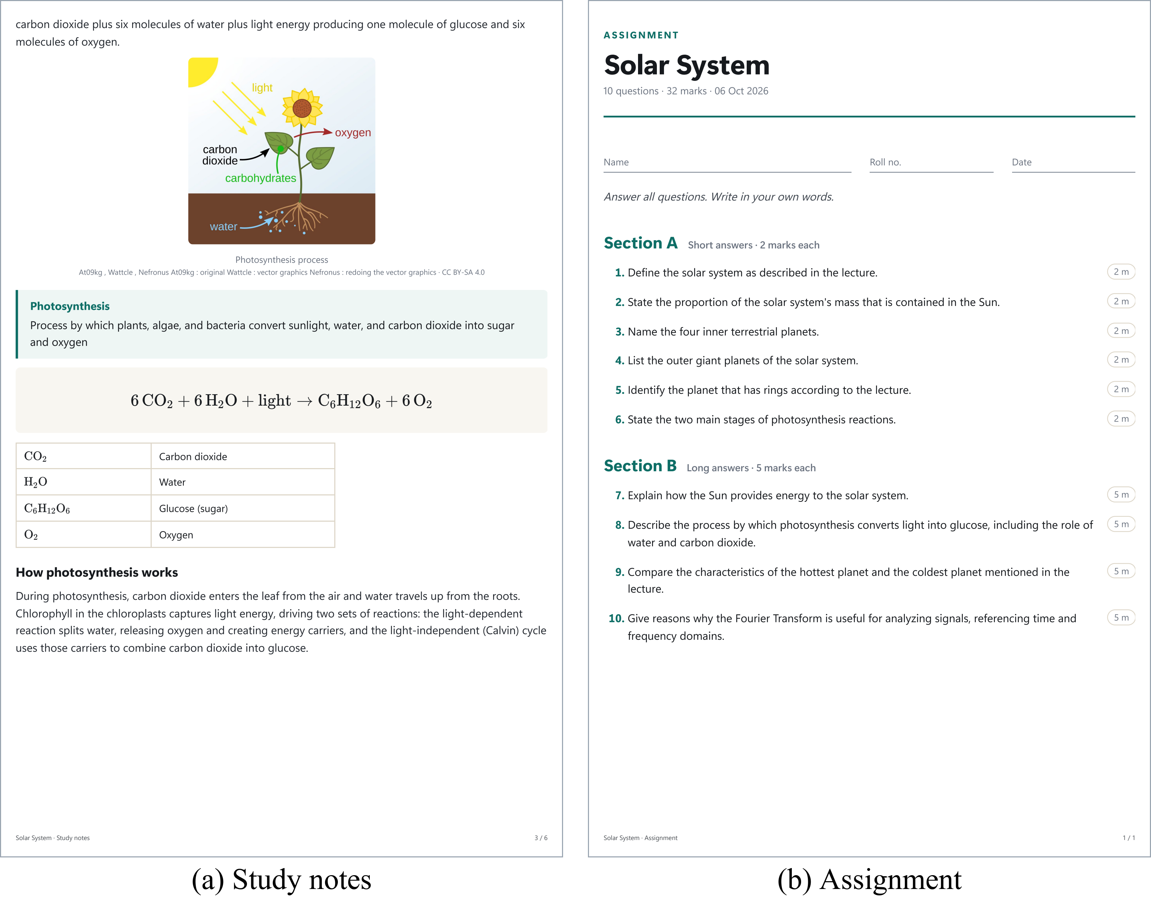
Fig. 3. Materials generated from the event log of a recorded D1 lecture (not evaluated): (a) a study-notes page; (b) the assignment.
IV. Experimental Evaluation
A. Setup and Data
Every run used one laptop (NVIDIA RTX 3050, 4 GB video memory; 16 GB system memory). D1 is six lectures spoken by the authors (114.1 min). The held-out set D2 (Tables II and III) has 30 lectures spoken live, unscripted, by six speakers into the laptop microphone (Recorded, physics to economics) and six 10-min public lectures played in as audio in real time (Public): MIT OpenCourseWare 7.016, 5.111, 18.01 and 8.01 (CC BY-NC-SA) and NPTEL Computer Networks and History of Economic Theory (CC BY-SA). The speakers consented to the recording. Against MIT's human captions of the 7.016 lecture (1,257 words), the live transcript has a word error rate of 7.1 %. Teachers did not edit slide text during a test; in D2 they deleted two items and accepted corrections from concern cards in two lectures. Three populations are evaluated: all 36 lectures for latency and operation, an annotated subset of 18 (12 Recorded, 6 Public; 191 min) for accuracy and the ablation, and 30 sampled slides for teacher ratings.
TABLE II
Evaluation Data
Set | Lectures | Minutes | Units | Fallback units | Slides
D1 (development) | 6 | 114.1 | 389 | 45 | 163
D2 Recorded | 30 | 349.2 | 1,275 | 59 | 453
D2 Public | 6 | 60.0 | 344 | 13 | 52
D2 all (held out) | 36 | 409.2 | 1,619 | 72 | 505
Units: groups of finished sentences sent for interpretation; fallback units were interpreted without the LLM (quota spent or provider failure).
TABLE III
Live System Performance (Session Logs)
Measure (s) | D1 | D2 Rec. | D2 Pub. | D2 all
Speech-to-text per utterance | 0.66 | 0.71 | 0.60 | 0.68
LLM call | 1.35 | 1.92 | 2.23 | 1.96
Speech to slide, median | 12.5 | 10.1 | 17.1 | 11.2
Speech to slide, 95th percentile | 36.8 | 23.2 | 93.4 | 53.0
Medians unless stated; speech to slide: from the end of a spoken line to its display. Public includes web4 and web6 (provider outages).
Annotation. Two authors (A and B) independently annotated the 18 lectures, chosen to mix subjects and speakers with 6–17 min each. Before seeing the slides, each marked topic boundaries (where a teacher would start a new board) and key facts in the transcript, then judged whether each key fact was on a slide and whether each slide statement was said and correct; scores are the mean of A and B, without adjudication. A system boundary is the utterance that opened a new content slide. Boundaries are scored by precision, recall and F1 within ±1 utterance, averaged per lecture, and by P_{k} [23], the probability that two utterances half a segment apart are wrongly split or joined; agreement is Cohen's κ [29] on the scale of Landis and Koch [30] and, for skewed labels, Gwet's AC1 [31]. Intervals are 95 % bootstrap intervals over lectures. Ratings. Five teachers (T1–T5), not involved in development, rated 30 random D2 slides, each shown with what was said, from 1 to 5 on four criteria; their consistency is the ICC(2,1) of Shrout and Fleiss [32].
B. Topic Boundaries and Content Accuracy
Slides change where the topic changes (Table IV): boundary precision is 0.78 (95 % interval 0.68–0.88), so a projected slide is rarely replaced within a topic, and P_{k} is 0.32. Recall is 0.42 (0.30–0.55): a new concept is not a new slide, so the planner merges into the live slide sub-points that annotators marked as boundaries, most often in the Public lectures (recall 0.19); Section IV-C shows this is a trade-off. Of 669 key facts, 86.6 % (84.6–88.5 %) reached a slide (partly shown counts ½), and only 0.9 % (0.2–1.8 %) of 2,504 statement judgments were not supported by the speech. The coverage guard (3) is needed for this: 60 of the covered facts reached a slide only through a sentence it restored, so without it coverage would be 77.7 %; the guard adds 9.0 points (6.4–11.7). Of the 3.7 % marked wrong, 41 of 79 were also marked as said (a slip or mis-hearing): slides follow the speech, and corrections go to the teacher's concern cards; transcript support is therefore not factual correctness. Agreement is substantial for boundaries (κ = 0.72 [30]) and high for "supported" (88.8 %, AC1 0.88); κ is only 0.07 there because nearly all statements were supported (the prevalence paradox [33]).
Test29, interpreted entirely by the fallback (quota spent), covered 83.1 % of key facts with 0.7 % unsupported statements but rarely opened a slide (recall 0.04) and used three layouts, 11 of its 13 slides plain points, against 12 layouts and 34 % plain points in the other lectures: the fallback preserves content, the LLM adds the structure. The 17 LLM lectures reach precision 0.77 and recall 0.45. The teachers rated the slides 3.87–4.17 of 5 (ICC(2,1) 0.45–0.56, moderate). In Fig. 4 the layout follows the kind of content, not the subject.
Table IV groups the results by what they measure. The Recorded lectures reach boundary precision 0.81, recall 0.54 and 88.0 % key-fact coverage; the Public lectures, university lectures recorded for online courses, reach 0.73, 0.19 and 84.0 %. In both groups fewer than 1 % of the slide statements were not said, and every mean rating is between 3.76 and 4.26.
TABLE IV
Accuracy and Teacher Ratings (18 Annotated D2 Lectures)
Measure | Recorded | Public | All
Topic boundaries
Precision ↑ | 0.81 | 0.73 | 0.78
Recall ↑ | 0.54 | 0.19 | 0.42
F1 ↑ | 0.59 | 0.29 | 0.49
P_{k} ↓ | 0.29 | 0.37 | 0.32
Slide content
Key facts on a slide ↑ | 88.0 % | 84.0 % | 86.6 %
without coverage guard | 81.9 % | 69.1 % | 77.7 %
Statements not said ↓ | 0.9 % | 0.9 % | 0.9 %
Statements marked wrong ↓ | 3.6 % | 4.0 % | 3.7 %
Teacher ratings (1–5) ↑
Correctness | 4.20 | 4.06 | 4.15
Relevance | 3.94 | 3.80 | 3.89
Readability | 4.12 | 4.26 | 4.17
Usefulness | 3.93 | 3.76 | 3.87
Annotator agreement
Boundaries, κ (raw) | 0.81 (94 %) | 0.56 (90 %) | 0.72 (92 %)
Statement said, AC1 (raw) | 0.89 (90 %) | 0.84 (85 %) | 0.88 (89 %)
↑ / ↓: higher / lower is better. Means over annotators A and B; boundaries match within ±1 utterance; ratings: mean of T1–T5 over 30 slides (20 Recorded, 10 Public).
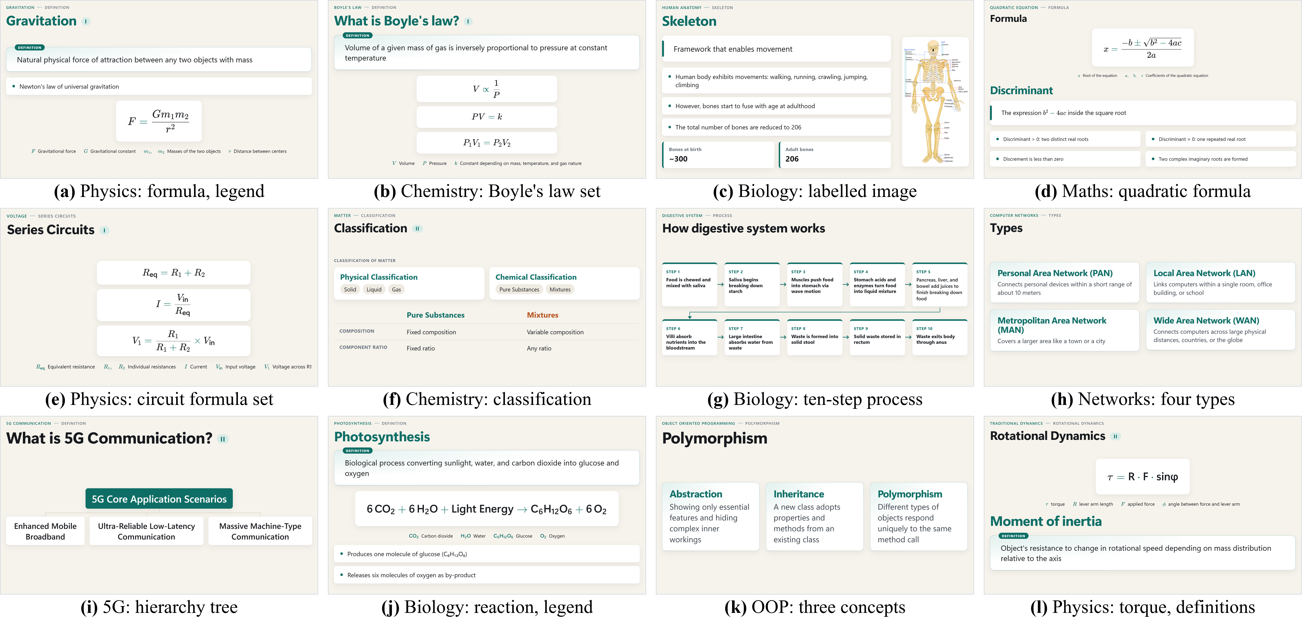
Fig. 4. Projected D1 slides; (c), (d), (f) are app screenshots, the others re-render recorded LLM answers. Text is as spoken (the slip "Discrement" in (d)).
C. Ablation of the Planner Rules
Table V replays the recorded signals and LLM answers of the 18 lectures through the planner with one rule changed (no new LLM calls; the unchanged replay reproduces the live decks). The continuity rule carries the result: if each concept opens a slide, the deck changes 3.2 times per minute, 200 slides are replaced within 10 s, and precision and P_{k} drop to 0.37 and 0.47. The dwell time delays a slide change rather than cancelling it, so changes per minute stay at 1.15, but slides replaced within 10 s fall from 25 to 16 without loss of accuracy; a dwell of up to 20 s leaves precision and recall unchanged, while 45 s lowers them to 0.67 and 0.32. The topic confirmation brought no measurable benefit on D2 (precision 0.79 without it); it remains as a safeguard. With the LLM's labels deciding directly but slides still only extended, boundaries are similar: stability comes from the extend-only operations.
TABLE V
Planner Ablation by Replay (18 Annotated D2 Lectures)
Planner variant | Precision ↑ | Recall ↑ | P_{k} ↓ | Changes per min | Replaced < 10 s ↓
Full planner (= live) | 0.78 | 0.42 | 0.32 | 1.15 | 16
No dwell time | 0.78 | 0.42 | 0.32 | 1.15 | 25
No topic confirmation | 0.79 | 0.45 | 0.31 | 1.12 | 10
LLM labels decide | 0.78 | 0.46 | 0.30 | 1.17 | 21
Each concept a slide | 0.37 | 0.86 | 0.47 | 3.18 | 200
Boundary scores as in Table IV; replaced < 10 s: slides replaced within 10 s of being shown.
D. Comparison With an LLM-Controlled Baseline
TABLE VI
Proposed System vs. LLM-Controlled Baseline (Same D2 Units)
Measure | Proposed | LLM baseline
Seen statements rewritten/removed ↓ | 2.0 % | 38.2 %
Seen statements lost from final deck ↓ | 6.2 % | 65.8 %
Lectures with fewer rewrites ↑ | 18 of 18 | 0 of 18
Boundary precision ↑ | 0.78 | 0.72
P_{k} ↓ | 0.32 | 0.36
Content slides per minute | 1.25 | 0.79
↑ / ↓: higher / lower is better. Rewritten: share of the statements of each replaced slide version that the next version changed or removed; lost: share of distinct shown statements absent from the final deck. Content slides per minute is not the changes per minute of Table V.
An LLM-controlled baseline without extend-only operations receives, for the same 850 units of the 18 annotated lectures, the slide it showed last and the last 60 s of transcript, and returns the slide to show, without planner, guards or composer (same two models, 0.5 M tokens). It placed slide changes about as well (Table VI; precision 0.72 vs. 0.78, p = 0.34) but rewrote or removed 1,439 of the 3,763 statements students had already seen (38.2 %), against 91 of 4,515 (2.0 %), and 65.8 % of what it showed was gone from its final deck, against 6.2 %. The difference holds in all 18 lectures: the mean per-lecture gap in rewrites is 39 points (95 % interval 32–47; exact paired sign-flip permutation test, p < 0.001). Of the proposed system's 91 changes, 24 extended a statement, 6 followed a correction the teacher accepted and 61 were composer merges. The comparison is between whole systems (the baseline also lacks the guards and composer); Table V isolates the planner rules.
E. End-to-End Latency
Over all 36 D2 lectures (Table III), planning and composing take 2 ms. From the end of a spoken line to its content on the display the median is 11.2 s, of which 7.6 s is the deliberate wait in the gate for a complete idea; the system is live, not hard real-time. In web4 and web6 the free provider failed (timeouts, HTTP 429), units queued, and the 95th percentile rose to 53.0 s; without these two lectures the median is 10.2 s and the 95th percentile 23.4 s.
V. Discussion and Conclusion
The Multimodal AI Teaching Copilot builds a continuity-aware deck from live speech with the LLM as a bounded interpreter; the planner's extend-only operations keep what students read stable (2.0 % vs. 38.2 % rewritten). Limitations: the annotators were authors (marking boundaries and facts before seeing the slides); recall is moderate by design; an append-only baseline prompt was not tested; the word error rate comes from the one lecture with human captions; the free provider caused outages; and without a classroom study no claim is made about learning. Anonymized annotations, ratings and evaluation scripts are available from the authors on request.
References
[1] R. E. Mayer, Multimedia Learning, 2nd ed. Cambridge, U.K.: Cambridge Univ. Press, 2009.
[2] J. Sweller, "Cognitive load during problem solving: Effects on learning," Cognitive Sci., vol. 12, no. 2, pp. 257–285, 1988.
[3] R. E. Mayer and R. Moreno, "Nine ways to reduce cognitive load in multimedia learning," Educ. Psychologist, vol. 38, no. 1, pp. 43–52, 2003.
[4] R. S. Kushalnagar, W. S. Lasecki, and J. P. Bigham, "Accessibility evaluation of classroom captions," ACM Trans. Accessible Comput., vol. 5, no. 3, Art. no. 7, 2014.
[5] T.-J. Fu, W. Y. Wang, D. McDuff, and Y. Song, "DOC2PPT: Automatic presentation slides generation from scientific documents," in Proc. AAAI Conf. Artif. Intell., vol. 36, no. 1, 2022, pp. 634–642.
[6] E. Sun, Y. Hou, D. Wang, Y. Zhang, and N. X. R. Wang, "D2S: Document-to-slide generation via query-based text summarization," in Proc. NAACL-HLT, 2021, pp. 1405–1418.
[7] Y. Hu and X. Wan, "PPSGen: Learning-based presentation slides generation for academic papers," IEEE Trans. Knowl. Data Eng., vol. 27, no. 4, pp. 1085–1097, Apr. 2015.
[8] E. Xie, G. Xiong, H. Yang, O. Coleman, M. Kennedy, and A. Zhang, "Leveraging grounded large language models to automate educational presentation generation," in Proc. Large Found. Models Educ. Assessment, PMLR, vol. 264, 2025, pp. 207–220.
[9] E. Xie, D. Waterfield, M. Kennedy, and A. Zhang, "SlideBot: A multi-agent framework for generating informative, reliable, multi-modal presentations," in Proc. AAAI Conf. Artif. Intell., vol. 40, no. 48, 2026, pp. 40907–40915.
[10] H. Zheng et al., "PPTAgent: Generating and evaluating presentations beyond text-to-slides," in Proc. EMNLP, 2025, pp. 14402–14418.
[11] J. Ge et al., "AutoPresent: Designing structured visuals from scratch," in Proc. IEEE/CVF CVPR, 2025, pp. 2902–2911.
[12] E. Kasneci et al., "ChatGPT for good? On opportunities and challenges of large language models for education," Learn. Individual Differences, vol. 103, Art. no. 102274, 2023.
[13] OpenAI, "gpt-oss-120b & gpt-oss-20b model card," arXiv:2508.10925, 2025.
[14] Z. Ji et al., "Survey of hallucination in natural language generation," ACM Comput. Surv., vol. 55, no. 12, Art. no. 248, 2023.
[15] R. A. Bartsch and K. M. Cobern, "Effectiveness of PowerPoint presentations in lectures," Comput. Educ., vol. 41, no. 1, pp. 77–86, 2003.
[16] A. Radford, J. W. Kim, T. Xu, G. Brockman, C. McLeavey, and I. Sutskever, "Robust speech recognition via large-scale weak supervision," in Proc. ICML, 2023, pp. 28492–28518.
[17] SYSTRAN, "faster-whisper: Faster Whisper transcription with CTranslate2," GitHub. [Online]. Available: https://github.com/SYSTRAN/faster-whisper
[18] Silero Team, "Silero VAD: Pre-trained enterprise-grade voice activity detector," GitHub, 2021. [Online]. Available: https://github.com/snakers4/silero-vad
[19] H. Gonzalez et al., "Automatically generated summaries of video lectures may enhance students' learning experience," in Proc. 18th Workshop BEA, 2023, pp. 382–393.
[20] M. A. Hearst, "TextTiling: Segmenting text into multi-paragraph subtopic passages," Comput. Linguistics, vol. 23, no. 1, pp. 33–64, 1997.
[21] N. Reimers and I. Gurevych, "Sentence-BERT: Sentence embeddings using Siamese BERT-networks," in Proc. EMNLP-IJCNLP, 2019, pp. 3982–3992.
[22] W. Wang, F. Wei, L. Dong, H. Bao, N. Yang, and M. Zhou, "MiniLM: Deep self-attention distillation for task-agnostic compression of pre-trained transformers," in Proc. NeurIPS, vol. 33, 2020, pp. 5776–5788.
[23] D. Beeferman, A. Berger, and J. Lafferty, "Statistical models for text segmentation," Mach. Learn., vol. 34, no. 1–3, pp. 177–210, 1999.
[24] B. T. Willard and R. Louf, "Efficient guided generation for large language models," arXiv:2307.09702, 2023.
[25] G. Kurdi, J. Leo, B. Parsia, U. Sattler, and S. Al-Emari, "A systematic review of automatic question generation for educational purposes," Int. J. Artif. Intell. Educ., vol. 30, no. 1, pp. 121–204, 2020.
[26] A. Yang et al., "Qwen3 technical report," arXiv:2505.09388, 2025.
[27] C.-Y. Lin, "ROUGE: A package for automatic evaluation of summaries," in Proc. ACL Workshop Text Summarization, 2004, pp. 74–81.
[28] A. Radford et al., "Learning transferable visual models from natural language supervision," in Proc. ICML, 2021, pp. 8748–8763.
[29] J. Cohen, "A coefficient of agreement for nominal scales," Educ. Psychol. Meas., vol. 20, no. 1, pp. 37–46, 1960.
[30] J. R. Landis and G. G. Koch, "The measurement of observer agreement for categorical data," Biometrics, vol. 33, no. 1, pp. 159–174, 1977.
[31] K. L. Gwet, "Computing inter-rater reliability and its variance in the presence of high agreement," Br. J. Math. Stat. Psychol., vol. 61, no. 1, pp. 29–48, 2008.
[32] P. E. Shrout and J. L. Fleiss, "Intraclass correlations: Uses in assessing rater reliability," Psychol. Bull., vol. 86, no. 2, pp. 420–428, 1979.
[33] A. R. Feinstein and D. V. Cicchetti, "High agreement but low kappa: I. The problems of two paradoxes," J. Clin. Epidemiol., vol. 43, no. 6, pp. 543–549, 1990.

