Multimodal AI Teaching Copilot: Live Slide Generation from Lecture Speech
Prachi Potdar, Paritosh Raut, Deepali Magdum, Swati Kale, and Sunita Patnaik
Department of Electronics and Telecommunication Engineering
JSPM's Rajarshi Shahu College of Engineering, Pune, Maharashtra, India – 411033
prachipotdar50@gmail.com, paritosh21raut@gmail.com, dipalimagdum@gmail.com, swatikale@gmail.com, sunitapatnaik@gmail.com

Abstract—Slides prepared before class cannot show what a teacher adds while explaining, live captions give only verbatim text, and a large language model (LLM) that regenerates slides from a growing transcript rewrites what students are reading. This paper presents a teaching copilot that builds a structured, continuity-aware slide deck on the classroom projector from the teacher's live speech. Locally transcribed speech is sent in bounded units to an LLM that only returns a schema-validated interpretation; a deterministic planner turns it into slide operations that extend, continue or open a slide but never rewrite what students have read, and transcript-coverage guards keep taught facts on screen. On 36 held-out lectures (409 min; six speakers and six public MIT OCW and NPTEL lectures) on a laptop with a 4 GB GPU, the median speech-to-slide delay was 11.2 s. On an annotated subset of 18 lectures, slide changes matched topic boundaries with precision 0.78, 86.6 % of key facts reached a slide, 0.9 % of statements were unsupported by the speech, and five teachers rated the slides 3.9–4.2 of 5. A replay ablation showed that opening a slide per concept lowers precision to 0.37 and nearly triples slide changes; against an LLM-controlled baseline, rewrites of shown statements fell from 56 % to 3 %.
Index Terms—Automatic slide generation, educational technology, large language models, live systems, speech recognition, human-in-the-loop
I. Introduction
Slides prepared before a lecture fix its order in advance, so the examples and answers a teacher adds while explaining never reach the screen. Learners understand better from words with organized pictures than from words alone [1], if the visuals add no extraneous load [2], [3], but no teacher can author such visuals while teaching.
Existing tools solve only parts of this problem: live captions show verbatim text without the structure of the lesson [4]; slide generators work offline from a finished document or prompt [5]–[11]; and a large language model (LLM) [12], [13] applied to a growing transcript rewrites slides while students read them and adds untaught content [14]. Three problems remain open: (P1) projected material does not follow what is taught; (P2) live speech is not turned into a structured visual lesson; and (P3) LLM output is neither stable nor faithful to the teacher's words.
This paper presents the Multimodal AI Teaching Copilot, an implemented system that addresses all three: spoken input becomes visual output (typed layouts, typeset formulas, diagrams and retrieved images) on the projector while the teacher speaks. The contributions are: (1) incremental slide generation from live speech; (2) a constrained update policy in which the LLM only labels bounded, schema-validated units and a deterministic planner turns the labels into slide operations that never rewrite what students have read; (3) transcript-coverage and formula guards; and (4) a held-out evaluation with annotation, teacher ratings, a replay ablation and an LLM-controlled baseline.
II. Related Work
A. Multimedia Learning and Slide Design
Mayer showed that words with pictures are understood better than words alone [1]; Sweller's cognitive load theory adds that working memory is limited [2], [3], and unrelated pictures lowered performance in PowerPoint lectures [15]; hence short typed layouts and an image only for a concrete taught object.
B. Lecture Speech Recognition and Captioning
Whisper by Radford et al. [16], run with 8-bit weights by faster-whisper [17], and Silero VAD [18] form the speech front end. Kushalnagar et al. showed that verbatim real-time captions are hard for students to follow [4], and Gonzalez et al. found that LLM summaries of recorded lectures improved quiz scores [19]; both produce text, not a structured visual lesson (P2).
C. Topic Segmentation and Semantic Similarity
TextTiling by Hearst places subtopic boundaries where the similarity of adjacent blocks drops [20]; Sentence-BERT by Reimers and Gurevych compares sentence embeddings by cosine similarity [21], and Wang et al. distilled it into MiniLM [22]. These methods segment a complete transcript offline; here the similarity drop is one online signal, evaluated with the measure of Beeferman et al. [23].
D. Automatic Slide Generation
PPSGen selects sentences of a paper for slides by integer linear programming [7], D2S summarizes document text for each slide title [6], and DOC2PPT generates slides with text and figures from scientific documents [5]. With LLMs, Xie et al. ground educational slides in retrieved sources [8], SlideBot adds multi-agent planning [9], PPTAgent edits reference slides [10], and AutoPresent writes slides as code [11]. All build a whole deck offline from written input; a lecture arrives incrementally as noisy speech (P1, P3).
E. LLMs in Education and Faithful Generation
Kasneci et al. stressed teacher oversight of LLMs in education [12], so the teacher overrides every automatic decision. Ji et al. surveyed hallucination [14], and Willard and Louf constrained generation to a JSON schema [24], which fixes the format but not the facts, so the output is also checked against the transcript; generated quizzes follow the review of Kurdi et al. [25].
Table I compares the systems on five properties that decide whether slides are usable in a live classroom: among the systems reviewed, none combines streaming speech input with incremental decisions about which slide to change while students read. This combination is the gap addressed here.
TABLE I
Comparison of the Proposed System With Prior Systems
System | Input | Produced | Topic structure | Faithfulness to source | Slide sequence
Live captions [4], [16] | Speech | Live | None (text stream) | Verbatim text | None
Lecture summaries [19] | Recorded lecture | Offline | None (summary) | LLM summary | None
PPSGen, D2S, DOC2PPT [5]–[7] | Paper / document | Offline | Document sections | Extracted from document | Whole deck at once
LLM slide generators [8]–[11] | Topic / document / prompt | Offline | LLM outline / planning | Retrieved sources [8], [9] or none | Whole deck at once
Proposed system | Live speech | During lecture | Online, confirmed topic / subtopic | Transcript coverage and formula guards | Deterministic planner + teacher
III. Methodology
A. System Overview
A lecture is processed as a stream through six stages (Fig. 1): speech capture and recognition; filtering and concept tracking; a gate that groups finished sentences into units; bounded LLM interpretation of each unit; a deterministic planner and composer that turn it into slide operations and layouts; and delivery to the projector, the teacher and students. Four rules guide the design: the LLM supplies labels but never executes a slide operation, it never sees the whole transcript, a new concept is not by itself a new slide, and user interfaces send commands instead of changing the state.
All components run in one Python asyncio process and exchange typed events on an in-process bus; one store owns the lecture state, and every event is logged in SQLite, from which each lecture is replayed for evaluation and materials. Recognition runs on the GPU, MiniLM and CLIP on the CPU (ONNX), and the LLM on the Groq free tier (openai/gpt-oss-120b [13]; qwen/qwen3.8-27b when that quota is spent; Oct. 2026), as a 7B-class local model does not fit beside the speech model in 4 GB. Of the 1,619 held-out units, 71.6 % were interpreted by the first model, 24.0 % by the second and 4.4 % by the deterministic fallback.
B. Speech Capture and Concept Tracking
Silero VAD [18] segments 16 kHz audio (utterances up to 15 s), and faster-whisper [17] with Whisper medium.en [16] (int8, beam size 1, keyword prompt) transcribes them. A deterministic filter removes classroom management, meta talk and fillers. Each content utterance is embedded with MiniLM [22]; with the L2-normalized embedding eₜ and concept centroid cₜ₋₁, the shift score is the cosine distance used with Sentence-BERT [21], and the centroid an exponentially weighted mean:
$s_{t}=1−e_{t}^{⊤}c_{t−1}$ (1)
$c_{t}=norm\left((1−α_{t})c_{t−1}+α_{t}e_{t}\right)$ (2)
where norm(x) = x/‖x‖ and α = 0.35, raised to 0.6 at a boundary so the centroid re-seeds on the new concept. Following the similarity-drop criterion of TextTiling [20], a boundary is signalled when
$b_{t}=κ_{t}∨\left(s_{t} ≥ τ\right),τ=0.75$ (3)
where κₜ marks a cue phrase ("moving on to", "next"); τ is high because shift scores within one facet were 0.3–0.6.
C. Gate and Token Budget
Content accumulates in a buffer until a rule-based gate fires. With pₜ the silence after a finished sentence, wₜ the buffered words and aₜ the age of the oldest pending line (s),
$G_{t}=(p_{t}≥1.2∧w_{t}≥6)∨w_{t}≥40∨b_{t}∨a_{t}≥12$ (4)
with an 8 s floor between calls, set by the free quota (200,000 tokens per key and model per day).
D. Bounded Interpretation and Transcript-Grounding Safeguards
The prompt holds the subject, level, an outline (≤ 150 tokens), the current slide with numbered items, a rolling summary (≤ 120 tokens) and the new lines, within 3,000 tokens (temperature 0.2). The LLM returns JSON with topic, subtopic, a relation (same concept, elaboration, sub-concept, sibling, new topic, digression), typed content, an image hint and concerns about possibly wrong statements. Pydantic validates it; after one failed repair, a deterministic fallback shows the spoken sentences as points. A coverage guard compares every content sentence u (≥ 6 words) with the output O; with W(·) the set of word stems and a recall-style overlap as in ROUGE-1 [26],
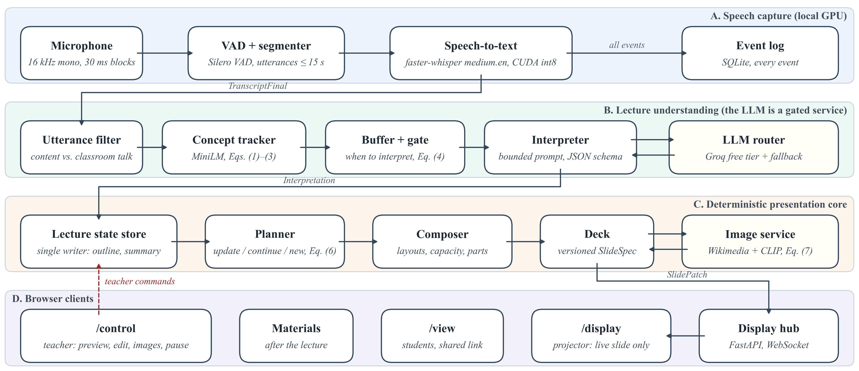
Fig. 1. Implemented architecture. Lanes A–C run in one Python process; the LLM is called only by the interpreter through the router. Browser clients receive versioned slide patches and send teacher commands back; the user interface never changes the core state directly.
$\left|W(u)∩W(O)\right|≤\frac{1}{3}\left|W(u)\right|⇒u\text{ is shown as said}$ (5)
so a fact the model left out still reaches the slide. A formula guard flags changed formula tokens, and a correction is applied only above a confidence of 0.75 (factual) or 0.4 (mis-hearing); otherwise the slide shows what was said and the teacher gets a card with both versions. These checks keep slides faithful to the transcript; they do not prove a statement correct. The router rotates free keys under token buckets with a 15 s deadline per unit.
E. Slide Planner
The planner turns each interpretation into one operation: update the working slide, continue on a new slide of the same topic, open a new topic slide, retitle, or nothing (Fig. 2); a shown item is never rewritten by the LLM. A topic change must be confirmed, because a single unit may be misread:
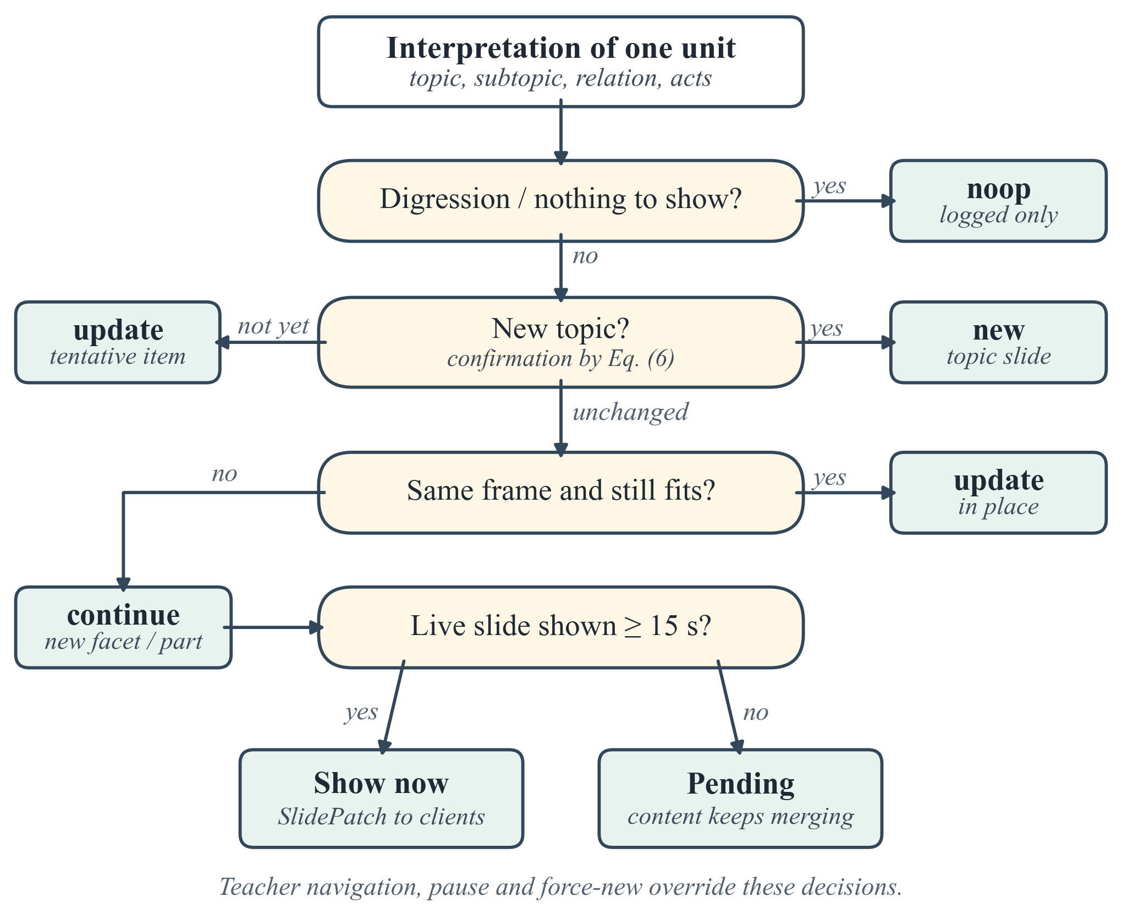
Fig. 2. Planner decision for one interpreted unit. The LLM supplies the relation and content; the decision itself is rule-based and unit-tested.
$C_{n}=B_{n}∨\left({\overline{s}}_{n}^{max} ≥ τ\right)∨\left(T_{n} ≡ {\overset{\sim }{T}}_{n−1}\right)$ (6)
where B_{n} is true if a boundary (3) occurred in unit n, s̄_{n}^{max} is its largest shift score smoothed over two utterances, T_{n} its topic and T̃_{n−1} an unconfirmed candidate from the previous unit. Unconfirmed content is shown tentatively and moved once confirmed. A minimum dwell of 15 s (6 s for the next part of a full slide) prevents rapid changes, near-duplicates (similarity ≥ 0.85) are merged, and teacher edits are never overwritten. All thresholds were set by hand on D1 and are tested by ablation in Section IV.
F. Composer and Image Retrieval
The composer maps items to definition cards, key points, fact tiles, process flows, comparison tables, timelines, cause-effect chains, classification trees and formulas; overflow moves to a further part (I, II, …) instead of shrinking text, and spoken mathematics is typeset with KaTeX. For a concrete object the LLM suggests a query q; openly licensed files from Wikipedia and Wikimedia Commons (source, author and licence kept) are scored by CLIP's zero-shot image–text similarity σ [27], and image I is accepted when
$σ(q,I)≥0.22∧σ(q,I)−\max_{d∈D}σ(d,I)≥0.01$ (7)
where D holds generic distractor prompts ("a logo", "a map"), and an image is placed only if its query matches the slide text (MiniLM similarity ≥ 0.25).
G. Live Display and Teacher Control
A FastAPI server pushes versioned slide patches over WebSocket to /display (projector), /control (teacher) and /view (students, shared link). The control view (Fig. 3) adds editing, image search and upload, pause, blank screen, mistake cards, the running transcript and the lecture structure tree.
H. Lecture Materials
After the lecture the event log is reused: on request it becomes study notes, an assignment, a PPTX deck, or a live quiz or test answered through the shared link, all from the taught content and edited by the teacher; the teacher's own notes can be indexed locally to spell terms. These features are not evaluated here.
IV. Experimental Evaluation
A. Setup and Data
All runs used a laptop with an RTX 3050 GPU (4 GB) and 16 GB RAM. All thresholds were set on D1, six lectures spoken by the authors (114.1 min). The held-out set D2 (Table II) has 30 lectures spoken live, unscripted, by six speakers into the laptop microphone (Recorded, physics to economics) and six 10-min public MIT OpenCourseWare (CC BY-NC-SA) and NPTEL (CC BY-SA) lectures played in as audio in real time (Public). The speakers consented to the recording. Of the 1,619 units, 72 (4.4 %) fell back because a quota was spent or the provider failed, and still produced slides. Slides were not edited during a test; only two items were deleted in all of D2. Three populations are evaluated: all 36 lectures for latency and operation, an annotated subset of 18 (12 Recorded, 6 Public; 191 min) for accuracy and the ablation, and 30 sampled slides for teacher ratings.
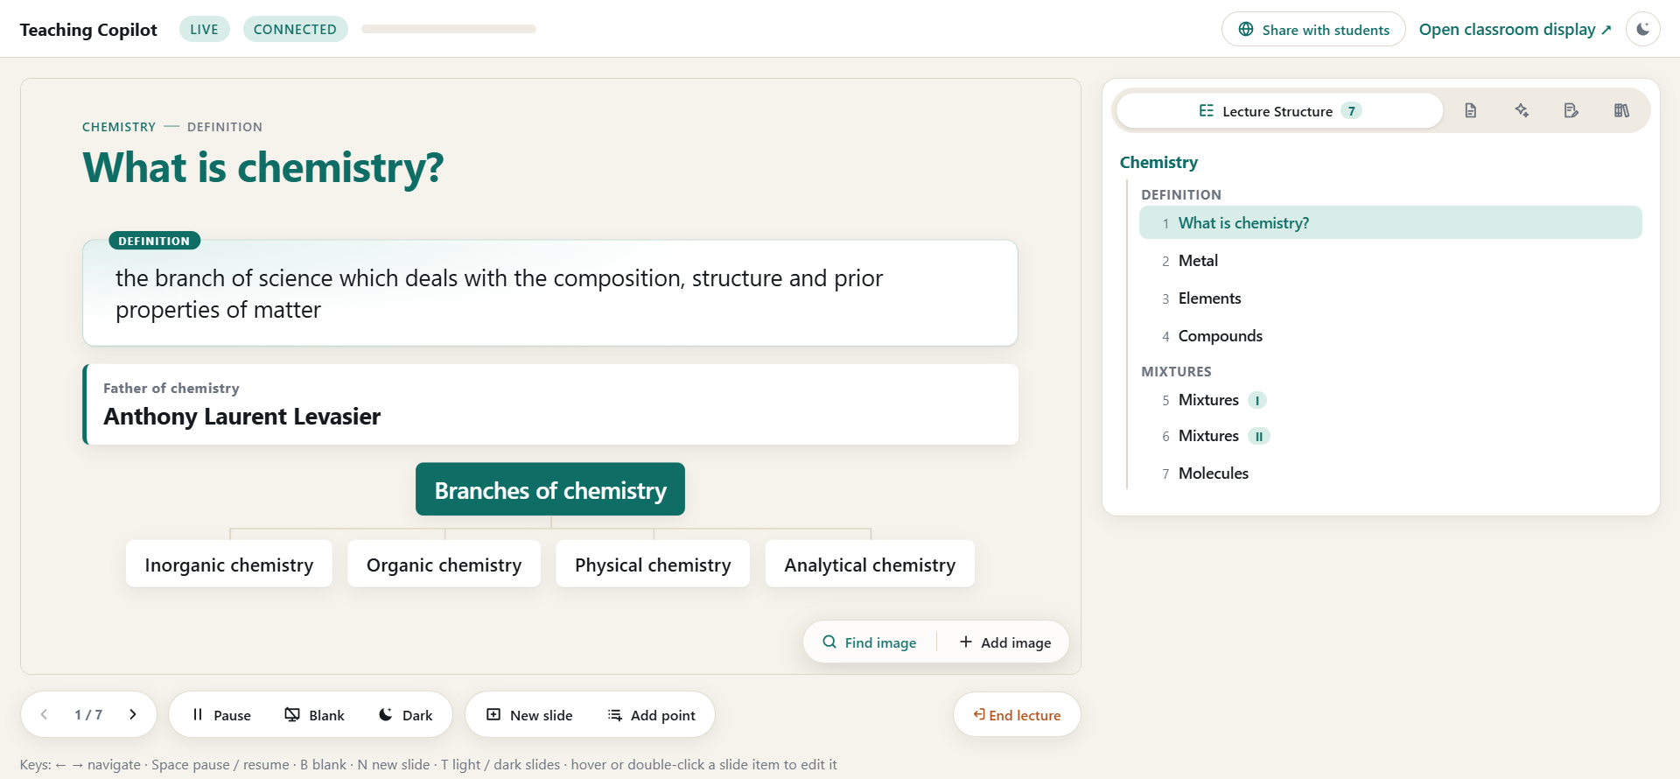
Fig. 3. Teacher control view (/control) in a live chemistry lecture: the projected slide as an editable preview with image tools and lecture controls (left) and the lecture structure tree built by the system, topic → facet → slides, with overflow parts I and II (right).
TABLE II
Evaluation Data and Latency (Session Logs)
Set | Lect. | Min | Units (fb) | Slides | STT | LLM | E2E (p95)
D1 | 6 | 114.1 | 389 (45) | 163 | 0.66 | 1.35 | 12.5 (36.8)
D2 Recorded | 30 | 349.2 | 1275 (59) | 453 | 0.71 | 1.92 | 10.1 (23.2)
D2 Public | 6 | 60.0 | 344 (13) | 52 | 0.60 | 2.23 | 17.1 (93.4)
D2 all | 36 | 409.2 | 1619 (72) | 505 | 0.68 | 1.96 | 11.2 (53.0)
fb: fallback units; STT, LLM: median per utterance / call (s); E2E: median (95th percentile) from the end of a spoken line to its display (s); Public includes web4, web6 (provider outages).
Annotation. Two authors (A and B) independently annotated the 18 lectures, chosen to mix subjects and speakers with 6–17 min each. Before seeing the slides, each marked topic boundaries (where a teacher would start a new board) and key facts in the transcript, then judged whether each key fact was on a slide and whether each slide statement was said and correct; scores are the mean of A and B, without adjudication. A system boundary is the utterance that opened a new content slide. Boundaries are scored by precision, recall and F1 within ±1 utterance, averaged per lecture, and by P_{k} [23], the probability that two utterances half a segment apart are wrongly split or joined; agreement is Cohen's κ [28] on the scale of Landis and Koch [29] and, for skewed labels, Gwet's AC1 [30]. Intervals are 95 % bootstrap intervals over lectures. Ratings. Five teachers (T1–T5), not involved in development, rated 30 random D2 slides, each shown with what was said, from 1 to 5 on four criteria; their consistency is the ICC(2,1) of Shrout and Fleiss [31].
B. Topic Boundaries and Content Accuracy
Slides change where the topic changes (Table III): boundary precision is 0.78 (95 % interval 0.68–0.88), so a projected slide is rarely replaced within a topic, and P_{k} is 0.32. Recall is 0.42 (0.30–0.55): a new concept is not a new slide, so the planner merges into the live slide sub-points that annotators marked as boundaries, most often in the Public lectures (recall 0.19). The ablation below shows that this is a trade-off, not a limit: opening a slide per concept raises recall to 0.86 but precision falls to 0.37. Of 669 key facts, 86.6 % (84.6–88.5 %) reached a slide (partly shown counts ½), and only 0.9 % (0.2–1.8 %) of 2,504 statement judgments were not supported by the speech. Of the 3.7 % marked wrong, 41 of 79 were also marked as said (a slip or mis-hearing): slides follow the speech, and corrections go to the teacher's concern cards; transcript support is therefore not factual correctness. Boundary agreement is substantial (κ = 0.72 [29]). For "supported" the annotators agreed on 88.8 % and AC1 is 0.88, whereas κ is only 0.07 because nearly all statements were supported, which pushes chance agreement toward 1 (the prevalence paradox [32]).
TABLE III
Annotated Accuracy and Teacher Ratings (18 D2 Lectures)
Measure | Recorded | Public | All
Boundary precision / recall | 0.81 / 0.54 | 0.73 / 0.19 | 0.78 / 0.42
Boundary F1 / P_{k} | 0.59 / 0.29 | 0.29 / 0.37 | 0.49 / 0.32
Key-fact coverage | 88.0 % | 84.0 % | 86.6 %
Unsupported / wrong | 0.9 / 3.6 % | 0.9 / 4.0 % | 0.9 / 3.7 %
κ boundaries (agreement) | 0.81 (94 %) | 0.56 (90 %) | 0.72 (92 %)
AC1 supported (agreement) | 0.89 (90 %) | 0.84 (85 %) | 0.88 (89 %)
Rating: correct. / relevance | 4.20 / 3.94 | 4.06 / 3.80 | 4.15 / 3.89
Rating: readab. / usefulness | 4.12 / 3.93 | 4.26 / 3.76 | 4.17 / 3.87
Means over annotators A and B (669 key facts, 2,504 statement judgments); boundaries ±1 utterance; unsupported / wrong: share of slide statements; ratings: mean of T1–T5 (1–5; 20 Recorded, 10 Public slides).
Test29, interpreted entirely by the fallback (quota spent), covered 83.1 % of key facts with 0.7 % unsupported statements but rarely opened a slide (recall 0.04): the fallback preserves content, the LLM adds the structure. The 17 LLM lectures reach precision 0.77 and recall 0.45. The teachers rated the slides 3.87–4.17 of 5 (ICC(2,1) 0.45–0.56, moderate). In Fig. 4 the layout follows the kind of content, not the subject.
C. Ablation of the Planner Rules
The recorded concept signals and LLM answers of the 18 annotated lectures were replayed on their recorded clock, without new LLM calls, through the planner with one rule changed (Table IV). The unchanged replay reproduces the live decks exactly; a variant approximates its live behaviour.
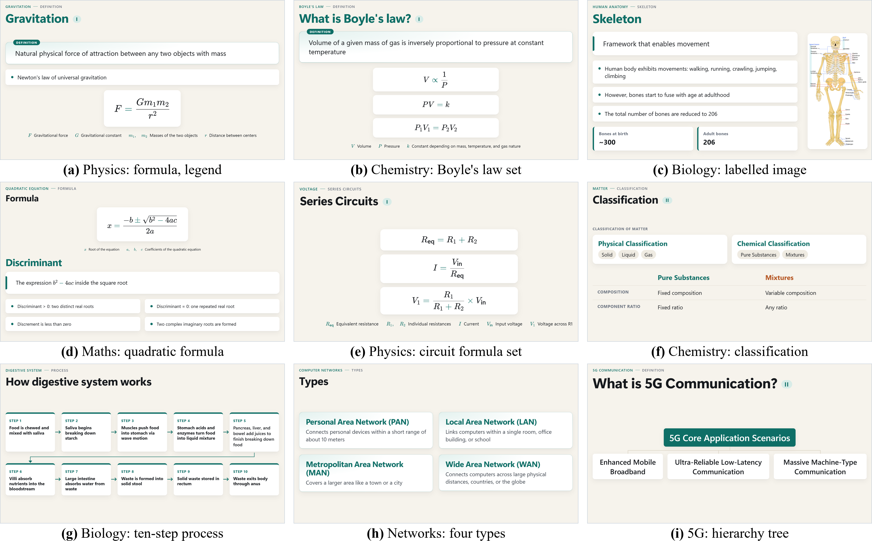
Fig. 4. Projected slides from the D1 lectures. (c), (d) and (f) are screenshots of the running application; the others are recorded LLM interpretations re-rendered by the current display engine without new LLM calls. Slide text is as spoken, including the slip "Discrement" in (d).
TABLE IV
Planner Ablation by Replay (18 Annotated D2 Lectures)
Variant | P | R | P_{k} | Chg./min | < 10 s
Full planner (= live) | 0.78 | 0.42 | 0.32 | 1.15 | 16
Without dwell time | 0.78 | 0.42 | 0.32 | 1.15 | 25
Without topic confirmation | 0.79 | 0.45 | 0.31 | 1.12 | 10
LLM labels decide directly | 0.78 | 0.46 | 0.30 | 1.17 | 21
Each concept a new slide | 0.37 | 0.86 | 0.47 | 3.18 | 200
P, R: boundary precision, recall (mean of A and B); Chg./min: slide changes per minute; < 10 s: slides replaced within 10 s of being shown.
The continuity rule carries the result: if each concept opens a slide, the deck changes 3.2 times per minute, 200 slides are replaced within 10 s, and precision and P_{k} drop to 0.37 and 0.47. The dwell time removes 36 % of these short-lived slides (25 to 16) without loss of accuracy; a dwell of up to 20 s leaves precision and recall unchanged, while 45 s lowers them to 0.67 and 0.32. The topic confirmation brought no measurable benefit on D2 (precision 0.79 without it); it remains as a safeguard. When the LLM's labels decide directly but slides are still only extended, the boundaries are similar: the stability comes from the extend-not-rewrite operations, not from the label source.
D. Comparison With an LLM-Controlled Baseline
The ablation keeps the extend-only operations. Without them, an LLM-controlled baseline gets, for the same units of two D1 lectures, its last slide and the last 60 s of transcript and returns the slide to show, without planner, guards or composer (Table V; a development-set comparison). In chemistry it rewrote or removed 56 % of the statements students had already seen and lost 75 % from its final deck. The proposed system appends to the live slide, rewriting 3 % (mostly mis-hearing fixes) and losing 4 %; in biology the baseline rewrote 30 % and lost 49 %, against none. In D1, 33 of 63 image searches found an accepted image; on a 30-concept labelled set the first image was relevant for all 28 that received one.
TABLE V
Proposed System vs. LLM-Controlled Baseline (Same D1 Units)
Lecture / system | Slides | Rewritten | Missing
Chemistry: proposed | 36 | 8 / 317 (3 %) | 5 / 136 (4 %)
Chemistry: baseline | 15 | 226 / 405 (56 %) | 220 / 293 (75 %)
Biology: proposed | 11 | 0 / 74 (0 %) | 0 / 39 (0 %)
Biology: baseline | 13 | 48 / 160 (30 %) | 44 / 90 (49 %)
Rewritten: statements of a shown slide that its next version rewrote or removed; missing: distinct statements shown but absent from the final deck.
E. End-to-End Latency
The models are fast (Fig. 5, Table II): over all 36 D2 lectures, speech-to-text takes a median of 0.68 s, an LLM call 1.96 s, and planning and composing 2 ms. From the end of a spoken line to its content on the display the median is 11.2 s, of which 7.6 s is the deliberate wait in the gate for a complete idea; the system is live, not hard real-time. In web4 and web6 the free provider failed (timeouts, HTTP 429), units queued, and the 95th percentile rose to 53.0 s; without these two lectures the median is 10.2 s and the 95th percentile 23.4 s.
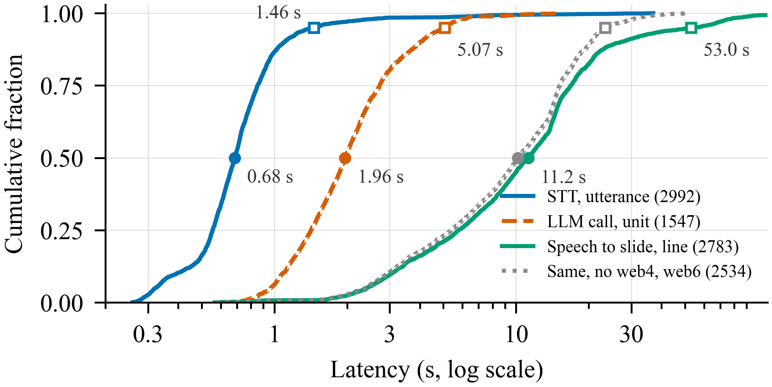
Fig. 5. Latency over D2 (log scale) per utterance, LLM call and spoken line; dotted: without the two lectures with provider outages. Filled: medians; open: 95th percentiles.
V. Discussion
If the LLM only labels bounded units and explicit operations extend the deck, a stable, faithful deck is built from live speech on modest hardware at a median delay of about 11 s. Limitations: the annotators were authors, although they marked boundaries and facts before seeing the slides; boundary recall is moderate by design; the baseline was run on D1 only; the free-tier provider caused outages; and without a classroom study no claim is made about learning outcomes. Anonymized annotations, ratings and evaluation scripts are available from the authors on request.
VI. Conclusion
The Multimodal AI Teaching Copilot builds a continuity-aware slide deck from live speech, with the LLM as a bounded interpreter and a deterministic planner in charge. On held-out lectures its slides changed at topic boundaries with precision 0.78 and kept 86.6 % of key facts with 0.9 % unsupported statements; the extend-not-rewrite policy cuts slide changes by about two thirds against a slide per concept and cuts rewrites of shown statements from 56 % to 3 % against an LLM in control.
References
[1] R. E. Mayer, Multimedia Learning, 2nd ed. Cambridge, U.K.: Cambridge Univ. Press, 2009.
[2] J. Sweller, "Cognitive load during problem solving: Effects on learning," Cognitive Sci., vol. 12, no. 2, pp. 257–285, 1988.
[3] R. E. Mayer and R. Moreno, "Nine ways to reduce cognitive load in multimedia learning," Educ. Psychologist, vol. 38, no. 1, pp. 43–52, 2003.
[4] R. S. Kushalnagar, W. S. Lasecki, and J. P. Bigham, "Accessibility evaluation of classroom captions," ACM Trans. Accessible Comput., vol. 5, no. 3, Art. no. 7, 2014.
[5] T.-J. Fu, W. Y. Wang, D. McDuff, and Y. Song, "DOC2PPT: Automatic presentation slides generation from scientific documents," in Proc. AAAI Conf. Artif. Intell., vol. 36, no. 1, 2022, pp. 634–642.
[6] E. Sun, Y. Hou, D. Wang, Y. Zhang, and N. X. R. Wang, "D2S: Document-to-slide generation via query-based text summarization," in Proc. NAACL-HLT, 2021, pp. 1405–1418.
[7] Y. Hu and X. Wan, "PPSGen: Learning-based presentation slides generation for academic papers," IEEE Trans. Knowl. Data Eng., vol. 27, no. 4, pp. 1085–1097, Apr. 2015.
[8] E. Xie, G. Xiong, H. Yang, O. Coleman, M. Kennedy, and A. Zhang, "Leveraging grounded large language models to automate educational presentation generation," in Proc. Large Found. Models Educ. Assessment, PMLR, vol. 264, 2025, pp. 207–220.
[9] E. Xie, D. Waterfield, M. Kennedy, and A. Zhang, "SlideBot: A multi-agent framework for generating informative, reliable, multi-modal presentations," in Proc. AAAI Conf. Artif. Intell., vol. 40, no. 48, 2026, pp. 40907–40915.
[10] H. Zheng et al., "PPTAgent: Generating and evaluating presentations beyond text-to-slides," in Proc. EMNLP, 2025, pp. 14402–14418.
[11] J. Ge et al., "AutoPresent: Designing structured visuals from scratch," in Proc. IEEE/CVF CVPR, 2025, pp. 2902–2911.
[12] E. Kasneci et al., "ChatGPT for good? On opportunities and challenges of large language models for education," Learn. Individual Differences, vol. 103, Art. no. 102274, 2023.
[13] OpenAI, "gpt-oss-120b & gpt-oss-20b model card," arXiv:2508.10925, 2025.
[14] Z. Ji et al., "Survey of hallucination in natural language generation," ACM Comput. Surv., vol. 55, no. 12, Art. no. 248, 2023.
[15] R. A. Bartsch and K. M. Cobern, "Effectiveness of PowerPoint presentations in lectures," Comput. Educ., vol. 41, no. 1, pp. 77–86, 2003.
[16] A. Radford, J. W. Kim, T. Xu, G. Brockman, C. McLeavey, and I. Sutskever, "Robust speech recognition via large-scale weak supervision," in Proc. ICML, 2023, pp. 28492–28518.
[17] SYSTRAN, "faster-whisper: Faster Whisper transcription with CTranslate2," GitHub. [Online]. Available: https://github.com/SYSTRAN/faster-whisper
[18] Silero Team, "Silero VAD: Pre-trained enterprise-grade voice activity detector," GitHub, 2021. [Online]. Available: https://github.com/snakers4/silero-vad
[19] H. Gonzalez et al., "Automatically generated summaries of video lectures may enhance students' learning experience," in Proc. 18th Workshop BEA, 2023, pp. 382–393.
[20] M. A. Hearst, "TextTiling: Segmenting text into multi-paragraph subtopic passages," Comput. Linguistics, vol. 23, no. 1, pp. 33–64, 1997.
[21] N. Reimers and I. Gurevych, "Sentence-BERT: Sentence embeddings using Siamese BERT-networks," in Proc. EMNLP-IJCNLP, 2019, pp. 3982–3992.
[22] W. Wang, F. Wei, L. Dong, H. Bao, N. Yang, and M. Zhou, "MiniLM: Deep self-attention distillation for task-agnostic compression of pre-trained transformers," in Proc. NeurIPS, vol. 33, 2020, pp. 5776–5788.
[23] D. Beeferman, A. Berger, and J. Lafferty, "Statistical models for text segmentation," Mach. Learn., vol. 34, no. 1–3, pp. 177–210, 1999.
[24] B. T. Willard and R. Louf, "Efficient guided generation for large language models," arXiv:2307.09702, 2023.
[25] G. Kurdi, J. Leo, B. Parsia, U. Sattler, and S. Al-Emari, "A systematic review of automatic question generation for educational purposes," Int. J. Artif. Intell. Educ., vol. 30, no. 1, pp. 121–204, 2020.
[26] C.-Y. Lin, "ROUGE: A package for automatic evaluation of summaries," in Proc. ACL Workshop Text Summarization, 2004, pp. 74–81.
[27] A. Radford et al., "Learning transferable visual models from natural language supervision," in Proc. ICML, 2021, pp. 8748–8763.
[28] J. Cohen, "A coefficient of agreement for nominal scales," Educ. Psychol. Meas., vol. 20, no. 1, pp. 37–46, 1960.
[29] J. R. Landis and G. G. Koch, "The measurement of observer agreement for categorical data," Biometrics, vol. 33, no. 1, pp. 159–174, 1977.
[30] K. L. Gwet, "Computing inter-rater reliability and its variance in the presence of high agreement," Br. J. Math. Stat. Psychol., vol. 61, no. 1, pp. 29–48, 2008.
[31] P. E. Shrout and J. L. Fleiss, "Intraclass correlations: Uses in assessing rater reliability," Psychol. Bull., vol. 86, no. 2, pp. 420–428, 1979.
[32] A. R. Feinstein and D. V. Cicchetti, "High agreement but low kappa: I. The problems of two paradoxes," J. Clin. Epidemiol., vol. 43, no. 6, pp. 543–549, 1990.

