**ASSIGNMENT 1**

**NAME : Paritosh Upadhyay**

**PRN NO. : 202201040213**

**ROLL NO : 378**

**DIV : C-4**

**INPUT**

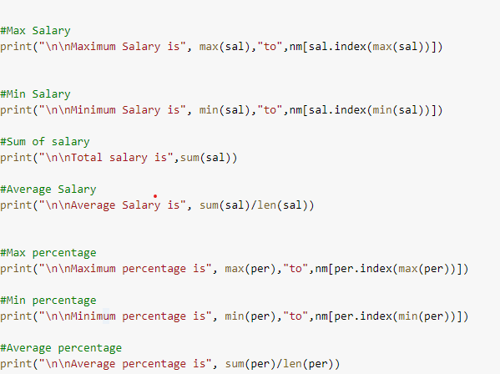

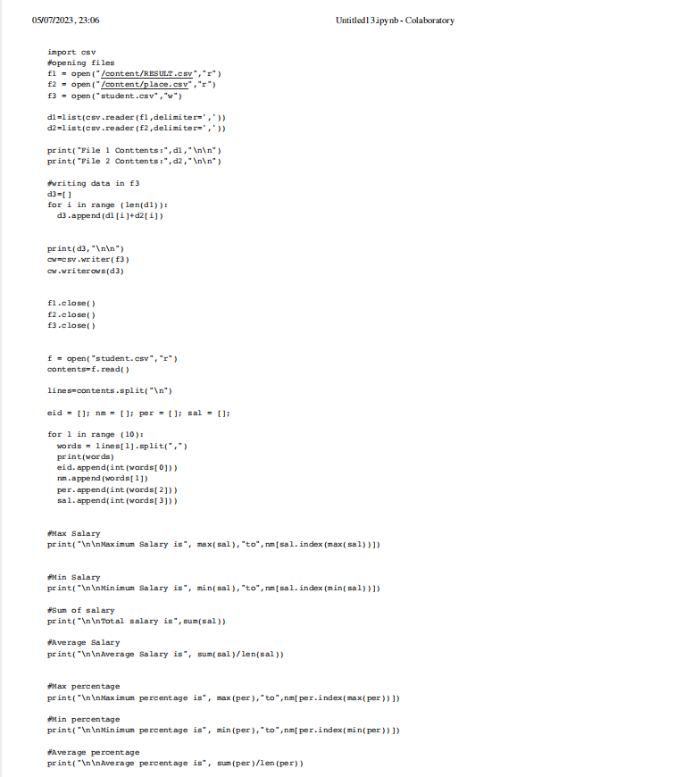

**OUTPUT**

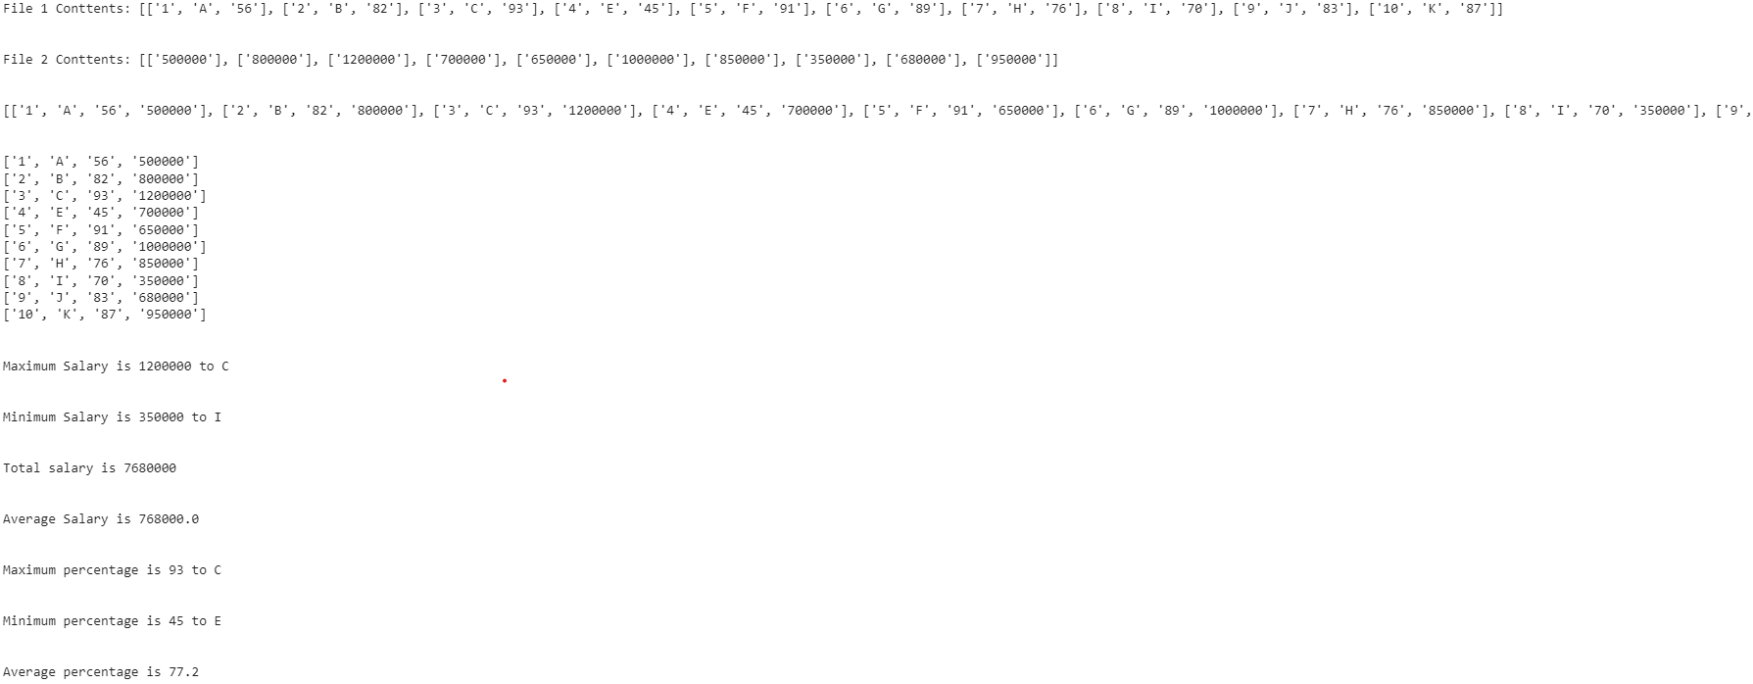

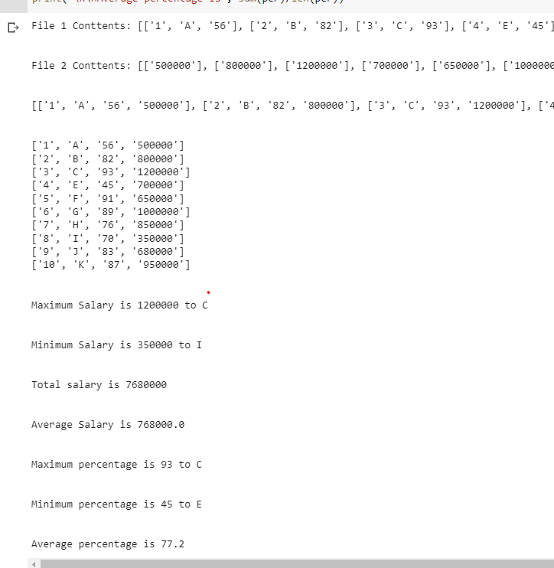

**Pdf link of program :**

<https://drive.google.com/file/d/1Q821oRTN_zJB34_HkA9YRKTcIFDekLFR/view?usp=share_link>

**Links for Files :**

1. **<https://drive.google.com/file/d/1uJdu1HRgRXwf0uFz-BlboEdA9UteJuXY/view?usp=share_link>**
2. **<https://drive.google.com/file/d/14bE1gAo_7mDCCTYBP2nsHXW-SIY0u57s/view?usp=share_link>**

**Link for colab**

**https://colab.research.google.com/drive/1c6vtxR8a6JZ79Cnis1lJD8oT0OIl74kf?authuser=2**