UXVR(Article)

Paritosh Khanwe CSE(DS)

Roll No:72

**VR in Gaming:**

The gaming industry is changing as a result of the revolutionary technology known as virtual reality (VR). It has gone beyond the limitations of conventional gaming and provides gamers with a wholly new level of immersion. We shall examine the development, advantages, difficulties, and potential uses of VR in gaming in this post**.**

**Introduction**

NLP offers potent tools for textual data analysis, comprehension, and response in the quickly developing field of cyber security. By utilizing the capabilities of NLP techniques like Named Entity Recognition, Sentiment Analysis, and Part-of-Speech Tagging, security professionals can gather insightful information, identify security vulnerabilities, and improve their overall cyber security posture. Organizations can improve their overall cyber security posture by utilizing the richness of knowledge found in unstructured data by utilizing NLP.

**Methodology**

The methodology portion of your study should include a description of the methods you utilized to gather and evaluate your data, as well as any ethical issues that came into play. Here is an illustration of how the methods part of a study on VR gaming may be organized:

1. Research Design :

In order to develop a thorough grasp of the subject, an exploratory study approach was adopted due to the rapidly evolving nature of VR technology in gaming.

2. Data Gathering Techniques

* Literature assessment: To lay a foundation of understanding and pinpoint trends, a thorough assessment of academic articles, and web resources linked to VR in gaming was carried out.
* Surveys: To compile information from gamers and VR aficionados, an online survey was developed. The purpose of the poll was to gather data on gamers VR experiences.
* Interviews: substantial interviews with business professionals, VR game creators, and players with substantial VR gaming experience were undertaken.

3. Survey Layout

Questionnaire: To allow respondents to offer qualitative insights, the survey's questionnaire mixed closed-ended questions with specified response alternatives with open-ended questions.

Pilot Testing: To detect any concerns with clarity, the survey underwent a pilot test with a small number of participants.

UXVR(Article)

Paritosh Khanwe CSE(DS)

Roll No:72

4. Analysis of Data

Quantitative Data Analysis: To provide descriptive statistics like frequencies, percentages, and mean scores, data from the surveys were examined using statistical software.

5. Considerations of an Ethics

Informed permission forms were given to survey and interview subjects outlining the study's objectives, the voluntary nature of participation, and the guarantee of data confidentiality.

6. Restrictions

Limitations of the sample size: The respondents to the survey and the interviewees were chosen via convenience and snowball sampling, so they might not accurately represent the total VR gaming community.

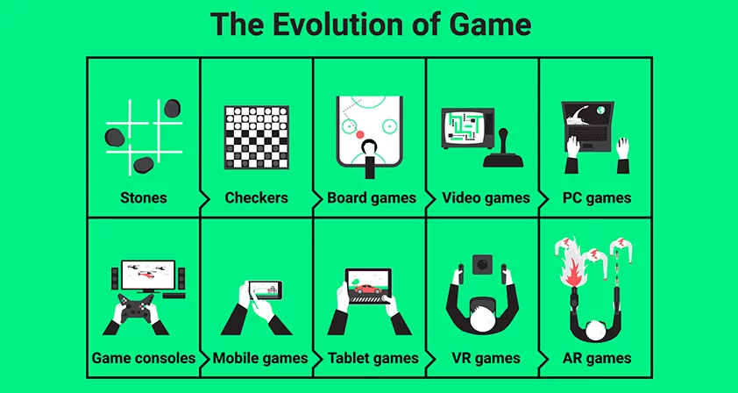**Evolution Of VR Gaming:**

## VR Hardware & Software:

## While VR software comprises the development tools, games, and material that enable VR experiences, R hardware covers the actual hardware, including as headsets, controllers, and tracking systems. These components work together to provide a smooth, lifelike virtual reality gaming experience that develops over time as technology improves.

## 1.HARDWARE DEVICES:

## VR headset: The main piece of hardware for VR gaming is a VR headset. For a stereoscopic 3D vision of the virtual world, they are made to be worn on the head and cover the eyes.

UXVR(Article)

Paritosh Khanwe CSE(DS)

Roll No:72

## VR headsets come in a variety of designs, including tethered, standalone, and mobile headsets.

## High-end visuals and performance are offered by tethered headsets like the Oculus Rift and HTC Vive, which need a potent PC or console to operate.

## Devices for Input and Control: Users can interact with the virtual environment using handheld VR controllers. They frequently have triggers, buttons, and motion tracking.

## Audio Equipment:An immersive experience is greatly aided by VR audio. Integrated headphones or audio connectors for external headphones are common features of VR headsets.

## 2.SOFTWARE DEVICES:

## Develop a game: To build VR experiences and games, game creators need specialized software development kits (SDKs). Popular game engines for VR creation include Unity and Unreal Engine.

## To create a seamless and engaging experience, VR development involves optimizing graphics, interactions, and performance.

## Games and Content:VR content comprises a variety of games, simulations, learning opportunities, and other things.

## VR is used for practical applications in educational and training software like architectural walkthroughs and medical simulations.

## Platforms for VR: The ecosystems and app marketplaces for various VR platforms vary. Examples include PlayStation VR for PlayStation consoles, Oculus Home for Oculus devices, and SteamVR for HTC Vive and Valve Index.

## Middleware for VR: For VR development, middleware solutions offer resources and services including physics engines, haptic feedback, and gesture detection.

## Content Representation:Users can buy and download VR experiences and games through digital marketplaces and platforms that distribute VR content.

**Conclusion:** virtual reality gaming has fundamentally changed how we view and play video games. It has dismantled the partitions between truth and fiction, luring players into brand-new settings and stories. VR gaming is positioned to influence the future of interactive entertainment as technology advances. The adventure has only just begun, and there is no end in sight. Virtual reality gaming offers an exhilarating and life-changing adventure that is well taking on, whether you are an experienced player or someone who is intrigued to explore this virtual frontier.