|  |  |
| --- | --- |
| **Name:** | Paritosh Khanwe |
| **Roll No & Branch:** | 72(CSE_DE) |
| **Class/Sem:** | BE/VII |
| **Experiment No.:** | 02 |
| **Title:** | Demonstration of the working of HTC Vive, Google Cardboard, Google Daydream and Samsung gear VR. |
| **Date of Performance:** |  |
| **Date of Submission:** |  |
| **Marks:** |  |
| **Sign of Faculty:** |  |

**Aim :-**

Demonstration of the working of HTC Vive, Google Cardboard, Google Daydream and Samsung gear VR.

**Theory:-**

In this VR headset demonstration for the lab, we explore four distinct virtual reality technologies: the HTC Vive, Google Cardboard, Google Daydream, and Samsung Gear VR. Each of these headsets offers unique features and experiences. The HTC Vive is a high-end VR system that uses external sensors for room-scale tracking, providing an immersive experience with handheld controllers. Google Cardboard is an entry-level option that transforms a smartphone into a basic VR headset, making use of the phone's sensors for head tracking. Google Daydream builds upon the Cardboard concept, offering a more comfortable design and motion controller for intuitive interactions. Samsung Gear VR is tailored for Samsung Galaxy smartphones, offering a wide range of VR content through the Oculus store. During the demonstration, participants will experience these headsets, gain insights into their functionalities, and explore the diverse VR environments they can offer. This hands-on experience aims to familiarize students with a spectrum of VR technologies, from high-end setups to more accessible and smartphone-driven solutions.

**HTC Vive:**

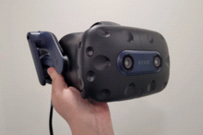

VIVE, sometimes referred to as HTC Vive, is a virtual reality brand of HTC Corporation. It consists of hardware like its titular virtual reality headsets and accessories, virtual reality software and services, and initiatives that promote applications of virtual reality in sectors like business, arts, and video gaming.

The brand's first virtual reality headset, simply called HTC Vive, was introduced as part of a collaboration with Valve Corporation, implementing its SteamVR hardware and software ecosystem. It was unveiled during HTC's Mobile World Congress keynote in March 2015. Development kits were sent out in August and September 2015, and the first consumer version of the device was released in April 2016.It has since been succeeded by newer models with upgraded specifications. HTC has also released accessories that integrate with the Vive and SteamVR, including sensors for motion capture and facial capture.

**Google Cardboard**

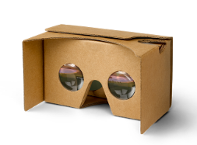

Cardboard VR is compatible with a wide range of contemporary smartphones. Google Cardboard’s biggest advantage is its low cost, broad hardware support, and portability. As a bonus, it is wireless. Using the phone’s gyroscopes, the VR applications can track the user in 360 degrees of rotation. While modern phones are very powerful, they are not as powerful as desktop PCs. But the user is untethered and the systems are lightweight.

**Google Daydream**

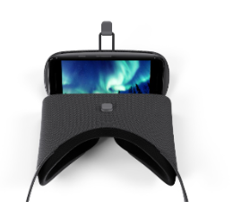

Rather than plastic, the Daydream is built from a fabric-like material and is bundled with a Wii-like motion controller with a trackpad and buttons. It does have superior optics compared to a Cardboard but is not as nice as the higher end VR systems. Just as with the Gear VR, it works only with a very specific list of phones. Users could insert their phones into a compatible Daydream VR headset, which often came with a comfortable fabric design and a motion controller for interaction.

Daydream offered a variety of VR applications and games through the Google Play Store, making it accessible for both entertainment and educational purposes.

**Samsung Gear VR**

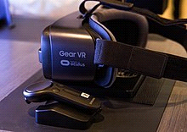

The Samsung Gear VR is a virtual reality headset developed by Samsung Electronics, in collaboration with Oculus VR, and manufactured by Samsung. The headset was released on November 27, 2015.

When in use, a compatible Samsung Galaxy device acts as the headset's display and processor, while the Gear VR unit itself acts as the controller, which contains the field of view, as well as a custom inertial measurement unit, or IMU, for rotational tracking, which connects to the smartphone via USB-C or micro-USB. The Gear VR headset also includes a touchpad and back button on the side, as well as a proximity sensor to detect when the headset is on.

The Gear VR was first announced on September 3, 2014.To allow developers to create content for the Gear VR and to allow VR and technology enthusiasts to get early access to the technology, Samsung had released two innovator editions of the Gear VR before the consumer version.

**Conclusion:-**