 | Pimpri Chinchwad Education Trust’s  Pimpri Chinchwad College of Engineering (PCCoE)  (An Autonomous Institute)  Affiliated to Savitribai Phule Pune University(SPPU)  ISO 21001:2018 Certified by TUV SUD

Subject: FSDL Div: C
Name: Paritosh Nimhan PRN: 123B1B212

ASSIGNMENT 2

Title:Design a Personal Portfolio Page using HTML and CSS. Use bootstrap CDN if required.

Objectives:
- To understand the structure of a web page using HTML.
- To apply CSS styling for designing visually appealing layouts.
- To learn responsive web design using the Bootstrap framework.
- To create a personal portfolio webpage showcasing skills, projects, and contact details.
- To understand layout components such as navigation bars, cards, grids, and sections.

Outcomes:
- Able to design a responsive portfolio webpage.
- Gain practical knowledge of HTML elements and CSS styling techniques.
- Understand how Bootstrap CDN helps in faster UI development.
- Learn webpage structuring using containers, rows, and columns.

Theory Concept :

A Personal Portfolio Page is a web application that represents an individual’s professional identity online. It typically includes sections such as About Me, Skills, Projects, Resume, and Contact Information. Portfolio websites are widely used by developers, designers, and professionals to present their work digitally.

1. HTML (HyperText Markup Language)
HTML is the standard markup language used to create the structure of web pages. It defines elements such as headings, paragraphs, images, links, forms, and sections. Semantic tags like <header>, <section>, <nav>, and <footer> improve readability and accessibility.

2. CSS (Cascading Style Sheets)
CSS is used to style and format HTML content. It controls colors, layouts, spacing, fonts, and responsiveness. CSS helps in improving user experience by making webpages visually attractive.

3. Responsive Web Design
Responsive design ensures that a webpage adjusts properly across different devices such as desktops, tablets, and mobile phones. Techniques include flexible layouts, media queries, and responsive grids.

4. Bootstrap Framework
Bootstrap is a popular front-end framework that provides pre-designed components and responsive grid systems. By using a Bootstrap CDN, developers can quickly include styling without downloading files. Bootstrap components such as navigation bars, buttons, cards, and forms reduce development time.

5. Front-End Development in Full Stack
In full stack development, the front-end layer focuses on user interaction and presentation. Designing a portfolio page helps understand UI layout, responsiveness, and user-friendly design principles.

Dataset Used:
No external dataset was required for this experiment.
The portfolio page uses self-generated content, including:
- Personal information (Name, education, profile summary)
- Skills list (technical and soft skills)
- Project descriptions
- Sample images/icons
- Contact details (email, phone, social media links)
All data used is static and manually entered within the HTML

Code:

HTML CODE
<!DOCTYPE html>
<html lang="en">
<head>
<meta charset="UTF-8">
<title>My Portfolio</title>

<!-- Bootstrap CSS -->
<link href="https://cdn.jsdelivr.net/npm/bootstrap@5.3.2/dist/css/bootstrap.min.css" rel="stylesheet">

<!-- Bootstrap Icons -->
<link
href="https://cdn.jsdelivr.net/npm/bootstrap-icons@1.11.1/font/bootstrap-icons.css" rel="stylesheet">

<!-- Custom CSS -->
<link rel="stylesheet" href="style.css">
</head>

<body>

<!-- Navbar -->
<nav class="navbar navbar-expand-lg navbar-dark bg-dark fixed-top">
<div class="container">
<a class="navbar-brand" href="#">MyPortfolio</a>
<button class="navbar-toggler" data-bs-toggle="collapse" data-bs-target="#navMenu">
<span class="navbar-toggler-icon"></span>
</button>

<div class="collapse navbar-collapse" id="navMenu">
<ul class="navbar-nav ms-auto">
<li class="nav-item"><a class="nav-link" href="#about">About</a></li>

<li class="nav-item"><a class="nav-link" href="#skills">Skills</a></li>
<li class="nav-item"><a class="nav-link" href="#projects">Projects</a></li>
<li class="nav-item"><a class="nav-link" href="#contact">Contact</a></li>
</ul>
</div>
</div>
</nav>

<!-- Hero Section -->
<section class="hero-unique">
<div class="hero-left">
<img src="images/img1.jpg" alt="Profile" class="hero-photo">
<h2 class="horizontal-name">Photo</h2>
</div>

<div class="hero-right">
<h1>Hello, I’m <span>Paritosh</span></h1>
<p>Student • Developer • Learner</p>
<a href="#contact" class="btn btn-light mt-3">Contact Me</a>
</div>
</section>

<!-- About -->
<section id="about" class="section">
<div class="container">
<h2 class="section-title">About Me</h2>
<p class="text-center">
I am a passionate student interested in Machine Learning, and building real-world projects using modern technologies.

</p>
</div>
</section>

<!-- Skills -->
<section id="skills" class="section">
<div class="container">
<h2 class="section-title">Skills</h2>

<div class="row text-center gy-4">

<div class="col-md-3 col-6">
<i class="bi bi-code-slash skill-icon"></i>
<p>HTML</p>
</div>

<div class="col-md-3 col-6">
<i class="bi bi-palette skill-icon"></i>
<p>CSS</p>
</div>

<div class="col-md-3 col-6">
<i class="bi bi-bootstrap skill-icon"></i>
<p>Bootstrap</p>
</div>

<div class="col-md-3 col-6">
<i class="bi bi-cup-hot skill-icon"></i>
<p>Java</p>
</div>

<div class="col-md-3 col-6">
<i class="bi bi-filetype-py skill-icon"></i>
<p>Python</p>
</div>

<div class="col-md-3 col-6">
<i class="bi bi-cpu skill-icon"></i>
<p>Machine Learning</p>
</div>

<div class="col-md-3 col-6">
<i class="bi bi-database skill-icon"></i>
<p>MySQL</p>
</div>

</div>
</div>
</section>

<!-- Projects -->
<section id="projects" class="section">
<div class="container">
<h2 class="section-title">Projects</h2>

<div class="row g-4">
<!-- Project 1 -->
<div class="col-md-4">
<div class="card h-100">
<div class="card-body">
<h5 class="card-title fw-bold">Medical Image Segmentation

(nnU-Net)</h5>

<p class="card-text">
Medical image segmentation project using nnU-Net on MSD dataset.
</p>
</div>
</div>

</div>

<!-- Project 2 -->
<div class="col-md-4">
<div class="card h-100">
<div class="card-body">
<h5 class="card-title fw-bold">Nut & Bolt Detection using

YOLOv8</h5>

<p class="card-text">
Object detection system to detect and classify M6 and M8 nuts and bolts using YOLOv8.
</p>
</div>
</div>

</div>

<!-- Project 3 -->
<div class="col-md-4">
<div class="card h-100">
<div class="card-body">
<h5 class="card-title fw-bold">Flight Price Prediction</h5>
<p class="card-text">

Machine learning model to predict flight ticket prices based on features like airline, source, destination, and journey date.
</p>
</div>
</div>
</div>
</div>
</div>
</section>

<!-- Contact -->
<section id="contact" class="section">
<div class="container">
<h2 class="section-title">Contact</h2>

<div class="row justify-content-center text-center">
<div class="col-md-6">

<p><strong>Name:</strong> Paritosh Nimhan</p>

<p>
<strong>Email:</strong>
<a href="mailto:paritosh@example.com"> paritosh@example.com
</a>
</p>

<p><strong>Location:</strong> Pune, India</p>

<!-- Social Icons -->
<div class="mt-4 d-flex justify-content-center">
<!-- LinkedIn -->
<a href="https://www.linkedin.com/in/paritosh-nimhan-028996292/" target="_blank"
aria-label="LinkedIn">
<i class="bi bi-linkedin social-icon linkedin"></i>
</a>

<!-- GitHub -->
<a href="https://github.com/paritoshnimhan70000"

target="_blank"
aria-label="GitHub">
<i class="bi bi-github social-icon github"></i>
</a>
</div>

</div>
</div>
</div>
</section>

<!-- Footer -->
<footer>
<p>&copy; 2026 </p>
</footer>

<!-- Bootstrap JS CDN -->
<script
src="https://cdn.jsdelivr.net/npm/bootstrap@5.3.2/dist/js/bootstrap.bundle.min.js"></scri pt>

<!-- Custom JS -->
<script src="script.js"></script>

</body>
</html>

CSS CODE
body {
font-family: "Segoe UI", Arial, sans-serif; line-height: 1.8;
margin: 0;
background: linear-gradient( 180deg,
#f1f5f9 0%,
#e2e8f0 100%
); /* soft slate gradient */ color: #1f2933;
}

.section {
padding: 100px 0; margin: 60px auto; width: 92%;
background-color: #ffffff; border-radius: 20px;
box-shadow: 0 20px 50px rgba(0, 0, 0, 0.08);
}

#about {
background-color: #ffffff;
}

#skills {
background-color: #f8fafc;
}

#projects {
background-color: #ffffff;
}

#contact {
background-color: #f1f5f9;
}

/* ========================= HERO SECTION
========================= */
.hero {
margin-top: 56px; /* for fixed navbar */ min-height: 65vh;
background-image:
linear-gradient(rgba(30,58,138,0.6), rgba(15,118,110,0.6)), url("./images/img1.jpg");
background-size: cover;
background-position: center; color: white;
display: flex;
align-items: center;

text-align: center; padding: 60px 0;
}

.hero h1 {
font-weight: 700;
margin-bottom: 15px;
}

.hero p {
font-size: 1.15rem; opacity: 0.95;
}

/* Profile Image */
.profile-img {
width: 140px; height: 140px;
border-radius: 50%; object-fit: cover;
border: 4px solid white; margin-bottom: 20px;
}

/* ========================= SECTIONS
========================= */
.section {
padding: 100px 0;
scroll-margin-top: 70px; background-image:
linear-gradient(rgba(255,255,255,0.9), rgba(255,255,255,0.9)), url("./images/img2.jpg");
background-size: cover;
background-position: center;
}

/* Section Titles */
.section-title {
text-align: center; margin-bottom: 50px;

font-weight: 700; color: #1e3a8a;
position: relative;
}

.section-title::after { content: "";
width: 60px; height: 3px;
background-color: #0f766e; display: block;
margin: 15px auto 0; border-radius: 2px;
}

/* Paragraphs */ p {
margin-bottom: 25px; font-size: 1.05rem;
}

/* ========================= SKILLS
========================= */
#skills .col-md-3 { padding: 25px 0;
font-size: 1.1rem; font-weight: 500;
color: #334155;
}

/* ========================= PROJECT CARDS
========================= */
.card {
padding: 30px;
border-radius: 16px;
background: linear-gradient(135deg, #ffffff, #e0f2fe); box-shadow: 0 10px 30px rgba(0,0,0,0.1);
border: none;
transition: transform 0.3s ease, box-shadow 0.3s ease;

}

.card:hover {
transform: translateY(-8px);
box-shadow: 0 18px 40px rgba(0,0,0,0.15);
}
/* Skill Icons */
.skill-icon {
font-size: 2.5rem; color: #0f766e;
margin-bottom: 10px;
transition: transform 0.3s ease, color 0.3s ease;
}

.skill-icon:hover {
transform: scale(1.2); color: #1e3a8a;
}

#skills p {
font-weight: 500;
}

/* UNIQUE HERO LAYOUT */
.hero-unique {
display: flex;
min-height: 100vh;
}

/* Left Panel */
.hero-left {
width: 40%;
background: #0f172a; color: white;
display: flex;
flex-direction: column; align-items: center;
justify-content: center; position: relative;
}

.hero-photo {
width: 180px; height: 180px;
border-radius: 50%; object-fit: cover;
border: 4px solid white; margin-bottom: 30px;
}

/* Vertical Name */
.vertical-name {
writing-mode: vertical-rl; transform: rotate(180deg); letter-spacing: 8px;
font-size: 1.2rem; opacity: 0.6;
}

/* Right Panel */
.hero-right { width: 60%;
background: linear-gradient(135deg, #1e3a8a, #0f766e); color: white;
display: flex;
flex-direction: column; justify-content: center; padding: 80px;
}

.hero-right h1 {
font-size: 3rem; font-weight: 700;
}

.hero-right h1 span { color: #a5f3fc;
}

.hero-right p {
font-size: 1.2rem; margin-top: 15px;

}

/* ========================= CONTACT ICONS (BOOTSTRAP ICONS)
========================= */
.social-icon {
font-size: 2.5rem; margin: 0 15px;
transition: transform 0.3s ease, color 0.3s ease;
}

.social-icon:hover {
transform: scale(1.2);
}

/* LinkedIn Icon */
.linkedin {
color: #0a66c2;
}

.linkedin:hover { color: #084c91;
}

/* GitHub Icon */
.github {
color: #24292e;
}

.github:hover {
color: #000000;
}

/* ========================= FOOTER
========================= */
footer {
background-image:
linear-gradient(rgba(2,6,23,0.9), rgba(15,23,42,0.9)), url("./images/img1.jpg");
background-size: cover;

color: white;
text-align: center; padding: 25px 0;
font-size: 0.95rem;
}
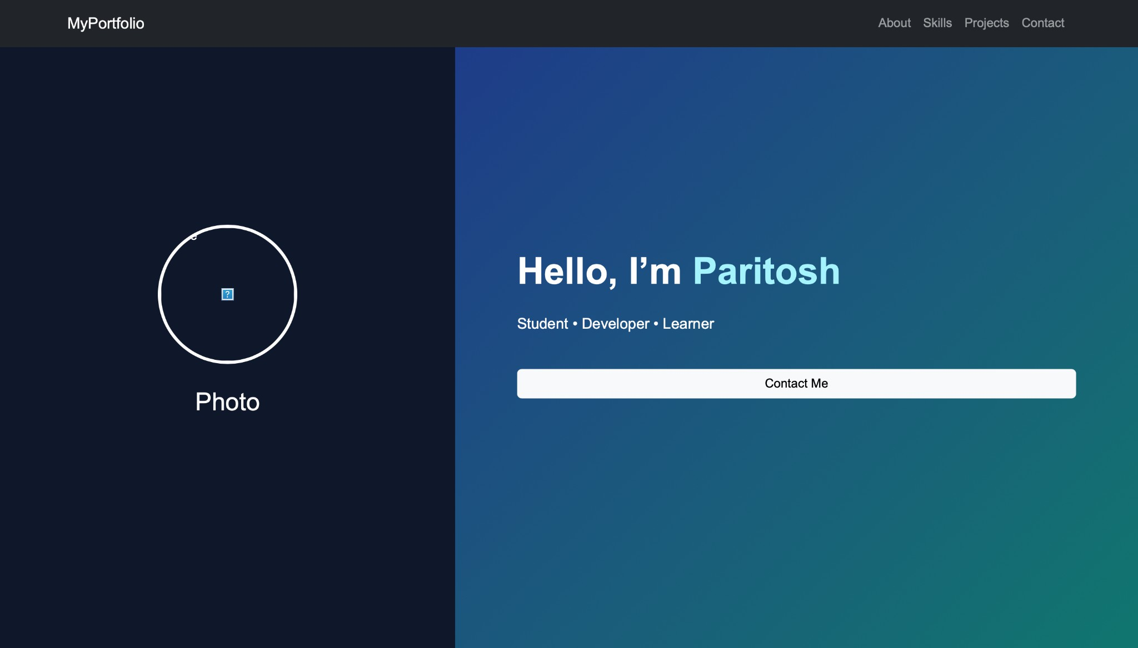

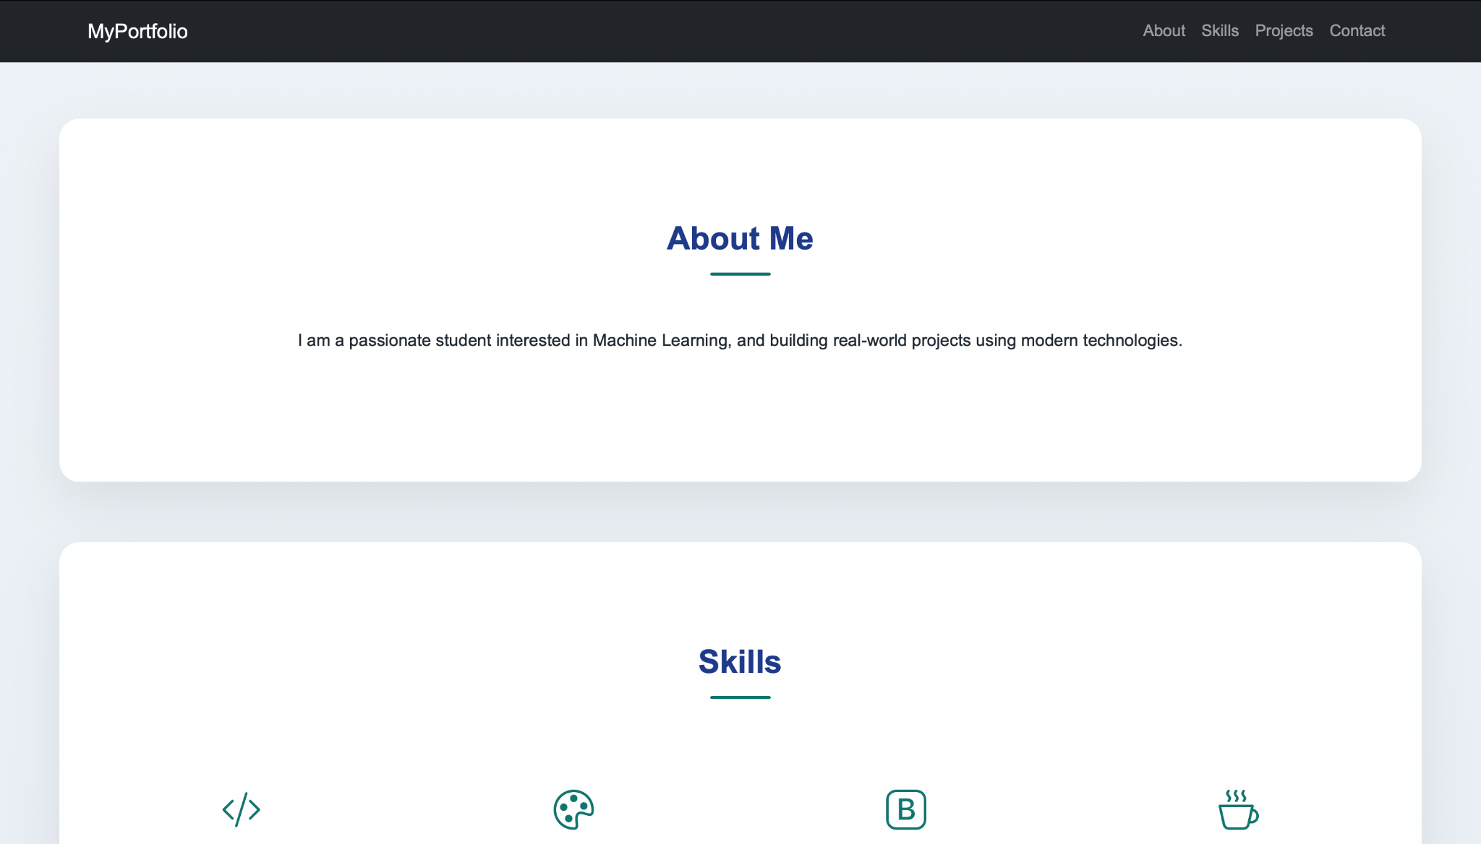
Link: https://portfolio-nu-indol-4etd5vd8ms.vercel.app/

