NETWORK DESIGN PROPOSAL FOR BANK

A PROJECT REPORT

Submitted by

RA1811029010018 – Parivesh Sood

RA1811029010019 – Satyam Gupta

RA1811029010020 – Aditya Anand

RA1811029010021 – Selva M.

Under the guidance of

Mrs. Annapoorani Panaiyappan
(Associate Professor, Department of Computer Science & Engineering)
in partial fulfillment for the award of the degree

of

BACHELOR OF TECHNOLOGY

in

COMPUTER SCIENE & ENGINEERING

of

FACULTY OF ENGINEERING AND TECHNOLOGY



S.R.M. Nagar, Kattankulathur, Kancheepuram District

November 2020
SRM INSTITUTE OF SCIENCE AND TECHNOLOGY

(Under Section 3 of UGC Act, 1956)

BONAFIDE CERTIFICATE

Certified that this project report titled “NETWORK DESIGN PROPOSAL FOR BANK
” is the Bona fide work of

RA1811029010018 – Parivesh Sood

RA1811029010019 – Satyam Gupta

RA1811029010020 – Aditya Anand

RA1811029010021 – Selva M.

who carried out the project work under my supervision. Certified further, that to the best of my knowledge the work reported herein does not form
any other project report or dissertation on the basis of which a degree or
award was conferred on an earlier occasion on this or any other candidate.

SIGNATURE SIGNATURE

Mrs. Annapoorani Panaiyappan Dr. B. AMUTHA
GUIDE HEAD OF THE DEPARTMENT
Associate Professor Dept. of Computer Science &
Dept. of Computer Science & Engineering Engineering

Signature of the Internal Examiner Signature of the External Examiner

Network Design Proposal for Bank

Table of Contents
Abstract 4
Objective 5
Introduction 6
Features and Services 7
Additional Requirements 8
Network Design and configuration strategy 8
Hardware inventory list 8
Modules of the Project 9
Network Topology Diagram 9
Network Topology Diagram explanation 10
Routers 10
Router Configuration 10
Routing Protocol 11
IP Network Design 12
IP Address Design 13
Inference from The Results 14
Future Work 14
Limitations 14
References 15

ACKNOWLEDGEMENT

We express our humble gratitude to Dr. Sandeep Sancheti, Vice-chancellor, SRM Institute of Science and Technology, for the facilities extended for the project work and his continued support. We extend our sincere thanks to Dr. C. Muthamizhchelvan, Pro-VC, Engineering and Technology, SRM Institute of Science and Technology, for his invaluable support.
We wish to thank Dr. B. Amutha, Professor & Head, Department of Computer Science and Engineering, SRM Institute of Science and Technology, for her valuable suggestions and encouragement throughout the period of the project work. We are extremely grateful to our Academic Advisor Mrs.Annapoorani Panaiyappan, Associate Professor, Department of Computer Science and Engineering, SRM Institute of Science and Technology, for her great support at all the stages of project work. We would like to convey my thanks to the Panel Head, Mrs. Annapoorani Panaiyappan, Associate Professor, Department of Computer Science and Engineering, SRM Institute of Science and Technology, for her inputs during the project reviews. Our inexpressible respect and thanks to our guide, Mrs.Annapoorani Panaiyappan, Associate Professor, Department of Computer Science and Engineering, SRM Institute of Science and Technology, for providing us an opportunity to pursue our project under her mentor ship. She provided us the freedom and support to explore the research topics of our interest. We sincerely thank staff and students of the Computer Science and Engineering Department, SRM Institute of Science and Technology, for their help during my research. Finally, We would like to thank our parents, family members and friends for their unconditional love, constant support and encouragement.

Abstract
Network design proposal for Bank
A network proposal has to be developed for a bank. The bank has a main office, which is located in Chennai, and has 5 branch offices located at Coimbatore, Madurai, Trichy, Salem and Thirunelveli. The bank has an application server, which is used by its customers across the world for online transactions. All the branches have high speed internet connection. There are approximately 50 users in each of the branch offices and 100 users in the main office.

Objective
The general aim of this project is to simulate a banking system which is secure and easy to use. This proposed system overcomes the lacking of the existing manual system. All branches of the Bank situated at District level provide the Banking services to customers and had to send report to the central branch manually, which sometimes creates problem to get, up-to-date information rapidly. But now through this system whenever any transaction will be taking place it will store in the central database and authorized person can get necessary information or report when they get into the system from any branches through Networking.

Introduction
The interconnection of computer with other related office equipment are finding increasing application in almost all field of human endeavor most especially the financial sector. More and more banks are introducing the use of computer networks in their establishment. These provide for easy access to the information and services available in the organization.
An ideal Bank Networking system will be fully network base and easy with friendly user interface staff task management system where any banking system manage their networking system somehow Head office, Branch Office, and other office are maintain LAN, MAN, WAN, VLAN, VLSM, VPN and some branch are maintained by manageable switch. LAN is used by Local Area Networking system for example one office and a one building. And MAN is used by the Metro Politian area Network for Example small town, and WAN are used by the WIDE AREA NETWORK. In this networking system are used by all banking users can use by shared their data very easily. So that every user use to take about Network Structure & Security of Banking System instantly this way anywhere.
Networks can also be characterized in terms of spatial distance as local area networks (LANs), metropolitan area networks (MANs), and wide networks (WANs). A given network can also be characterized by the type of data transmission technology in use on it (for example, a TCP/IP or Systems Networks Architecture network); by whether it carries voice, data, or both kinds of signals; by who can use the network (public or private); by the usual nature of its connections (dial-up or swathed, dedicated or no switched, or virtual connections); and by the types of physical links (for example, optical fiber, coaxial cable, and Unshielded twisted Pair).

Features and Services
- VLAN - Two networks are required at the main office. One network would be for the LAN, where the offices users would be connected. The second network would be the DMZ network, where the application server is hosted. This is required since the application server would require access from outside. Two VLANS would be created which would be mapped with the LAN and DMZ network. VLANS would be configured on the Switches.
- Access control lists - Access control lists are configured on the VPN appliance at the main office. The ACLs are used to restrict communication from the internet to only the allowed port, which is TCP port 443 on the application server in the DMZ. ACL is also configured to allow all traffic from the branch office networks to the DMZ and LAN network in the main office.
- Static NAT - Static NAT is configured on the VPN Appliance to allow traffic from the public IP address of the application server, to the LAN IP address.
- Failover cluster - Failover cluster is configured on the Windows 2008/2012, on which the application server is hosted. This would ensure that high availability is provided to the application.

Additional Requirements
All the locations have high speed internet connection. At the main office, an additional public IP address would be required to host the application server. The IP address would be registered with a domain name, which would enable users on the outside world (internet), to access the application.

Network Design and Configuration Strategy
- Connect the VPN appliances to the appropriate internet connections.
- Configure VLANS, VLAN 2 and VLAN 3 on the switches at the main office.
- Connect one of the ports on the switch to the trunk port on the NSA appliance.
- Configure the VLAN 2 and VLAN 3 gateway on the NSA appliance as 192.168.1.1 and 192.168.2.1 respectively.
- Configure site to site IPSEC tunnels between the TZ170 and NSA.
- Configure static NAT on the NSA appliance to map the public IP address of the application server with the LAN IP address.
- Configure ACL on the NSA appliance to allow only TCP port 443 (https) communication the application server. Configure ACL’s to allow all traffic between the branch and main office networks.
- Configure failover cluster on the application server, for high availability.

Hardware inventory list

Item | Model | Qty
VPN appliance | Sonic wall NSA 220/w | 1
VPN appliance | Sonic wall TZ170 | 5
Switch | Cisco Catalyst 2960S-  48FPD-L | 20
Server | HP ProLiant ML350 G8  Server | 1

Modules of the Project
At the main office, a VPN appliance would be required, which would have integrated firewall and deep packet inspection. The recommended VPN appliance is Sonic wall NSA 220/W, which has the capacity to support site to site VPN tunnels and also has deep packet inspection and firewall capabilities. There are 200 users in the main office. A total of 5 nos of 48 port switches are recommended considering ports for servers, VPN appliance and expansion plan. The Cisco Catalyst 2960S-48FPD-L is recommended for the same. At the branch offices, the SonicWall TZ105 series is recommended to establish site to site VPN connectivity with the main office. There is a total of 100 users each at the branch office. A total of 3 nos of 48 port switches is recommended, which are Cisco Catalyst 2960S- 48FPD-L, considering future expansion plans. Windows 2008/2012 is recommended for the application server with server hardware.

Proposed Network Topology Diagram
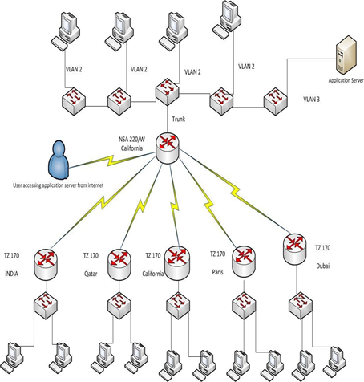

Network Topology Diagram Implementation

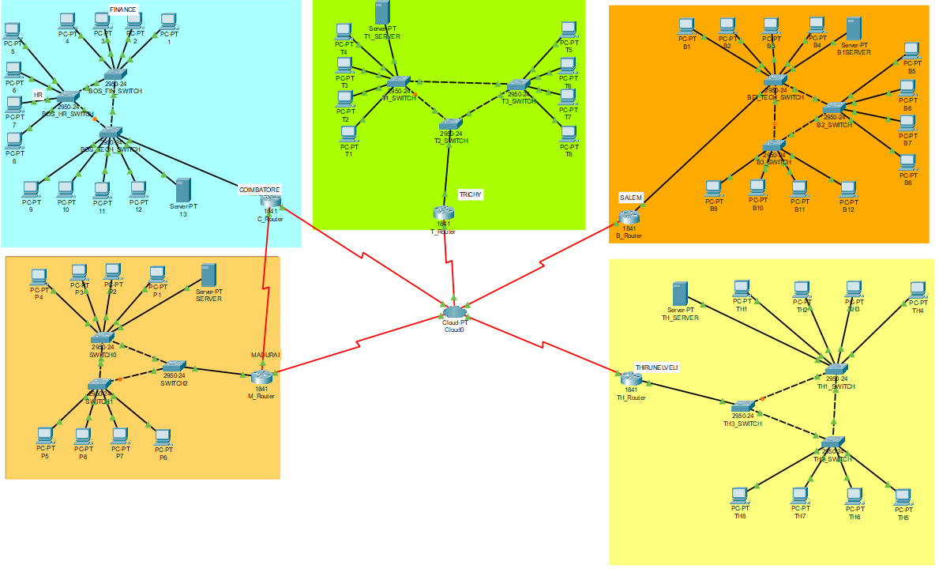

Routers
A router is a special type of computer. It has the same basic components as a standard desktop PC. It has a CPU, memory, a system bus, and various input/output interfaces. However, routers are designed to perform some very specific functions that are not typically performed by desktop computers. For example, routers connect and allow communication between two networks and determine the best path for data to travel through the connected networks. Just as computers need operating systems to run software applications, routers need the Internet work Operating System (IOS) software to run configuration files? These configuration files contain the instructions and parameters that control the flow of traffic in and out of the routers. Routers use routing protocols to determine the best path for packets. The configuration file specifies all the information for the correct setup and use of the selected or enabled, routing and routed protocols on a router.

Router Configuration
Here we have discussed about the routing configuration

Setting Hostname
A router should be given a unique name as one of the first configuration tasks. This task is accomplished in global configuration mode with the following command.
Now router configuration start
Router (config) #hostname JU
WUB (config) #
Now setting Router Password:
Console password:
Router(config)#line console 0
Router(config-line)#login
Router(config-line)#password
Virtual Privileged EXEC Mode:
Router(config)#line console 0 4
Router(config-line)#login
Router(config-line)#password

Secure Privileged EXEC Mode
The enable password and enable secret commands are used to restrict access to the privileged EXEC mode. The enable password is only used if the enable secret has not been set. The enable secret command should be used because the enable secret command is encrypted. The enable passwords command is not encrypted.
Router (config) #enable password
Router(config)#enable secret
Password
Encryption
The service password-encryption command applies a weak encryption to all unencrypted passwords. The enable secret command uses a strong MD5 algorithm for encryption.
Router (config) #service password-encryption.

Backup Configuration File :
A current copy of the configuration can be stored on a TFTP server. The copy running-configuration TFTP command can be used to store the current configuration on a network. TFTP server.
Router# copy running-config tftp

Interface Configuration:
Serial Interface Each connected serial interface must have an IP address and subnet mask to router IP packet. Configuration the IP address with the following commands:
Router:r(config)#interface serial 0/0/0
Router(config)#ip address <ip address> <subnetmask>
Setting Clock Rate & No Shutdown:
By default, Cisco routers are DTE devices but they can be configured as DCE devices. By default, interfaces are turned off, or disabled. To turn on or enable an interface, the command no shutdown.

Routing Protocol
A routing protocol is used by routers to dynamically find all the networks in the internet work and to ensure that all routers have the routing table. Basically, a routing protocol determines the path of a packet through an internet work. Examples of routing protocols are Static, RIP, EIGRP, and OSPF.

RIP Configuration
The command syntax is as follows:
Router (config) #router rip
Router (config-router) #network network-number net-mask

IGRP Configuration
To configure the IGRP routing process use the router igrp configuration command. The command syntax is as follows.
Router A (config) #router igrp as-number
Router A (config) #network network-number net-mask
There as number identifies the IGRP process. To specify a list of networks for IGRP routing process, se the network router configuration command. To remove an entry, use the no form of the command.

EIGRP Configuration
EIGRP is an ideal choice for large, multi-protocol networks built primary on Cisco routers.
RouterA(Config)#router eigrp as-number
RouterA(Config)#network network-number net-mask.

OSPF Features and Operation
OSPF configuration requires that he OSPF routing process be enabled on the router with network addresses and area information specified. Network addresses are configured with a wildcard mask and not a subnet mask. The wildcard mask represents the links or host addresses that can be present in this segment. Area IDs can be written as a whole number or doted decimal notation.

To enable OSPF routing, use the global configuration command syntax:
Router (configure) #router ospf process-id
Router (configure-router) #network address wildcard-mask area area-id

Inference from The Results
Now a days, technological development, and automat. system developments more essential and crying need for the expansion of banking services because they will need less employers by using automated system. On top of that Security is a major issue regarding banking issues. With this system network will be easier to handle and it will route the data in a shortest path in a vast distributed system. In future we will try to implement It In real life so that banks can use it and get benefited from this project.

Future Work
- Add time-based transmission.
- Security system will be upgraded
- Make the project more user friendly
- Real lite implementation.

Limitations
- The main limitation is to implement the project in real work because we only simulate it via Packet Tracer.
- Due to less time and work pressure, we could not add more features which could have made the project more useful.

References

- http://www.cisco.com/
- http://www.packettracernetwork.com/
- http://www.weikipedia.com
- http://www.routeralley.com/
- http://www.networkessential.com/
- http://www.google.com/

