**User Account Use-Case**

Table of Contents

Overview 2

Technologies used 2

Tools Used 2

Assumptions 2

Resource URI’s 2

Logging in the Application 2

Checking account details 2

Deposit money: 2

Adding test data (Not the part of use case, based on assumption) 2

Database Tables 3

Validation/Error Message 3

Repository URL 3

Application Flow with screenshot 3

# Overview

This application has been created w.r.t. use case provided for user account management. Using this App user can do the following functionalities.

* User will be able to login the application with valid credentials.
* User will be able to see the personal and account details with provided values in database.
* User can submit the amount in his/her own account as well as some other’s account as well.

# Technologies used

* AngularJs 1.x
* Restful Web Service (Jax-RS)
* Hibernate

# Tools Used

* Eclipse Mars 2.0
* Brackets
* Git Repository
* H2 Database
* Maven

# Assumptions

* There are 2 main roles : Admin and User
* Admin Role: Access provided for personal details and Deposit Money Tab.
* User Role: Access provided for all three tabs i.e. personal details, account details and Deposit Money Tab
* Assuming that test data is already provided and it’s not the part of test cases.
* Data needed to be provided in the table structure decided for this use case during development.
* For development H2 database is being used and interacted with hibernate. If different database to be used then driver name and dialect needed to be updated in hibernate configuration.

# Resource URI’s

## Logging in the Application

users/{userName}/{password}

## Checking account details

users/{customerId}/accounts/{accountId}

## Deposit money:

users/accounts/{accountId}/deposits/{amountDeposited}/{paymentMode}/{chequeNumber}

## Adding test data (Not the part of use case, based on assumption)

users/addtestdata

# Database Tables

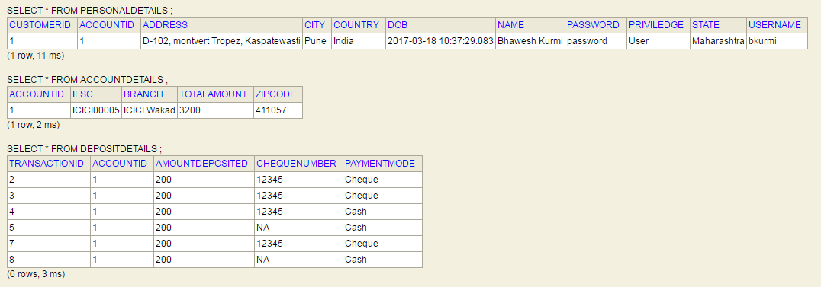

# Validation/Error Message

* If User/Admin trying to deposit money and server or Database is down.
  + Exception Message: “Database or Server is down.”
* If User/Admin trying to deposit money via Cash/Cheque and Account does not exist.
  + Exception Message: “Account does not exist.”
* User/Admin trying to login and username or password is invalid.
  + Exception Message: “Invalid Username and Password.”

# Repository URL

* UI Code (Angular JS)
  + <http://wosggitlab.wipro.com/PA316586/WproProjectUISubmission.git>
* RESTFul API (JAX-RS)
  + <http://wosggitlab.wipro.com/PA316586/UserAccountAPI.git>
* User Account API Document
  + http://wosggitlab.wipro.com/PA316586/WiproUseCaseDocuments.git

# Application Flow with screenshot

1. Application Login

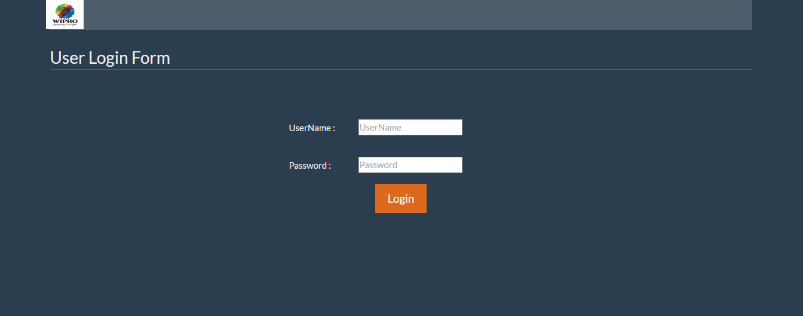

1. Personal Details

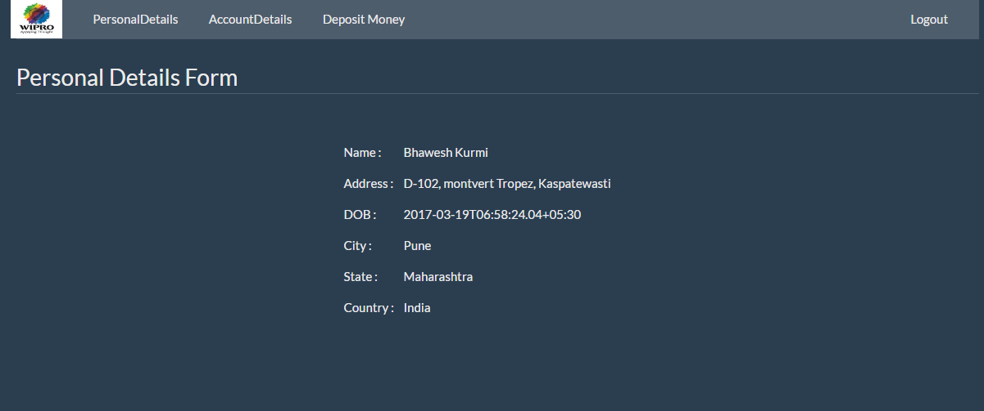

1. Account Details(Enabling tab as per type of user (Admin/User))

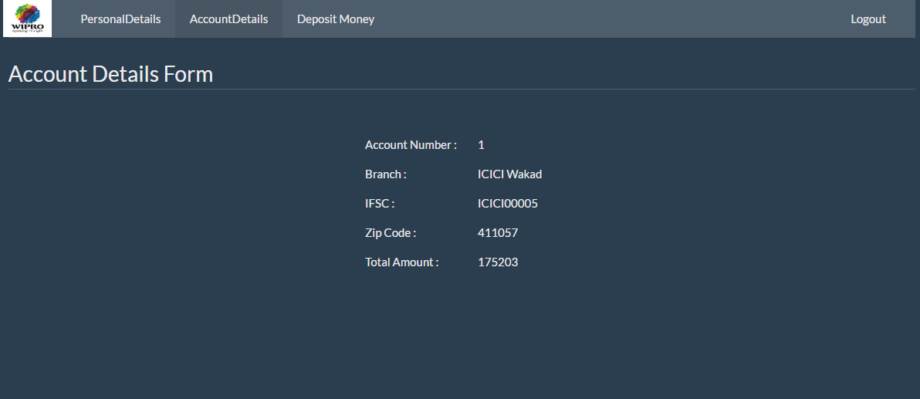

1. Deposit Money with Cash

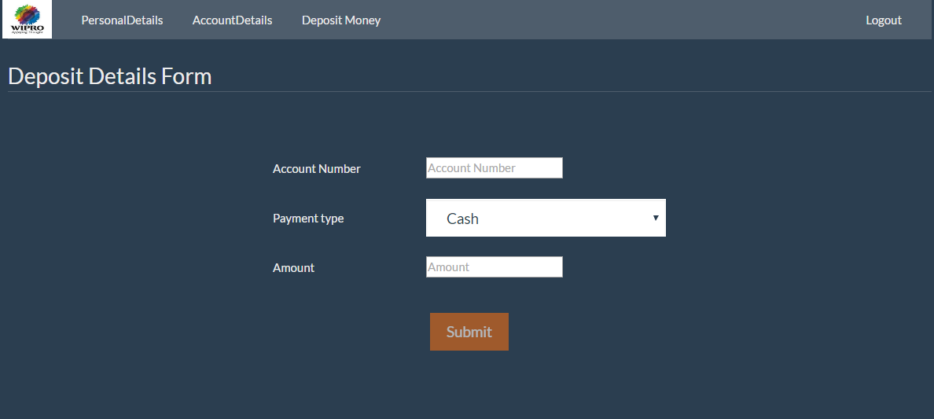

1. Deposit Money with Cheque

