To,

GirlScript Technologies Pvt. Ltd. & GirlScript Foundation

Re: No due declaration and release

Dear Madam/Sir,

I confirm that there are no dues/documents payable to me by the company. I undertake that I will not make any statement orally or in writing which is derogatory and defamatory, or that would reflect negatively towards the company, its affiliates or its officers.

I further acknowledge my continued obligation of confidentiality towards company’s confidential information which I have had access to. And I will never use the data and information in any way personal or commercially. Further if any opportunities knock which might include similar/same idea to the project I was looking, I will take a written consent first before agreeing to join .

And I further acknowledge that I do not have any relationships with the company and the offer letter and contract I signed will be considered null & void .

Signature 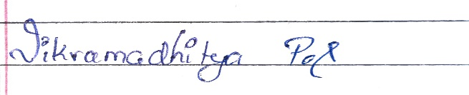

Name : Vikramadhitya

Date :10-8-21