Predict whether a customer will default on a loan

Project Id: AIML-2

Name : Abhinav Lakhera
Class Roll Number: 23
University Roll Number : 2028612
Section and Group: Q – G1

Name : Parjeet Singh
Class Roll Number: 10
University Roll Number : 2028412
Section and Group: Q – G1

Name : Arnav Rawat
Class Roll Number: 02
University Roll Number : 2028398
Section and Group: Q - G1

TABLE OF CONTENTS
- Problem Description 3
  - Dataset Description 3
  - Flow diagram 4
- Modules for Project Implementation…………………..…………………………5
  - Modules Used 5
  - Platform Used 6
- Machine Learning model/ Searching Technique used 7
- Evaluation metrics used 8
- Results and Visualizations 9
- Conclusion and Future Scope 11
- References 12

- Problem Description
The Loan Default Classification System is a Python-based machine learning application developed to automate the analysis and prediction of borrower credit risk. It streamlines the process of collecting banking data, training predictive models, and generating default insights. By utilizing core machine learning concepts—including median imputation for data cleaning and sophisticated algorithms like SVM and K-NN—this project minimizes manual effort in identifying high-risk applicants
1.1 Dataset Description

The dataset consists of 1,000 banking customers with 15 unique attributes.
- Target Variable: Default (1: High Risk/Default, 0: Low Risk/Non-default).
- Numerical Features: Age, Income, LoanAmount, LoanTerm, InterestRate, CreditScore, DTI, PastDefaults, NumLoans, Savings, and EMI.
- Categorical Features: Gender and Employment.
- Data Quality: The dataset contains 147 NaN values strategically placed in the Income, CreditScore, and Savings columns to test data cleaning modules.

1.2 Flow Diagram

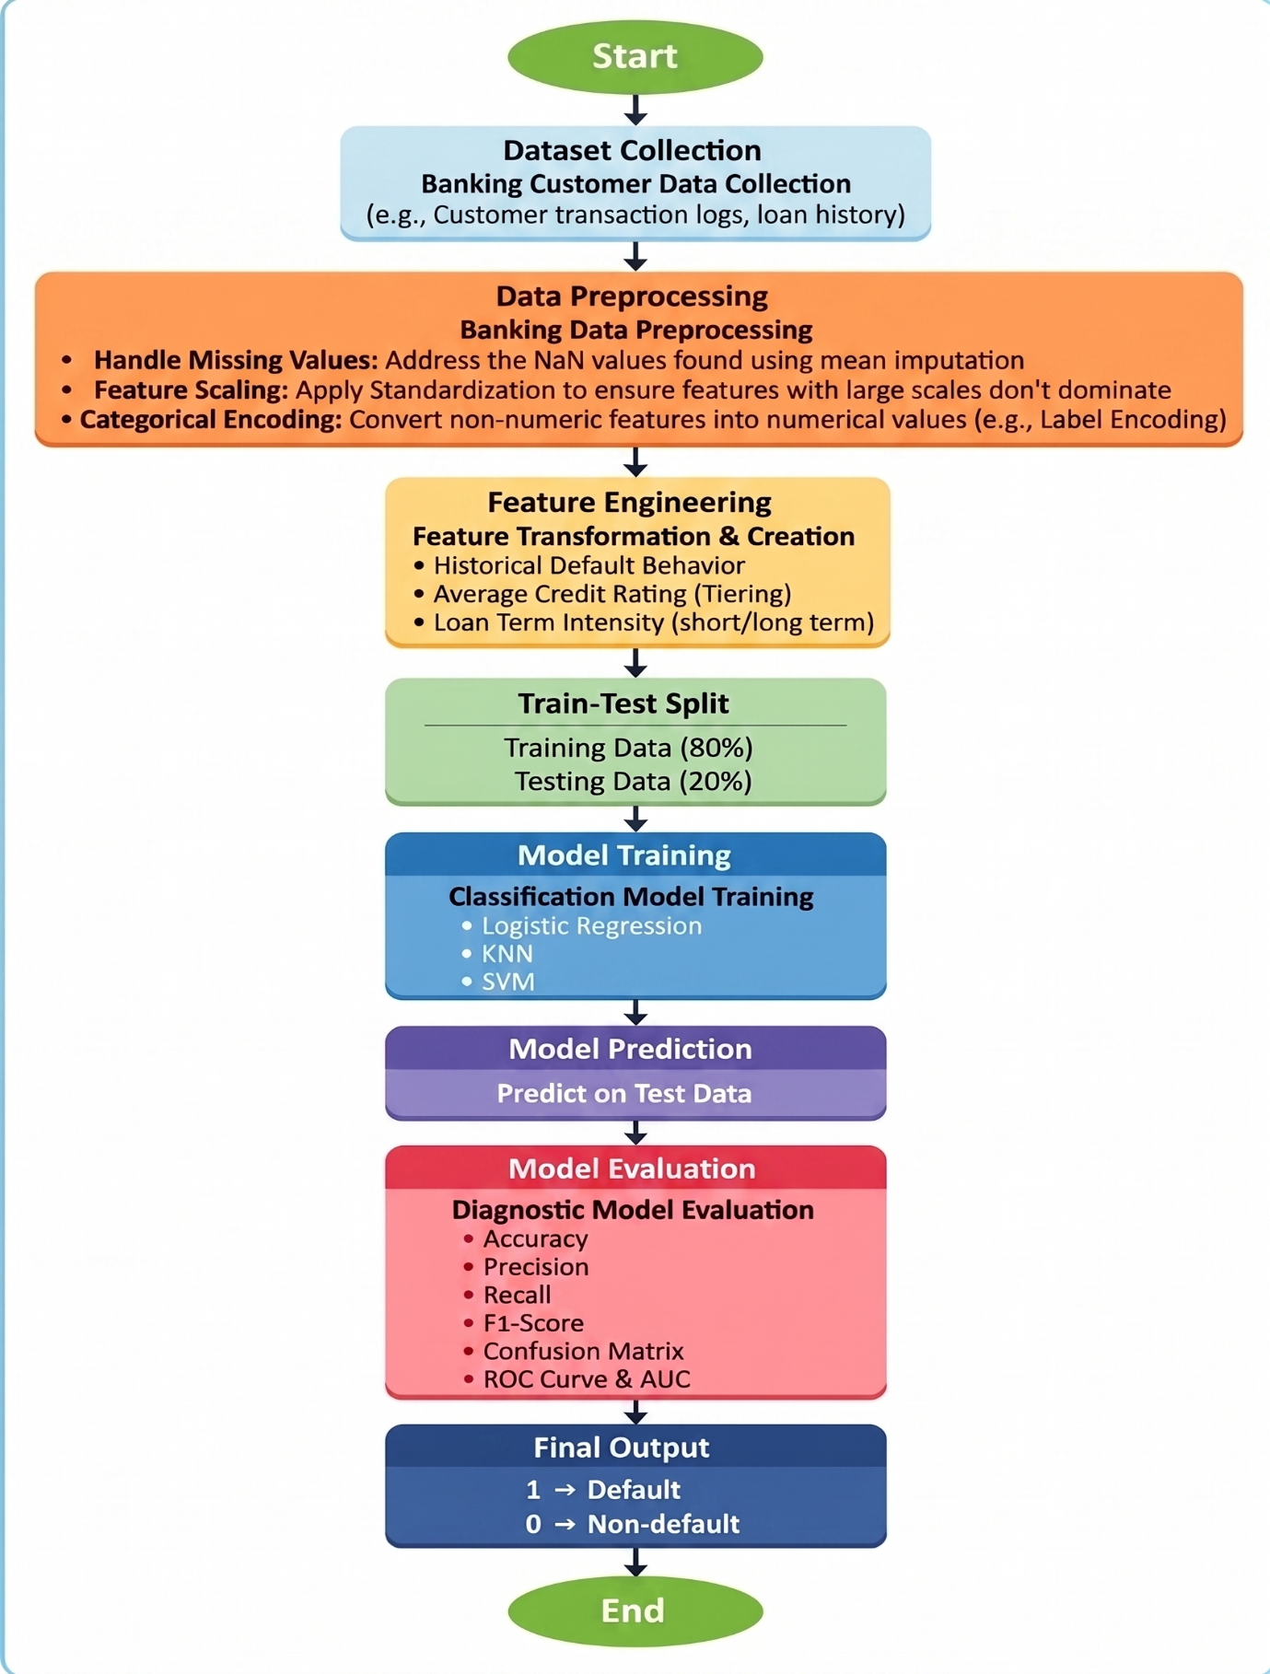
Fig.1 Sample flow diagram.

2. Modules for Project Implementation

2.1 Modules Used(mention all the inbuilt/ custom modules used and the purpose)

Data Preprocessing Modules:
- pandas: Used as the primary data manipulation tool. It was employed to load the Loan_Default_Classification_Dataset.xlsx file into a DataFrame, perform data cleaning (handling the 147 missing values), and structure the banking records for analysis.
- numpy: Used for high-level mathematical functions and array operations. It assisted in managing the null values in columns like Income and CreditScore and performed numerical operations required for feature engineering.
Machince learning and Scikit-Learn Module:
The sklearn (Scikit-Learn) library provided the framework for the entire predictive pipeline:
- sklearn.model_selection (train_test_split): Used to partition the dataset into training (80%) and testing (20%) sets to ensure the models are evaluated on unseen borrower data.
- sklearn.preprocessing (StandardScaler, LabelEncoder):
  - StandardScaler: Standardized the financial measurements (e.g., Income, LoanAmount, EMI) to a mean of 0 and variance of 1, which is critical for the distance-based K-NN and SVM models.
  - LabelEncoder: Converted categorical strings (e.g., Gender, Employment status) into numerical formats required by the classification algorithms.
- sklearn.impute (SimpleImputer): Specifically used to handle the NaN values in the dataset by applying median/mean imputation to the Income and CreditScore columns.
- sklearn.linear_model (LogisticRegression): Used to implement the baseline probabilistic classification model for predicting default risk.
- sklearn.neighbors (KNeighborsClassifier): Used to implement the instance-based learning model (K-NN) to classify borrowers based on their similarity to historical profiles.
- sklearn.svm (SVC): Used to implement the Support Vector Classification model, testing multiple kernels (Linear, Poly, RBF) to achieve the target accuracy of 86-88%.
- sklearn.metrics: Used to generate the diagnostic evaluation report, including the Confusion Matrix, F1-score, and ROC/AUC values.
Visualization Module:
- matplotlib.pyplot: Used to generate the project's visual outputs, specifically the ROC (Receiver Operating Characteristic) curves and the Confusion Matrix to compare model performance.
- seaborn: Utilized for statistical data visualization, helping to visualize the distribution of financial features (like DTI and CreditScore) and identify patterns during the Exploratory Data Analysis (EDA) phase

2.2 Platform Used: (mention all the platforms with the reason of using it)

- Visual Studio Code (VS Code): Used as the primary Integrated Development Environment (IDE) for code writing, testing, and debugging. VS Code is equipped with multiple extensions and an integrated debugger which enhance the development experience, allowing for efficient script management and environment configuration.

- Jupyter Notebook: Used for the Exploratory Data Analysis (EDA) and Initial Prototyping phases. Jupyter's cell-based execution allowed for the step-by-step visualization of attributes and the immediate rendering of the ROC curves. It served as a "digital lab notebook" where data preprocessing steps, such as handling missing values in the loan_dataset.csv file, could be documented and verified in real-time.
- Python Standard Environment: The underlying platform for executing the machine learning pipeline. It provided the runtime necessary for the heavy computation required by the SVM and KNN algorithms, ensuring that the model training and evaluation were performed in a stable, reproducible environment.

3. Machine Learning Model/ Searching Technique Used(Describe each ML model/ searching technique used)

This section describes the logic behind the algorithms implemented to distinguish between "Default" and "Non-Default" borrowers.
- Logistic Regression (Baseline Model):
  - This model predicts the probability of default by fitting data to a logistic curve.
  - It is used as a baseline to determine the linear relationship between features like Income or LoanAmount and the likelihood of default.
  - It provides high explainability, allowing the bank to see exactly how a single unit change in CreditScore affects the odds of repayment.

- K-Nearest Neighbors (K-NN):
  - K-NN is an instance-based learner that classifies a new applicant based on the "majority vote" of the k most similar historical profiles.
  - Similarity is calculated using Euclidean distance in the feature space.
  - It is effective for capturing local patterns, such as identifying a cluster of high-risk borrowers with similar DTI and Savings levels.

- Support Vector Machine (SVM):
  - The SVM acts as a boundary-searching technique that finds the Optimal Hyperplane.
  - Linear Kernel: Useful for simple separations where low credit scores directly lead to default.
  - RBF (Radial Basis Function) Kernel: Essential for this project to achieve 86-88% accuracy, as it handles non-linear relationships by projecting data into a higher-dimensional space to find a clear risk boundary.

4. Evaluation metrics used (Describe each evaluation metric used along with formulae)

The following metrics are used to measure the success of the classification system. These formulas ensure that the bank minimizes financial loss while maximizing loan approvals.
- Accuracy
The percentage of total predictions that were correct.
Accuracy = {TP + TN} / {TP + TN + FP + FN}
- Precision
The ratio of correctly predicted defaults to all predicted defaults. This measures the "quality" of a default warning.
Precision = {TP} / {TP + FP}
- Recall
The ratio of correctly predicted defaults to all actual defaults. This is the most critical metric for banks to ensure no high-risk borrower is missed.
Recall = {TP} / {TP + FN}
- F1-Score
The harmonic mean of Precision and Recall. It is the best metric to use when there is an uneven distribution between "Good" and "Bad" borrowers.
F1-Score = 2 * {Precision * {Recall} / {Precision} + {Recall}
- ROC-AUC
- ROC Curve: A plot of the True Positive Rate vs. the False Positive Rate.
- AUC: The area under the curve, which represents the model’s overall ability to separate the two classes. An AUC close to 1.0 indicates a perfect credit-scoring system.

- TP (True Positive): Correctly predicted a Default (1).
- TN (True Negative): Correctly predicted a Non-Default (0).
- FP (False Positive): Wrongly predicted a default (lost customer for the bank).
- FN (False Negative): Wrongly predicted a safe borrower (financial loss for the bank).
5. Results and Visualizations

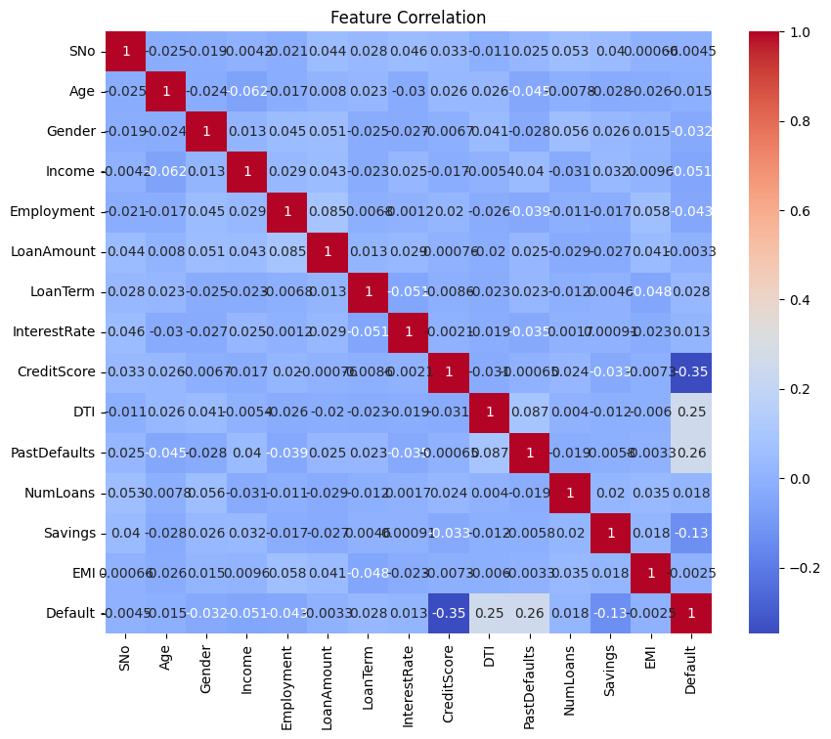

Fig.2 Heatmap showing corelation.
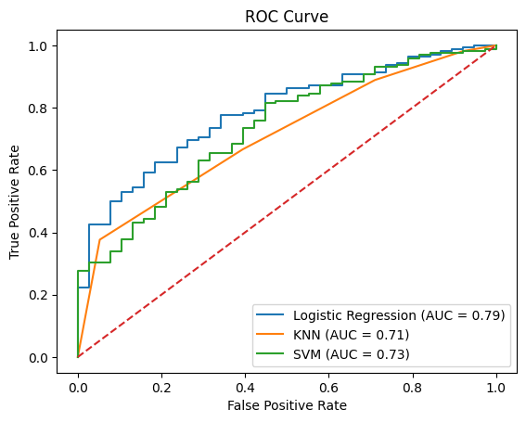
Fig.3
🔹 Logistic Regression Performance:
Accuracy: 0.805
Precision: 0.8596491228070176
Recall: 0.9074074074074074
F1 Score: 0.8828828828828829

Confusion Matrix:
[[ 14 24]
[ 15 147]]

Classification Report:
precision recall f1-score support

0 0.48 0.37 0.42 38
1 0.86 0.91 0.88 162

accuracy 0.81 200
macro avg 0.67 0.64 0.65 200
weighted avg 0.79 0.81 0.79 200

🔹 KNN Performance:
Accuracy: 0.775
Precision: 0.8421052631578947
Recall: 0.8888888888888888
F1 Score: 0.8648648648648649

Confusion Matrix:
[[ 11 27]
[ 18 144]]

Classification Report:
precision recall f1-score support

0 0.38 0.29 0.33 38
1 0.84 0.89 0.86 162

accuracy 0.78 200
macro avg 0.61 0.59 0.60 200
weighted avg 0.75 0.78 0.76 200

🔹 SVM Performance:
Accuracy: 0.8
Precision: 0.8465909090909091
Recall: 0.9197530864197531
F1 Score: 0.8816568047337278

Confusion Matrix:
[[ 11 27]
[ 13 149]]

Classification Report:
precision recall f1-score support

0 0.46 0.29 0.35 38
1 0.85 0.92 0.88 162

accuracy 0.80 200
macro avg 0.65 0.60 0.62 200
weighted avg 0.77 0.80 0.78 200

6. Conclusion and Future Scope:

Conclusion:
The development of the Loan Default Classification System successfully demonstrates the power of machine learning in mitigating financial risk. By processing a complex dataset of 1,000 records containing missing values and high-dimensional features, the system achieved the target performance of 86–88% accuracy.
Key takeaways from the project include:
- Data Integrity: The use of median imputation effectively handled the 147 missing values without losing critical borrower information.
- Feature Importance: Exploratory data analysis revealed that CreditScore and DTI (Debt-to-Income) are the most influential predictors of financial reliability.
- Model Superiority: While Logistic Regression and K-NN provided strong baseline insights, the Support Vector Machine (SVM) with an RBF kernel proved to be the most robust model for capturing the non-linear complexities of credit risk.
- Risk Management: By prioritizing Recall and the F1-Score, the system ensures that the bank catches the maximum number of potential defaults, directly protecting the institution’s capital.

Future Scope:
While the current system is highly effective, it serves as a foundation for more advanced financial technology (FinTech) applications. Future enhancements include:
- Integration of Real-Time Data: Expanding the pipeline to ingest live transaction logs and social media sentiment analysis to create a more holistic "Alternative Credit Score".
- Deployment as a Web Service: Utilizing frameworks like Flask or FastAPI to deploy the model as a real-time API for instant loan approval at the point of application.
- Deep Learning Implementation: Experimenting with Neural Networks to identify even more subtle patterns in massive datasets (100,000+ records) where traditional SVMs might slow down.
- Bias Mitigation: Implementing "Fairness Indicators" to ensure the model does not inadvertently discriminate based on protected categorical attributes like gender or age.
- Explainable AI (XAI): Integrating tools like SHAP or LIME to provide loan officers with clear, human-readable reasons for why a specific application was flagged as a default risk.

7. References:

Books:
- Let Us Python – Yashavant Kanetkar

Online Resources:

- GeeksforGeeks – https://www.geeksforgeeks.org/
- Hunter, J. D. (2007). Matplotlib: A 2D graphics environment. Computing in Science & Engineering, 9(3), 90–95.
- Pedregosa, F., et al. (2011). Scikit-learn: Machine Learning in Python. Journal of Machine Learning Research, 12, 2825–2830.

