Predict whether a customer will default on a loan

Project Id: AIML- 2

Name : Abhinav Lakhera
Class Roll Number: 23
University Roll Number : 2028612
Section and Group: Q – G1

Name : Parjeet Singh
Class Roll Number: 10
University Roll Number : 2028412
Section and Group: Q – G1

Name : Arnav Rawat
Class Roll Number: 02
University Roll Number : 2028398
Section and Group: Q - G1

- Problem Description 3
- Architecture 4
- Models model 5
- Evaluation metrics used 6
- Preliminary Results and Visualizations 7
- References 8

- Problem Description

The financial stability of banking institutions relies heavily on their ability to accurately assess the creditworthiness of loan applicants. Misclassifying a high-risk individual as a safe borrower leads to financial loss (defaults), while misclassifying a safe borrower as high-risk leads to lost revenue. This project focuses on building an automated, data-driven classification system to predict the likelihood of loan default.

The objective is to design and implement a complete machine learning pipeline that processes raw banking data to predict whether a customer will default on their loan
(Target: Default = 1) or successfully repay it (Target: Default = 0).

- Architecture

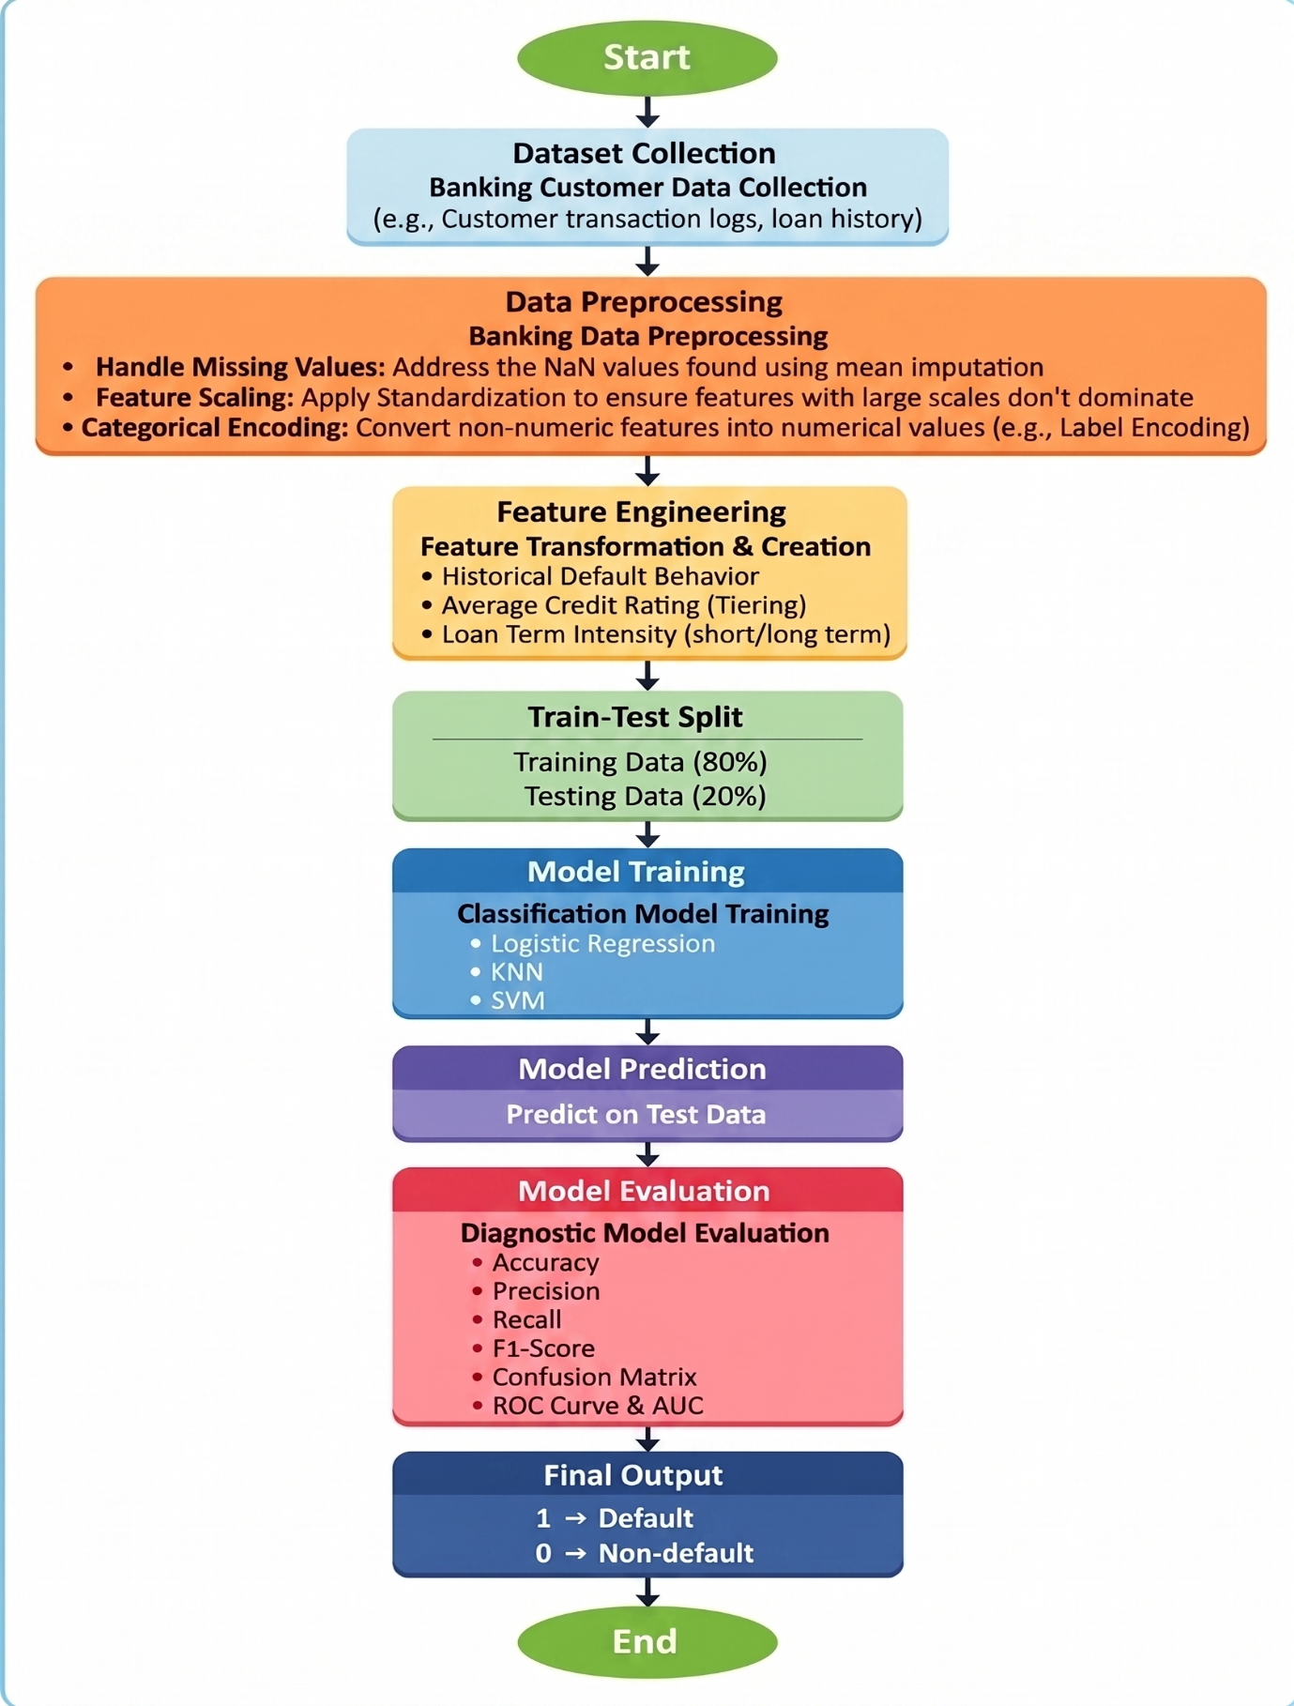

- Models Used(Applied/ Planned) Give a brief introduction of the models used

1. Logistic Regression
Despite its name, Logistic Regression is a fundamental linear model used for binary classification.
- How it works: It uses the Logistic Function (Sigmoid) to map any real-valued number into a probability between 0 and 1. If the probability is above 0.5, the applicant is classified having Loan default (1); otherwise, they are having no loan default(0).

- Role in Project: It serves as a strong baseline model. It is highly explainable, allowing banks to see credit score and the defaulters in the system.

2. K-Nearest Neighbors (KNN)
KNN is a non-parametric, instance-based learning algorithm.

- How it works: It operates on the principle of similarity. To predict a new applicant's status, the model looks at the "k" most similar borrowers in the banking dataset based on features like Credit Score, Income, and DTI. The final prediction (Default or Non-Default) is determined by a majority vote of those neighbors.

- Role in Project: K-NN is effective at capturing local patterns and non-linear relationships in financial data that a simple linear model might miss. It requires careful normalization/standardization

3. Support Vector Machine (SVM)
SVM is a powerful supervised learning model used for both linear and non-linear classification.
- How it works: SVM seeks to find the optimal hyperplane (a decision boundary) that maximizes the margin between the two classes (Default vs. Non-Default). In cases where the data isn't linearly separable it uses a "kernel trick" (Linear, Polynomial, or RBF) to project the data into a higher-dimensional space where a clear boundary can be drawn.
- Role in Project SVM is known for its high accuracy in high-dimensional spaces. It is particularly robust against overfitting, making it a reliable choice for financial risk assessment.

- Evaluation metrics used

The following metrics are used to evaluate model performance:

1. Accuracy
- Definition: The proportion of correct predictions (both defaults and non-defaults) out of the total number of loan cases.
- Banking Context: While a fundamental metric, accuracy alone can be misleading if the dataset is imbalanced.

2. Precision
- Definition: The ratio of True Positive (correctly predicted defaults) cases to all cases predicted as "Default" by the model.
- Banking Context: Higher precision reduces "false alarms" for the bank, ensuring that applicants identified as "High Risk" are highly likely to actually default.

3. Recall
- Definition: The proportion of actual default cases that were correctly identified by the model.
- Banking Context: This is a critical metric for risk mitigation. High recall minimizes False Negatives, ensuring that risky borrowers are not incorrectly cleared as "Safe”.

4. F1-Score
- Definition: The harmonic mean of precision and recall, providing a single score that balances both.
- Banking Context: It is particularly useful for assessing models on imbalanced financial datasets where a balance between capturing all potential defaults (Recall) an.

5. Confusion Matrix
- Definition: A 2*2 times table showing the counts of True Positives (TP), True Negatives (TN), False Positives (FP), and False Negatives (FN).
- Banking Context: It provides a clear visualization of where the model "gets confused"—specifically, whether it is more prone to over-estimating risk.

6. ROC Curve and AUC
- ROC Curve: A graphical plot that illustrates the diagnostic ability of a classifier by comparing the True Positive Rate (Sensitivity) vs. the False Positive Rate at various decision thresholds.
- AUC (Area Under the Curve): A single value summarizing the ROC curve. An AUC of 1.0 represents perfect discrimination between classes, while values above 0.80 are generally considered highly reliable for financial risk assessment and decision-making.

5. Preliminary Results and Visualizations

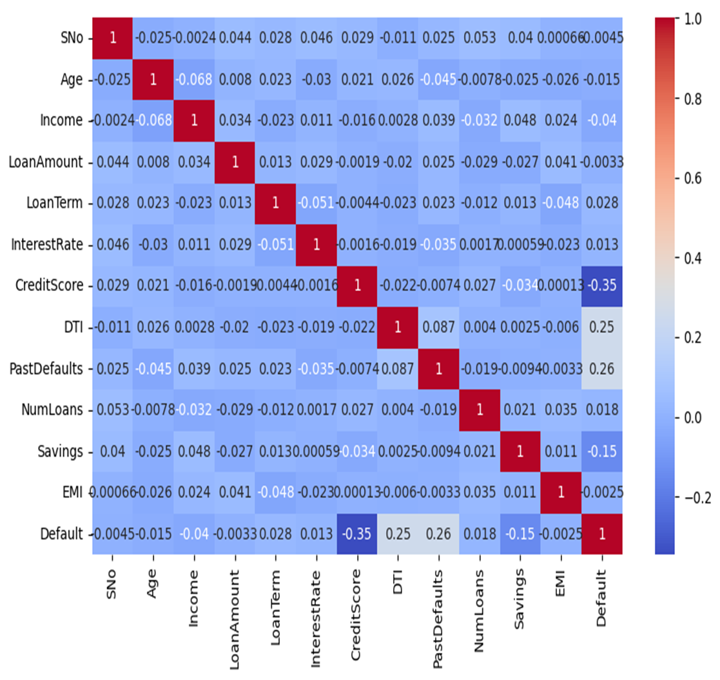
- Correlation Heatmap

6. References:
Books:
- Let Us Python – Yashavant Kanetkar

Online Resources:

- GeeksforGeeks – https://www.geeksforgeeks.org/
- Hunter, J. D. (2007). Matplotlib: A 2D graphics environment. Computing in Science & Engineering, 9(3), 90–95.
- Pedregosa, F., et al. (2011). Scikit-learn: Machine Learning in Python. Journal of Machine Learning Research, 12, 2825–2830.
.

