**Test Canbus**

C file test_canbus.c

1. **Hardware environment**

**DEMO_IT976AU_CAR-HMI**

**Support two SPI control two canbus modules**

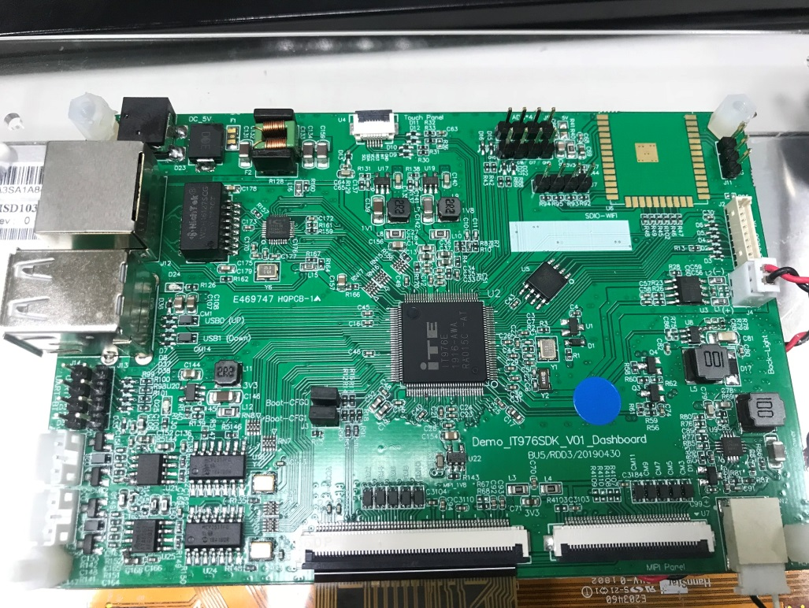

**CANBUS Pin Define**

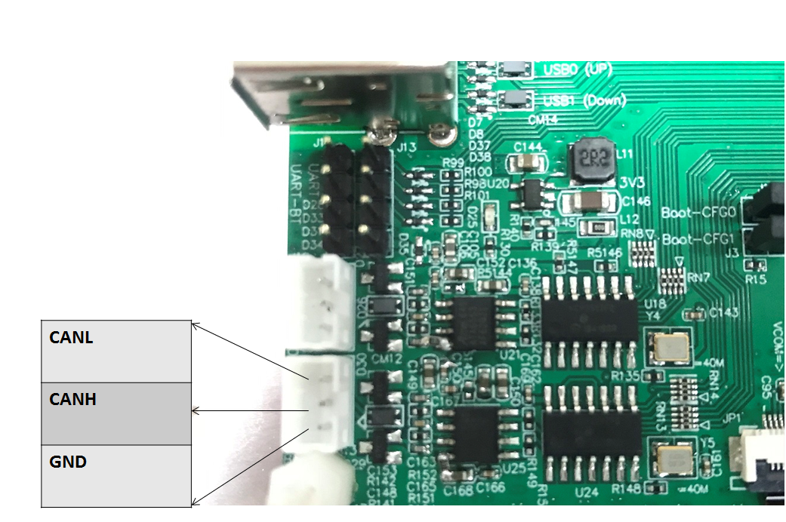

1. **Set SPI**

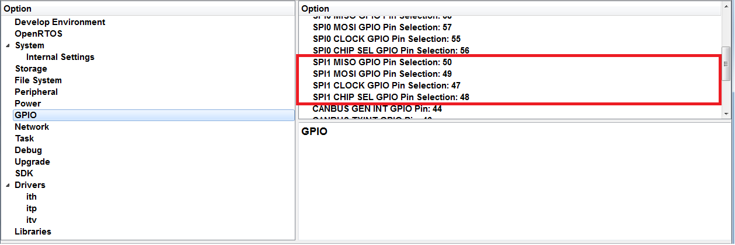

1. **Check Build Can bus Enable & GPIO**

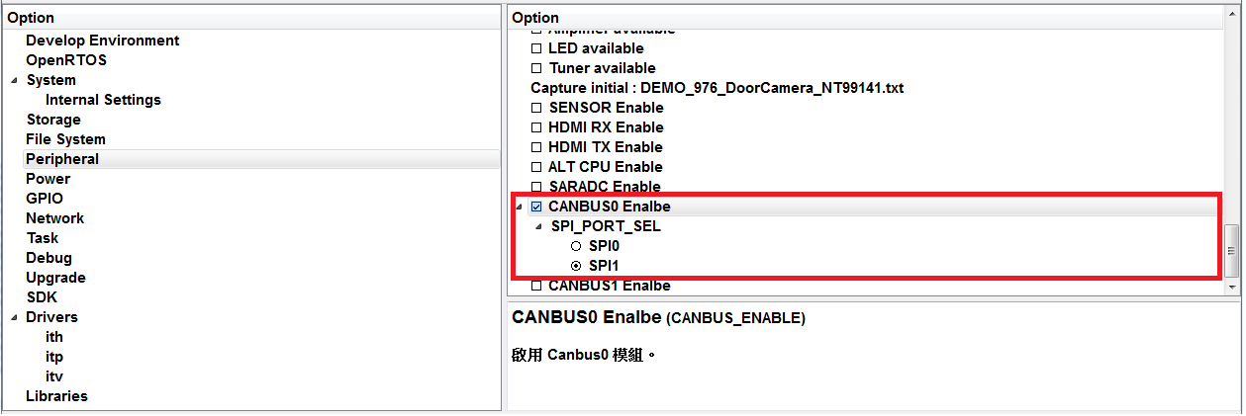

GPIO if not use , set -1.

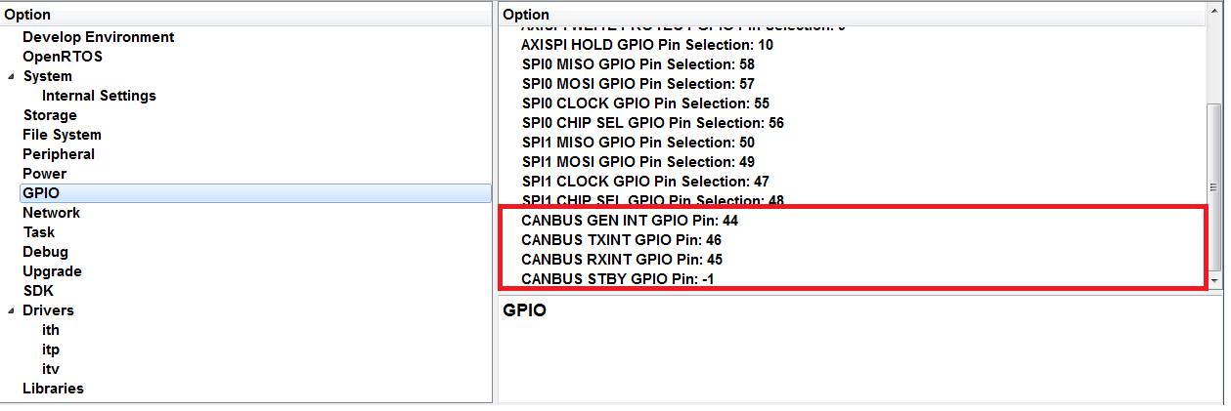

1. **Connect IT97X to can bus**

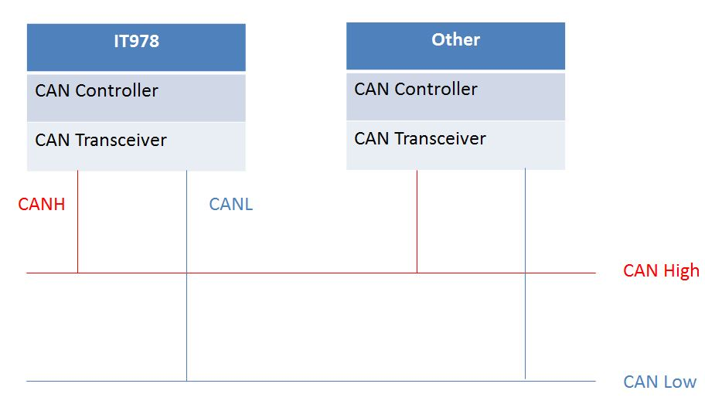

1. **Set bit rate(the device have same bit rate on the bus)**

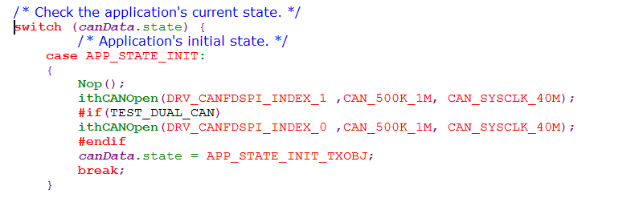

1. **Change define to choose test function**

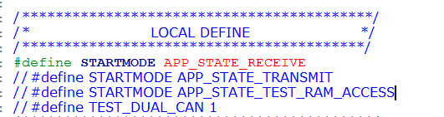

APP_STATE_RECEIVE : IT976 is receiver

APP_STATE_TRANSMIT: IT976 is transmitter , while loop transmit data

TEST_DUAL_CAN:

Use two canbus test , kconfig need open CANBUS 0 ENABLE and CANBUS1 ENABLE

1. **Run test project**

