**1.** **Hardware environment**

|  |  |
| --- | --- |
| mode | Device |
| CAP_HDMIRX_MODE | Source is HDMI RX (IT6801) |
| CAP_MODULE_MODE | Source is sensor |
| CAP_DELAYWINDOWS_MODE | Scan target board delay window |
| Target board:EVB977 144PIN | |

**2.Choose front-end device**

2.1 choose sensor (sensor on ,hdmi off)

* sensor enable

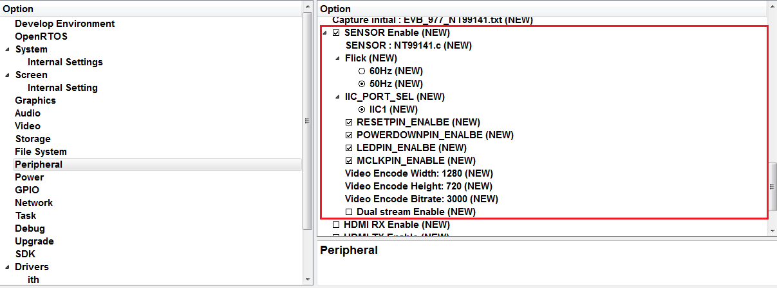

* sensor gpio

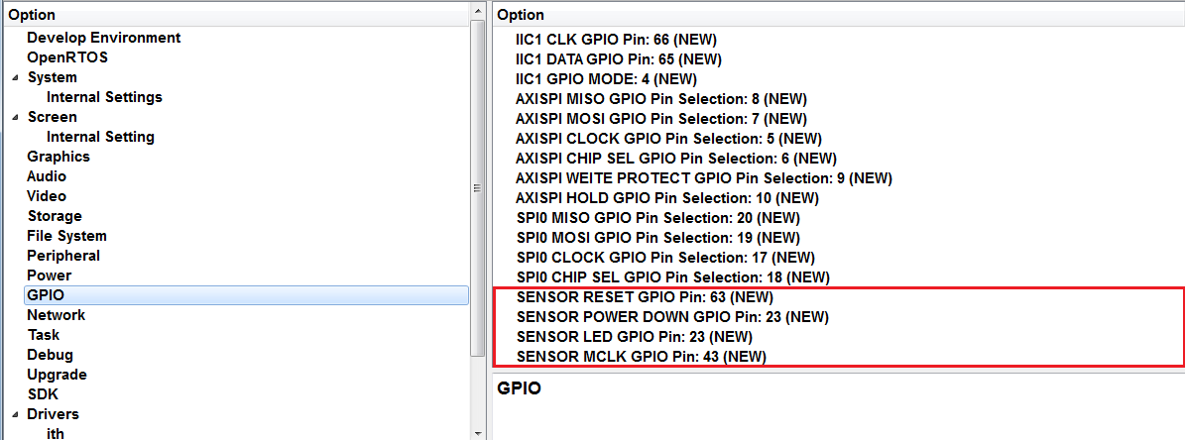

2.2 choose hdmirx(hdmi on ,sensor off)

* Hdmirx enable

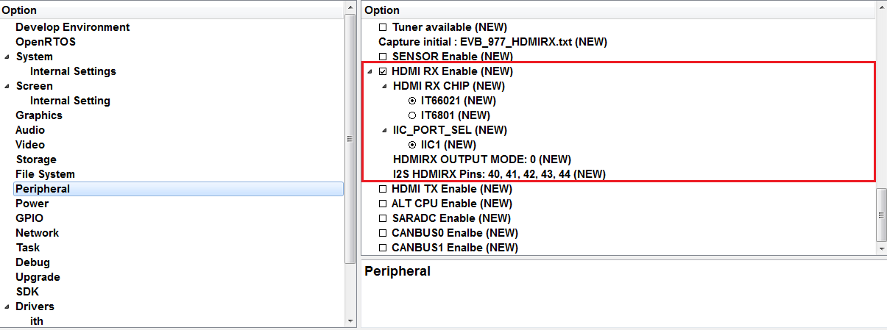

**3.Load capture init define:**

**根據**target board & source**來做設定:**

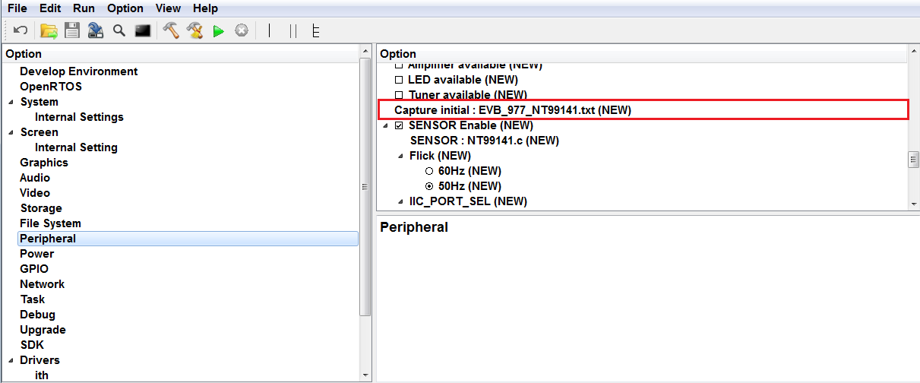

3.1如果要新增sensor就要新增一個 (xxx.txt) file 至path: sdk\target\defcap\

**4.IIC Setting**

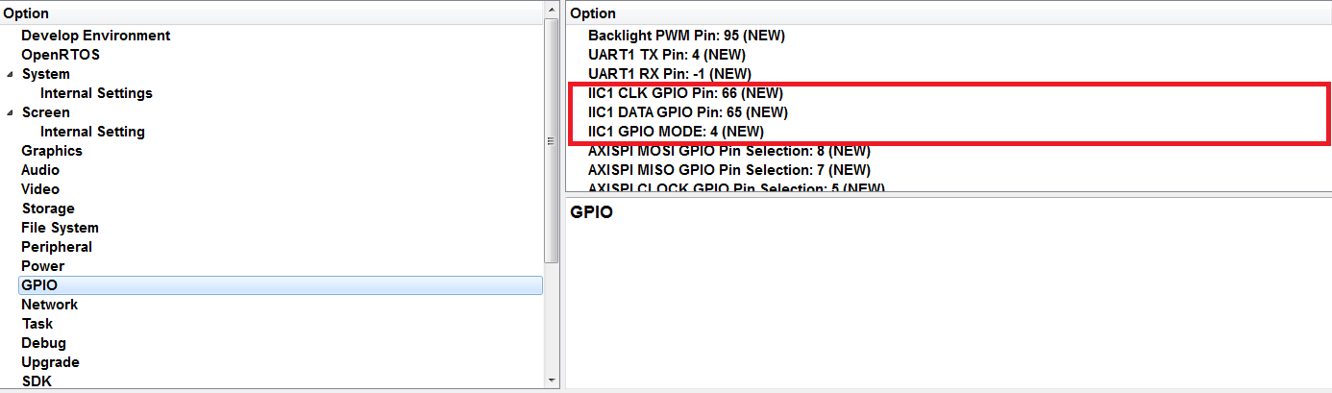

**5.Capture delay test**

Use CAP_DELAYWINDOWS_MODE run

show delay value = 0 ~ 15 stage , stable or unstable

example:

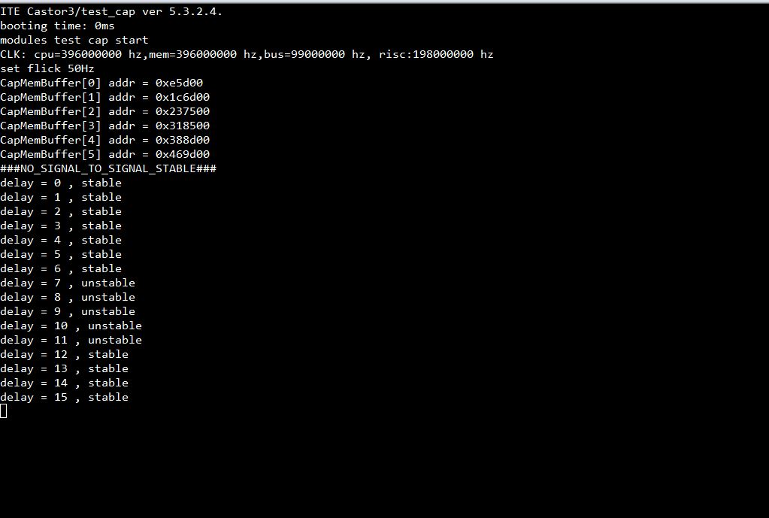

12 13 14 15 0 1 2 3 4 5 6 7 is stable. the median is 1 or 2 , 1 or 2 is best.

Set 1 or 2 in the VIDEO_TALBE ClkDelay item(according to your source timing)

sdk\include\capture\video_device_talbe.h

static CAP_NORMAL_TIMINFO_TABLE VIDEO_TABLE []={

{ Index, HActive, VActive,…,…, ClkDelay },

}

**6.Run Normal Test**

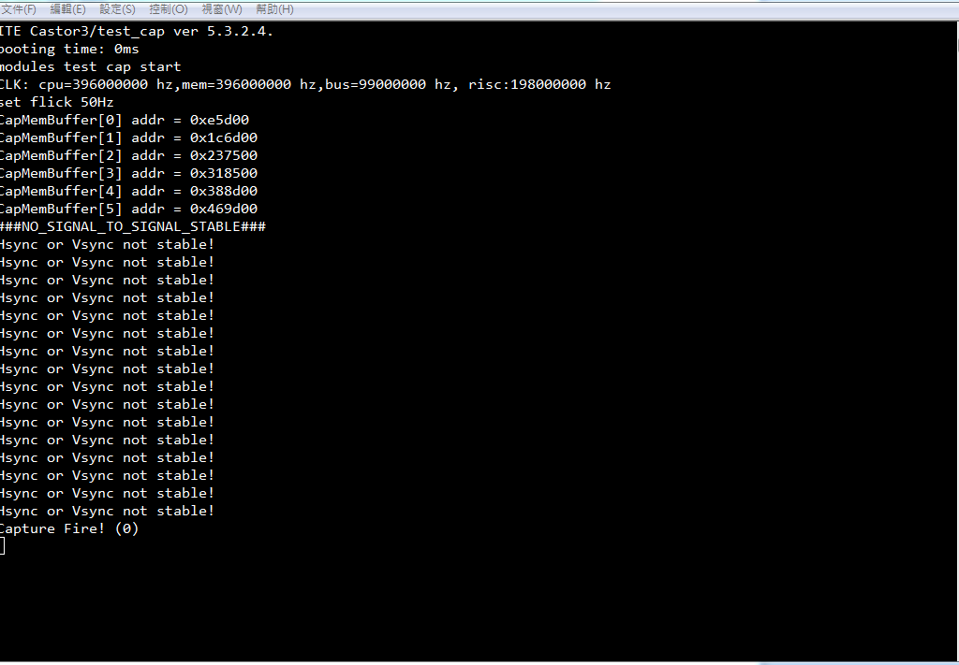

7.Error Status

Error code table:

|  |  |  |
| --- | --- | --- |
| Bits | Type | description |
| 0 | Read Only | 1:Hsync Stable  0:Hsync Unstable |
| 1 | Read Only | 1:Vsync Stable  0:Vsync Unstable |
| 2 | Read Only | 1:DE Stable(X)  0:DE Unstable(X) |
| 3 | Read Only | 1:DE Stable(Y)  0:DE Unstable(Y) |
| 11:8 | Read Only | Error code  [1]:Hsync loss  [2]:Vsync loss  [3]:DE loss  [4]:frame end error  [5]:capture overflow  [7]:frame rate change  [8]:time out |

Example:

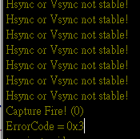

error code is [3] DE Loss.

9.Show on the Panel

Set Kconfig Screen. LCD enable.

