Indexing Images for Content Based Retrieval

Tianyi Zhuang
2014012056
THSS 41
zty0826@gmail.com
Songzhou Yang
2014013422
THSS 41
yangsongzhou.tsinghua@gmail.com

ABSTRACT
Image retrieval is one of the most important research scopes in recent days on computer science. In this paper, we compare different methods of image retrieval with different feature extraction methods, and evaluate the efficiency of r-tree.
Keywords
Image retrieval, feature extraction, r-tree, image histogram, HSV

IMAGES
We use two different color models, RGB and HSV. The RGB color model is an additive color model in which red, green, and blue light are added together in various ways to reproduce a broad array of colors. The HSV color model stands for hue, saturation, and value, and is also often called HSB (B for brightness). Compared with the RGB model, the HSV model may be more effective.

FEATURES
We use the color histogram with different implementation. And this part use MATLAB as a tool.

RGB histogram
This is a naive implementation of the color histogram, we calculate color histograms of RGB without any preprocess. And finally we get a vector of 768-dimension of every image.

HSV histogram
Consider that the HSV is more ocular than the RGB, so firstly we convert RGB images to HSV images before calculate histograms. The result is also a vector of 768-dimension of every image.

Gray histogram
In order to diminish the dimension of feature, we calculate a gray image for every image. With this process, we will get a vector of 256-dimension of every image.

Advanced RGB histogram
Even a 256-dimension vector seems to be of high dimension, so we try to diminish deeply. We re-divide the RGB model for 6Rs, 2Gs and 2Bs, and calculate histogram again. Finally, we get a 10-dimension vector and a 20-dimension vector.

Advanced HSV histogram
RGB works not as well as what we expected, so we do the same operation in HSV images. And got another sets of 10-dimension vector and 20-dimension vector.
In order to get a better results, we normalize every vector and get another sets of features.
Table 1. Accuracy of different features
Features | Dimension | Accuracy
RGB Hist 10d | 10 | 23.9106%
HSV Hist 10d | 10 | 33.4759%
RGB Hist 20d | 20 | 23.9337%
HSV Hist 20d | 20 | 35.8952%
Standardized RGB Hist | 10 | 24.0477%
Standardized HSV Hist | 10 | 33.2924%
Standardized RGB  Hist | 20 | 24.0834%
Standardized HSV  Hist | 20 | 35.9202%
Color Moment | 9 | 26.2890%

From this table we can see that our own HSV features can reach a higher accuracy compared with TA’s. Because HSV model can show image more ocular than color moment and RGB model.

EXPERIMENT RESULTS
We chose different features, calculate Euler distance between the query feature and stored features and return the nearest 10 results. These are some of our results.

Using Standardized 10-dimension RGB Hist-vector


Using Standardized 10-dimension HSV Hist-vector
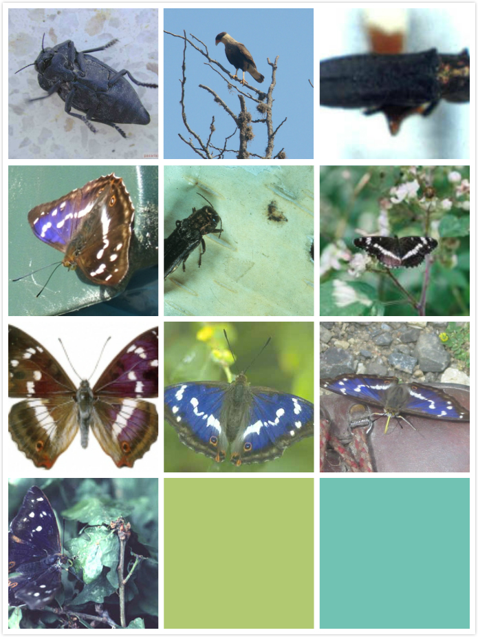

Using Standardized 20-dimension RGB Hist-vector


Using Standardized 20-dimension HSV Hist-vector


THE EFFICIENCY OF R-TREE
Because data in this experiment is low-scale, we store data in RAM rather than in disk. In this satiation, we use the node access times to imitate the disk access times.
We test with different parameters about the max number of data stored in one node, the number of data and the dimension of data.
In order to evaluate r-tree entirely, we generate some new features with different dimensions.
Here are results.

Table 2. Efficiency of R-Tree
The max number of data stored in one node: 4
 | 1000 | 2000 | 3000 | 4000 | 5000
4 | 47936 | 87915 | 121693 | 166713 | 195338
8 | 51577 | 90046 | 126545 | 159694 | 198996
12 | 63514 | 118011 | 160204 | 227214 | 266957
16 | 53704 | 106543 | 148847 | 185232 | 217470
20 | 63388 | 119121 | 171383 | 205733 | 271546

The max number of data stored in one node: 8
 | 1000 | 2000 | 3000 | 4000 | 5000
4 | 30419 | 55734 | 81127 | 99879 | 128094
8 | 31692 | 59636 | 77159 | 97291 | 119555
12 | 43640 | 77800 | 111082 | 134741 | 160101
16 | 41510 | 77214 | 106083 | 137250 | 175426
20 | 41098 | 76838 | 109882 | 141383 | 181638

The max number of data stored in one node: 12
 | 1000 | 2000 | 3000 | 4000 | 5000
4 | 25520 | 41892 | 54439 | 71425 | 84177
8 | 24009 | 41132 | 59130 | 77239 | 87362
12 | 29267 | 58100 | 75902 | 98288 | 130296
16 | 32104 | 61472 | 90132 | 114418 | 139251
20 | 32829 | 65151 | 96135 | 119793 | 150430

From above tables, we will know that the node access times are concerned with the max number of data stored in one node, the number of data and the dimension of data. The more the number of data stored, the fewer the number of data is, so the node access times is fewer. The more the dimension of data is, the more complex the query space is, so the node access times are more.

CONCLUSIONS
The efficiency of r-tree is concerned with many factors, we can take different methods to enhance r-tree on the basis of different usages. In general, the more dimension the data has, the bad efficiency the r-tree has, so there is a large optimization space. Aimed at the image retrieval problem, the accuracy seems to be lower, so it’s important to modify feature extraction methods even rebuild a framework.

REFERENCES
- Y Rui, TS Huang, SF Chang. 1999 Image Retrieval: Current Techniques, Promising Directions, and Open Issues. Journal of Visual Communication and Image Representation Volume 10, Issue 1, 1 March 1999, Pages 39–62
- Anil K. Jain, Aditya Vailaya. 1996 Image retrieval using color and shape. Pattern Recognition Volume 29, Issue 8, August 1996, Pages 1233–1244
- A. W. M. Smeulders ; Amsterdam Univ., Netherlands ; M. Worring ; S. Santini ; A. Gupta. 2002 Content-based image retrieval at the end of the early years. IEEE Transactions on Pattern Analysis and Machine Intelligence (Volume:22 , Issue: 12 )

