Website Planning Document- Weather 1-30-19

**Site Name:**

LetsPlayWeather.com

**Site Logo:**

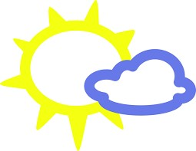

**Site Moto:**

Lets Get you out in the Weather

**Site Purpose:**

The purpose of this website is intended to give the most accurate weather forecast. As friends, family, and youth get ready to go out for practice, go to a game, or even a family outing many ask, “What’s the weather like or what should I wear or even is it cold out?” The intent is to be quickly attainable for any age, so that if a parent asked even a younger individual could browse the site with ease and attain the information. In doing so they can find that excitement to get prepared for the days events or make some adjustments in the schedule to make it Play Weather.

It will not be very complex, you pick the location and it will present the information for the next few hours or days dependent on developer options and client feedback. We want people to rely on accurate weather updates so they can understand the conditions now and to come. It is also a way to help the youth to gain an understanding to be aware of their surrounds and environments.

**Target Audience:**

Benny- 10 years old, works a lemonade stand, in the 4th grade, does not own any electronics so a novice to how to use sites, but needs to gain understanding what the weather will be like for the next 3 hours to be prepared to go play in his soccer game. Also, he can let his parents know if they need to bring an umbrella or a hat.

Parents to Benny- 45 years old, works on the PTO, but does make picture books for all ages so she understands the need of a clean yet, attention grabbing site. She graduated college with a degree in communications and the purpose is to understand whether it might be acceptable to send her children outside to play for the next little while with friends. Do they need sun block, hat, jacket? She is already concerned for their safety, but wants to have the peace of mind that the weather won’t be another thing to worry about.

Scenario 1: Benny has a game coming up at 4:00 this afternoon, his mother is already stressed out about a deadline to submit a new picture book and has to help her son get ready. She knows she needs to use her time wisely. While she continues to produce her product, she asks Benny to get on LetsPlayWeather and see what it will look like so she can make sure those appropriate clothes are ready for the game.

Scenario 2: The Parents of Benny are getting ready to leave on a small business lunch with the coworkers. The parents are concerned about how the weather might be while they are gone and doesn’t want the baby sitter to let them be out in the cold or bad weather. Before the go they want to rely on a website to know they will at least be safe being outside in the weather, despite knowing they could get hurt. But it will mean one less thing to worry about, they have 5 minutes before they leave.

**Site Map:**

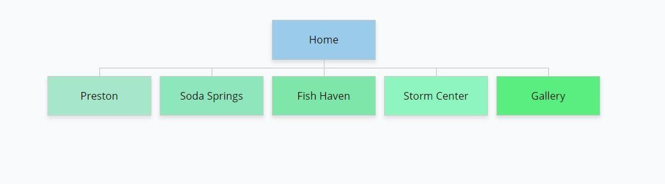

**Color Scheme:**

Light Gray Footer

Cadet Blue Header

Dark Olive Green Forecast

Dark Cyan Font

**Typography:**

Site Header: Times New Roman 40px

|  |  |  |
| --- | --- | --- |
| Primary Navigation Points: | Times New Roman | 30px |
| H1: Times New Roman | 30px |  |
| H2: Times New Roman | 30px |  |
| H3: Times New Roman | 30px |  |
| Paragraph Notes (Text): | Open Sans 16px |  |

**WireFrame:**

