**CPSC 481 - FALL 2020 TEAM A**

**Team A Project**

**Interactive Cookbook**

**Stage Three: Create Something!**

**Parker Siroishka Hardeep Kaler Chris Selinger Richard Chow Abigayle LeFranc**

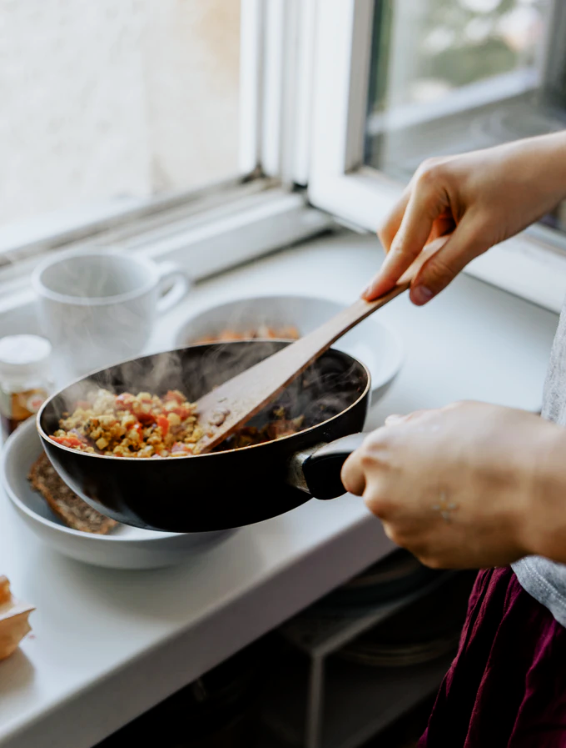

# Project Description: Updated Project Idea

Our mobile/web cookbook application will be a new tool that will help users in all aspects of the kitchen. Be it, the user is a beginner or highly advanced cook, this application will have all the resources anyone needs.

Users can search for new recipes in a higher-level search function that will personalize the filter when avoiding certain ingredients, different diets and various allergies. In choosing a recipe, serving sizes can be changed, substitutes for ingredients will be given as well as easy step by step video guidance for any recipe.

This application will also come with tools needed in the kitchen such as a timer, translator and encyclopedia of unknown cooking terms and instructions as well as a unit converter for ingredient amounts.

Finally, one unique feature will include two functions that will help users keep track of ingredients and items they have at home. The pantry function allows users to log and search for food items they have. This function will also notify the user when the expiry date is near, and users can quickly add these items to the applications shopping list. Using the shopping function, users can keep track of what they need and what they should buy later, as well as share this list with others. Anybody can use this application to make things simpler and more organized when in the kitchen.

# Updated User Tasks

## Must be included

* Searching for and filter through recipes
* Be able to open and easily navigate a recipe in either standard or an expanded mode
  + Standard mode: Previewing a recipe
  + Expanded mode: Cooking with the recipe

## Important

* Utilize as a virtual pantry list and shopping list
* Manage, create, save, edit and share recipes

## Could be included

* Utilize included tools such as unit converter, cooking timer, instructional videos, and cooking definitions.

# Storyboard

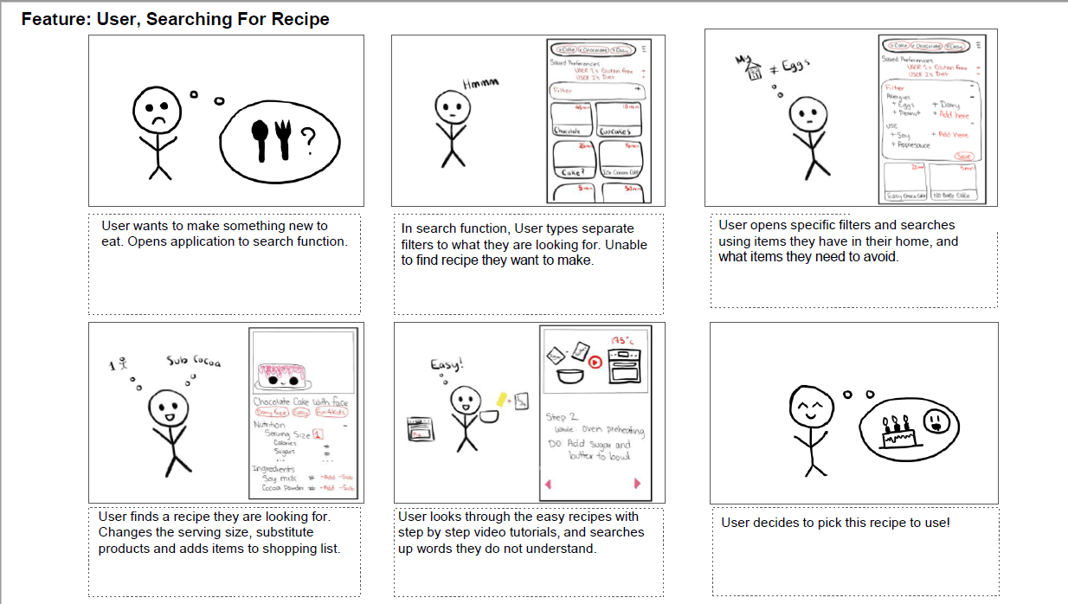

# Discussion of Task Centered System Cognitive Walkthrough

The process that was taken during the task centered system cognitive walkthrough was to break up our user tasks into different steps, then evaluate them based on the questions in the task centered walkthrough template, asking ourselves whether the user would have the training or knowledge to do the task step, whether it’s believable they would do it and are they motivated to do it. Afterwards, depending on our answers to those questions, we would comment on the reason why the users would respond to those questions the way that they do. Throughout this process, we found that our user tasks fit the use cases very effectively, with all the responses being yes to the questions. It is also important to note that the answers to the questions are based on the notion that the user has experience with a smartphone. If a user has never used a smartphone before there will be an unfamiliarity with the functionality we made.

# Reflection

## What went well

The Brainstorming went well, as everyone was involved in creating ideas and were willing to edit and refine other people’s ideas as well see how our idea mesh together. This all came together and formed the skeleton for our prototype. Having done the structure in this step the idea polishing step and creating a storyboard went very well and lead to the prototyping step going smoothly.

## What went poorly

The Affinity Diagram part went poorly: there was issue with understanding what exactly an affinity diagram was as well as how it would interpret about our ideas. This costed time as we created multiple attempts at what the affinity diagram could and should be but we received clarification later which helped us with our understanding.

## What would we do differently

What we would do differently if we did this again would be to define properly what an affinity diagram should be earlier on and work within that definition. For brainstorming, we’d like either more time or maybe a tool to help facilitate more unique ideas for the brainstorming step.

# Appendix

## Sample of Sketches

**Calendar Pantry**

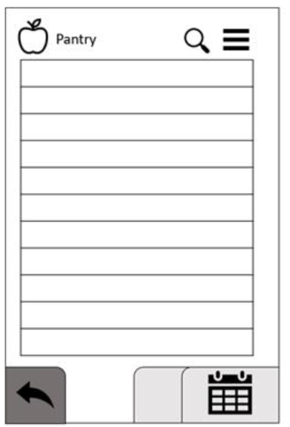

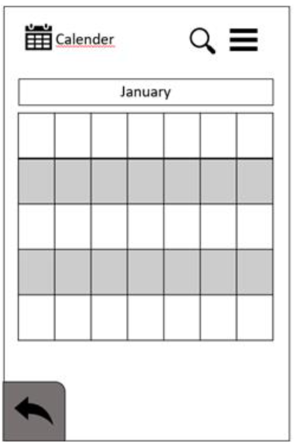

**Gesture Control**

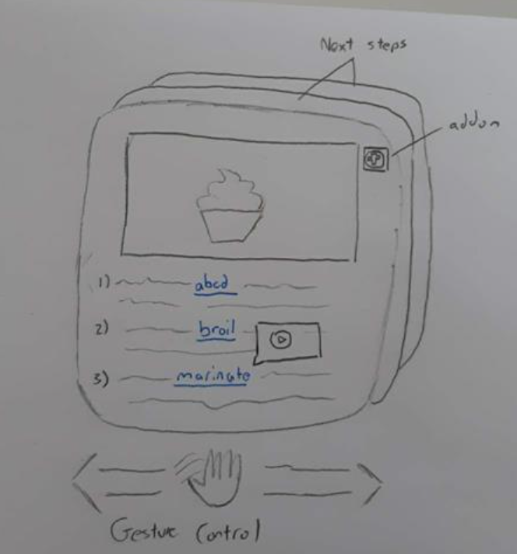

**Home Screen**

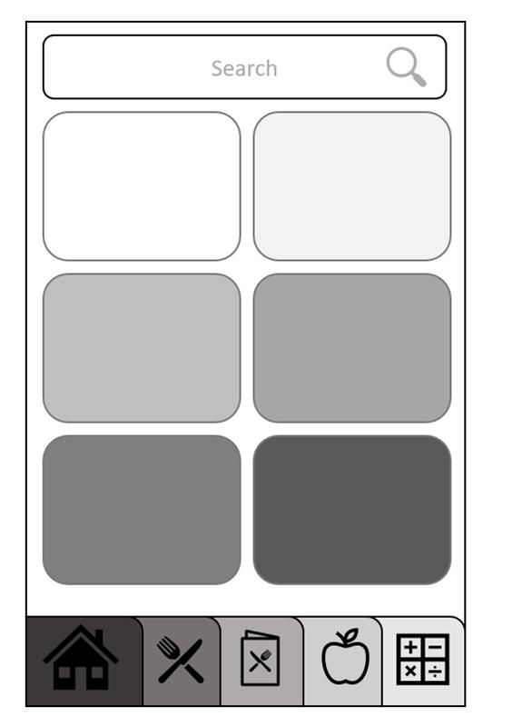

**Menu**

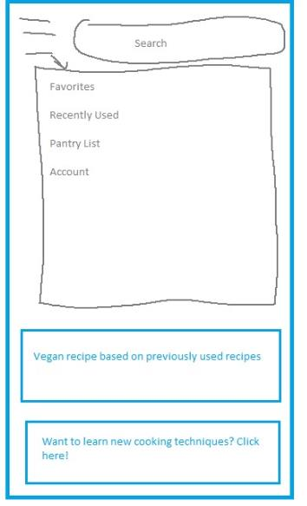

**Pantry List**

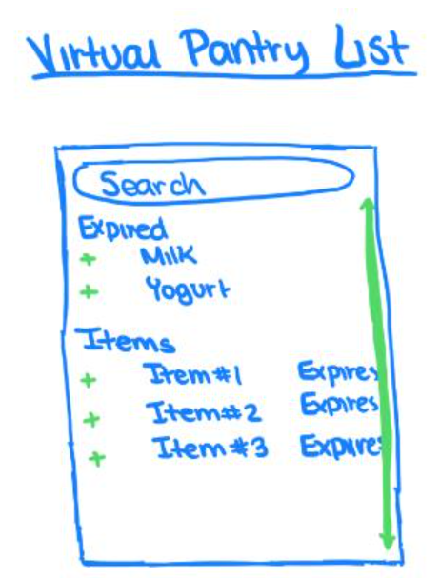

**Recipe Start Page**

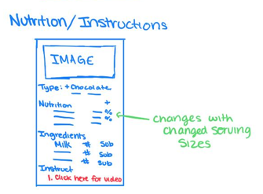

**Recipe Step**

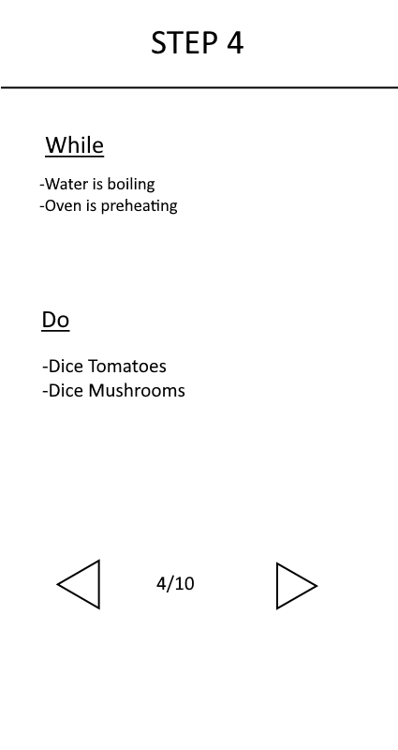

**Search Landing Page**

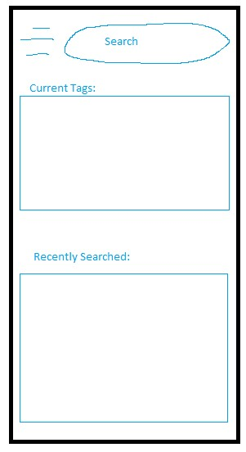

**Search Filtering**

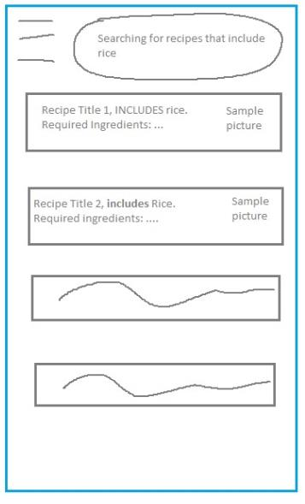

**Shopping List**

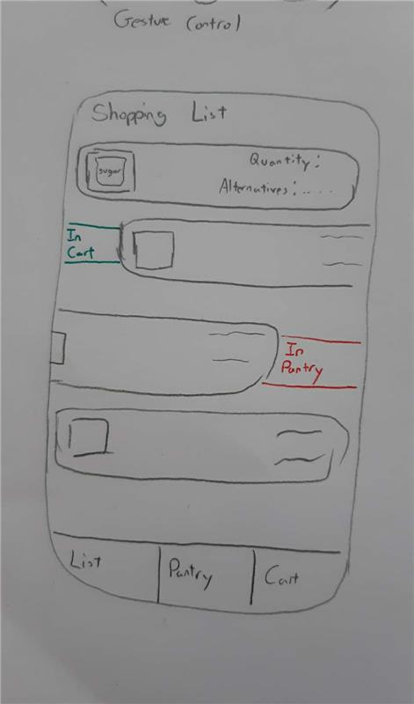

**Technique Model**

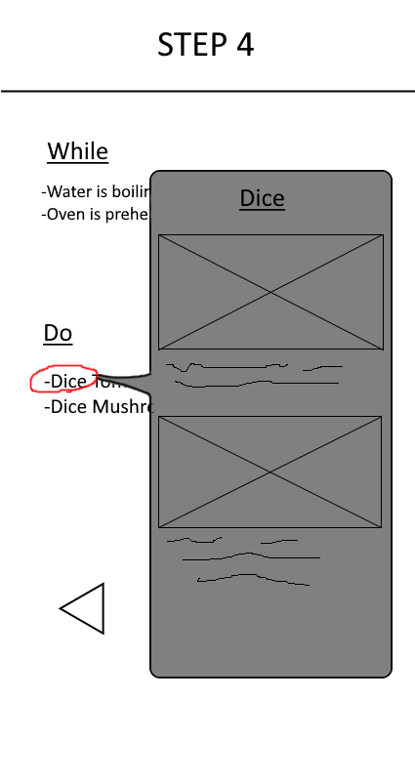

**Tools**

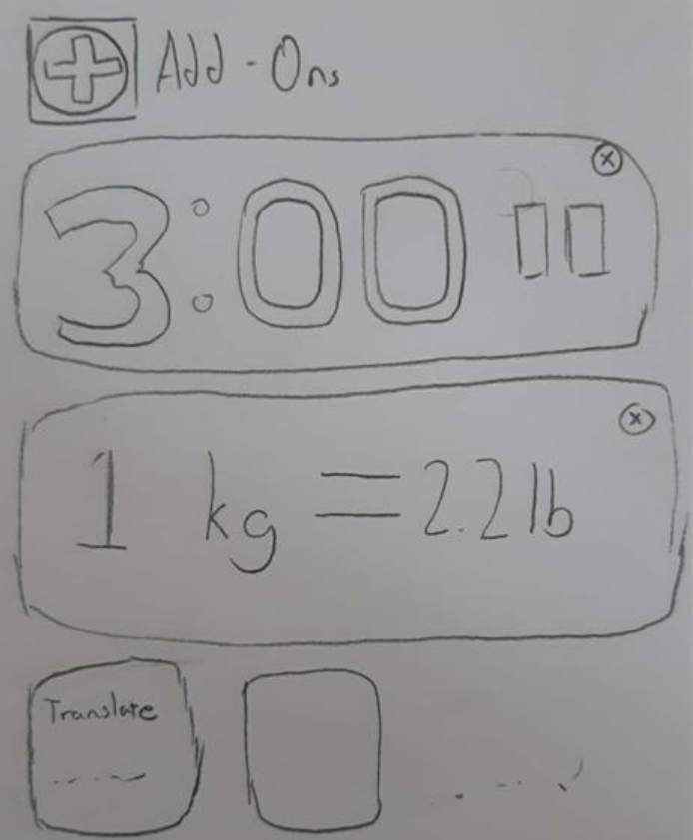

## Affinity Diagrams

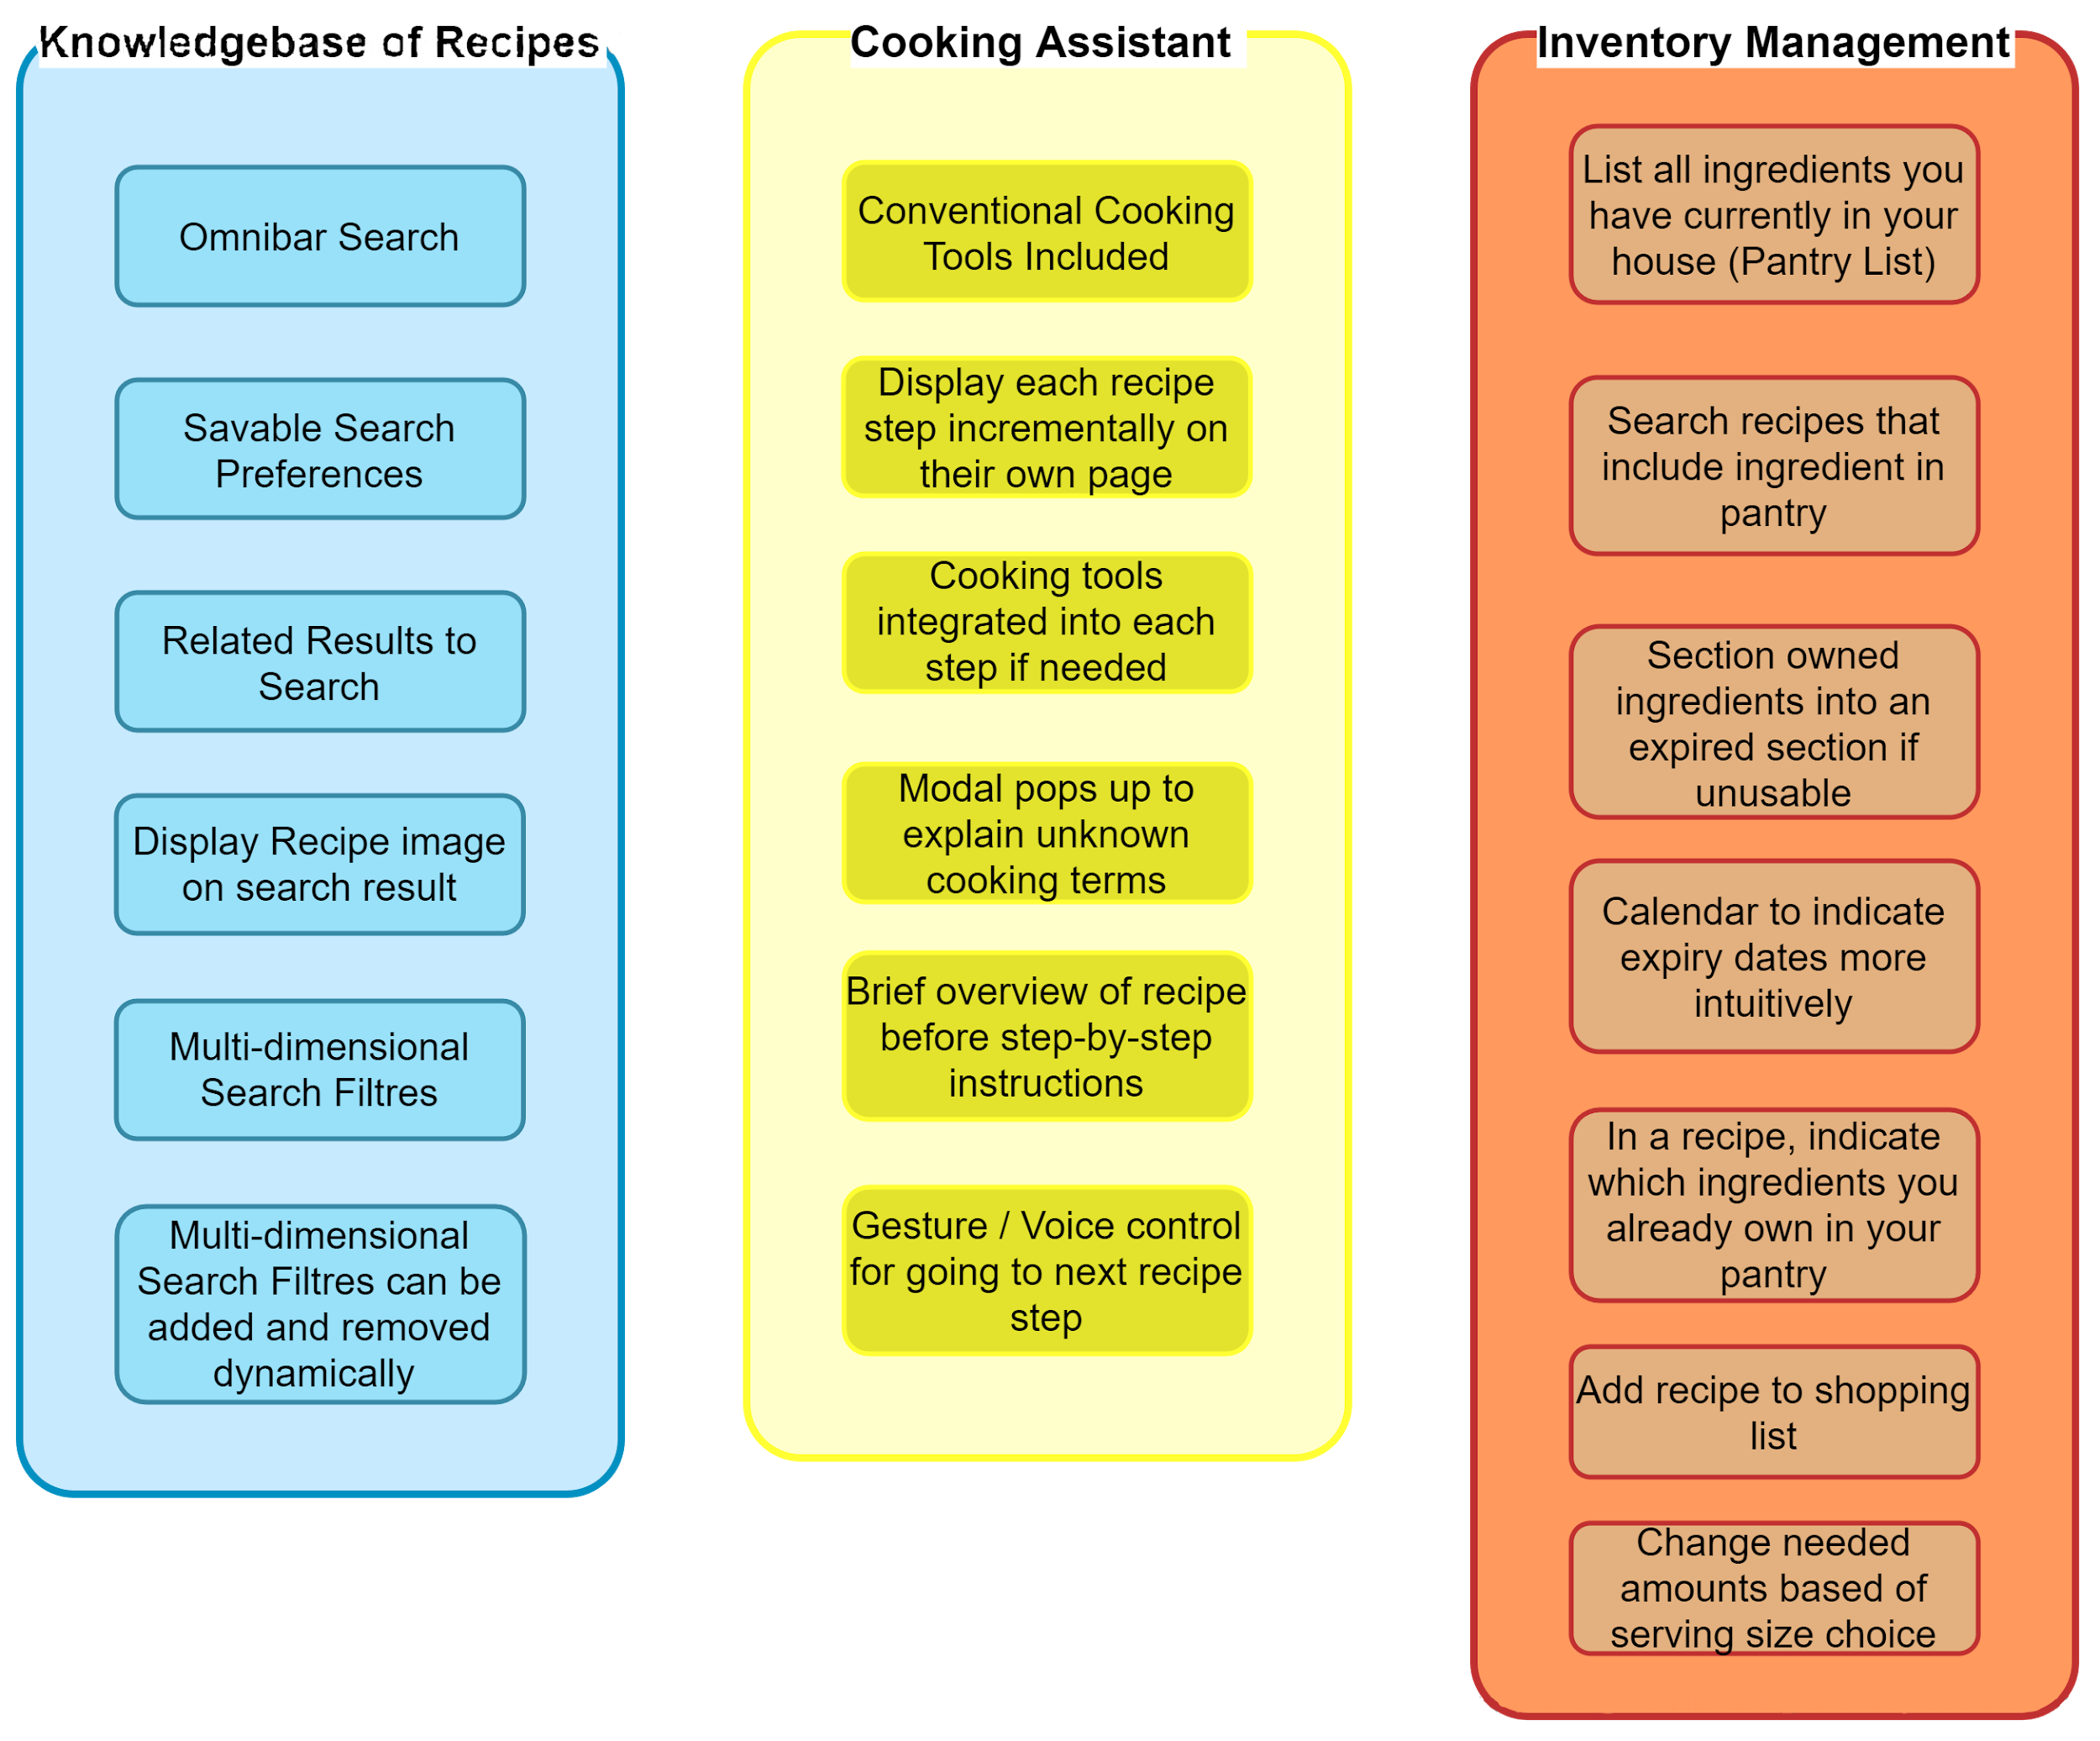

## Cognitive Walkthrough

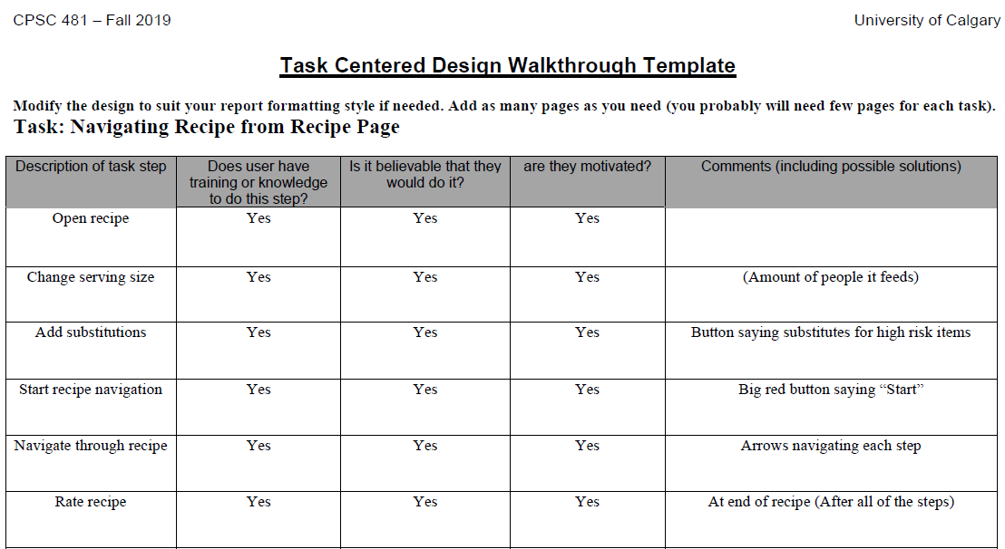

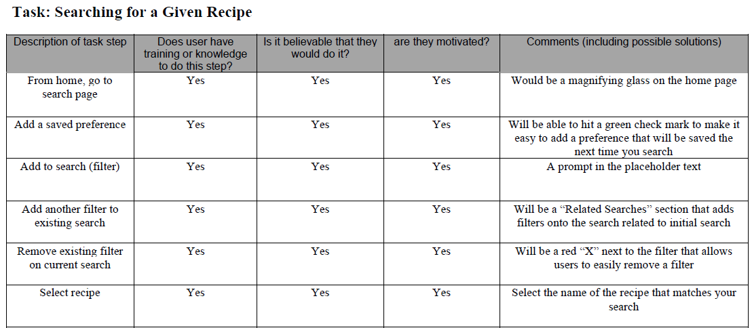

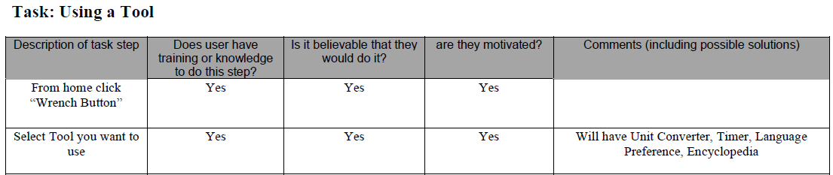

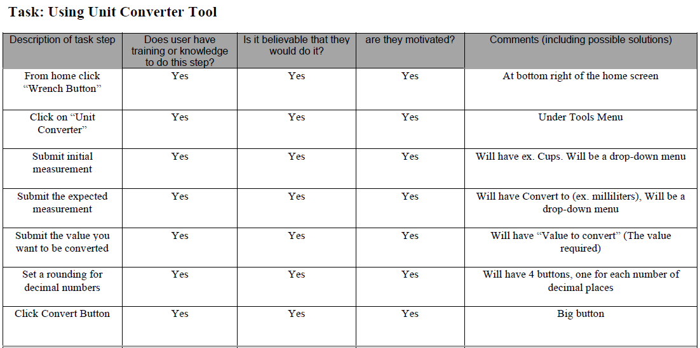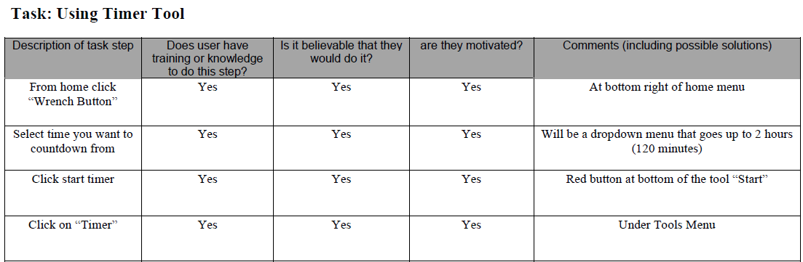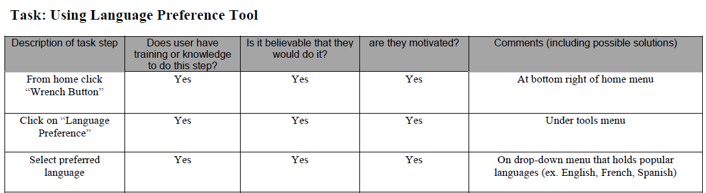

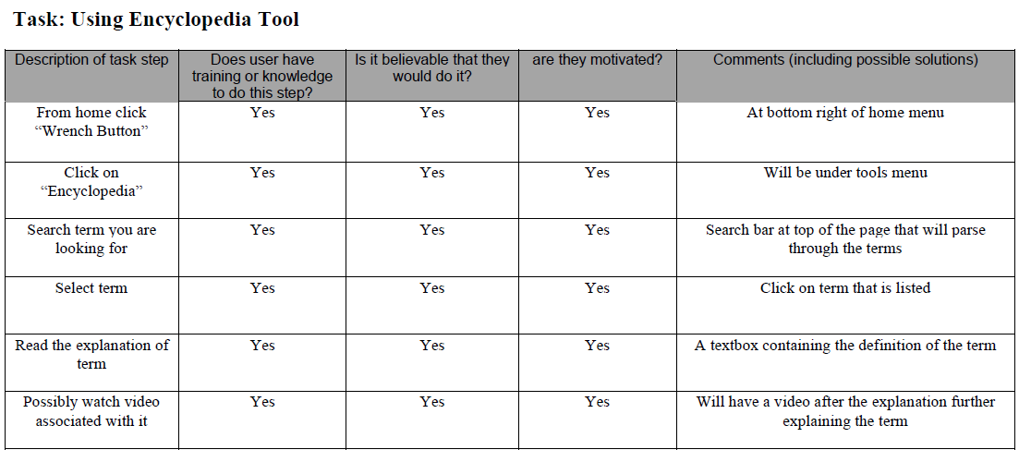

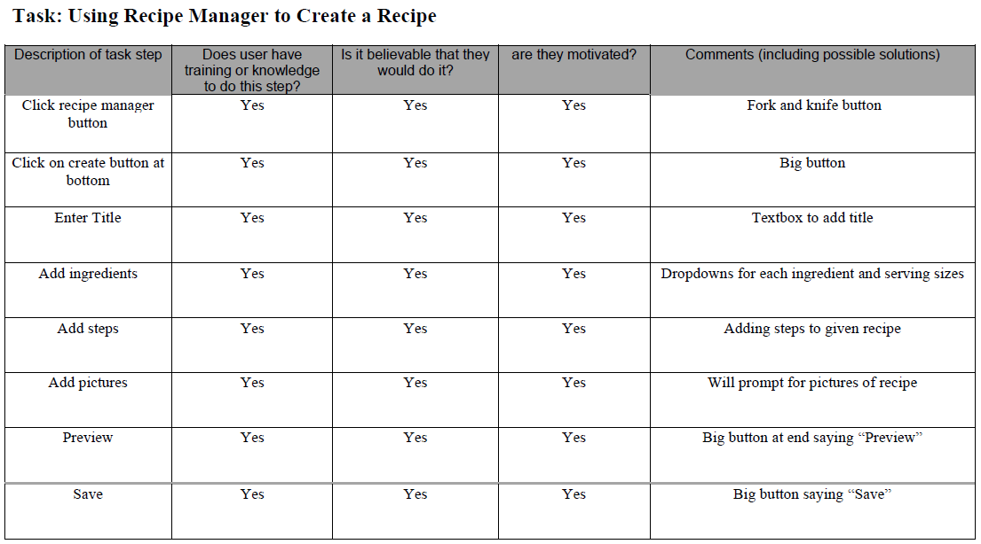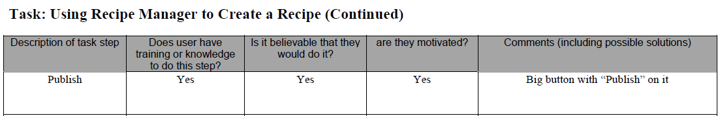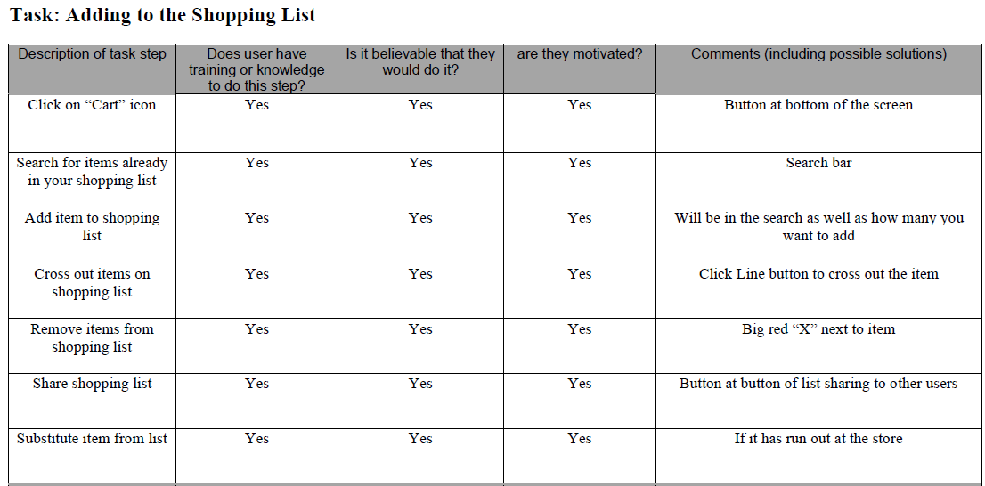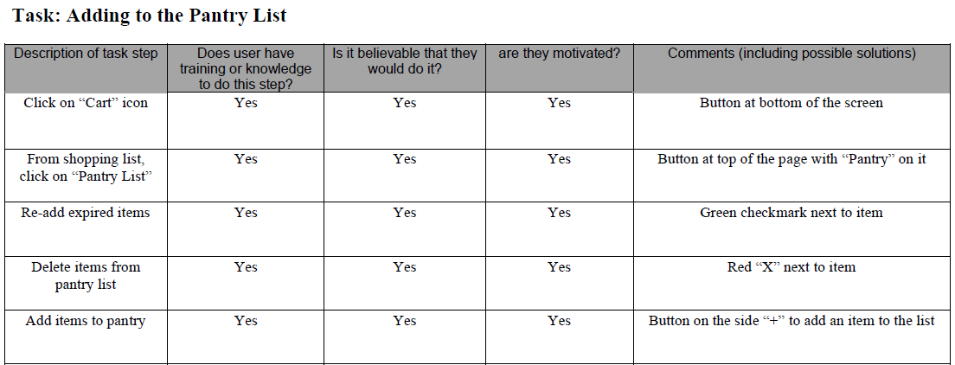

# Portfolio

<https://the-a-team-d0122b.webflow.io/>