SFWE 504 Team 5, University of Arizona
Software Requirements Specification
Produced by , 11/04/2025
Table of Contents
1 System Architecture 5
1.1 Backend-Data Flow Diagram 5
1.2 Matching Engine Class Diagram 6
1.3 Front-End State Diagram 7
1.4 Report Engine Use Case Diagram 8
2 Front End Functional Requirements 8
2.1 Scholarship Application Form UI 8
2.2 Existing Scholarship Application Customization 8
2.3 Scholarship Applicant Profile Interface 9
2.4 Applicant Landing Page 9
2.5 Administrator Landing Page 9
2.6 Reviewer Landing Page 9
2.7 Sponsor & Donor Landing Page 9
2.8 Stewards Landing Page 9
2.9 Document Locker GUI 9
2.10 Scholarship Creation Page 9
2.11 Applicant Review UI 10
2.12 Suitable Applicant Report 10
2.13 Reviewer Scoring 10
2.14 Final Decision Panel 10
2.15 Admin Reports 10
3 Back End Functional Requirement 10
3.1 Applicant Information Collection 10
3.2 Online Scholarship Form Creation 10
3.3 Applicant Document Upload 10
3.4 Scholarship Information Entry 10
3.5 Applicant Status Notifications 11
3.6 Sponsor/Donor Communications 11
3.7 Reviewer Notifications 11
3.8 Applicant Pre-Screening 11
3.9 Qualified Applicant List/Report 11
3.10 User Authentication 11
3.11 Unauthorized Access Prevention 11
3.12 Role-Based Permissions 11
3.13 Scholarship CRUD 11
3.14 Scholarship Search (Keyword) 11
3.15 Reviewer Score & Comment 12
3.16 Submission prevention 12
4 Matching Engine Functional Requirements 12
4.1 Data Input 12
4.2 Eligibility Check 12
4.3 Ineligibility Exclusion 12
4.4 Compute a match score 12
4.5 Ranking 12
4.6 Preliminary Match Report 12
4.7 Reviewer Access 12
4.8 Manual Override 12
4.9 Data Storage 13
4.10 Reviewer Feedback 13
4.11 Batch Processing 13
4.12 Real-Time Matching 13
4.13 Logging & Audit Trail 13
4.14 Final Match Confirmation 13
4.15 Award Status Update and Cross-Scholarship Visibility 13
5 Report Engine Functional Requirments 13
5.1 Scholarship Reports 13
5.2 Applicant Reports 13
5.3 Candidate Matching and Review Reports 14
5.4 Final Award Disbursement Report 14
5.5 Export Formats 14
5.6 Role-Based Report Access 14
5.7 Report Filtering 14
5.8 Report Scheduling 14
5.9 Summary Visualization 14
5.10 Report Versioning 14
5.11 Access Logging 14
5.12 User Log In Reports 14
5.13 Funding Report 14
5.14 User Support Report 15
5.15 API Error Report 15
6 Non-Functional Requirements 15
6.1 System Performance 15
6.2 Browser Compatibility 15
6.3 Maintainability and Upgradability 15
6.4 Scalability 15
6.5 Security 15
6.6 Backup and Recovery 15
6.7 Auditability 15
6.8 Monitoring and Alerts 16
6.9 Interoperability 16
6.10 Password Security 16
6.11 Data Encryption 16
6.12 Error Handling 16
6.13 Transmission Protocols 16
6.14 FERPA Adherence 16
6.15 Interfacing 16

System Architecture

Backend-Data Flow Diagram
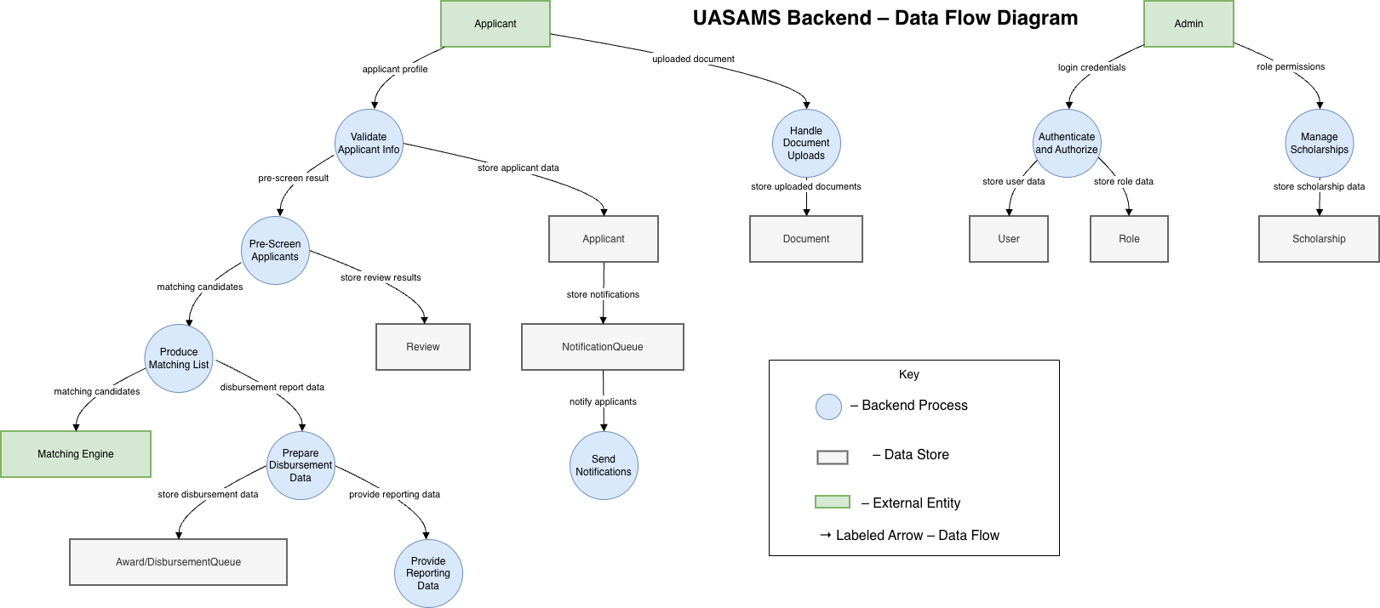

Matching Engine Class Diagram
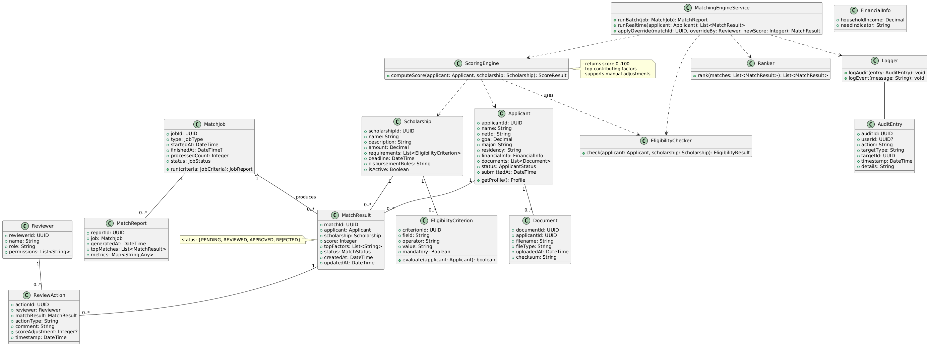

Front-End State Diagram
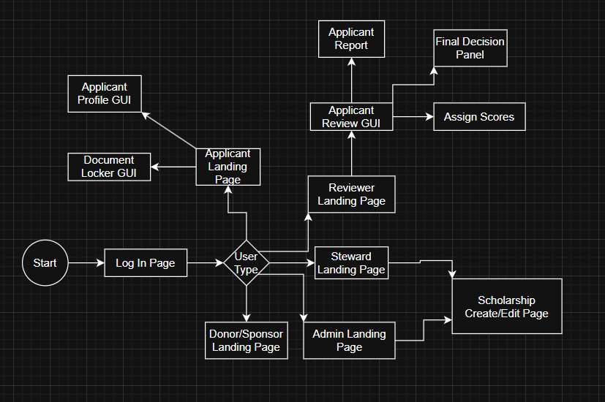

Report Engine Use Case Diagram
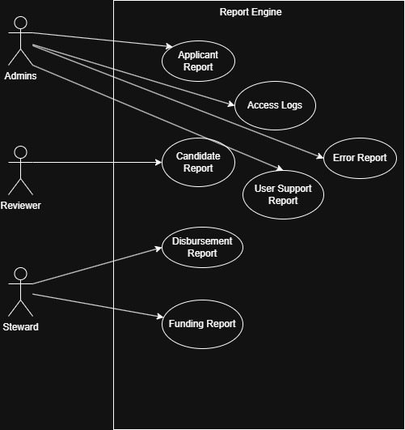

Front End Functional Requirements

Scholarship Application Form UI
The Front End Sub System shall allow a Users identified as Stewards and ENGR Scholarship Admins to create the following information about a scholarship : Scholarship Name, Citizenship Requirements, GPA Requirements, Academic Level, Degree Major, Degree Minor (Optional), Award Amount, Financial information and additional document requirements.

Existing Scholarship Application Customization
The Front-end Subsystem shall allow Users identified as Stewards and ENGR Scholarship Admins to customize existing information about a scholarship : Scholarship Name, Citizenship Requirements, GPA Requirements, Academic Level, Degree Major, Degree Minor (Optional), Award Amount, Financial information and additional document requirements.

Scholarship Applicant Profile Interface
The Front-end will allow Users of type Student Applicants to enter the following information into their personal profile : Name, Student ID, NetID, Degree Major, Degree Minor (Optional), Academic Achievements, Financial information and any written essays.

Applicant Landing Page
The Front-end will provide Applicants with a GUI specific to their role as scholarship applicants with links to available applications, In progress applications, Application status's and profile customization.

Administrator Landing Page
The Front-End subsystem shall provide the ENGR Administrators with a Landing Page with all the links to User edit/create/delete, application edit/create/delete, help page, disbursement controls, reports and user password management.

Reviewer Landing Page
The Front-End Sub-System shall provide Reviewers a Landing Page with links to application reviews, Accepted Applications and Applicant Qualifications.

Sponsor & Donor Landing Page
The Front-End shall provide Sponsors and Donors with a Landing Page with links to scholarship creation request/change.

Stewards Landing Page
The Front-End Sub-System shall provide Stewards with a Landing Page with links to all the features available to them.

Document Locker GUI
The Front-End will provision Applicants with a GUI used to submit documents such as transcripts, letters of recommendation, and essays.

Scholarship Creation Page
The Front-End shall provide Sponsors/Donors the ability to submit the following information for a new scholarship offering : cholarship name, scholarship description/requirements, recipient selection requirements, scholarship point of contact and
contact information, scholarship amount, disbursement requirements, frequency of scholarship offering and an other box.

Applicant Review UI
The Front-End shall provide Reviewers the ability to evaluate applicant submissions for scholarships.

Suitable Applicant Report
The Front-End shall display a report when Reviewers are evaluating applicants that shows who fulfills the requirements.

ReviewAer Scoring
The Front-End shall allow Reviewers to assign scores, make comments and track application progress for applicants.

Final Decision Panel
The Front-End shall allow the Reviewer to have a dedicated UI for final decisions for scholarship awarding.

Admin Reports
The Front-End shall provide Admins a GUI that will generate reports and analytics for insight on application process, demographics and the impact of scholarship awards.

Back End Functional Requirement

Applicant Information Collection
The backend shall prompt the applicant for the following information: name, student ID, NetID, degree major, degree minor (if applicable), academic achievements, financial information, and written essays.

Online Scholarship Form Creation
The backend shall allow the College of Engineering to create and customize scholarship application forms that are available online.

Applicant Document Upload
Applicants shall be allowed to upload required documents such as transcripts, letters of recommendation, and essays directly into the system.

Scholarship Information Entry
For creation of new scholarships, the backend shall provide a scholarship donor or sponsor to enter scholarship name, scholarship description/requirements, recipient selection requirements, scholarship point of contact and contact information, scholarship amount, disbursement requirements, frequency of scholarship offering, and other relevant information.

Applicant Status Notifications
The backend shall include communication features to send automated emails or notifications to applicants that inform them of application status updates, deadlines, and other relevant information.

Sponsor/Donor Communications
The backend shall include communications to current and prospective scholarship sponsors/donors including key dates and deadlines, notification of applicants for a given scholarship, and post-award reports.

Reviewer Notifications
The backend shall inform designated scholarship application reviewers that there are applicants to be reviewed for a specific scholarship.

Applicant Pre-Screening
The backend shall pre-screen the applicants’ information to ensure that they meet the requirements of the scholarship; if the applicant does not meet requirements, they will be excluded from further consideration.

Qualified Applicant List/Report
The backend shall generate a list/report of applicants that meet all scholarship requirements for a given scholarship.

User Authentication
The backend shall require that all users have a valid username and password in order to access the UASAMS.

Unauthorized Access Prevention
The backend shall prevent unauthorized users from gaining access to the system.

Role-Based Permissions
The backend shall allow authorized users to only have access to portions of the system that they are granted permissions for.

Scholarship CRUD
The backend shall create, read, update, and delete scholarship records (title, description/requirements, amount, deadlines).

Scholarship Search (Keyword)
The backend shall return scholarships filtered by a simple keyword that matches name or description (case-insensitive).

Reviewer Score & Comment
The backend shall allow reviewers to submit a numeric score and a comment for each assigned application.

Submission prevention
The backend shall prevent applicants from submitting or editing an application after the scholarship deadline has passed.

Matching Engine Functional Requirements

Data Input
The system shall accept applicant data (e.g., GPA, major, residency, financial info) and scholarship data (e.g., eligibility requirements, amounts, deadlines) from the back-end database for processing.

Eligibility Check
The system shall compare each applicant’s information with scholarship eligibility criteria to determine qualification status.

Ineligibility Exclusion
The system shall exclude applicants who do not meet one or more mandatory eligibility requirements with appropriate reasoning.

Compute a match score
The system shall compute and return a matching numeric score (0-100) representing match strength, plus top contributing factors for every applicant.

Ranking
The system shall rank eligible applicants for each scholarship in descending order of total match score.

Preliminary Match Report
The system shall generate a preliminary match report listing each scholarship, its matched applicants, and match scores for review by administrators and reviewers.

Reviewer Access
The system shall allow authorized reviewers or administrators to view, approve, or reject matched applicants.

Manual Override
The system shall allow reviewers or administrators to adjust scores or override automatic match results.

Data Storage
The system shall store match results, reviewer actions, and timestamps for audit and reporting.

Reviewer Feedback
The system shall allow reviewers to record short comments or feedback for matched applicants.

Batch Processing
The system shall process bulk matching jobs for all scholarships upon administrator request.

Real-Time Matching
The system shall perform on-demand matching for a single applicant immediately after submission.

Logging & Audit Trail
The system shall log all match operations with start time, end time, number processed, and status.

Final Match Confirmation
The system shall confirm a scholarship–applicant match only after reviewer approval and update the match status to “Approved.” Once it is approved no edits can me madee on the sholarship.

Award Status Update and Cross-Scholarship Visibility
Once a scholarship match is approved and an applicant is awarded, the system shall update the applicant’s overall status to “Awarded.”. The system shall make the “Awarded” status visible in all other scholarship applications belonging to that applicant so that it can be clearly visible when reviewing other scholarships.

Report Engine Functional Requirments

Scholarship Reports
The Report Engine shall generate scholarship reports showing scholarship name, number of applicants, recipients selected, and total funds awarded.

Applicant Reports
The Report Engine shall generate applicant reports that include applicant demographic information, scholarship applied for, and application status.

Candidate Matching and Review Reports
The Report Engine shall generate candidate matching and reviewer evaluation reports summarizing reviewer scores, comments, and ranking outcomes.

Final Award Disbursement Report
The Report Engine shall generate a final scholarship award disbursement report summarizing amounts awarded and recipients for each scholarship.

Export Formats
The Report Engine shall provide options to export generated reports in standard formats such as CSV and PDF.

Role-Based Report Access
The Report Engine shall restrict access to specific reports based on user roles (e.g., administrator, reviewer, donor).

Report Filtering
The system shall allow users to filter reports by scholarship name, academic term, award year, or applicant status.

Report Scheduling
The system shall allow administrators to schedule automatic generation of standard reports (e.g., weekly or monthly).

Summary Visualization
The system shall generate summary charts or graphs (e.g., total awards by department or funding distribution) for quick analysis.

Report Versioning
The system shall maintain a version history of generated reports, including generation date and creator.

Access Logging
The system shall log all report generation, export, and viewing actions with timestamps and user IDs for auditing purposes.

User Log In Reports
The Reporting Engine shall provide the functionality to generate a report of the times and frequencies that users Log into the system.

Funding Report
The reporting engine shall provide stewards with a funding report of funds available to them after disbursements are distributed.

User Support Report
The Reports Engine shall provide a report on User support requests.

API Error Report
The Report Engine shall provide a report that shows which API calls returned errors with a date and time.

Non-Functional Requirements

System Performance
The system shall respond to user requests (e.g., form submission, search, or report generation) within five seconds under normal operating load of up to 100 concurrent users.

Browser Compatibility
The system shall operate correctly and consistently on the latest stable releases of Google Chrome, Microsoft Edge, and Apple Safari without requiring additional plug-ins.

Maintainability and Upgradability
The system architecture shall allow modular updates to components such as scholarship forms, report templates, and database connections without impacting existing functionality.

Scalability
The system shall be able to store and display scholarship and application data for multiple users without crashing or slowing down noticeably during normal use.

Security
The system shall protect user information by ensuring login credentials and application data are not visible or accessible to unauthorized users.

Backup and Recovery
The system shall perform automated daily backups and support disaster recovery.

Auditability
The system shall maintain immutable audit logs of all critical actions (logins, submissions, approvals, awards) including user ID, timestamp, and action details, retrievable for at least 3 year.

Monitoring and Alerts
The system shall include automated monitoring and alerting for performance issues, failed jobs, or security incidents, notifying administrators within 5 minutes of detection.

Interoperability
The system shall support standard file formats for uploading and downloading data and reports, including .pdf, .docx, .xlsx, and .csv files, to ensure compatibility with commonly used tools and systems.

Password Security
The system shall protect all user passwords using standard cryptographic hashing algorithms (such as SHA-256 or bcrypt) to ensure that passwords are not stored or transmitted in plain text.

Data Encryption
The System shall encrypt data using the Advanced Encryption Standards.

Error Handling
The System shall return users to their respective landing pages if an unexpected error occurs.

Transmission Protocols
The System shall conform to communication protocols by using the latest version of HTTPS/TLS protocols.

FERPA Adherence
The System shall comply to FERPA regulations.

Interfacing
The System shall include APIs to allow for other UofA systems to integrate the system.

