"Your team has created the following product backlog. Assume that the stories are independent: they each contribute business value and can be built in any order. Further, assume that the estimates are in ideal days and that the team has the capacity to complete thirty ideal days of work per sprint. Based on this, complete the following:

a. Allocate stories to Sprint 1 using the agile sprint-by-sprint planning approach, being sure to respect the thirty-day capacity constraint.

b. Allocate the remaining stories to additional sprints, per hybrid release planning.

c. Determine how many sprints this should take, assuming the estimates are correct.

**2 total sprints**

d. Based on the assumptions provided previously, which makes more sense to use: agile sprint-by-sprint planning or hybrid release planning? Explain your answer."

**Based on the information and what is planned and generally accepted, the best way of going about the release would be that of a hybrid release planning schedule, as doing this will give the user stories room to operate and work without having the constraint of a thirty-day program that most likely won't be finished on time with the given schedule for. It. the thirty-day constraint limits the user from filling out the full thirty days. At the same time, it while instead, a hybrid release would then allow for more flexibility and liberties while potentially speeding up the process long term.**

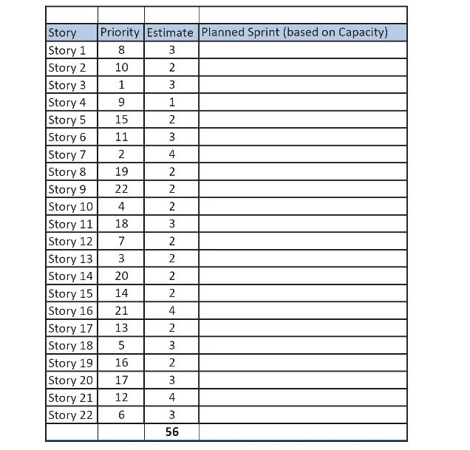

| Story | Priorty | Estimate | Planned Sprint |  |
| --- | --- | --- | --- | --- |
| Story 3 | 1 | 3 | Sprint 1 |  |
| Story 7 | 2 | 4 | Sprint 1 |  |
| Story 13 | 3 | 2 | Sprint 1 |  |
| Story 10 | 4 | 2 | Sprint 1 |  |
| Story 18 | 5 | 3 | Sprint 1 |  |
| Story 22 | 6 | 3 | Sprint 1 |  |
| Story 12 | 7 | 2 | Sprint 1 |  |
| Story 1 | 8 | 3 | Sprint 1 |  |
| Story 4 | 9 | 1 | Sprint 1 |  |
| Story 2 | 10 | 2 | Sprint 1 |  |
| Story 6 | 11 | 3 | Sprint 1 | 28 Days |
| Story 21 | 12 | 4 | Sprint 2 |  |
| Story 17 | 13 | 2 | Sprint 2 |  |
| Story 15 | 14 | 2 | Sprint 2 |  |
| Story 5 | 15 | 2 | Sprint 2 |  |
| Story 19 | 16 | 2 | Sprint 2 |  |
| Story 20 | 17 | 3 | Sprint 2 |  |
| Story 11 | 18 | 3 | Sprint 2 |  |
| Story 8 | 19 | 2 | Sprint 2 |  |
| Story 14 | 20 | 2 | Sprint 2 |  |
| Story 16 | 21 | 4 | Sprint 2 |  |
| Story 9 | 22 | 2 | Sprint 2 | 28 Days |
|  |  |  |  |  |

"The I2C2 MWRE project team has completed functional design, technical architecture, and overall project planning, and has obtained project approval. The last step before starting construction is to perform hybrid release planning of the sprints. The following table (which appears after PE 6-8) shows the MWRE product backlog: epics, user stories, MoSCoW priorities, user story dependencies, and estimates in ideal development days. The sprint length is one week (five working days), and each sprint has a capacity of twenty-five ideal days. Note that a few of the larger stories have been split into smaller stories (e.g., Story ID IE4 has been split into IE4.1 and IE4.2). Please complete the following:

a. Considering the story dependencies, “promote” stories that are predecessors of higher-priority stories to that higher priority. (Hint: Not every predecessor story should be promoted; remember that only a lower-priority predecessor story should be promoted. If the predecessor is higher priority than the successor, leave those story priorities unchanged.)

b. Using the updated priorities, allocate stories to sprints based on MoSCoW priorities (and show your answer in the “Sprint” column). Note that the epics naturally build on each other in the order shown, so allocate stories to sprints by working from the top of the table to the bottom.

c. Indicate how many sprints this work should take to complete.

4-5

d. How many sprints would we require to complete MVP (all MH priority) user stories?

4

e. How would the sprint allocation change if, at the end of Sprint 1, we identified fifteen additional ideal days of must-have stories in the Provider Credentialing epic? How would that change the number of sprints we would require to complete the overall (revised) product backlog?"

5-6 most likely 5 as we already have 4 and it would just require one more to complete an addition 15 days to the back log

"Using your solution from PE 6-7, create an agile release plan (or “flight plan”) depicting how different parts of the scope would be allocated to the various sprints. Use the general format shown in Figure 6-11 (you may neatly hand draw your answer). Be sure to use meaningful language, rather than just listing the stories allocated for each epic and sprint (e.g., “Basic Logic,” “Advanced Logic,” “Artificial Intelligence”)."

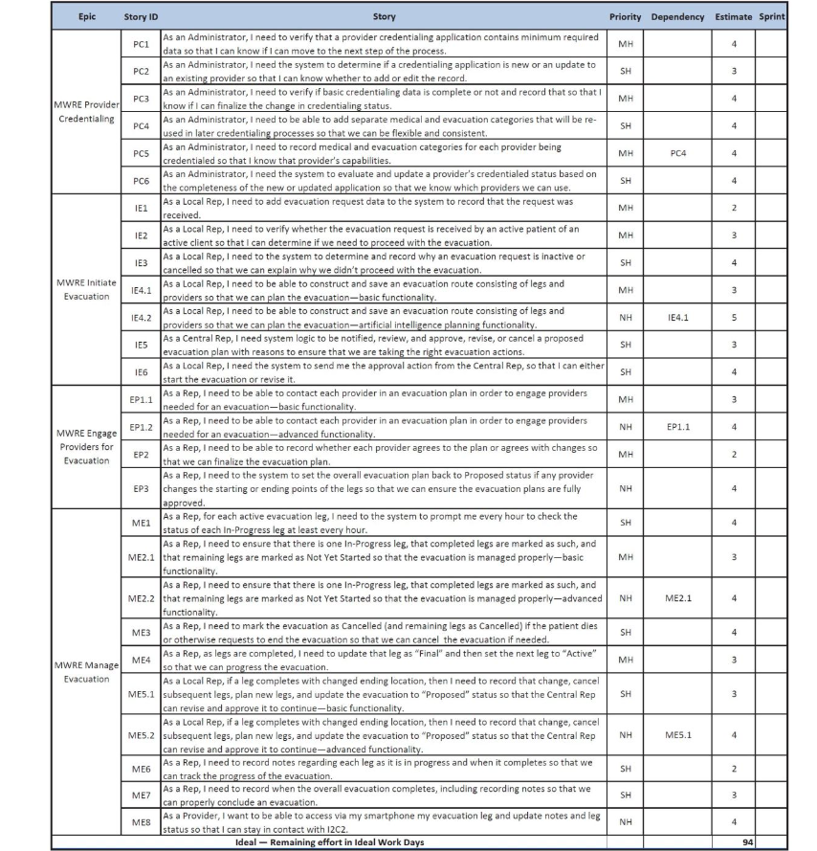

Sprints in order

As well as the general structure one would use when reorganizing this table set.

| Story | Days | Dep | Priority | Rank | Cumm Days | Sprint |
| --- | --- | --- | --- | --- | --- | --- |
| IE1 | 2 |  | MH | 1 | 2 | 1 |
| EP2 | 2 |  | Mh | 1 | 4 | 1 |
| IE2 | 3 |  | MH | 1 | 7 | 1 |
| IE4.1 | 3 |  | MH | 1 | 10 | 1 |
| EP1.1 | 3 |  | MH | 1 | 13 | 1 |
| ME2.1 | 3 |  | MH | 1 | 16 | 1 |
| ME4 | 3 |  | MH | 1 | 19 | 1 |
| PC1 | 4 |  | MH | 1 | 23 | 1 |
| Me6 | 2 |  | SH | 2 | 25 | 1 |
| PC3 | 4 |  | MH | 1 | 4 | 2 |
| PC4 | 4 |  | SH | 1 | 8 | 2 |
| PC5 | 4 | PC4 | MD | 1 | 12 | 2 |
| PC2 | 3 |  | SH | 2 | 15 | 2 |
| IE5 | 3 |  | SH | 2 | 18 | 2 |
| ME5.1 | 3 |  | SH | 2 | 21 | 2 |
| ME7 | 3 |  | SH | 2 | 24 | 2 |
| PC6 | 4 |  | SH | 2 | 4 | 3 |
| IE3 | 4 |  | SH | 2 | 8 | 3 |
| IE6 | 4 |  | SH | 2 | 12 | 3 |
| ME1 | 4 |  | SH | 2 | 16 | 3 |
| ME3 | 4 |  | SH | 2 | 20 | 3 |
| EP1.2 | 4 | EP1.1 | NH | 3 | 24 | 3 |
| EP3 | 4 |  | NH | 3 | 4 | 4 |
| ME2.2 | 4 | ME2.1 | NH | 3 | 8 | 4 |
| ME5.2 | 4 | ME5.1 | NH | 3 | 12 | 4 |
| ME8 | 4 |  | NH | 3 | 16 | 4 |
| IE4.2 | 5 | IE4.1 | NH | 3 | 21 | 4 |