# **Logo, company name Description automatically generatedMEMO**

**To:** Dr. Kate Skipsey, Projects Coordinator

**From:** Parker DeBruyne, Student

**Date:** January 29, 2023

**Subject:** Consideration of client’s *Request for Proposals*

­­­­­­­­

## **Client Profile**

Ocean Networks Canada (ONC), of the University of Victoria, manages a cabled network of observation equipment along Canadian coastlines and the deep sea. Their efforts collect and supply ocean and geological data to researchers and the public. ONC has put forward a Request for Proposals (RFP) to help them design a web-based dashboard that allows users to access and visualize this data.

Of their many initiatives, ONC seeks to reduce noise pollution for BC orca populations as it can severely disrupt their behaviour and health. Their current platform, Oceans 3.0 Dashboards, offers a host of widgets to developers:

* **Audio:** mp3 format from Oceans 3.0 Hydrophones
* **Charts:** time series data or interactive plots
* **Images:** time aware, URL-based, or task generated
* **Latest Readings:** table data from selected sensors
* **Text:** interactive text fields
* **Video:** Oceans 3.0 video data dashboard

The mission of Ocean Networks Canada is to launch world-leading, next-generation physical and digital infrastructures, grow data services, and foster partnerships for a bright ocean future and a resilient planet. Their organization is guided by principles of (a) integrity, (b) respect, (c) commitment, and (d) innovation.

## **Speed Regulation for Marine Captains**

Captains of pleasure crafts and commercial ships need to know how fast they can operate their vessels with respect to orca population safety and comply with speed limit recommendations. Successful solutions will calculate the decibels of a ship based on its motor size and speed, compare it against ONC recommended sound limits, and incentivize captains to reduce their speed. Any solution should allow a captain to maximize his speed with variable limits based on migratory patterns of orcas and account for compounding sound effects from neighboring ships. The calculation and display of information should not take more than 10 seconds of a captain’s time and must meet the criteria outlined in the RFP.

## **Solution Ideas**

### *Ship Dashboard Attachment*

A small, adhesive, satellite based, box with an LED display could be attached to the dashboard of any ship, as seen in **Figure 1**. A user would input their vessel’s weight class and would be notified by a blinking orca-shaped light when they have exceeded recommended speed limits. The device would use public data from Marine Traffic Control to triangulate their speed and compare it against ONC’s data on migratory orca pods and decibel limits per ship weight class.

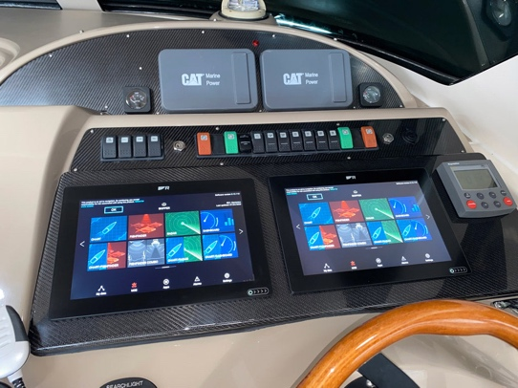

*Figure 1. Available dashboard space on ships*

### *ONC Orca Alert Mobile App*

Using the same calculation methods as the previous solution, any captain with a mobile phone and access to satellite data could download an app to notify them of dangerous decibel levels. This would allow for rapid scalability and apply most effectively to coastal community demographics.

### *Web-Based Orca Harm Dashboard*

A dashboard similar to MarineTraffic.com, **Figure 2**, could be created that compares marine traffic data against ONC orca migratory data to see which ships are offending decibel guidelines. This dashboard could include a statistics display that informs policy makers during decisions about legislation.

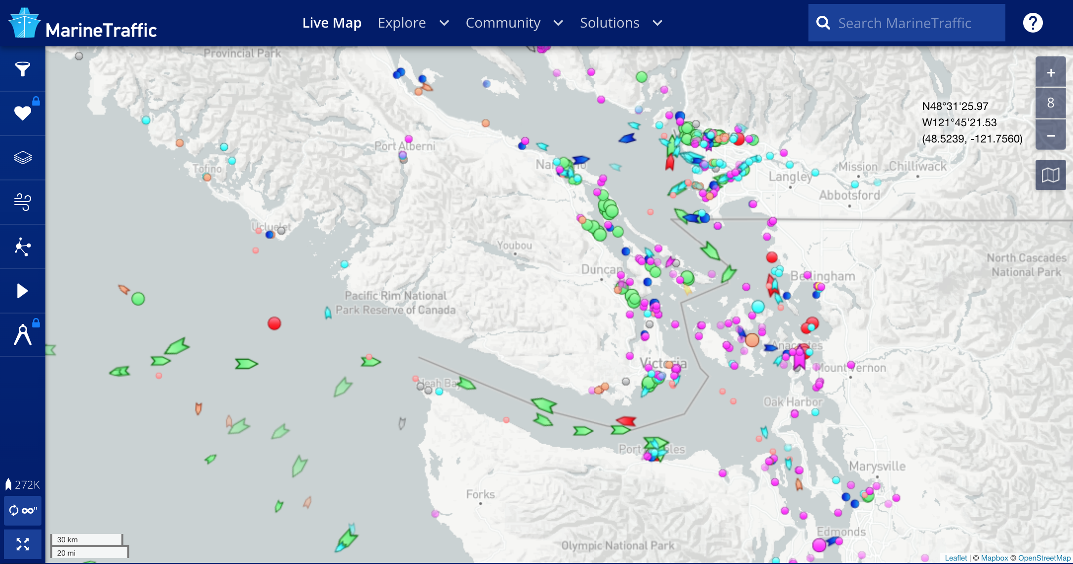

*Figure 2. Live marine traffic dashboard of Victoria, BC, Canada*

Thank you for your time and attention in considering this memo. Our design team is well positioned to prototype any of the above solutions. Should you require additional information or would like to request a set of new ideas please do not hesitate to reach out. I look forward to hearing your response.

P. DeBruyne