**Comparing Models**

a) Connectance

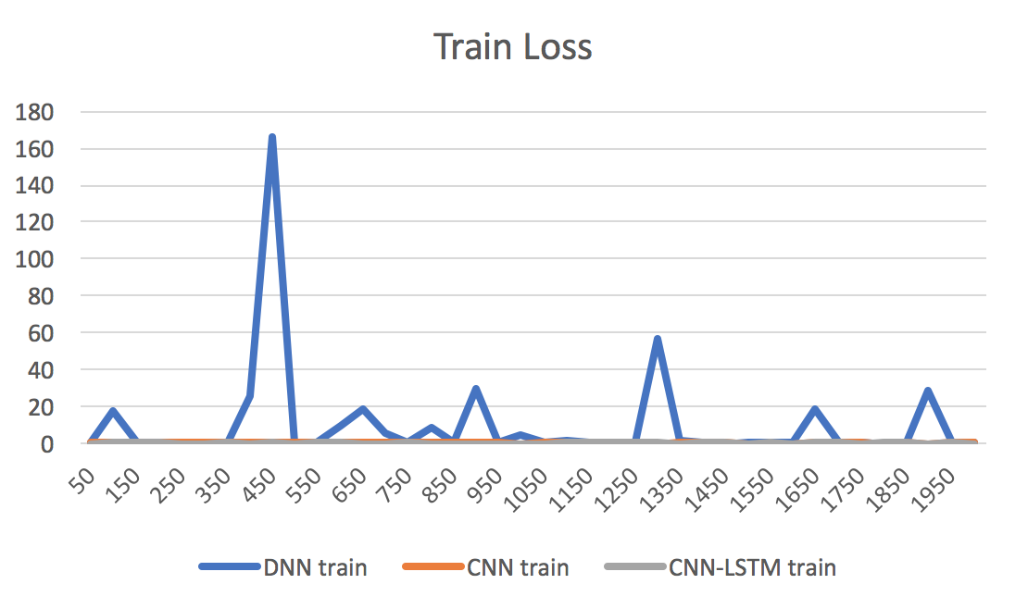

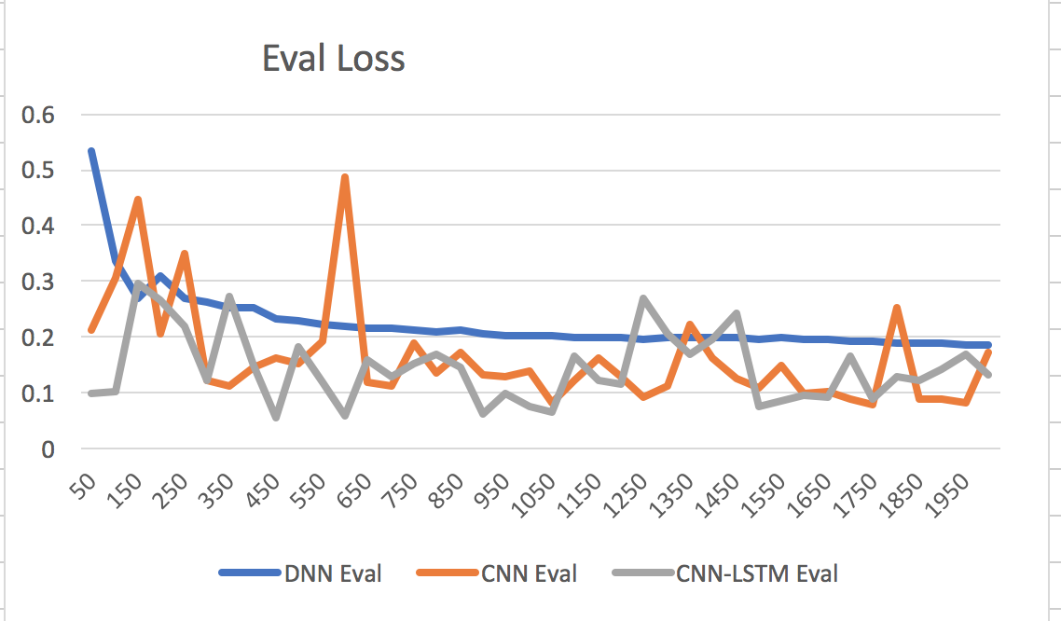

Conclusions:

CNN and CNN-LSTM are more “brittle”. (Shown by sporadic learning curve)

CNN and CNN-LSTM outperform DNN

CNN-LSTM seems slightly better than CNN

CNN-LSTM holds record for minimum loss in eval

b) Links Per Species

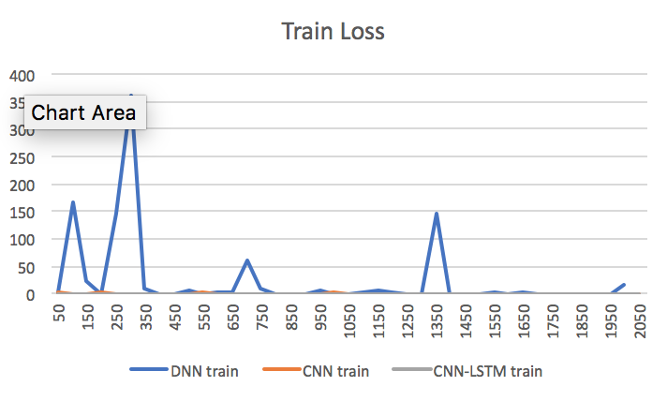

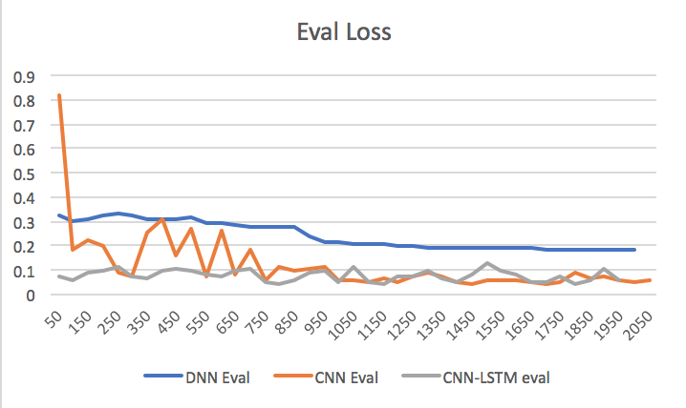

Conclusions:

CNN and CNN-LSTM are more “brittle”. (Shown by sporadic learning curve)

CNN and CNN-LSTM outperform DNN

CNN-LSTM better than CNN

CNN-LSTM holds record for minimum loss in eval

c) Characteristic Path Length

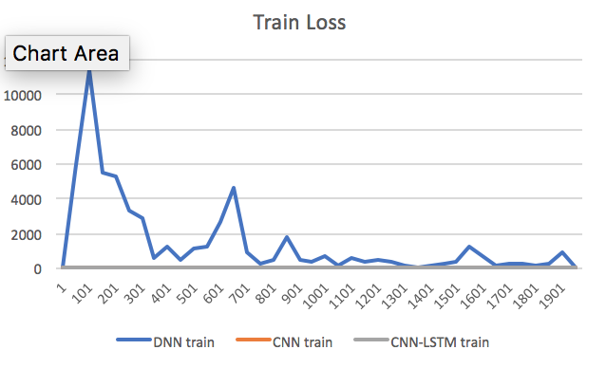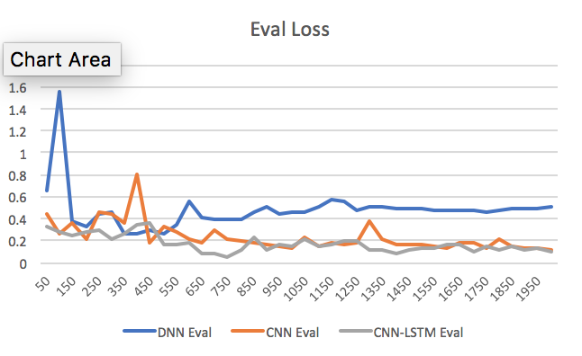

Conclusions:

CNN and CNN-LSTM are more “brittle”. (Shown by sporadic learning curve)

CNN and CNN-LSTM outperform DNN

CNN-LSTM better than CNN

CNN-LSTM holds record for minimum loss in eval

**Conclusion about models from performance on the three topologic metrics:**

**CNN-LSTM > CNN > DNN**

**The CNN-LSTM and CNN are more “brittle” -> suggests tuning of hyper parameters**

**CNN-LSTM holds record for lowest loss in all cases**

**Comparing Metrics:**

c = connectance

cl = characteristic length

lps = links per species

a) DNN (dark lines are smoothed, light lines are the unsmoothed data)

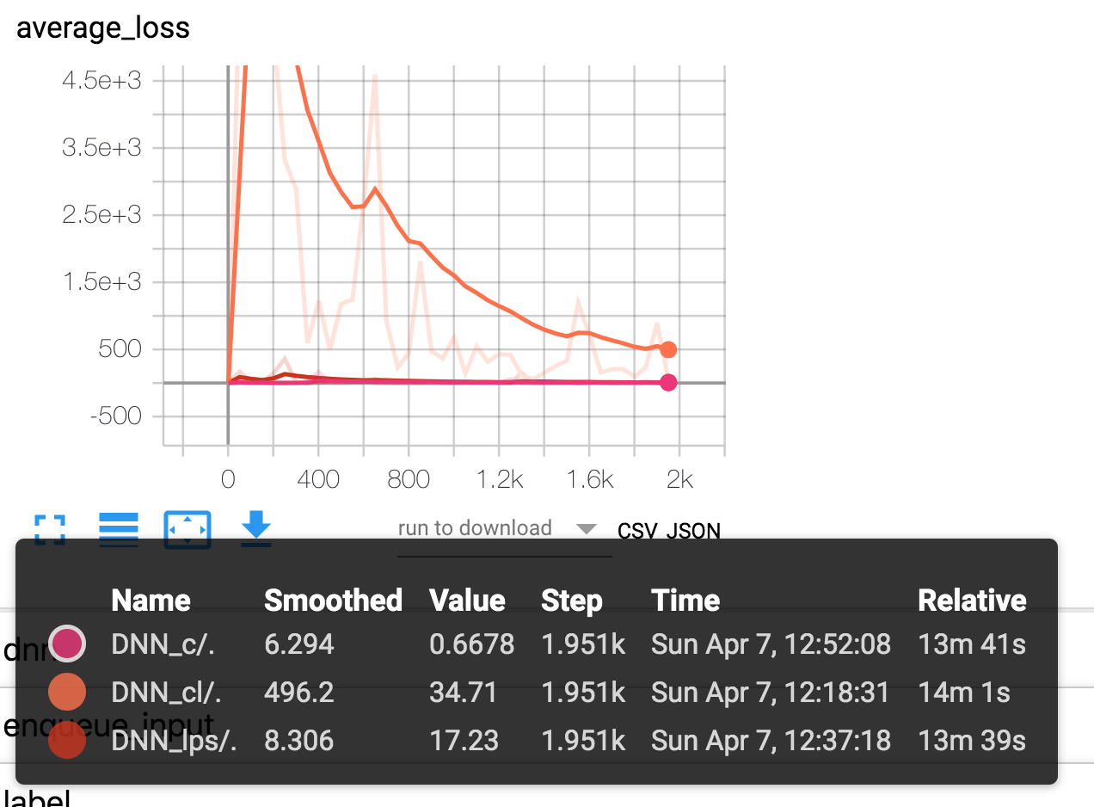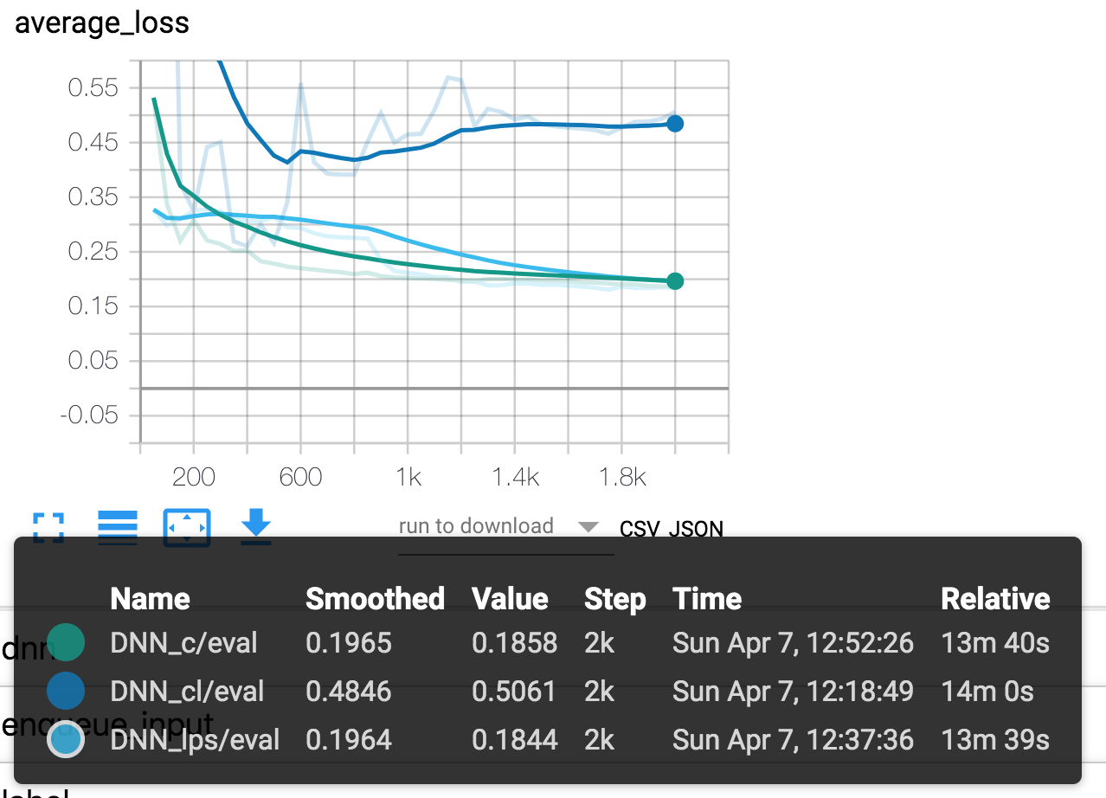

Conclusions:

Links per species and Connectance are ‘easier’ to regress than characteristic length

Too close to tell between links per species and connectance

CNN)

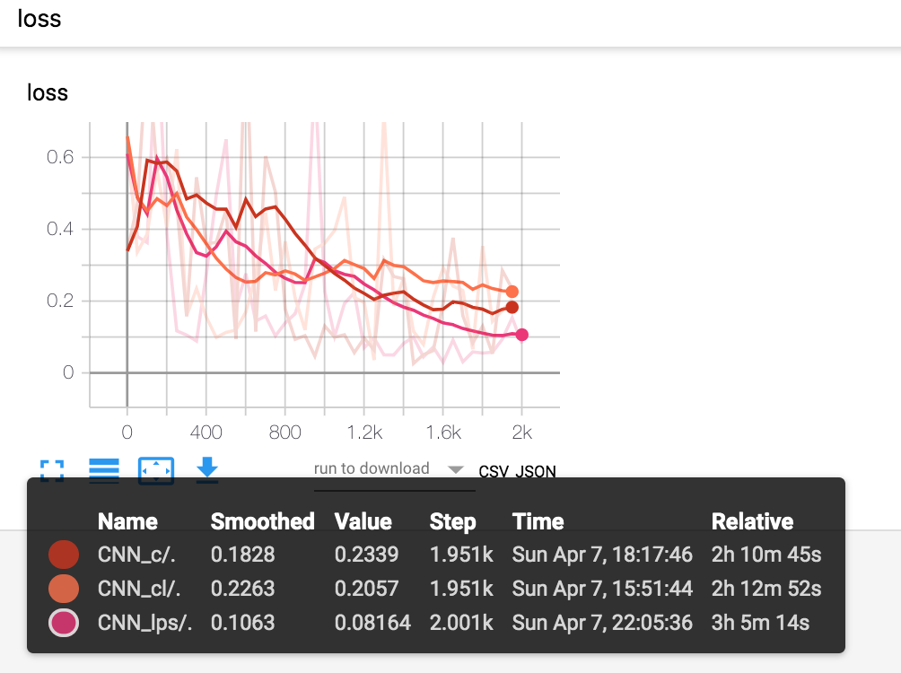

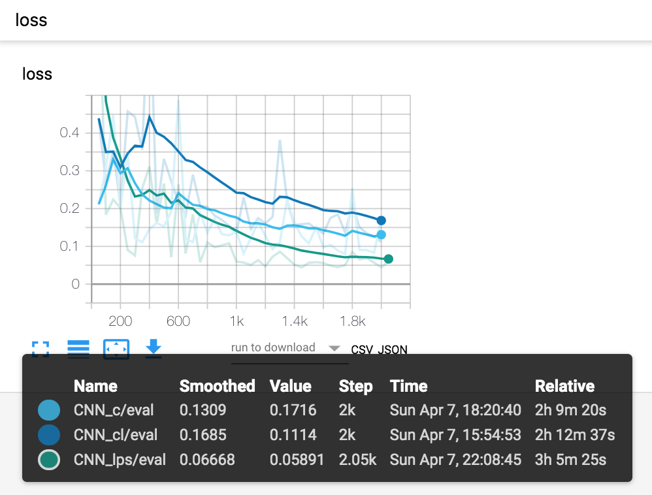

Conclusions:

Links per species > connectance > characteristic length

(here ‘>’ means ‘easier than’)

Models all look brittle here

CNN-LSTM)

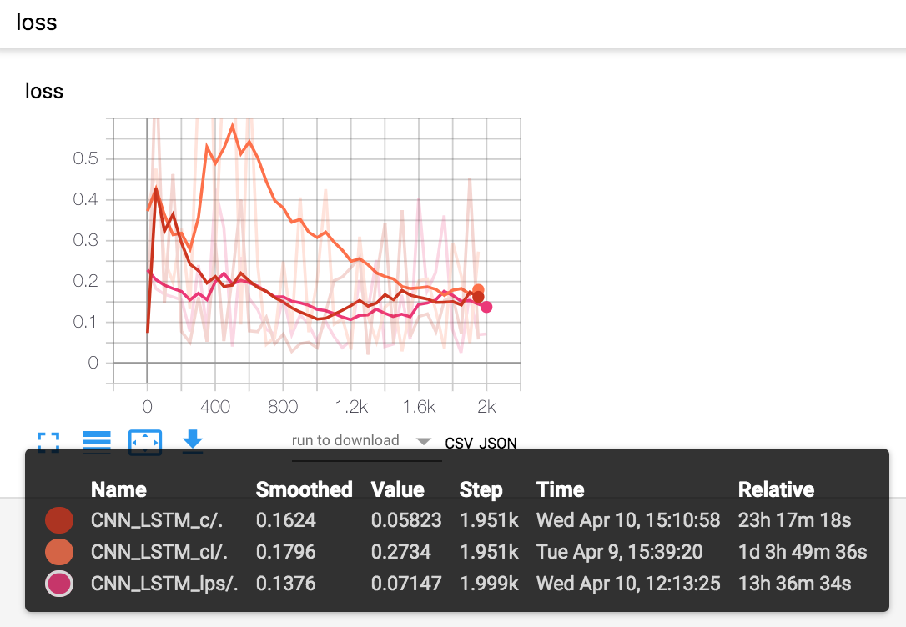

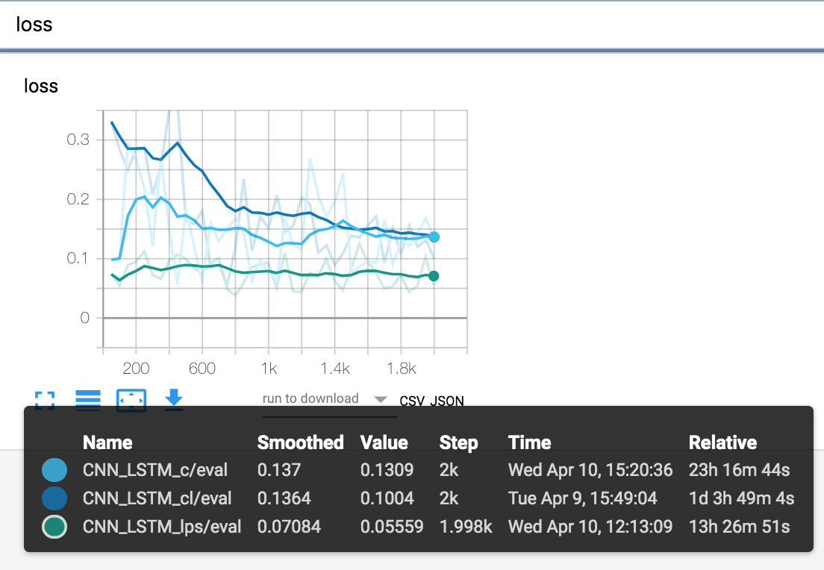

Conclusions:

Links per species significantly easier than connectance and characteristic length

Still looks like connectance is slightly easier than characterstic length (given training results)

Models look brittle here

**Conclusions about topologic metrics from performance of the three models:**

Clear trend of links per species > connectance > characteristic length

(here ‘>’ means ‘easier than’)

CNN and CNN-LSTM are brittle -> tune hyper parameters

Questions:  
 what does the CNN-LSTM and CNN being better models imply about the ecologic networks they are regressing?

Why is links per species easier to regress? Why is characteristic path length harder?