**CMSC203 Assignment 0**

Class: CMSC203 CRN 23999

 Program: Assignment 0

Instructor: Farnaz Eivazi

 Summary of Description: I set up all of the steps needed in order to get a fully functioning development environment set up on my computer to run java properly. This including learning how to set up a Git repository for each of my assignments. Installing JDK and learning to run programs from the command line. Installing an IDE (Eclipse) in order to run my java in a GUI with additional capabilities covered later. I setup Junit to prepare to run test cases in the future for my code. Finally I have gotten JavaFX installed and configured properly to display GUI interfaces that can be interacted with.

 Due Date: 9/8/2022

 Integrity Pledge: I pledge that I have completed the programming assignment independently.

 I have not copied the code from a student or any source.

**Part1: Setup GitHub:** Provide the screen shots of your GitHub account with Assignment 0 file is uploaded on GitHub:

**Part 2 -Install JDK, Test java Application from Command Line**

Provide the screen shots from Step 1 and 2 here:

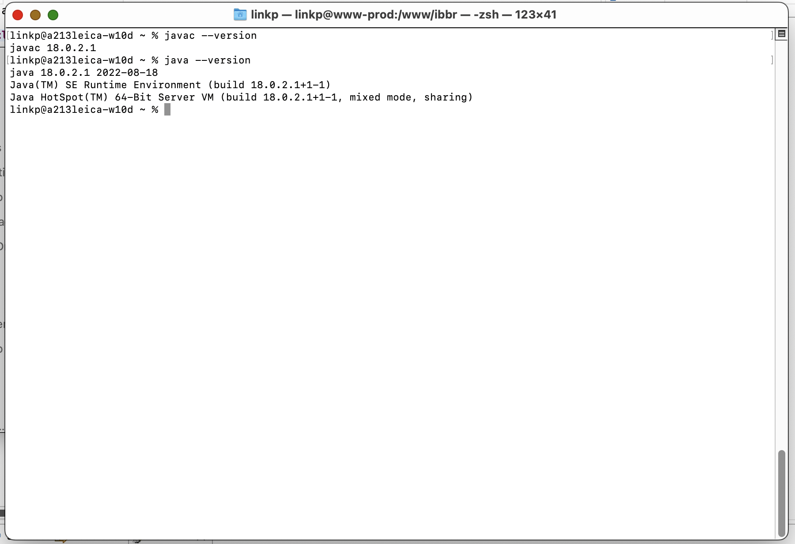

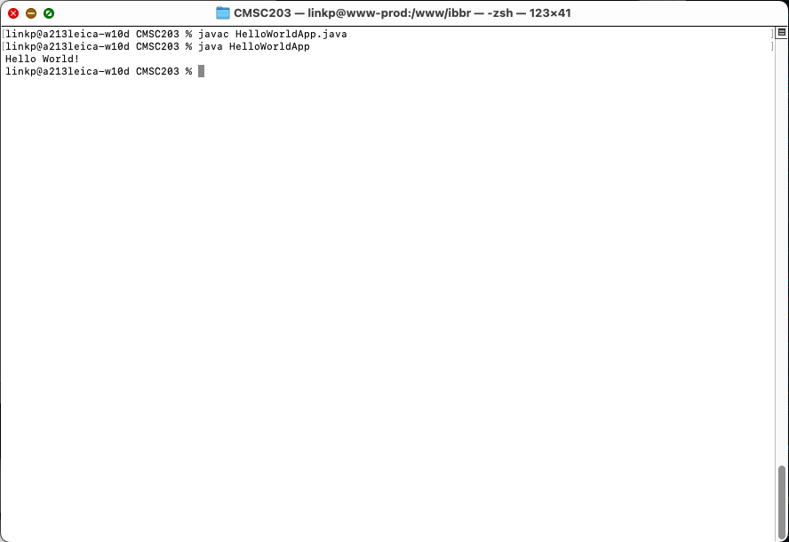

**Part 3 - Install Eclipse, Test Eclipse Java Application**

Provide the screen shots from Step 1 and 2 here:

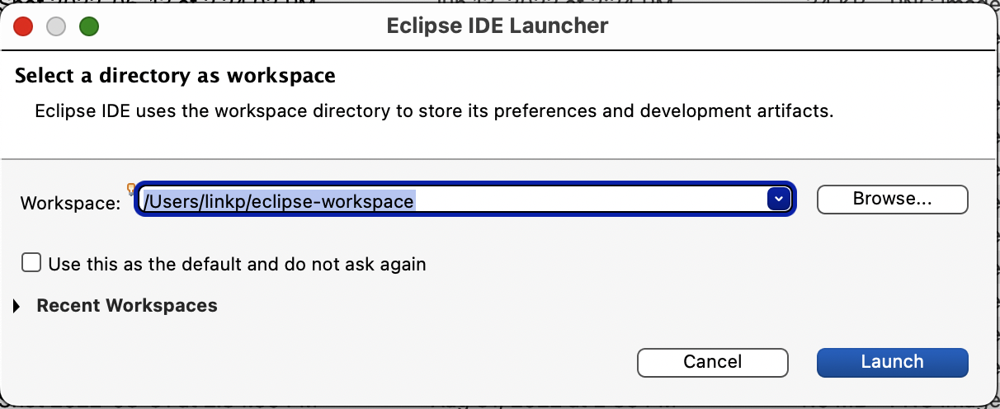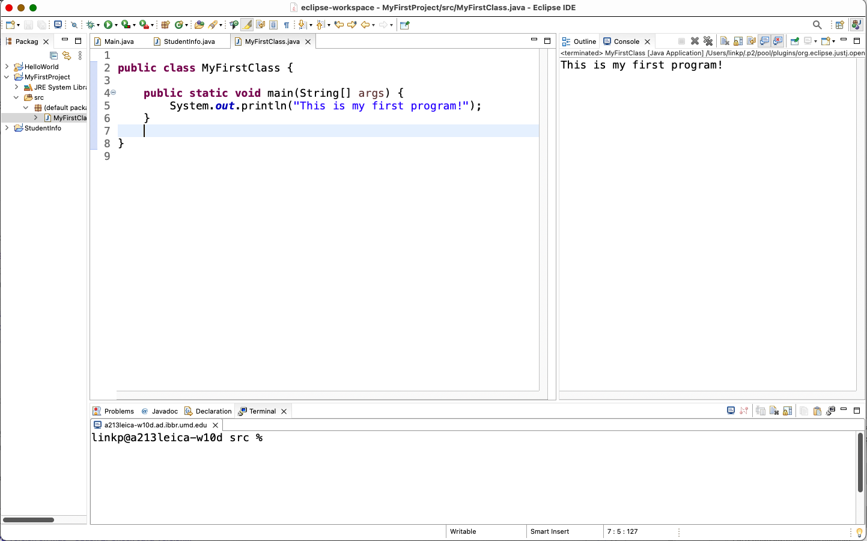

**Part 4 - Install, Setup, Test Junit Program.**

Provide the screen shots showing:

* 1. Eclipse with working JUnit Test example
  2. Project screenshot
  3. Running example screenshot

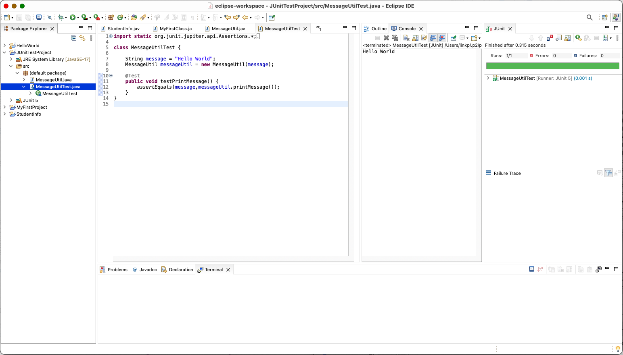

**Part 5 - Install, Setup, and Test JavaFX Application.**

Provide the screen shots showing:

1. JavaFX Project screenshot
2. Running example screenshot
3. Java Source Code File

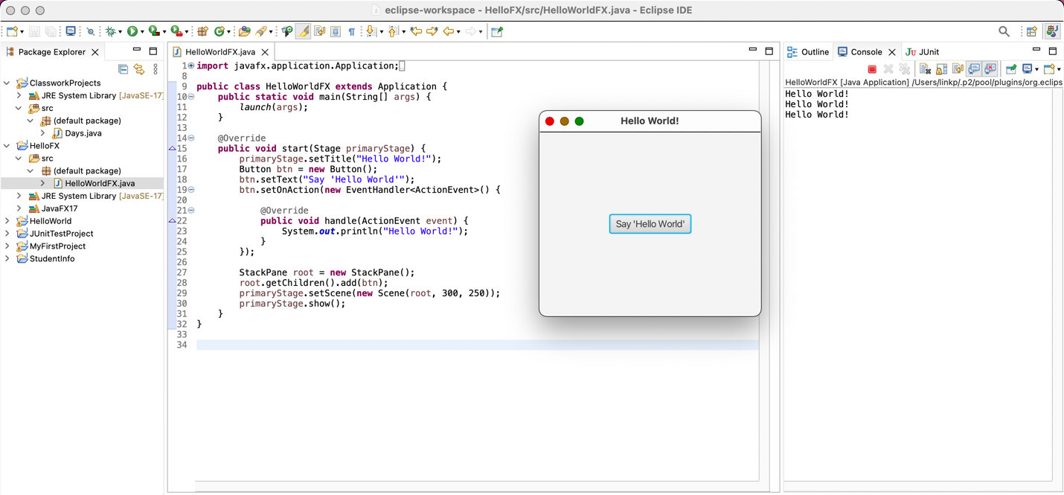

**Lessons Learned:**

Write about your Learning Experience, highlighting your lessons learned and learning experience from working on this assignment.

What have you learned?

I’ve learned to get the JavaFX configured properly, this kind of installation and configuration has been tough for me to do in the past but this time I felt the slides were very helpful and made a lot of sense. I also now know how to build test cases to test my code properly.

What did you struggle with?

While setting up JavaFX I had a hard time with running the file with a certain configuration and including the proper file path when doing the VM arguments. Thankfully I was able to figure it out.

What parts of this assignment were you successful with, and what parts (if any) were you not successful with?

I felt that I had a very solid understanding how to use Eclipse, and how to use GitHub. In the past I’ve used GitLab which has a different sort of interface but I felt pretty comfortable adapting to GitHub.

Provide any additional resources/links/videos you used to while working on this assignment.

**Check List:** <Provide answers to the column Y/N or N/A >**:**

|  |  |  |  |
| --- | --- | --- | --- |
| **#** |  | **Y/N** | **Comments** |
|  | **Assignment files:** |  |  |
|  | * FirstInitialLastName_Assignment0.docx/pdf | **Yes or No** |  |
|  | * Source java files | **Yes or No** |  |
|  | **Program compiles** | **Yes** |  |
|  | **Program runs with desired outputs related to a Test Plan** | **Yes** |  |
|  | **Documentation file: Screenshots of** |  |  |
|  | * Part1: Setup GitHub | **Yes** |  |
|  | * Part 2 -Install JDK, Test java Application from Command Line | **Yes** |  |
|  | * Part 3 - Install Eclipse, Test Eclipse Java Application | **Yes** |  |
|  | * Part 4 - Install, Setup, Test Junit Program | **Yes** |  |
|  | * Part 5 - Install, Setup, and Test JavaFX Application. | **Yes** |  |
|  | * Lessons Learned | **Yes or No** |  |
|  | * Checklist is completed and included in the Documentation | **Yes or No** |  |