MSBA Capstone Class (BMKT 699) – Code Submissions

General Information

Your Name: Parker Munsey

GitHub Repository Link: https://github.com/parkermunsey/Capstone

Directions

- Please choose five sections of code to demonstrate good coding principles and good documentation practices that are consistent with your code style guide of choice.
- Try to keep your submitted code sections 25 lines or shorter, unless you have a very good reason for submitting a longer section.
- Each code section should illustrate a different aspect of good coding principles and/or good documentation practice.
- Include the information and explanation for each code section in the fields below.

Code Sections

(1)
- File name: ingest_mpm_listings.py

- Starting code line:
  - (58) def parse_mpm_availability(available_text: str | None, observed_at: datetime):
- Ending code line:
  - (94) return status, available_date, is_current
- What coding principle or documentation practice is this section intended to illustrate?
  - This section demonstrates clear function design, documentation, and defensive data handling. The function has a descriptive name and a docstring that explains what the function returns and how the values are interpreted. It also uses type hints (str | None, datetime) to make the function easier to understand and maintain. Additionally, the logic handles multiple possible availability cases such as waitlist, unavailable, or available, and safely parses dates using a try/except block to prevent runtime errors if the format is incorrect.

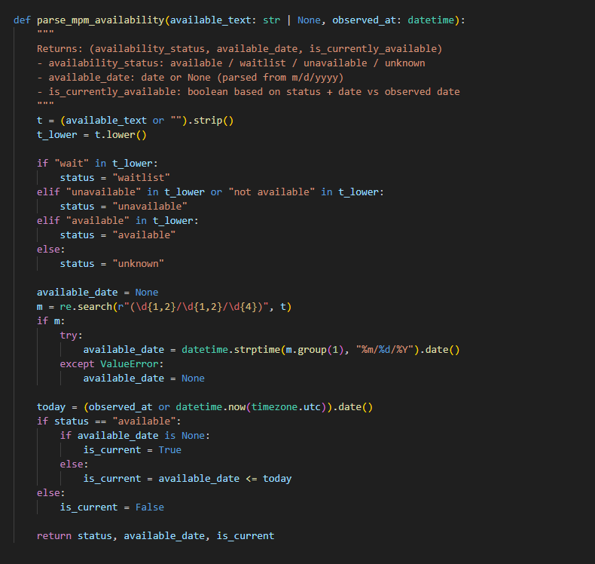
(2)
- File name:
  - Run_demo.py
- Starting code line:
  - (20) def run_step(name, cmd):
- Ending code line:
  - (35) sys.exit(result.returncode)
- What coding principle or documentation practice is this section intended to illustrate?
  - This section demonstrates modular design and reusable automation logic. The run_step() function encapsulates the logic required to execute each pipeline step in the project. Instead of repeating subprocess execution logic multiple times, the function allows each ingestion or setup task to be run using a consistent interface. It also includes structured console output and error handling to make debugging easier. If any step fails, the script exits immediately, which prevents downstream pipeline steps from running with incomplete data.

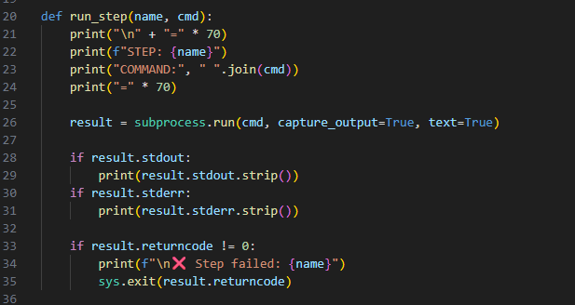

(3)
- File name:
  - Utils.py
- Starting code line:
  - (64) def normalize_bedrooms(value: object)
- Ending code line:
  - (98) return none
- What coding principle or documentation practice is this section intended to illustrate?
  - This section demonstrates clear utility function design, defensive programming, and helpful inline documentation. The function has a focused purpose, a descriptive name, type hints, and a docstring that explains both the business rule and the kinds of messy inputs it is designed to handle. It also uses step-by-step conditional logic to safely normalize inconsistent bedroom text such as “Studio,” “1 Bedrooms,” or text strings where bedroom information is embedded inside a larger sentence. This illustrates how a small, reusable helper function can make downstream data cleaning more reliable and easier to maintain.

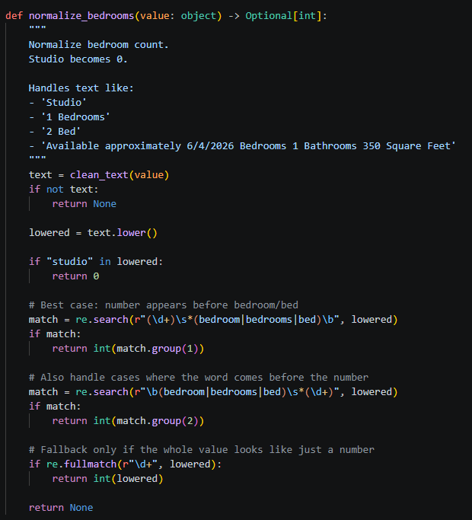

(4)
- File name:
  - normalize_raw_to_stg.py
- Starting code line:
  - (337) def normalize_address(address: Optional[str]) -> Optional[str]:
- Ending code line:
  - (361) return sha256_hex(f”{base}|{unit}|{beds}”)
- What coding principle or documentation practice is this section intended to illustrate?
  - This section demonstrates data standardization for consistency and downstream matching. The normalize_address() function cleans raw address text into a more uniform format by removing location noise, standardizing abbreviations, and reducing punctuation and spacing inconsistencies. The cross_source_fp() function then uses that cleaned address information, along with unit and bedroom values, to build a stable fingerprint for comparing listings across sources. Together, these functions show how preprocessing logic can support duplicate detection and improve data quality in a multi-source pipeline. The section also illustrates good separation of concerns by breaking the workflow into smaller functions that each do one job clearly.

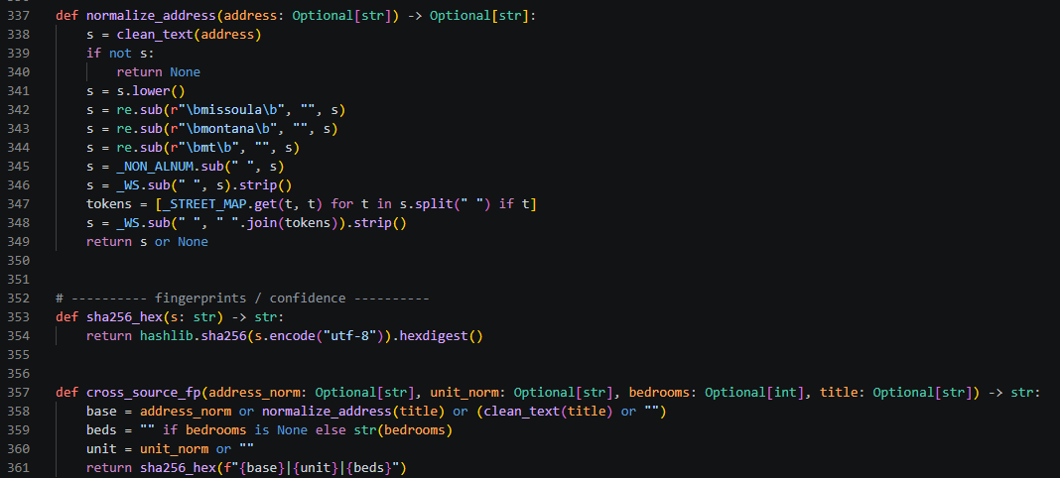

(5)
- File name:

- Starting code line:

- Ending code line:

- What coding principle or documentation practice is this section intended to illustrate?

