1. Login on your shopify partner account.

<https://shopify.com/partner>

When login in on your shopify partner account, you can see bellow screen.

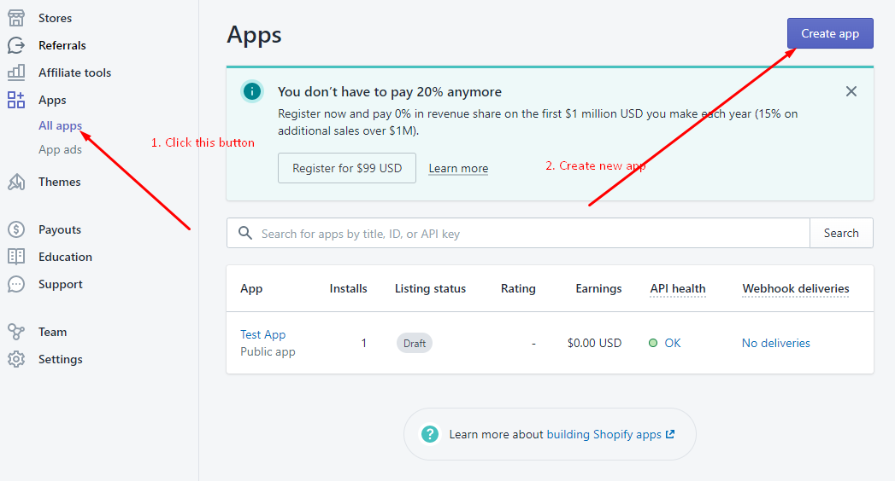

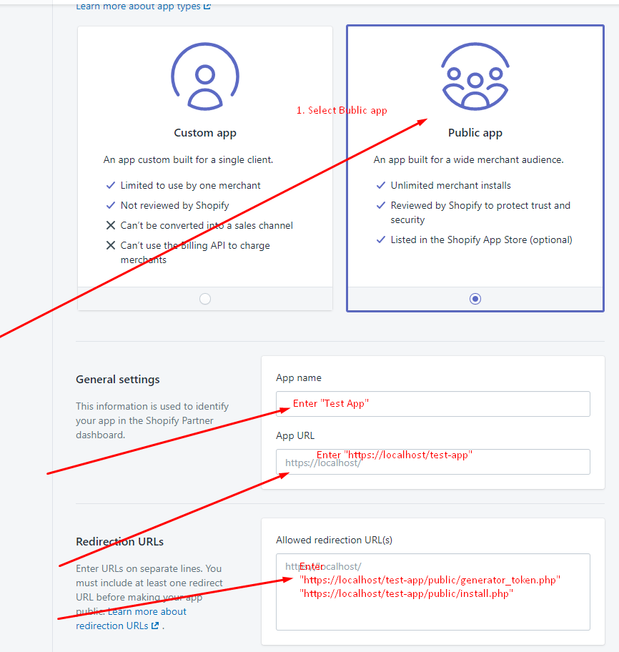

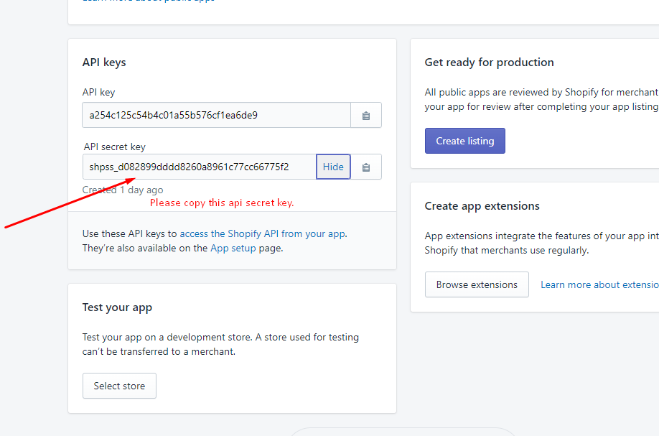

1. Go to test-app folder(app code)

Got to -> Test-app/public/install.php

Please past api_key.

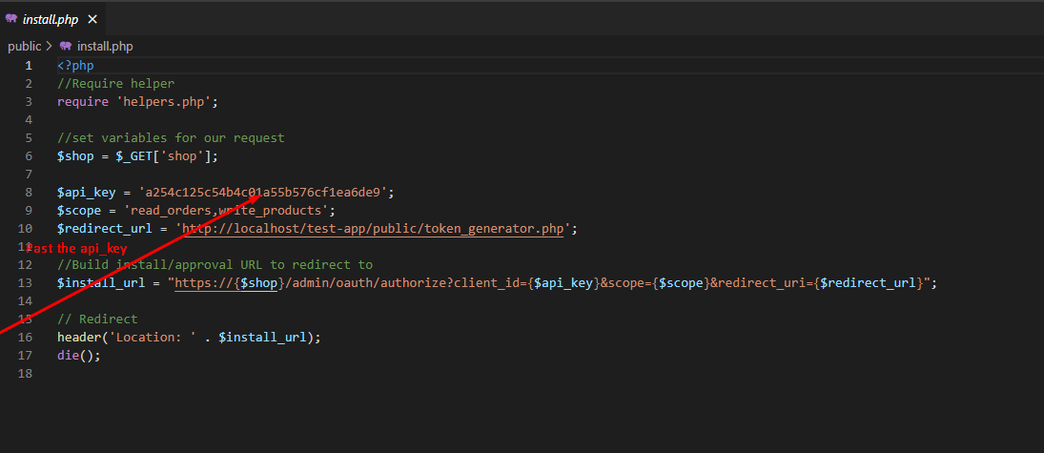

Past the test-app holder to xampp/htdocs.

1. Install app.

