Cultural Transmission and Technological Transitions during the Late Paleolithic in Korea

Gayoung Park

Ben Marwick

Archaeologists have applied evolutionary concepts linking material evidence and cultural phenomena to understand human behavior. Evolutionary approaches suggest that technological transitions can occur through changes in social learning processes, and transmission biases are important loci of changes. The onset of the Late Paleolithic period in Korea, represented by the appearance of stemmed points and blades, is a key event in understanding modern human dispersal in Northeast Asia. Previous studies mainly focus on possible origin locations of new technologies, but they rarely address the process of the technological transition. In this research we use a cultural transmission framework to investigate the social contexts that can give us insights into the emergence of these new technologies. Our main question is: what was the dominant mode of cultural transmission during the time of technological innovation in the Korean Late Paleolithic? Inspired by Bettinger and Eerkens (1999), we build two models using guided variation and indirect bias. To test the models and understand the transmission processes, we use coefficients of variation (CV), and Principal Component Analysis (PCA). Here we show that the information about the new technology was transmitted via selective combinations of guided variation and indirect bias. We found that some attributes including length and width were transmitted through indirect bias, while other attributes appear to have been more dependent on raw materials or other factors.

# Keywords

Stemmed points; Korean Paleolithic; Cultural Transmission; Learning process, Transmission Biases

# Introduction

The application of evolutionary theory to archaeological research has guided the interpretation of technological transitions and related human behaviors (Dunnell 1980; Lipo et al. 1997; Bettinger et al. 1997; Bettinger and Eerkens 1999; Mesoudi and O’Brien 2008). For example, archaeologists have used evolutionary theory and methods to study human behavioral ecology, cultural transmission, artifact phylogenetics, and niche construction in the past Garvey (2018). We use cultural transmission theory to investigate technological transitions during the Korean Late Paleolithic. This technological innovation is not just the appearance of new tools such as stemmed points and blades, but may also represent a key event related to modern human dispersal in East Asia, if the appearance of these new technologies represents the first arrival of modern humans in this region (Chuntaek Seong 2009). Previous studies mainly focussed on the possible origin locations of stemmed points, to connect Korea with global patterns of modern human dispersal. Questions about the processes of technological change remain largely unanswered (Chuntaek Seong 2008; K. Bae 2010; C. J. Bae, Douka, and Petraglia 2017). In this research, we apply a cultural transmission framework to investigate the social contexts of the emergence of new technologies in the Korean Late Paleolithic. Our main question is: what is the dominant mode of cultural transmission for technological innovation in the Korean Late Paleolithic? Additionally we ask: Do the modes of cultural transmission vary over space? Do the modes of cultural transmission vary over time? We consider three possibilities, guided variation (trial and error), or indirect bias (copying others), or a combination of the two. Our results can help to determine if these new technologies were introduced from outside of the Korean Peninsula, or if they were locally, independently developed.

# The Late Paleolithic of the Korean Peninsula

The onset of the Late Paleolithic period is marked by the appearance of stemmed points around 40-35 ka. The stemmed point is a projectile point made out of an elongated flake or blade with slight retouch on the proximal end to shape an acute tip, and on the distal end to make a stem, which connects to a shaft. The stemmed point is the first composite tool type and represents new hunting strategies in the Korean Peninsula, as well as other adjacent regions (Chuntaek Seong 2008; G.-K. Lee and Sano 2019). Stemmed points, combined with blade technology and multi-stage production sequences, and evidence of being resharpened and reused, are important aspects of Late Paleolithic technological innovation in Korea because these features are rarely seen in earlier periods (Chang 2013; Bamforth 2009; Chuntaek Seong 2015). Currently the earliest stemmed points in Northeast Asia are from Yongho-doing site in Korea dated to 38.5ka and made on elongate flakes (Chuntaek Seong 2009, 2015; C. J. Bae, Douka, and Petraglia 2017). After their first appearance in Korea, the stemmed points spread to the Japanese archipelago (Chang 2013).

Previous studies of technological transitions during the Late Paleolithic in Korea mainly focussed on possible origin locations of stemmed points, along with the issue of the timing and routes of the dispersal of modern human dispersals in eastern Asia. The debate about the origin of stemmed points can be summarized into two competing models: in situ evolution (Chuntaek Seong 2009) and heterogenic migration (K. Bae 2010). The in situ model claims that stemmed points and other Late Paleolithic assemblages including blade industries autonomously emerged in the Korean peninsula, as a form of convergent evolution (C. Seong 2006; Chuntaek Seong 2008, 2009). To support his claim of an in situ development, Chuntaek Seong (2009) examined the blade-to-flake ratios of stone artifact assemblages. In his view, the blade industry represents a new technology while flakes indicate a continuously-used existing one. He argues that the increased ratio of blades in stone artifact assemblages during the Late Paleolithic shows an expansion of the new technology after its local invention. In addition, Seong argues that increased numbers of stemmed points over time, and standardization of their shape, supports the idea of gradual, local, evolutionary process.

The migration model argues that the new blade industry including stemmed points and the earlier simple flake tool tradition, including large cores, polyhedrals, choppers and handaxes, came from different origins (K. Bae 2010; C. J. Bae and Bae 2012; C. Bae, Bae, and Kim 2013). While the in situ model claims that the heterogenic character is the result of indigenous development, the migration model proposes that it is the result of the continuous influx of modern human populations from both north and south. Specifically, the blade technology was introduced from Siberia, Mongolia, or other regions of northeast China following the Liaohe and Sunghe rivers around 35 ka BP while the simple flake tool tradition came from southern China (C. Bae, Bae, and Kim 2013). The migration from the southern route is supported by genetic studies of the Y chromosome, indicating that the O3-M122 M122 haplotype originated from southern East Asia and moved to northeastern Asia including Korea in 30-25 ka BP (Shi et al. 2005). Bae et al. (2012) assume this southern migration was related to paleoenvironmental fluctuations during the MIS 3 to 2 transition, which made the Yellow Sea/West Sea region open.

Lee (2013) argues that the transition to the Korean Late Paleolithic might be more complicated than those models of migration or in situ development. He partly agrees with the in situ model that simple flake tools had continuously been used in Korea as the result of ancestor-descendent relationships, under conditions of low effective population size. With regard to the blade industry, he claims that low degrees of uniformity and small quantities of blade-associated toolkits indicate an origin outside of Korea, perhaps resulting from trade or migration. We explore these three options, in situ, migration, and a mixture of the two, by measuring transmission biases in assemblages of stemmed points.

# Cultural transmission and transmission biases

Darwinian evolutionary theory has helped archaeologists to understand technological innovation and related human behaviors, for example using human behavioral ecology, phylogenetics, cultural transmission theory, and niche construction theory (Dunnell 1980; Richerson and Boyd 1992; Lipo et al. 1997; Bettinger and Eerkens 1997; Bettinger and Eerkens 1999; Eerkens and Bettinger 2008; Mesoudi and O’Brien 2008). Cultural evolutionary approaches can explain cultural changes using mechanisms of inheritance, variation-generating processes, and selection. The mechanisms are similar to biological evolution, but unique to cultural systems. We focus here on how different social contexts result in different modes of social transmission of tool-making skills. Social transmission can occur through various learning processes, such as stimulus enhancement, emulation, imitation, and teaching (O’brien and Lyman 2000; Schillinger, Mesoudi, and Lycett 2014).

Cultural transmission theory holds that information about how to behave is acquired through interaction with other individuals and the environment (Boyd and Richerson 1988; Richerson and Boyd 1992). Individuals learn by themselves (e.g. trial and error), or from each other by sharing information. Information can be modified (also known as ‘biased’) depending on an individual’s transmission context and cultural repertoire through recombination, loss, or partial alteration (Eerkens and Lipo 2005; O’Brien and Bentley 2017). Transmission biases can be important loci of changes in material culture, and can be influenced by social contexts of cultural transmission (Heyes 1994; Eerkens and Lipo 2007; Lycett 2015; Creanza, Kolodny, and Feldman 2017; Kendal et al. 2018). These biases include guided variation (where individuals learn new behaviors and then modify them through trial and error), content-based bias (where some aspect of the transmitted instructions, such as cultural preferences, makes them more likely to be adopted), frequency-based bias (where an individual is biased to choose particular instructions based on their perceived frequency in the population, such as extremely popular or rare instructions), and indirect bias (where a variant is transmitted because of its association with other attributes, such as the prestige or skill of other individuals) (Boyd and Richerson 1988; Richerson and Boyd 1992; O’Brien and Bentley 2017).

Bettinger and Eerkens (1997; 1999; 2008) have shown how these biases can be identified in stone artifact assemblages. Their research focused on metric variables of stone points during the introduction of bow and arrow technology in the Great Basin around AD 300-600. They equated guided transmission with high metric variation and low correlation between metric attributes. Conversely, they inferred indirect bias from less variation and more correlated variables. They found that artifacts in the new bow and arrow technology in eastern California have low correlations of basal width and mass, which they interpreted as a result of guided transmission dominating the introduction and spread of these tools. From these results, they inferred a social context in eastern California of distant and unfamiliar neighbors, with limited contact between groups to acquire technology directly, with new technologies developed largely by trial and error. On the other hand, in central Nevada metric variables are highly correlated, indicating that the bow and arrow was introduced and spread by indirect bias.

Garvey (2018) also explores Bettinger and Eerkens’ framework and uses simulation to explore the degree of standardization represented by coefficient of variation (CV) values of projectile points. With the two types of projectile points, Washita and Fresno points, from Henderson site, she measured CV values of weight, thickness, width and lengths. She then computed simulated CV values according to various learning scenarios of knapper skill, raw material quality and human perception (i.e. CV = 10%, 5%, and 3%). The observed metrics of the archaeological projectile points are closest to the metrics of the simulated assemblage with 3% CV, which represents “extremely high-fidelity copying”. Garvey’s modeling and simulation shows how the concept of cultural transmission can be useful to interpret the archaeological record.

Although Garvey and Bettinger and Eerkens were unable to directly observe transmission processes, Mesoudi and O’Brien (2008) conducted experimental research using groups of undergraduate students to test the underlying assumptions of Bettinger and Eerkens’ study. They simulated model-based bias in projectile point making by providing the design of a model and information of the model’s prior success to their research participants. They also simulated guided variation by allowing their participants to explore their own designs. They observed that the majority of participants who were able to choose the previous design copied the most-successful model. Metric attributes of the points made when copied from successful models were more highly correlated than attributes of points made by trial and error. Mesoudi and O’Brien’s results demonstrate the robustness of previous assumptions about cultural transmission biases and their consequences for variation and correlation in material culture variation.

# Modeling the social context of the appearance of stemmed points

Inspired by the previous studies that used Bettinger and Eerkens’ approach, we use the two contrasting transmission modes, guided variation and indirect, to understand the spread of stemmed point technology during the Korean Late Paleolithic period. We propose a spectrum for foraging groups and how they started to make stemmed points: on one end we have socially isolated groups who made stemmed points entirely stimulated by guided variation; and on the other end of the spectrum we have socially connected groups whose knowledge of stemmed points derived from indirect bias on the transmission process.

To contextualize this further, on one end of our spectrum we have socially isolated groups who stayed in physically remote places from other groups, or had unfamiliar neighbors with limited contact between groups. Our assumption for this social context is that individuals or groups acquired the technology of stemmed points by modifying existing flake tool forms through trial-and-error processes to solve problems relating to resource procurement. This trial and error behavior leaves a distinctive signature on metric variables of the stemmed points. If trial and error was the dominant bias in the appearance of stemmed points, we expect that the morphological attributes on a stemmed point will be poorly correlated and show high variation between sites.

On the other end of our spectrum, socially connected groups occupied places close to other groups or had regular contact with other groups over long or short distances. Individuals or groups learned the technology of stemmed points by copying a model from another individual or group. The model stemmed point might be a highly successful and frequently chosen one, and the learners copy all information about the point design as a package. In this social context, indirect bias is the dominant influence on transmission of lithic technology. If indirect bias was prominent in the Korean Paleolithic, we expect that stemmed points should be more standardized, and attributes on the stemmed points will be more correlated, and assemblages from multiple sites will be less varied.

Korean Paleolithic Chronology edited based on @seong2015diversity; @Park_2013

| Phase | SP | Blades | Micro-blade | SP Blank | Newly added raw materials | New changes | Example sites | Radiocarbon ages |
| --- | --- | --- | --- | --- | --- | --- | --- | --- |
| 1 | Present | Absent | Absent | Flake | Higher-quality quartzite, vein quartz | Increasing number of small flake tools, appearance of SP | Hwadaeri Yonghodong Sachang | ~35 ka |
| 2 | Present | Present | Present | Blade | Porphyry, siliceous shale, hitherto | Appearance of blades, increasing number of SP |  | 35-25 ka |
| 3 | Present until 16ka | Present | Present | Blade, Micro-blade | Obsidian | Appearance of Micro-blade, microliths |  | 25-12 ka |

# Materials and methods

1. Materials and stemmed points chronology

After the first discovery in Seokjangri site in the 1960s, around 300 stemmed points have been found in Korea. Most sites contain only a few points but a few sites have many more, such as Suyanggae (n = 55), Jingeuneul (n = 99), and Yongsandong (n = 38) (Kim 2017). Among these stemmed points, we selected those that are unbroken from the tip to the stem. We excluded artifacts that were recorded as stemmed points but lack a stem. This resulted in a sample of 152 stemmed points from 28 assemblages unearthed from 20 sites spanning the period 40-17 ka (Figure 1). The images of the stemmed points were obtained from published excavation reports and by direct photography during our research on local museum collections. We defined multiple assemblages in a site where artifact-bearing deposits were separated by culturally sterile deposits, or where distinct artifact-bearing stratigraphic units could be identified by major differences in the texture, color, and composition of the sedimentary deposits.

We used previously developed chronologies that identify three phases in the Korean Late Paleolithic (Chuntaek Seong 2015; Park 2013). These chronologies were built on the presence of blades, stemmed point blanks, toolkit composition and radiocarbon ages. We arranged our 28 assemblages containing stemmed points in chronological order. For example, Sachang site has two assemblages that are fitted into phase 1 and 2. Applying the chronology is useful because some sites such as Yonghodong, Goryeri, Jungmal, and Mungyeong have no radiocarbon dates due to various research situations and limitations, chronological order help us estimate the time periods of those assemblages as well as understand the morphological change of stemmed points associated with the introduction of blade technology. Based on the existence of blade and micro blade and types of stemmed point blanks, we divided the assemblages into three chronological phases: 1) stemmed points made out of flakes and no blades in assemblages, 2) stemmed points made out of blade or flake and the existence of blade in assemblages, and 3) stemmed points made out of blade and the existence of micro blade in assemblages.

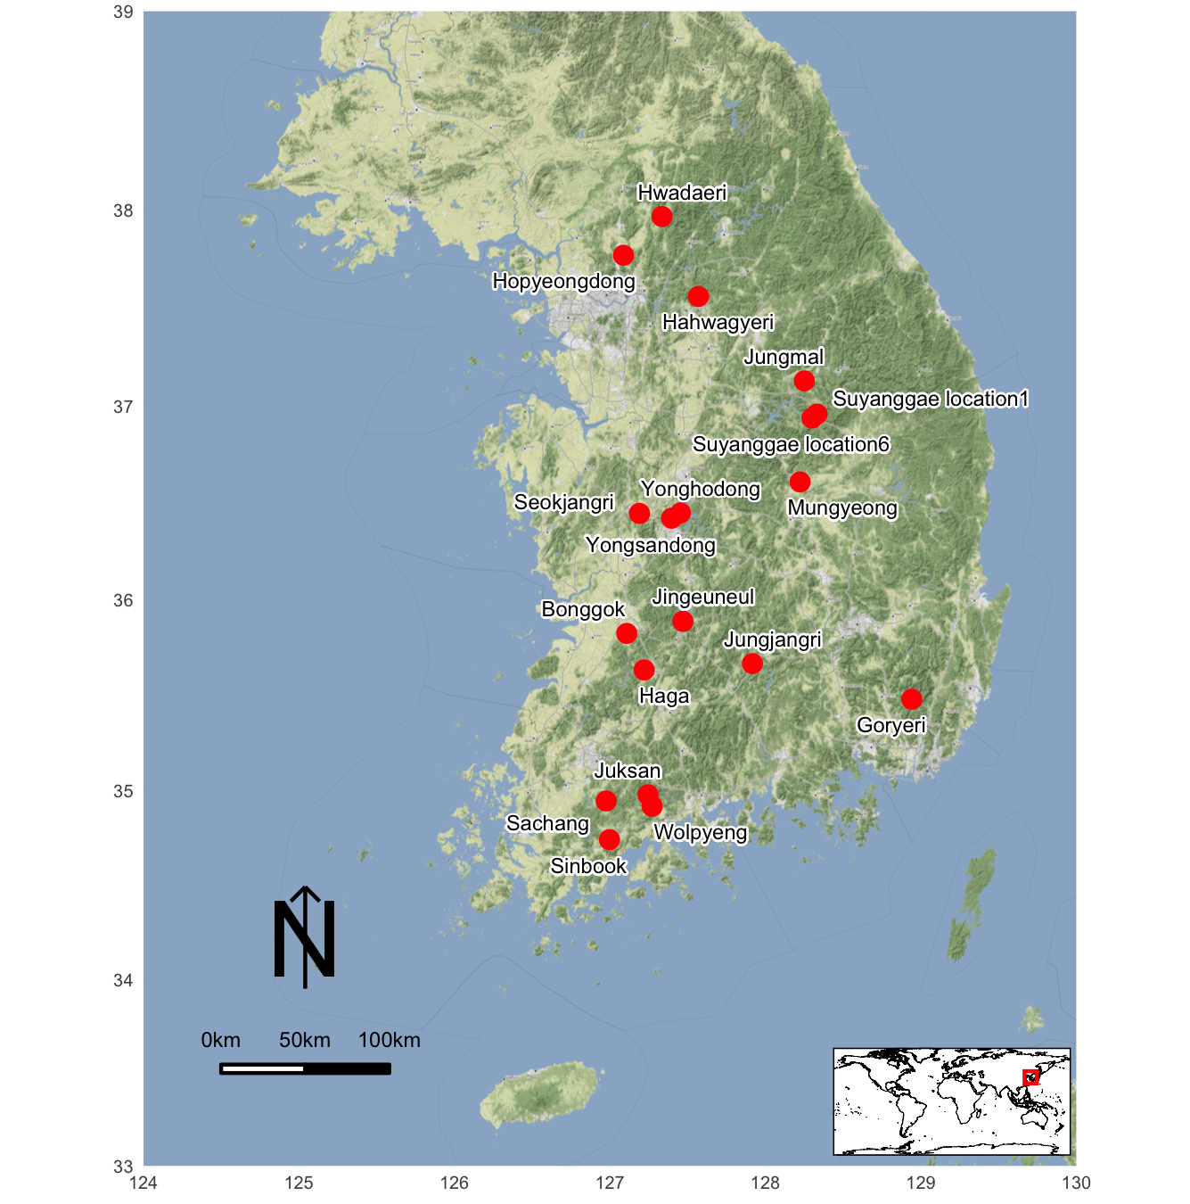

Bae, Christopher J, and Kidong Bae. 2012. “The Nature of the Early to Late Paleolithic Transition in Korea: Current Perspectives.” *Quaternary International* 281: 26–35.

Bae, Christopher J, Katerina Douka, and Michael D Petraglia. 2017. “On the Origin of Modern Humans: Asian Perspectives.” *Science* 358 (6368): eaai9067.

Bae, Christopher, Kidong Bae, and Jong Chan Kim. 2013. “The Early to Late Paleolithic Transition in Korea: A Closer Look.” *Radiocarbon* 55 (2–3): 1341–49.

Bae, Kidong. 2010. “Origin and Patterns of the Upper Paleolithic Industries in the Korean Peninsula and Movement of Modern Humans in East Asia.” *Quaternary International* 211 (1-2): 103–12.

Bamforth, Douglas B. 2009. “Projectile Points, People, and Plains Paleoindian Perambulations.” *Journal of Anthropological Archaeology* 28 (2): 142–57.

Bettinger, Robert L, and Jelmer Eerkens. 1999. “Point Typologies, Cultural Transmission, and the Spread of Bow-and-Arrow Technology in the Prehistoric Great Basin.” *American Antiquity*, 231–42.

Bettinger, Robert L, Jelmer W Eerkens, CM Barton, and GA Clark. 1997. “Rediscovering Darwin: Evolutionary Theory and Archaeological Explanation.”

Bettinger, Robert L, and Jeltner Eerkens. 1997. “Evolutionary Implications of Metrical Variation in Great Basin Projectile Points.” *Archeological Papers of the American Anthropological Association* 7 (1): 177–91.

Boyd, Robert, and Peter J Richerson. 1988. *Culture and the Evolutionary Process*. University of Chicago press.

Chang, Yongjoon. 2013. “Human Activity and Lithic Technology Between Korea and Japan from MIS 3 to MIS 2 in the Late Paleolithic Period.” *Quaternary International* 308: 13–26.

Creanza, Nicole, Oren Kolodny, and Marcus W Feldman. 2017. “Cultural Evolutionary Theory: How Culture Evolves and Why It Matters.” *Proceedings of the National Academy of Sciences* 114 (30): 7782–89.

Dunnell, Robert C. 1980. “Evolutionary Theory and Archaeology.” In *Advances in Archaeological Method and Theory*, 35–99. Elsevier.

Eerkens, Jelmer W, and Robert L Bettinger. 2008. “Cultural Transmission and the Analysis of Stylistic and Functional Variation.” *Transmission and Archaeology: Issues and Case-Studies*, 21–38.

Eerkens, Jelmer W, and Carl P Lipo. 2005. “Cultural Transmission, Copying Errors, and the Generation of Variation in Material Culture and the Archaeological Record.” *Journal of Anthropological Archaeology* 24 (4): 316–34.

———. 2007. “Cultural Transmission Theory and the Archaeological Record: Providing Context to Understanding Variation and Temporal Changes in Material Culture.” *Journal of Archaeological Research* 15 (3): 239–74.

Garvey, Raven. 2018. “Current and Potential Roles of Archaeology in the Development of Cultural Evolutionary Theory.” *Philosophical Transactions of the Royal Society B: Biological Sciences* 373 (1743): 20170057.

Heyes, Cecilia M. 1994. “Social Learning in Animals: Categories and Mechanisms.” *Biological Reviews* 69 (2): 207–31.

Kendal, Rachel L, Neeltje J Boogert, Luke Rendell, Kevin N Laland, Mike Webster, and Patricia L Jones. 2018. “Social Learning Strategies: Bridge-Building Between Fields.” *Trends in Cognitive Sciences* 22 (7): 651–65.

Kim, Eun-jeong. 2017. “Morphological Diversity and Functional Differentiation of Tanged-Point: Focused on Suyanggae, Jingeuneul and Yongsandong Site.” *Journal of Korean Paleolithic Society*, no. 36 (December): 29–47.

Lee, Gi-Kil, and Katsuhiro Sano. 2019. “Were Tanged Points Mechanically Delivered Armatures? Functional and Morphometric Analyses of Tanged Points from an Upper Paleolithic Site at Jingeuneul, Korea.” *Archaeological and Anthropological Sciences* 11 (6): 2453–65.

Lee, Hyeong Woo. 2013. “Current Observations of the Early Late Paleolithic in Korea.” *Quaternary International* 316: 45–58.

Lipo, Carl P, Mark E Madsen, Robert C Dunnell, and Tim Hunt. 1997. “Population Structure, Cultural Transmission, and Frequency Seriation.” *Journal of Anthropological Archaeology* 16 (4): 301–33.

Lycett, Stephen J. 2015. “Cultural Evolutionary Approaches to Artifact Variation over Time and Space: Basis, Progress, and Prospects.” *Journal of Archaeological Science* 56: 21–31.

Mesoudi, Alex, and Michael J O’Brien. 2008. “The Cultural Transmission of Great Basin Projectile-Point Technology i: An Experimental Simulation.” *American Antiquity*, 3–28.

O’Brien, Michael J, and R Alexander Bentley. 2017. “Dual Inheritance, Cultural Transmission, and Niche Construction.” *The Handbook of Culture and Biology*.

O’brien, Michael J, and R Lee Lyman. 2000. *Applying Evolutionary Archaeology: A Systematic Approach*. Springer Science & Business Media.

Park, Gayoung. 2013. “A Study on the Stemmed Points of the Late Paleolithic in the Korean Peninsula.” *Yeongnam Archaeological Review* 64: 39–69.

Richerson, Peter J, and Robert Boyd. 1992. “Cultural Inheritance and Evolutionary Ecology.” *Evolutionary Ecology and Human Behavior*, 61–92.

Schillinger, Kerstin, Alex Mesoudi, and Stephen J Lycett. 2014. “Copying Error and the Cultural Evolution of" Additive" Vs." Reductive" Material Traditions: An Experimental Assessment.” *American Antiquity*, 128–43.

Seong, C. 2006. “Structure and Evolution of Late Paleolithic Assemblages in Korea.” *Journal of the Korean Archaeological Society* 59: 4–39.

Seong, Chuntaek. 2008. “Tanged Points, Microblades and Late Palaeolithic Hunting in Korea.” *Antiquity* 82 (318): 871–83.

———. 2009. “Emergence of a Blade Industry and Evolution of Late Paleolithic Technology in the Republic of Korea.” *Journal of Anthropological Research* 65 (3): 417–51.

———. 2015. “Diversity of Lithic Assemblages and Evolution of Late Palaeolithic Culture in Korea.” *Asian Perspectives*, 91–112.

Shi, Hong, Yong-li Dong, Bo Wen, Chun-Jie Xiao, Peter A Underhill, Pei-dong Shen, Ranajit Chakraborty, Li Jin, and Bing Su. 2005. “Y-Chromosome Evidence of Southern Origin of the East Asian–Specific Haplogroup O3-M122.” *The American Journal of Human Genetics* 77 (3): 408–19.