How did the introduction of Stemmed Points affect Mobility and Site Occupation during the Late Pleistocene in Korea?

Gayoung Park

Ben Marwick

15 December, 2020

Human behavioural ecological models use stone artefacts as a source of information for understanding forager mobility. We use these models to examine stone artefacts from 22 sites in Korea to investigate mobility and site occupation during the Late Pleistocene. This study focuses on two questions: how did the introduction of stemmed points change forager’ mobility and landscape use? And how did this new technology change the way people use habitation sites? We analyse artefact volumetric density, retouch frequency, composition of toolkits, artefact raw materials, environmental and demographic contexts. Quartz and side scrapers, in addition to cores and choppers, remain dominant in assemblages before and after the introduction of stemmed points throughout the Late Pleistocene. Our results show that forager groups using stemmed points were associated with occupation of marginal or extreme environments. In addition, groups with stemmed points were associated with expedient technologies indicating residential and less mobile behaviours. The environmental context of this technological innovation was a gradual decrease in temperature into the LGM. A population increase followed after the appearance of stemmed points.

# Introduction

The appearance of stemmed points in the Late Pleistocene (~40-35 ka) in Korea is often assumed to have transformed forager lifeways because it reflected more specialized hunting practices (Chang, 2013; Seong, 2008). Stemmed points are often called as tanged points in the western hemisphere, but we use ‘stemmed point’ to distinguish from Bronze Age stone projectile points that have long been called ‘tanged points’ in Korea. The stemmed point is a projectile point made out of elongated flake or blade with slight retouch on the proximal end to shape an acute tip and on the distal end to make a stem, which connects to a shaft. Stemmed points are likely to have been projectile weapon tips because the stem of these tools is considered to represent hafting technology that joins the lithic to a wooden shaft. If they were projectile weapon tips, stemmed points represent the first appearance of hafting technology in Korea. Most Korean Paleolithic sites do not preserve organic remains, so we lack direct fauna evidence on hunting and subsistence strategies. Here we explore questions about the implications of the appearance of this new technology using a behavioural ecological framework and stone artefacts. We explore changes in the way people occupied the landscape, the way people used sites, and impact of social and ecological environment. We examined stone artefacts from 22 sites in South Korea to investigate the changes in human behaviour associated with the appearance stemmed points, and the blade industry that followed.

Previous work on this technological change in Korea has focussed on issues of the transition from the Early to the Late Paleolithic and modern human dispersals (Bae, 2010; Norton and Jin, 2009). To our knowledge, the implications of the appearance of stemmed points for forager mobility and site use have not been explored in detail. Here, we attempt to identify patterns of mobility through analysis of the stone artefact assemblages using Human Behavioural Ecology (HBE) models. Drawing on established relationships between lithic technology and forager mobility (Capriles et al., 2018; Hiscock, 1994; Kuhn et al., 2016; Kuhn, 2004, 1994; Kuhn and Miller, 2015; Shott, 1986), we hypothesize that the appearance of the new hunting tool might reflect a preference for more portable and efficient technologies, that are part of a broader strategy of moving frequently and further, possibly as an adaptation to environmental or population changes.

# Background

In the Eastern hemisphere, major technological innovations during the Late Pleistocene are restricted to Northeast Asia, such as northern China, Japan and Korea. These innovations include blade and micro technology, high frequencies of retouched blade tools, several novel tools such as projectile points, stemmed points, end scrapers, burins, denticulates, etc, and using high-quality raw materials (Bae et al., 2017; Bar-Yosef, 2002; Bar-Yosef and Kuhn, 1999; Brantingham et al., 2001; Nakazawa and Bae, 2018). Previous work has argued that the appearance of new stone artefact technologies in this region may be linked to modern human dispersals (Bae et al., 2017; Bae, 2010; Seong, 2008).

The Shuidonggou site in northern China is an important example of the transition from cobble to blade tool industries in the Late Pleistocene of Northeast Asia (Brantingham and Perreault, 2010; Gao et al., 2010; Pei et al., 2012). Shuidonggou Locality SDG 2, which dates to around c. 32,000 years, contains fauna specimens, ostrich eggshell beads, and stone artefacts including blades, retouched flakes, cores, and debris along with well-preserved hearths. In Locality 9 dated to c. 29,000 years, there is a small scatter of stone artefacts consisting of blades, Levallois flakes, cores and other retouched flakes. The recent excavation of Locality 12 shows that its archaeological context, dated to 13,078–13,296 cal BP, includes ground stone and more than 30,000 microlithics made out of a variety of raw materials such as fine-grained and siliceous rocks. In addition, more than 10,000 animal fossils and bone tools including a tool for fishing nets, an awl, and two needles were excavated (Gao et al., 2014; Pei et al., 2012; Zhang et al., 2016). Stemmed points are not part of the Shuidonggou assemblages, but microblade technology is argued to have appeared in China after 29ka BP, related to changes in mobility associated with colder climates towards LGM (Yi et al., 2014). Shuidonggou shows that the blade component came from Siberia and/or Mongolia at 41 ka (SDG Locality1 and 9), advanced core and flake tools were likely to have been locally developed at 33 ka (2 and 8), and at 10.8 ka microblade technology appears but the origin is uncertain (12) (Li et al., 2019; Yi et al., 2014).

Late Pleistocene technological innovations in Japan appeared in different regions of the archipelago around 38,000 years ago accompanied by remains of Homo sapiens found in Okinawa Island (c.36,000 cal BP) (Izuho and Kaifu, 2014; Yamaoka, 2012). These new technologies include trap pits, cobble concentrations, hearths, charcoal concentrations, and toolkits including trapezoids, pointed-shaped backed blades, backed points, burins, end scrapers, side scrapers, wedges, beak-shaped tools, axes, edge-ground axes, hammerstones, cobble tools, and anvils (Bae et al., 2017; Izuho and Kaifu, 2014). These innovations have been interpreted as evidence of new foraging methods such as watercraft (marine transport of obsidian from the Kozu Island) and bow-and-arrow technology, driven by increased population and ecological changes (Bae et al., 2017; Morisaki et al., 2019; Nakazawa and Bae, 2018; Yamaoka, 2012). Hafted trapezoids were likely multifunctional tools adapted to the specific environmental settings of the different Japanese Islands (Ono et al., 2002; Yamaoka, 2012). Ishinomoto 8-ku is one of the earliest sites dated to 39,690–34,790 cal BP, located in Takuma upland of Kumamoto Prefecture. A total of 500 stone artefacts were discovered including trapezoids, side scrapers, flakes, flake cores, edge-ground axes, and cobble tools. The main lithic raw materials are chert and andesite (Izuho and Kaifu, 2014). Stemmed points appear much later, dated to between about 15,500 and 13,800 cal BP (Ono et al., 2002; Tsutsumi, 2007).

What makes the Korean Late Pleistocene technological transition distinctive from what we see at Shuidonggou and in Japan is that the earliest signs of new technologies in Korean assemblages are stemmed points, followed by blade technologies. Stemmed points appeared in both regions after the case of Korean Peninsula. The oldest stemmed points so far is from the Yonghodong site dated to 38.5 ka and made on elongated flakes (Bae et al., 2017; Seong, 2015, 2009). After blades appeared at c. 27 ka and were adopted to the stemmed points, the shape of points became more standardized with one or two ridges on the dorsal side and triangular cross section. Replacing flake to blade as a blank of the points led to an increase in quantity over time. In addition to the stemmed points, flake tools became more complex, with a greater diversity in both type and size along with continuously used core tools during the Late Pleistocene (Bae, 2010; Lee, 2016, 2013). There are several attempts to explain the technological transition and they can be summarized into two competing models: ‘heterogenic’ migration (Bae, 2010) or *in situ* evolution (Seong, 2009). The migration model argues that the new blade industry including stemmed points, and the earlier coarse flake tradition including large cores, polyhedrons, choppers, and even handaxes, came from different origins as the result of continuing influx of model human migration from two routes. Bae (2010) explains that blade and stemmed points arrived in the Korean peninsula from Siberia, Mongolia, or other regions of northeast China following the Liaohe and Sunghe rivers around 35 ka BP with the earliest evidence of blade in those regions. He assumes that core and flake industry come from southern China based on the existence of similar assemblages in both Korea and southern China in addition to a genetic analysis of the Y-chromosome of the modern population (Bae et al., 2013; Lee, 2013). The ‘*in situ*’ model claims that stemmed points and other Late Paleolithic assemblages including blade industries autonomously emerged in the south of the Korean peninsula with no external influence (Seong, 2008). This claim is supported by the earliest appearance of stemmed points among Northeast Asia, such as Hwadae-ri, Hopyeong-dong, and Yonghodong sites dated to 40-35ka BP (Seong, 2009). Seong(2009) uses the increased blade-to-flake ratios on lithic assemblages to support the *in situ* model based on the premise that the blade industry represents new technology while flakes indicate a continuing local one.

## Behavioural ecology and forager land use behaviours

Our brief review of Late Pleistocene technological innovations in Northeast Asia shows that previous work has largely focussed on timing, location, origins and description of these new tools, but modelling the land-use behaviours that generated these assemblages has rarely been undertaken. We focus on the appearance of stemmed points in Korea because these are a new technology that represents a new hunting method. This is because the hafting implies throwing techniques that can reach long-distance targets (Keeley, 1982; Kuhn and Miller, 2015). We draw on behavioural ecological theory to model the effects of this technological change. Behavioural ecology theory offers structured and testable models based on optimality assumptions that stand on economic rationality and environmental knowledge (Prentiss, 2019; Winterhalder and Smith, 1992). The patch choice model and marginal value theorem predict that forager mobility and travel times will increase when resource patch productivity decreases (Bettinger and Eerkens, 1997; Llano, 2015; Smith, 1991; Smith et al., 1983; Wolverton et al., 2015). We can also model individual artefact types as a kind of resource patch. Foragers may find a more costly and complicated technology (such as stemmed points relative to flakes) optimal if they have a long cumulative time in use, if they are maintainable and reusable in a landscape where lithic raw material supply is uncertain. That is, they may move to a patch where they can stay longer (i.e. an artefact type that has a long and extendible use-life) when they are not certain of the productivity and travel times of other patches (Kuhn and Miller, 2015).

We ask two questions to investigate the period around the introduction of stemmed points in Korea. First, how did the introduction of the new tools change foragers’ landscape use? Specifically, was the use of stemmed points associated with occupation of marginal or extreme environments? Our assumption here is that this new technology might have allowed foragers to explore and sojourn in less productive landscapes by increasing their mobility. In Australia during the mid-Holocene, Hiscock et al. argue that the first appearance of microlithics in many locations represent a portable and multi-functional toolkit that minimize travel expenses and increase tool readiness to adapt to patchy and unpredictable resources associated with environmental change (Hiscock et al., 2011; Hiscock, 1994).Similarly, in Japan, Morisaki et al. (Morisaki et al., 2015) argue that the transition from trapezoid to the blades and projectile points around 25 ka cal BP in north Paleo-Honshu Island enabled the foragers to extend their occupation into cold grassland landscapes.

Second, we ask how the new technology changed the way people use habitation sites and mobility. After the appearance of these new tools, did people tend to stay in one location for longer or shorter periods, perhaps for specific purposes? The stone artefact assemblage from a site can inform us how long individuals or groups stayed and give insights into their activities (Binford, 1979; Holdaway and Davies, 2019; Kelly, 1995; Kuhn et al., 2016). For example, stone artifact density and the frequency of retouched pieces (scaled to the volume of excavated sediment) can be used as proxies to represent occupation patterns (Barton et al., 2011; Clark and Barton, 2017). Assemblages with low density but a high proportion of retouched and backed pieces may indicate the remains of ‘short-term camp,’ which is a site for small and ephemeral overnight camp or limited activity station. On the other hand, the combination of high density and low retouched pieces represent logistically organized basecamp, which is a site with greater residential stability, long site occupation and occupied by larger groups (Clark et al., 2019; Clark and Barton, 2017).

# Methods

## Sites and dates

After the first excavation of a Paleolithic site in Korea at Seokjang-ri site in the 1960s, more than 200 Paleolithic sites have been discovered in South Korea (Lee and Sano, 2019). We selected sites dated to before and after the transition period (40-35 ka) to analyze the process of technological change. This resulted in a sample of analysed 33 assemblages from 22 sites spanning 49-24 ka (Figure 1). We identified multiple assemblages in a site where culturally sterile deposits separated artefact-bearing deposits, or where stratigraphic units could be identified by major differences in the texture and composition of the sedimentary deposit containing the stone artefacts. For example, the Hwadae-ri site has three cultural layers. The lowest horizon at the bottom, dated to 39,000±1400 BP by OSL, contains coarse flake tools made of vein quartz and quartzite. The middle cultural horizon has stemmed points made of porphyry, with quartz and quartzite dominating the assemblage. This layer was dated to 31,200±900 BP by radiocarbon dating and 30,000±1,700 BP by OSL. The uppermost layer, dated to 22,000±100 BP by OSL, contains blades, scrapers, awls, and denticulates (Seong, 2009). We obtained the data from published excavation reports held by provincial museums.

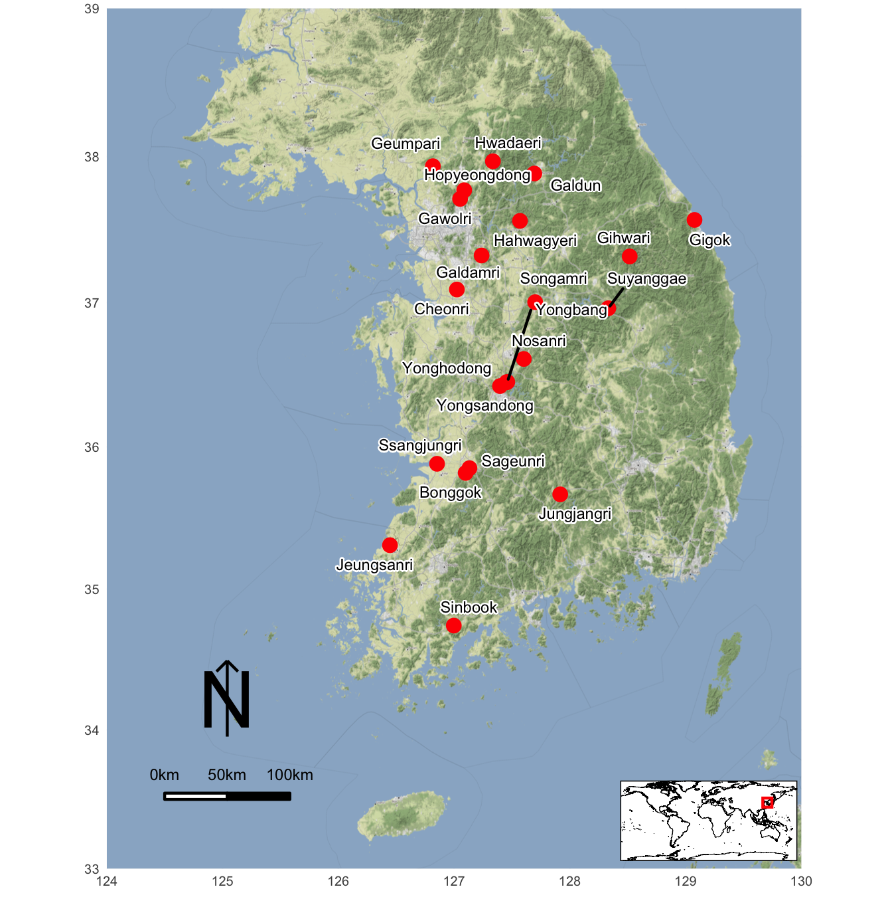

Figure 1: Korean Paleolithic sites mentioned in the text.

## Assemblages

The 33 assemblages consist of cores, blade cores, blades, flakes, debris, hammers, choppers, plans, polyhedrals, side scrapers, end scrapers, notches, cleavers, stemmed points, awls, denticulates, burins, handaxes, blanks, knives, handadzes, peaks, flatters, flakers etc. We excluded some artefacts from our sample because of uncertainty about their typology. The stone artefacts from all of these sites are stored in museums located throughout South Korea, and have been briefly described in the excavation reports. We have visited most of these collections to obtain permission to study the materials.

## Statistical methods

To answer the two research questions, we compiled information about artefact density, retouch frequency, toolkit composition, raw materials, site elevation, and radiocarbon ages.

The artefact volumetric density is defined as the total number of artefacts per cubic meter of excavated sediment, and serves as a proxy for the accumulation ratio of artefacts (Clark et al., 2019; Clark and Barton, 2017). We used these density values to evaluate mobility and land-use practices of hunter-gatherers during the Late Pleistocene. The retouch frequency is the number of retouched tools divided by the total number of artefacts in an assemblage. This value represents mobility and duration of site occupation based on the concept that tool reduction is an tactic to extend the use-life of a tool by generating sharp, usable edges while minimizing the cost of transporting tools or bulky raw materials by reducing the total load weight (Buvit et al., 2014; Clark et al., 2019; Kuhn, 1990). In other words, producing and carrying highly retouched tools will increase portability and efficiency by decreasing the size of both individual tools and the assemblages so that hunter-gatherers could move often or further, or both (Andrefsky, 1994; Davies et al., 2018; Kuhn, 2004, 1994, 1991). Combining these two proxies, the artefact volumetric density and the retouch frequency, we expect to determine whether or not the hunter-gatherers were residentially mobile or logistically organized. If the assemblage in a site has a high artefact density and small proportion of retouch, we interpret it as a more expedient assemblage that represents “base camps” or “residences,” while less density with higher proportions of retouch shows a more curated assemblage and indicates either residential mobility or certain task groups away from residential sites (Clark and Barton, 2017; Riel-Salvatore and Barton, 2004).

We calculated toolkit composition by analysing tool and debitage frequencies to identify changes in the assemblages during the transition period. Toolkit composition helps us answer the question of how site occupation patterns changed before and after the appearance of new technology. The type and proportion of retouched tools and knapping products, including debris and hammerstones, could give information about settlement patterns based on a premise that more activities are conducted with a wider range of tool types for longer occupation (Buvit et al., 2014; Centi et al., 2019; Garcı́a-Medrano et al., 2017). For instance, small sized assemblages with a few types of tools represent short duration of site occupation (Buvit et al., 2014; Shott, 2010) .

Studying the raw material consumption patterns is based on an assumption that stone raw materials were transported and consumed to optimize mobility and minimize risk of not having artefacts when they were needed (Andrefsky, 1994; Brantingham, 2003; Brantingham et al., 2000; Yue et al., 2020). The representation of raw materials in an assemblage can be an indicator of site occupation patterns. For example, a large variability of raw materials in a site can suggest long-term settlement, while varied and exotic raw materials can indicate higher mobility (Valde-Nowak and Cieśla, 2020). Here we want to know the specific raw materials that relate to the appearance of a new technology, and understanding site occupation patterns by examining changes in the proportions of raw material types in the assemblages.

HBE models require environmental proxies to build hypotheses of behavioural change influenced by the surrounding environment. However, there are few paleoenvironmental proxies in Korean relevant to our target period. For example, geoarchaeological observations suggest that environment of the period was “overall cooler and drier during MIS 3” (BAK and LEE, 2017; Chang, 2013; Choi, 2011; Han, 2008; Im and Choo, 2015; Seong, 2008). To supplement the limited availability of high-resolution local proxies, we used climate information from the simulated data set of paleoclimate including global monthly temperature, covering the last 120,000 years (Beyer et al., 2020). We applied information of site location including elevation, latitude and longitude to the simulated data set to get the annual temperature of our research period and area. Besides the climate analysis, we analysed site elevation as a proxy to represent different environments at local scales, to identify how these impact mobility and site occupation. We mainly focused on the elevation of the sites before and after the appearance of new technology and its relationship with the stemmed points.

We used radiocarbon dates as a reference for population level. Summed probability distributions (SPD) of radiocarbon dates are often used to understand temporal trends in past human populations (Bamforth and Grund, 2012; Contreras and Meadows, 2014; Rick, 1987; Riris and Arroyo-Kalin, 2019; Shennan et al., 2013; Timpson et al., 2014). Despite limitations of the validity of SPD (Bamforth and Grund, 2012; Williams, 2012), including the lack of excavated sites in certain periods, sample size, and calibration effects, this method may be helpful as a proxy for a first approximation of population fluctuations. Although this is often used with samples of thousands of ages, this method can also be useful for small sample sizes. For instance, Timpson et al. apply SPD to 93 ages from Eastern Middle Sweden and demonstrate that the result is equivalent to a larger sample size (n= 243) (Timpson et al., 2014). We used 108 radiocarbon ages from 22 sites to examine connections between population trends during the Late Pleistocene in Korea and technological innovation.

There is a debate about whether past population growth has played a role in technological change (Kline and Boyd, 2010; Shennan, 2001). Shennan (2009) observed a correlation between population decrease and technological simplification in their study of lithic arrowheads from the southern Scandinavian Mesolithic. They found that the lithics became less complex, and point shape changed as the population level dropped. On the other hand, Collard et al. (2013) argue that regional archaeological data do not support the population-driven models (Buchanan et al., 2016). For example, Buchanan et al. (2016) concluded that changes in point types from >13,000 years ago to 400 years ago in Texas were related to environmental risk, and not dependent on population size. We explored SPD to test for correlations between population, environmental risk and technological change. We used the R package ‘rcarbon’ (Crema and Bevan, n.d.) to perform statistical analyses and conduct model testing using Monte Carlo methods. We generated exponential, uniform, linear, and logistic models and evaluated the model goodness-of-fit by applying Akaike’s Information Criterion (AIC) as a selection criterion (Bevan et al., 2017; Riris and Arroyo-Kalin, 2019; Sakamoto et al., 1986).

All analyses and visualization are performed in the R Environment (Team, 2017). Our R code and data are available on the following GitHub repository: <https://github.com/parkgayoung/koreapaleolithicmobilityoccupation> as well as on the Open Science Framework: <https://osf.io/yagd2/> to enable full reproducibility (Marwick, 2017).

# Results

## Artefact volumetric density and retouch frequency

Figure 2 shows that there is no clear temporal pattern of changes in artefact density, although the density of some assemblages are two or three times higher than others, especially after 30ka. The inset figure shows that assemblages with stemmed points have higher artefact densities than the assemblages without. With the newer tools, hunter-gatherers may have stayed in the same location for longer durations, and we may be seeing site occupation patterns in this sample that represent the use of both base camps or residences, with the artefact higher densities, and more briefly occupied camps with lower densities.

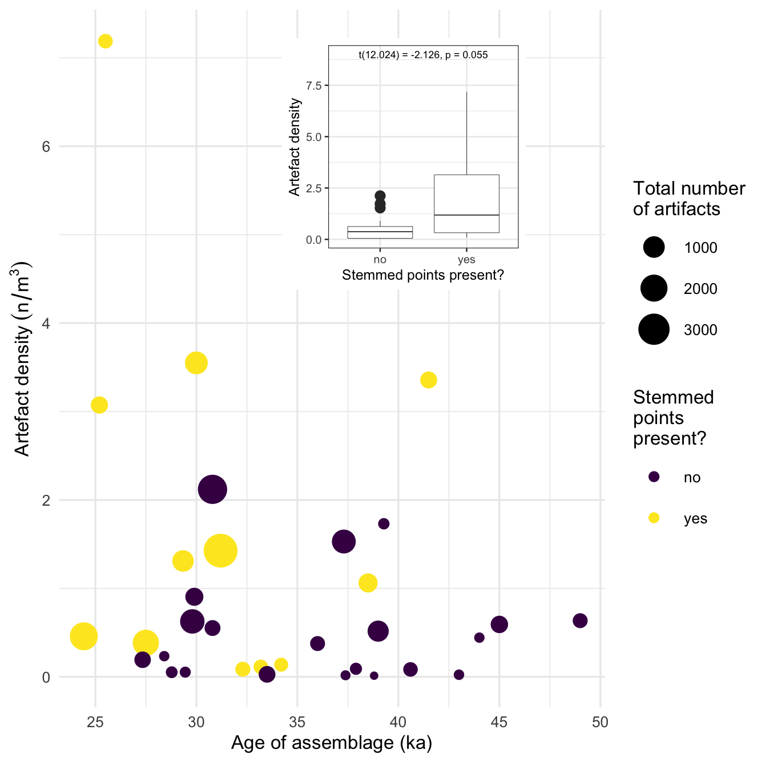

Figure 2: The main plot shows the artefact volumetric density over time. The size of data points represent the total number of artefacts from each assemblage and the colour indicates the presence of stemmed points. The inset plot shows direct comparison of artefact densities for assemblages with and without stemmed points.

Figure 3 shows a strong pattern of artefacts from less dense assemblages having higher retouch frequencies while more dense assemblages have lower retouch frequencies (p=0.043), further showing a spectrum of site functions in this sample. As for artefact density, there are no clear chronological trends in retouch frequencies. The assemblages containing stemmed points tend to have fewer retouched pieces compared to assemblages without stemmed points (p=0.011).

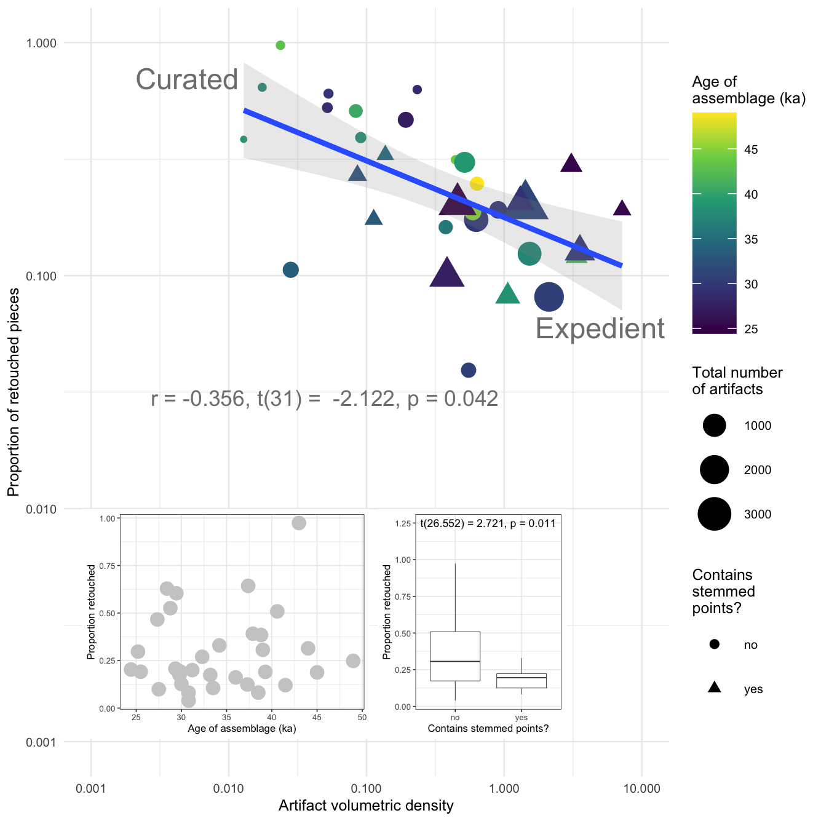

Figure 3: Main plot shows relationship between artefact density and retouch frequency. The colour of the data points indicate the age of the assemblage, point size indicates assemblage size, and shape indicates presence or absence of stemmed points. Assemblages with higher proportions of retouched pieces and lower densities indicate curated technologies, and assemblages at the other end of the spectrum indicate expedient technologies (Riel-Salvatore and Barton, 2004). The inset plot on the bottom left shows the proportion of retouched pieces in the assemblages over time. The inset plot on the bottom right shows the proportion of retouched pieces in the assemblages with or without stemmed points.

## Toolkit composition

Figure 4 shows that side scrapers are the major part of most assemblages and are present in all assemblages. For example, more than 70 percent of the two assemblages from Hwaderi are side scrapers. After around 31 ka, the proportion of side scrapers declines. In addition to side scrapers, cores also exist in all assemblages often as a high proportion. The proportion of choppers decreased towards in more recent assemblages. Blades first appeared in Gawolri-A at 43 ka and then often found in assemblages thereafter. Stemmed points first appear in Bonggok around 41.5ka and were typically found in assemblages that contain blades, except for Songamri-A. Other artefacts, including burins, denticulates, end scrapers, handaxes, knives, notches, planes, and polyhedrals made up a small proportion of the assemblages.

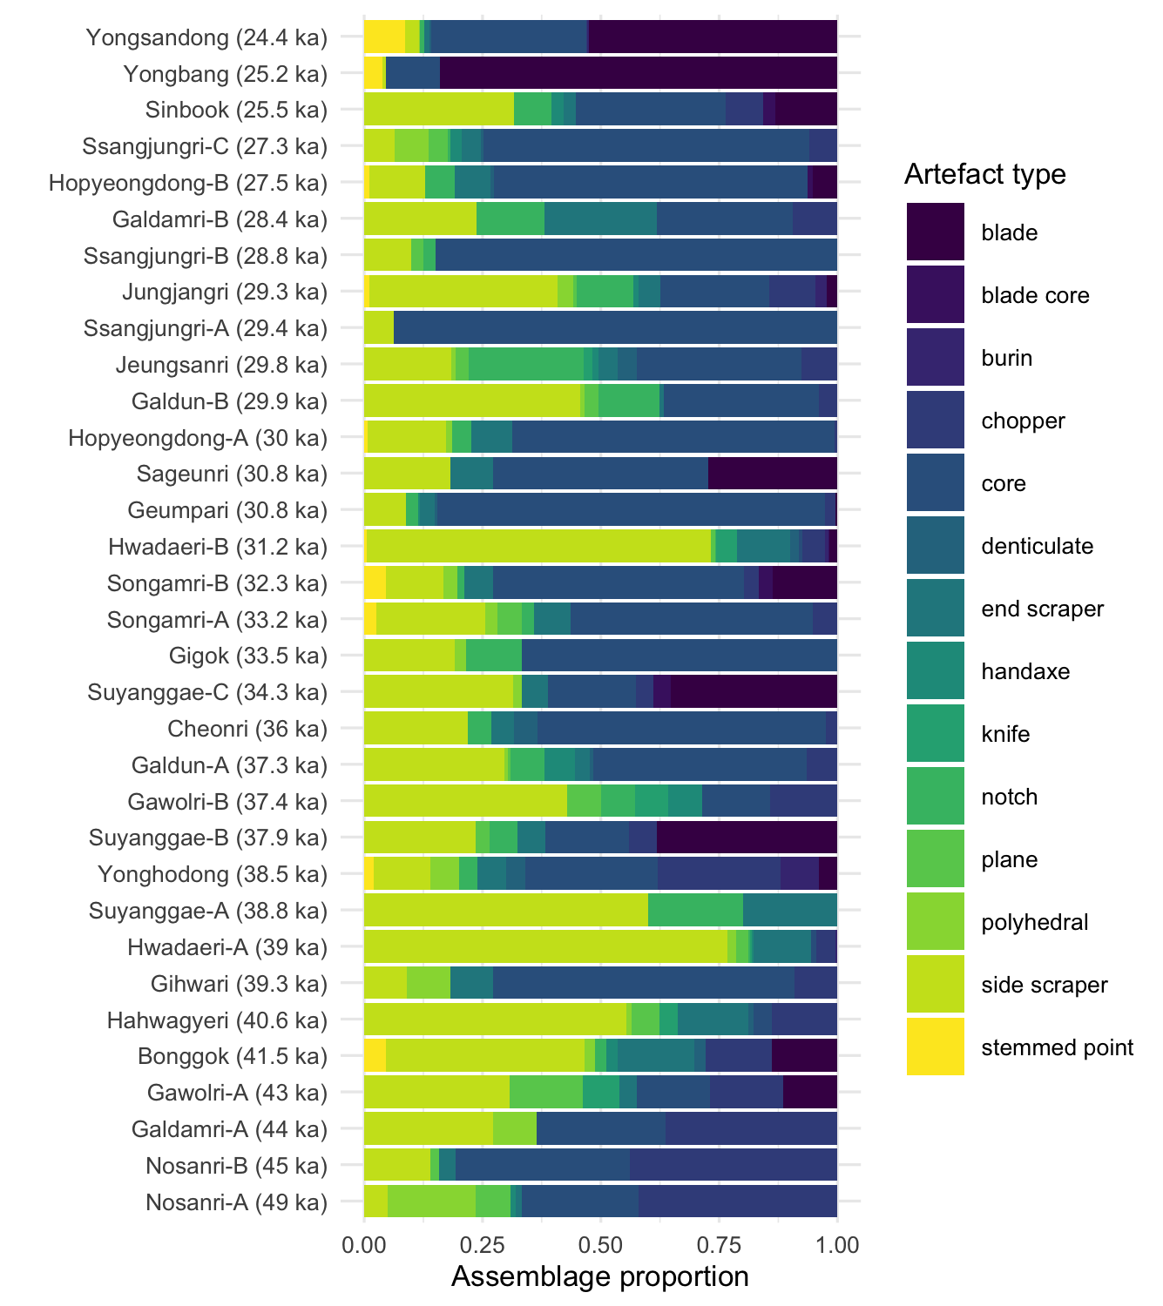

Figure 4: This plot shows the composition of each assemblage. We excluded artefacts related to manufacturing processes such as pebbles, hammers, flakes and debris, artefacts appeared only in a few assemblages including point, beak shaped, and awl, and unknown and unfinished pieces. The colour represents different types of tools and the assemblages are placed in chronological order.

## Raw materials

Quartz, quartz vein and quartzites were the most frequently found raw materials, and they were constantly used throughout the Late Pleistocene (Figure 5). For example, both Galdamri-A, dated to 44ka with a small assemblage, and Hopyeongdong-B, dated to 27.5ka with a larger assemblage, consist of only the quartz related materials. The use of chert, hornfels, rhyolite, and shale increased after 41.5 ka. All artefacts in Sageunri are made of rhyolite. Hornfels are dominant at Yongsandong and Yongbang sites at 25 ka. Chert, hornfels, rhyolite, and shale are very suitable to make elongate blades and stemmed points because of the predictability of flaking afforded by their fine-grained texture. For example, Yongsandong has the largest number of stemmed points (n=40) among the assemblages studied here, and all stemmed points from Yongsandong are made from hornfels. Other raw materials, such as porphyry and sandstone, were found in just a few assemblages in small proportions.

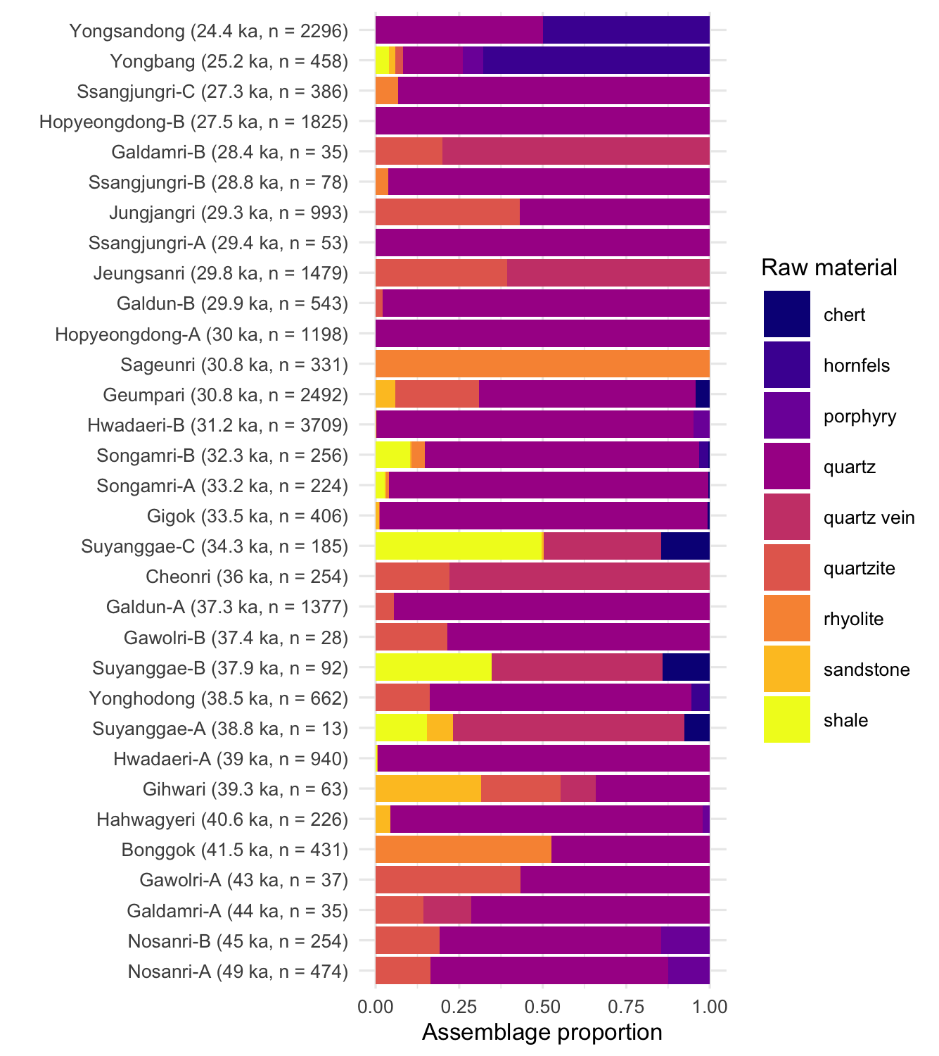

Figure 5: This plot shows the composition of raw material type in each assemblage. We excluded raw materials that are included in less than 5 assemblages including crystal, basalt, iron_ore, slate, limestone, granite, gneiss, tuff, and unidentified ones. Hornfels are shown in 4 assemblages but since it occupies more than half of the Yongsandong and Yongband assemblages, we included it in the plot. The color represents different types of raw materials, and the assemblages are placed in chronological order.

## Environmental context

Figure 6 shows that people occupied sites located at similar elevations, around 0 to 200 meters above sea level. However, there is a substantial difference in elevation between sites with stemmed points and sites without. The distribution of elevations of sites without stemmed points is generally lower than the elevations of sites with stemmed points. Although not a statistically significant difference in elevations (p = 0.102), this may indicate that forager groups who used stemmed points were able to occupy higher altitudes, while the groups without tended to prefer lower altitudes. Sites without stemmed points reach a maximum elevation of about 150 m at around 39ka. Sites containing stemmed points reach a maximum elevation of 175 m at 28ka.

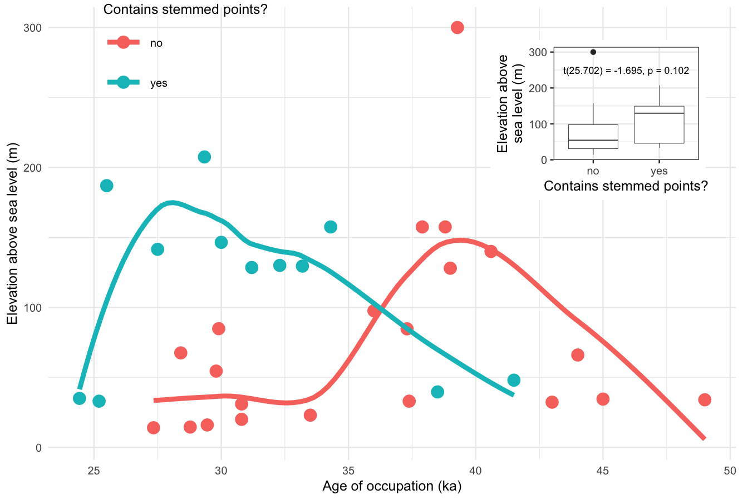

Figure 6: The main plot shows the site elevation by the age of the deposit. Colour indicates presence/absence of stemmed points. The lines display a locally weighted regression. The inset plot shows a direct relationship between the site elevation and stemmed points.

Among the sites in our sample there is a variation of about 5 degrees in the mean annual temperature (MAT), mostly controlled by elevation (Figure 7). Compared to the east side of the Korean Peninsula, the west side tends to be relatively warmer. The range of MAT at the sites over our study period is 2-10℃. Gihwari and Gigok sites have the lowest (3℃) and Jeungsan-ri site has the highest MAT (8℃). The mean MAT for all sites fluctuated within 4℃ between 50ka and 10ka. Through MIS 3, the temperature gradually decreased until the Last Glacial Maximum (LGM, 26.5-20 ka) (Clark et al., 2009). The first appearance of stemmed points occurs in the middle of the decreasing MAT trend in MIS 3, at 40-35ka. The MAT of MIS 2, including LGM, was relatively stable. The temperature increased again from late MIS 2 towards MIS 1. Figure 7D shows a negative relationship between temperature and elevation (p = 0.073). For example, Gihwa-ri Cave site, with one of the lowest MAT distributions, is located in the highest elevation around 300m above sea level. Jeungsan-ri is located at a lower elevation and has one of the highest MAT distributions.

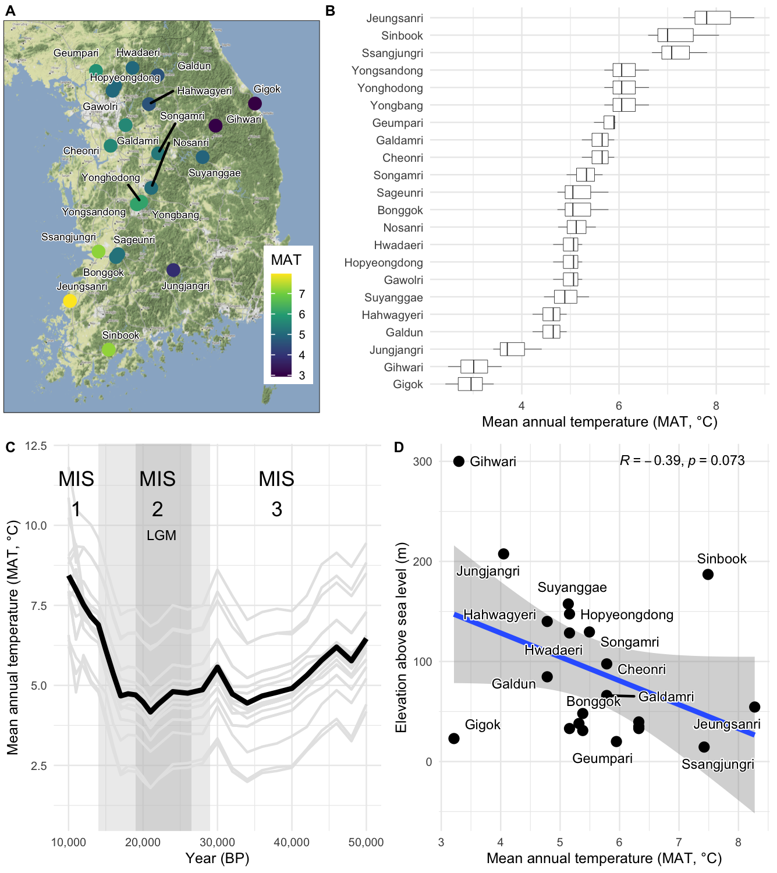

Figure 7: Mean Annual Temperature (MAT) of the Korean Paleolithic assemblages mentioned in this research. A: Site locations on the map and MAT. B: MAT distributions for each site during the period they were occupied. C: MAT from 50ka to 10ka. The grey lines indicate the MAT for each site and the black line is the mean temperature of all sites. The light grey area in the middle of the plot indicates the duration of MIS 2, separating MIS 3 and 1, and dark grey area represents the duration of LGM. D: The relationship between MAT and site elevation. The blue line is a linear regression on elevation and MAT with the grey area showing the 95% confidence interval.

## Demographic context

Figure 8 shows the four theoretical null models of demographic change for the period 50ka to 10ka, exponential, uniform, linear, and logistic, generated from the radiocarbon dates. Statistical significance of each model is computed using 200 simulations and the global p-values are 0.004, 0.004, 0.009, and 0.004, respectively. In this case, the linear model is the best fit with lower value verified by AIC. However, the other models have similar patterns with a minor margin at -48.6. The radiocarbon dates fit well with the overall trajectory of the null models (grey shading) with both positive and negative deviations. SPD shows a steady growth until 35ka, stays at the peak with minor deviation 32ka, and then starts declining with frequent temporary fluctuations (relatively sharp). The beginning and ending of the SPD indicates significant negative deviation with low density of radiocarbon dates.

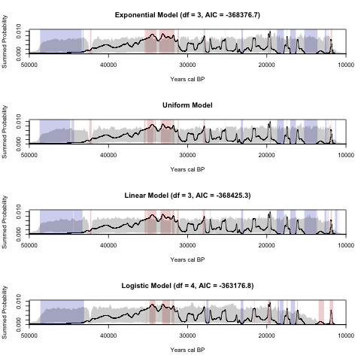

Figure 8: Summed probability distribution of 108 radiocarbon dates. The black solid line represents actual radiocarbon ages. The grey shaded region shows the critical envelope that encompasses the 95% confidence interval for the null models. The red and blue vertical bands highlight the portions of the SPD where positive and negative deviations are detected. We applied logistic, exponential and linear to AIC along with the logistical growth model (fit) to evaluate each model (Riris and Arroyo-Kalin, 2019). We excluded the uniform model because it has no fitted curve or surface to evaluate. The best fit model has the lowest AIC score. In this case, the linear model is the best fit, with the next-best fit (exponential) having a higher AIC score by a minor margin at -48.6.

# Discussion

Our study focused on two questions: how did the introduction of the new tools change foragers’ mobility and landscape use; and how did the new technology change the way people use habitation sites? Overall, our results show that assemblages with stemmed points tend to have higher artefact densities and lower proportions of retouched pieces. Quartz and side scrapers, in addition to cores and choppers, remain dominant in assemblages before and after the introduction of stemmed points. The environmental context of this technological innovation was a gradual decrease in temperature into the LGM.

## Artefact volumetric density and retouch frequency

We examined the artefact volumetric density and retouch frequency to understand the difference in mobility strategies and site occupation patterns before and after the introduction of stemmed points. The analyses are based on the premise that highly mobile groups would carry lightweight toolkits with more retouched and easily replaceable composite tools, and leave a smaller amount of artefacts on site as a result of short-term occupations. These curated technologies invest time and effort in stone artefact manufacturing and maintenance to optimize travel costs for groups using high mobility or special purpose forays. On the other hand, less mobile groups would produce fewer retouched tools and more simple tools, and leave higher densities of artefacts generated from long-term occupations. These expedient technologies are more typical for groups with greater residential stability who can make, use, abandon, and remake their tools frequently in the same location (Binford, 1979; Clark et al., 2019; Kuhn, 2014, 1994; Meignen et al., 2006; Torrence et al., 1989; Vaquero and Romagnoli, 2018). Our data support the concept of the curated and expedient technology by showing a strong pattern of artefacts from less dense assemblages having higher retouch frequencies, while more dense assemblages have lower retouch frequencies. Our results show that foragers with stemmed points tended to stay in the same site for longer periods with higher artefact densities and fewer retouched pieces, compared to assemblages without stemmed points. In general, the new technology of stemmed points was more associated with expedient technological strategies.

It could be assumed that foragers with stemmed points were highly mobile groups and chose curated technologies since the stemmed points were likely used for hunting activities (Chang, 2013; Lee and Sano, 2019). However, our results show the opposite that the new technology was more often associated with expedient technological strategies. Furthermore, our results show that different sites represent different occupation patterns during the time of technological transition, making it difficult to characterise this period with a single land use strategy. Seong claims that transitions from the expedient to curated technology in the Late Pleistocene were neither a straightforward nor unilineal processes and diverse site types can be more related to different occupation purposes including hunting camps, limited activity stations, caches, and so forth (Seong, 2015). Our findings support Seong, with some sites such as Bonggok and Yonghodong containing only 2 stemmed points, while Yongsandong has 38 points including broken tips and a base. More than 70% of Yongsandong stemmed points were unearthed, dominating the tool kit with 233 blades and other byproducts related to lithic manufacturing including cores and debris made of the same raw materials (Bae and Bae, 2012; Kim, 2004). In the specific case of Yongsandong it seems likely that stemmed points were manufactured for hunting purposes, which dominated the function of the site. On the other hand, at Bonggok and Yonghodong stemmed points were only a minor part of activities there.

## Toolkit composition and raw materials

The composition of toolkits during the Late Pleistocene of Korea has been described within multiple chronological sub-periods. Seong divides five successive assemblage types for the Late/Upper Paleolithic in Korea: (1) quartzite and quartz vein artefacts; (2) mostly small quartzite and quartz vein artefacts with some large artefacts such as cores and choppers; (3) stemmed points dominant; (4) typical blade assemblages including stemmed points; and (5) microblade after 30ka (Seong, 2015). Lee focuses on the Honam region in southwestern Korea and divides the same time frame into two phases; ‘core tool industry with large flake knapping’ during early MIS 3 (59−40 ka), and ‘blade industry with tanged point chiefly’ during late MIS (40−24 ka) (Lee, 2012). Both Seong and Lee mention that core tools made of quartz or quartz vein never disappeared and they point out the appearance of stemmed points and blade technology as an addition, rather than replacement. Our results, covering 49-24 ka and corresponding to the first three types of Seong’s divisions, support the continuation of core tools abundantly throughout the Late Pleistocene. In addition, our data show that side scrapers stayed as major tools while other tools occupied only a small portion of the assemblages. As stemmed points and blades increased in the toolkits, both choppers and side scrapers went through minor decreases but still remained abundant.

Changes in raw material composition were closely associated with the appearance of stemmed points. Previous studies claim that the existing tools, including choppers, polyhedrals, handaxes and cores were usually made of locally acquired quartzite, while the new tools including stemmed points and other blade assemblages were made of more fine-grained materials such as siliceous shale, hornfels, and obsidian which might be brought from distant sources (Chang, 2013; Seong, 2015). Our data also show that quartz, quartz vein and quartzite were consistently dominant and the use of fine-grained materials including chert, hornfels, rhyolite, and shale, increased after 41.5 ka, around the time that stemmed points appear. Projectile points, such as stemmed points, need high quality materials which enable high flaking quality, durability and effectiveness of an edge, as well as the creation of well-defined outline forms (Bamforth, 2009). The increased use of finer-grained raw materials likely changed forager mobility patterns to ensure their movements over the landscape supplied them with the materials needed to make stemmed points.

## Environmental and demographic contexts

We hypothesized that the introduction of stemmed points might reflect a preference for more portable and efficient hunting tools, as an adaptation to environmental or population changes. As the first composite tool appearing on the Korean Peninsula, stemmed points represent a major change in stone artefact technology. An important quality of composite tools is that the user can easily replace damaged parts, contributing to an increased maintainability of the tool (Cardillo, 2010; Kuhn and Miller, 2015). Combining the stone projective with a wooden shaft further materials enhances functionality of the tool such as improving penetration by increasing weight (Browne, 1940). We expected that the functional advantage of the new composite tool might have allowed foragers to be more active in less productive landscapes. Previous studies simply describe the environment of the research period as “overall cooler and drier during MIS 3” but lack detail due to a lack of direct paleoenvironmental proxies in Korea (BAK and LEE, 2017; Chang, 2013; Choi, 2011; Han, 2008; Im and Choo, 2015; Seong, 2008). To explore environmental and demographic context related to the technological transition, we examined the distribution of site elevations, and simulated MAT during the Late Pleistocene. The results show that groups with stemmed points occupied higher elevations, where the MAT was lower. This supports our hypothesis that stemmed points supported occupation of more marginal habitats. Through MIS 3 the temperature gradually decreased until the LGM, suggesting that stemmed points may have been part of a suite of adaptations to cooler temperatures. We see a similar pattern of new technologies enabling expansion into marginal areas at a later time in north Paleo-Honshu Island, Japan, where the appearance of blade and projectile points at about 25 ka were associated with foragers moving into cold grassland areas (Morisaki et al., 2015).

We investigated forager population dynamics to assess if population change might be a relevant mechanism to explain the appearance of stemmed points. The output of our SPD models indicate population increasing until 35 ka and remaining at the peak with minor deviations for about 3,000 years. If population dynamics were a key driver, then we expect population to be high at the time the new technology first appears. However, with the first stemmed points appearing at 38 ka, well before the observed peak in population, we conclude that population dynamics were not a major mechanism in the appearance of this new technology. Bae claims that stemmed points are the result of the continuous influx of modern humans from a Siberian migration (Bae, 2010). Our results are consistent with this scenario, showing a gradual increase in population after the appearance of stemmed points which may reflect a continuous influx of migrants over a long period.

# Conclusion

To understand the change in mobility and site occupation related to the appearance of new technologies during the late Pleistocene in Korea, we examined stone artefacts from 22 sites dated to 49-24 ka. The results show that the forager groups with stemmed points tended to be located at higher elevations, which means the use of stemmed points was associated with occupation of marginal or extreme environments. In addition, the groups with stemmed points had expedient technologies which reflect residential and less mobile land use patterns. The temperature gradually decreased during the technological transition and after the appearance of stemmed points, population gradually increased.

Our findings are limited by the relatively small number of sites and radiocarbon ages currently available. The absence of detailed stratigraphic data limit the chronological resolution for the assemblages in our sample. Furthermore, we currently lack functional data on individual artefact assemblages to support our conclusions about site use. With future work we may be better able to distinguish a high density of stone artefacts as results from a long-term/small group occupation versus a short-term/large group occupation. Further research should focus on detailed assemblage analysis at each site to better understand foragers mobility and site use strategies.

# Acknowledgements

##### 0.0.0.0.1 pagebreak

# References

Andrefsky, W., 1994. Raw-material availability and the organization of technology. American Antiquity 59, 21–34.

Bae, C.J., Bae, K., 2012. The nature of the early to late paleolithic transition in korea: Current perspectives. Quaternary International 281, 26–35.

Bae, C.J., Bae, K., Kim, J.C., 2013. The early to late paleolithic transition in korea: A closer look. Radiocarbon 55, 1341–1349.

Bae, C.J., Douka, K., Petraglia, M.D., 2017. On the origin of modern humans: Asian perspectives. Science 358, eaai9067.

Bae, K., 2010. Origin and patterns of the upper paleolithic industries in the korean peninsula and movement of modern humans in east asia. Quaternary International 211, 103–112.

BAK, Y.-S., LEE, Y.-U., 2017. Late quaternary paleoclimatic change in the ulleung basin, east sea, korea. Acta Geologica Sinica-English Edition 91, 263–269.

Bamforth, D.B., 2009. Projectile points, people, and plains paleoindian perambulations. Journal of Anthropological Archaeology 28, 142–157.

Bamforth, D.B., Grund, B., 2012. Radiocarbon calibration curves, summed probability distributions, and early paleoindian population trends in north america. Journal of Archaeological Science 39, 1768–1774.

Barton, C.M., Riel-Salvatore, J., Anderies, J.M., Popescu, G., 2011. Modeling human ecodynamics and biocultural interactions in the late pleistocene of western eurasia. Human Ecology 39, 705–725.

Bar-Yosef, O., 2002. The upper paleolithic revolution. Annual Review of Anthropology 31, 363–393.

Bar-Yosef, O., Kuhn, S.L., 1999. The big deal about blades: Laminar technologies and human evolution. American Anthropologist 101, 322–338.

Bettinger, R.L., Eerkens, J., 1997. Evolutionary implications of metrical variation in great basin projectile points. Archeological Papers of the American Anthropological Association 7, 177–191.

Bevan, A., Colledge, S., Fuller, D., Fyfe, R., Shennan, S., Stevens, C., 2017. Holocene fluctuations in human population demonstrate repeated links to food production and climate. Proceedings of the National Academy of Sciences 114, E10524–E10531.

Beyer, R.M., Krapp, M., Manica, A., 2020. High-resolution terrestrial climate, bioclimate and vegetation for the last 120,000 years. Scientific Data 7, 1–9.

Binford, L.R., 1979. Organization and formation processes: Looking at curated technologies. Journal of anthropological research 35, 255–273.

Brantingham, P.J., 2003. A neutral model of stone raw material procurement. American Antiquity 68, 487–509.

Brantingham, P.J., Krivoshapkin, A., Jinzeng, L., Tserendagva, Y., 2001. The initial upper paleolithic in northeast asia. Current Anthropology 42, 735–746.

Brantingham, P.J., Olsen, J.W., Rech, J.A., Krivoshapkin, A.I., 2000. Raw material quality and prepared core technologies in northeast asia. Journal of Archaeological Science 27, 255–271.

Brantingham, P.J., Perreault, C., 2010. Detecting the effects of selection and stochastic forces in archaeological assemblages. Journal of Archaeological Science 37, 3211–3225. <https://doi.org/10.1016/j.jas.2010.07.021>

Browne, J., 1940. Projectile points. American Antiquity 5, 209–213.

Buchanan, B., O’Brien, M.J., Collard, M., 2016. Drivers of technological richness in prehistoric texas: An archaeological test of the population size and environmental risk hypotheses. Archaeological and Anthropological Sciences 8, 625–634.

Buvit, I., Izuho, M., Terry, K., Shitaoka, Y., Soda, T., Kunikita, D., 2014. Late pleistocene geology and paleolithic archaeology of the shimaki site, hokkaido, japan. Geoarchaeology 29, 221–237.

Capriles, J.M., Albarracin-Jordan, J., Bird, D.W., Goldstein, S.T., Jarpa, G.M., Maldonado, S.C., Santoro, C.M., 2018. Mobility, subsistence, and technological strategies of early holocene hunter-gatherers in the bolivian altiplano. Quaternary International 473, 190–205.

Capriles, J.M., Albarracin-Jordan, J., Bird, D.W., Goldstein, S.T., Jarpa, G.M., Maldonado, S.C., Santoro, C.M., 2018. Mobility, subsistence, and technological strategies of early holocene hunter-gatherers in the bolivian altiplano. Quaternary International 473, 190–205.

Cardillo, M., 2010. Some applications of geometric morphometrics to archaeology, in: Morphometrics for Nonmorphometricians. Springer, pp. 325–341.

Centi, L., Groman-Yaroslavski, I., Friedman, N., Oron, M., Prévost, M., Zaidner, Y., 2019. The bulb retouchers in the levant: New insights into middle palaeolithic retouching techniques and mobile tool-kit composition. PloS one 14, e0218859.

Chang, Y., 2013. Human activity and lithic technology between korea and japan from MIS 3 to MIS 2 in the late paleolithic period. Quaternary International 308, 13–26.

Choi, S.-Y., 2011. Natural environment of the paleolithic in gangwon region. Journal of Humanity and Science 28.

Clark, G., Barton, C.M., 2017. Lithics, landscapes & la longue-durée–curation & expediency as expressions of forager mobility. Quaternary international 450, 137–149.

Clark, G., Barton, C.M., Straus, L.G., 2019. Landscapes, climate change & forager mobility in the upper paleolithic of northern spain. Quaternary International 515, 176–187.

Clark, P.U., Dyke, A.S., Shakun, J.D., Carlson, A.E., Clark, J., Wohlfarth, B., Mitrovica, J.X., Hostetler, S.W., McCabe, A.M., 2009. The last glacial maximum. science 325, 710–714.

Collard, M., Buchanan, B., O’Brien, M.J., 2013. Population size as an explanation for patterns in the paleolithic archaeological record: More caution is needed. Current Anthropology 54, S388–S396.

Contreras, D.A., Meadows, J., 2014. Summed radiocarbon calibrations as a population proxy: A critical evaluation using a realistic simulation approach. Journal of Archaeological Science 52, 591–608.

Crema, E., Bevan, A., n.d. Analysing radiocarbon dates using the rcarbon package.

Davies, B., Holdaway, S.J., Fanning, P.C., 2018. Modeling relationships between space, movement, and lithic geometric attributes. American Antiquity 83, 444–461.

Gao, X., Guan, Y., Chen, F., Yi, M., Pei, S., Wang, H., 2014. The discovery of late paleolithic boiling stones at SDG 12, north china. Quaternary international 347, 91–96.

Gao, X., Zhang, X., Yang, D., Shen, C., Wu, X., 2010. Revisiting the origin of modern humans in china and its implications for global human evolution. Science China Earth Sciences 53, 1927–1940. <https://doi.org/10.1007/s11430-010-4099-4>

Garcı́a-Medrano, P., Cáceres, I., Ollé, A., Carbonell, E., 2017. The occupational pattern of the galerı́a site (atapuerca, spain): A technological perspective. Quaternary International 433, 363–378.

Han, C., 2008. Natural environment of the upper paleolithic period in korea. Journal of the Korean Archaeological Society 33, 3–46.

Hiscock, P., 1994. Technological responses to risk in holocene australia. Journal of World Prehistory 8, 267–292. <https://doi.org/10.1007/BF02221051>

Hiscock, P., Clarkson, C., Mackay, A., 2011. Big debates over little tools: Ongoing disputes over microliths on three continents. World Archaeology 43, 653–664. <https://doi.org/10.1080/00438243.2011.624755>

Holdaway, S.J., Davies, B., 2019. Surface stone artifact scatters, settlement patterns, and new methods for stone artifact analysis. Journal of Paleolithic Archaeology 1–21.

Im, J.H., Choo, C.O., 2015. A study on tree-ring dating and speciation of charcoal found in pumiceous deposit of the quaternary nari caldera, ulleung island, korea. Economic and Environmental Geology 48, 501–508.

Izuho, M., Kaifu, Y., 2014. The 21 appearance and characteristics of the early upper paleolithic in the japanese archipelago. Emergence and diversity of modern human behavior in Paleolithic Asia 289.

Keeley, L.H., 1982. Hafting and retooling: Effects on the archaeological record. American Antiquity 47, 798–809. <https://doi.org/10.2307/280285>

Kelly, R.L., 1995. The foraging spectrum: Diversity in hunter-gatherer lifeways. Smithsonian Institution Press Washington, DC.

Kim, H.-I., 2004. Yongsan-dong paleolithic site, daejeon. Hanguk Guseoki Hakbo 10, 83–94.

Kline, M.A., Boyd, R., 2010. Population size predicts technological complexity in oceania. Proceedings of the Royal Society B: Biological Sciences 277, 2559–2564.

Kuhn, S.L., 2014. Mousterian lithic technology: An ecological perspective. Princeton University Press.

Kuhn, S.L., 2004. Upper paleolithic raw material economies at Üçağızlı cave, turkey. Journal of Anthropological Archaeology 23, 431–448.

Kuhn, S.L., 1994. A formal approach to the design and assembly of mobile toolkits. American Antiquity 59, 426–442.

Kuhn, S.L., 1991. “Unpacking” reduction: Lithic raw material economy in the mousterian of west-central italy. Journal of Anthropological Archaeology 10, 76–106.

Kuhn, S.L., 1990. A geometric index of reduction for unifacial stone tools. Journal of Archaeological Science 17, 583–593. <https://doi.org/10.1016/0305-4403(90)90038-7>

Kuhn, S.L., Miller, D.S., 2015. Artifacts as patches: The marginal value theorem and stone tool life histories. Lithic technological systems and evolutionary theory 172.

Kuhn, S.L., Raichlen, D.A., Clark, A.E., 2016. What moves us? How mobility and movement are at the center of human evolution. Evolutionary Anthropology: Issues, News, and Reviews 25, 86–97.

Lee, G., 2012. Characteristics of paleolithic industries in southwestern korea during MIS 3 and MIS 2. Quaternary International 248, 12–21.

Lee, G.-K., Sano, K., 2019. Were tanged points mechanically delivered armatures? Functional and morphometric analyses of tanged points from an upper paleolithic site at jingeuneul, korea. Archaeological and Anthropological Sciences 11, 2453–2465.

Lee, H.W., 2016. Patterns of transitions in paleolithic stages during MIS 3 and 2 in korea. Quaternary International, Paleoenvironmental studies in the korean peninsula and adjacent geographic areas IV 392, 44–57. <https://doi.org/10.1016/j.quaint.2015.06.019>

Lee, H.W., 2013. Current observations of the early late paleolithic in korea. Quaternary international 316, 45–58.

Li, F., Kuhn, S.L., Bar-Yosef, O., Chen, F., Peng, F., Gao, X., 2019. History, chronology and techno-typology of the upper paleolithic sequence in the shuidonggou area, northern china. Journal of World Prehistory 1–31.

Llano, C., 2015. On optimal use of a patchy environment: Archaeobotany in the argentinean andes (argentina). Journal of Archaeological Science 54, 182–192.

Marwick, B., 2017. Computational reproducibility in archaeological research: Basic principles and a case study of their implementation. Journal of Archaeological Method and Theory 24, 424–450.

Meignen, L., Bar-Yosef, O., Speth, J.D., Stiner, M.C., 2006. Middle paleolithic settlement patterns in the levant, in: Transitions Before the Transition. Springer, pp. 149–169.

Morisaki, K., Izuho, M., Terry, K., Sato, H., 2015. Lithics and climate: Technological responses to landscape change in upper palaeolithic northern japan. Antiquity 89, 554–572. <https://doi.org/10.15184/aqy.2015.23>

Morisaki, K., Sano, K., Izuho, M., 2019. Early upper paleolithic blade technology in the japanese archipelago. Archaeological Research in Asia 17, 79–97.

Nakazawa, Y., Bae, C.J., 2018. Quaternary paleoenvironmental variation and its impact on initial human dispersals into the japanese archipelago. Palaeogeography, palaeoclimatology, palaeoecology 512, 145–155.

Norton, C.J., Jin, J.J., 2009. The evolution of modern human behavior in east asia: Current perspectives. Evolutionary Anthropology: Issues, News, and Reviews: Issues, News, and Reviews 18, 247–260.

Ono, A., Sato, H., Tsutsumi, T., Kudo, Y., 2002. Radiocaron dates and archaeology of the late pleistocene in the japanese islands. Radiocarbon 44, 477–494.

Pei, S., Gao, X., Wang, H., Kuman, K., Bae, C.J., Chen, F., Guan, Y., Zhang, Y., Zhang, X., Peng, F., others, 2012. The shuidonggou site complex: New excavations and implications for the earliest late paleolithic in north china. Journal of Archaeological Science 39, 3610–3626.

Prentiss, A.M., 2019. Handbook of evolutionary research in archaeology. Springer.

Rick, J.W., 1987. Dates as data: An examination of the peruvian preceramic radiocarbon record. American Antiquity 52, 55–73.

Riel-Salvatore, J., Barton, C.M., 2004. Late pleistocene technology, economic behavior, and land-use dynamics in southern italy. American Antiquity 257–274.

Riris, P., Arroyo-Kalin, M., 2019. Widespread population decline in south america correlates with mid-holocene climate change. Scientific reports 9, 1–10.

Sakamoto, Y., Ishiguro, M., Kitagawa, G., 1986. Akaike information criterion statistics. Dordrecht, The Netherlands: D. Reidel 81.

Seong, C., 2015. Diversity of lithic assemblages and evolution of late palaeolithic culture in korea. Asian Perspectives 91–112.

Seong, C., 2009. Emergence of a blade industry and evolution of late paleolithic technology in the republic of korea. Journal of Anthropological Research 65, 417–451.

Seong, C., 2008. Tanged points, microblades and late palaeolithic hunting in korea. Antiquity 82, 871–883.

Shennan, S., 2009. Pattern and process in cultural evolution. Univ of California Press.

Shennan, S., 2001. Demography and cultural innovation: A model and its implications for the emergence of modern human culture. Cambridge archaeological journal 11, 5–16.

Shennan, S., Downey, S.S., Timpson, A., Edinborough, K., Colledge, S., Kerig, T., Manning, K., Thomas, M.G., 2013. Regional population collapse followed initial agriculture booms in mid-holocene europe. Nature communications 4, 2486.

Shott, M.J., 2010. Size dependence in assemblage measures: Essentialism, materialism, and" SHE" analysis in archaeology. American Antiquity 886–906.

Shott, M.J., 1986. Settlement mobility and technological organization: An ethnographic examination. Journal of Anthropological Research 42, 15–51.

Smith, E.A., 1991. Inujjuamiunt foraging strategies: Evolutionary ecology of an arctic hunting economy. Transaction Publishers.

Smith, E.A., Bettinger, R.L., Bishop, C.A., Blundell, V., Cashdan, E., Casimir, M.J., Christenson, A.L., Cox, B., Dyson-Hudson, R., Hayden, B., others, 1983. Anthropological applications of optimal foraging theory: A critical review [and comments and reply]. Current Anthropology 24, 625–651.

Team, R.C., 2017. R: A language and environment for statistical computing. R foundation for statistical computing, vienna. Http s. www. R-proje ct. org.

Timpson, A., Colledge, S., Crema, E., Edinborough, K., Kerig, T., Manning, K., Thomas, M.G., Shennan, S., 2014. Reconstructing regional population fluctuations in the european neolithic using radiocarbon dates: A new case-study using an improved method. Journal of Archaeological Science 52, 549–557.

Torrence, R., Audouze, F., Renfrew, C., Schlanger, N., Sherratt, A., Taylor, T., Ashmore, W., others, 1989. Time, energy and stone tools. Cambridge university press.

Tsutsumi, T., 2007. The dynamics of obsidian use by the microblade industries of the terminal late paleolithic. The Quaternary Research (Daiyonki-Kenkyu) 46, 179–186.

Valde-Nowak, P., Cieśla, M., 2020. Models of raw material exploitation as an indicator of middle paleolithic mobility: Case studies from uplands of northern central europe, in: Short-Term Occupations in Paleolithic Archaeology. Springer, pp. 105–120.

Valde-Nowak, P., Cieśla, M., 2020. Models of raw material exploitation as an indicator of middle paleolithic mobility: Case studies from uplands of northern central europe, in: Short-Term Occupations in Paleolithic Archaeology. Springer, pp. 105–120.

Vaquero, M., Romagnoli, F., 2018. Searching for lazy people: The significance of expedient behavior in the interpretation of paleolithic assemblages. Journal of Archaeological Method and Theory 25, 334–367.

Williams, A.N., 2012. The use of summed radiocarbon probability distributions in archaeology: A review of methods. Journal of Archaeological Science 39, 578–589.

Winterhalder, B., Smith, E.A., 1992. Evolutionary ecology and the social sciences. Evolutionary ecology and human behavior 3–23.

Wolverton, S., Otaola, C., Neme, G., Giardina, M., Gil, A., 2015. Patch choice, landscape ecology, and foraging efficiency: The zooarchaeology of late holocene foragers in western argentina. Journal of Ethnobiology 35, 499–518.

Yamaoka, T., 2012. Use and maintenance of trapezoids in the initial early upper paleolithic of the japanese islands. Quaternary international 248, 32–42.

Yi, M., Bettinger, R.L., Chen, F., Pei, S., Gao, X., 2014. The significance of shuidonggou locality 12 to studies of hunter-gatherer adaptive strategies in north china during the late pleistocene. Quaternary international 347, 97–104.

Yue, J.-P., Li, Y.-Q., Zhang, Y.-X., Yang, S., 2020. Lithic raw material economy at the huayang site in northeast china: Localization and diversification as adaptive strategies in the late glacial. Archaeological and Anthropological Sciences 12.

Zhang, Y., Gao, X., Pei, S., Chen, F., Niu, D., Xu, X., Zhang, S., Wang, H., 2016. The bone needles from shuidonggou locality 12 and implications for human subsistence behaviors in north china. Quaternary International 400, 149–157.

##### 0.0.0.0.2 pagebreak

### Colophon

This report was generated on 2020-12-16 00:04:23 using the following computational environment and dependencies:

#> ─ Session info ───────────────────────────────────────────────────────────────  
#> setting value   
#> version R version 4.0.3 (2020-10-10)  
#> os macOS Catalina 10.15.7   
#> system x86_64, darwin17.0   
#> ui X11   
#> language (EN)   
#> collate en_US.UTF-8   
#> ctype en_US.UTF-8   
#> tz America/Los_Angeles   
#> date 2020-12-16   
#>   
#> ─ Packages ───────────────────────────────────────────────────────────────────  
#> package * version date lib source   
#> abind 1.4-5 2016-07-21 [1] CRAN (R 4.0.0)   
#> assertthat 0.2.1 2019-03-21 [1] CRAN (R 4.0.0)   
#> backports 1.1.10 2020-09-15 [1] CRAN (R 4.0.2)   
#> bitops 1.0-6 2013-08-17 [1] CRAN (R 4.0.0)   
#> blob 1.2.1 2020-01-20 [1] CRAN (R 4.0.0)   
#> bookdown 0.21 2020-10-13 [1] CRAN (R 4.0.2)   
#> broom 0.7.1 2020-10-02 [1] CRAN (R 4.0.2)   
#> callr 3.5.1 2020-10-13 [1] CRAN (R 4.0.2)   
#> car 3.0-10 2020-09-29 [1] CRAN (R 4.0.2)   
#> carData 3.0-4 2020-05-22 [1] CRAN (R 4.0.0)   
#> cellranger 1.1.0 2016-07-27 [1] CRAN (R 4.0.0)   
#> cli 2.1.0 2020-10-12 [1] CRAN (R 4.0.2)   
#> codetools 0.2-16 2018-12-24 [1] CRAN (R 4.0.3)   
#> colorspace 1.4-1 2019-03-18 [1] CRAN (R 4.0.0)   
#> cowplot * 1.1.0 2020-09-08 [1] CRAN (R 4.0.2)   
#> crayon 1.3.4 2017-09-16 [1] CRAN (R 4.0.0)   
#> curl 4.3 2019-12-02 [1] CRAN (R 4.0.0)   
#> data.table 1.13.0 2020-07-24 [1] CRAN (R 4.0.2)   
#> DBI 1.1.0 2019-12-15 [1] CRAN (R 4.0.0)   
#> dbplyr 1.4.4 2020-05-27 [1] CRAN (R 4.0.0)   
#> deldir 0.1-29 2020-09-13 [1] CRAN (R 4.0.2)   
#> desc 1.2.0 2018-05-01 [1] CRAN (R 4.0.0)   
#> devtools 2.3.2 2020-09-18 [1] CRAN (R 4.0.2)   
#> digest 0.6.27 2020-10-24 [1] CRAN (R 4.0.2)   
#> doSNOW 1.0.18 2019-07-27 [1] CRAN (R 4.0.2)   
#> dplyr * 1.0.2 2020-08-18 [1] CRAN (R 4.0.2)   
#> drc * 3.0-1 2016-08-30 [1] CRAN (R 4.0.2)   
#> ellipsis 0.3.1 2020-05-15 [1] CRAN (R 4.0.0)   
#> evaluate 0.14 2019-05-28 [1] CRAN (R 4.0.0)   
#> fansi 0.4.1 2020-01-08 [1] CRAN (R 4.0.0)   
#> farver 2.0.3 2020-01-16 [1] CRAN (R 4.0.0)   
#> forcats * 0.5.0 2020-03-01 [1] CRAN (R 4.0.0)   
#> foreach 1.5.1 2020-10-15 [1] CRAN (R 4.0.2)   
#> foreign 0.8-80 2020-05-24 [1] CRAN (R 4.0.3)   
#> fs 1.5.0 2020-07-31 [1] CRAN (R 4.0.2)   
#> generics 0.0.2 2018-11-29 [1] CRAN (R 4.0.0)   
#> ggmap * 3.0.0 2019-02-05 [1] CRAN (R 4.0.0)   
#> ggplot2 * 3.3.2 2020-06-19 [1] CRAN (R 4.0.0)   
#> ggpubr * 0.4.0 2020-06-27 [1] CRAN (R 4.0.1)   
#> ggrepel * 0.9.0 2020-05-11 [1] Github (slowkow/ggrepel@3941cf1)  
#> ggsignif 0.6.0 2019-08-08 [1] CRAN (R 4.0.0)   
#> glue * 1.4.2 2020-08-27 [1] CRAN (R 4.0.2)   
#> goftest 1.2-2 2019-12-02 [1] CRAN (R 4.0.0)   
#> gtable 0.3.0 2019-03-25 [1] CRAN (R 4.0.0)   
#> gtools 3.8.2 2020-03-31 [1] CRAN (R 4.0.2)   
#> haven 2.3.1 2020-06-01 [1] CRAN (R 4.0.0)   
#> here * 0.1 2017-05-28 [1] CRAN (R 4.0.0)   
#> highr 0.8 2019-03-20 [1] CRAN (R 4.0.0)   
#> hms 0.5.3 2020-01-08 [1] CRAN (R 4.0.0)   
#> htmltools 0.5.0 2020-06-16 [1] CRAN (R 4.0.0)   
#> httr 1.4.2 2020-07-20 [1] CRAN (R 4.0.2)   
#> iterators 1.0.13 2020-10-15 [1] CRAN (R 4.0.2)   
#> jpeg 0.1-8.1 2019-10-24 [1] CRAN (R 4.0.0)   
#> jsonlite 1.7.1 2020-09-07 [1] CRAN (R 4.0.2)   
#> knitr 1.30 2020-09-22 [1] CRAN (R 4.0.2)   
#> labeling 0.4.2 2020-10-20 [1] CRAN (R 4.0.2)   
#> lattice * 0.20-41 2020-04-02 [1] CRAN (R 4.0.3)   
#> legendMap * 1.0 2020-05-08 [1] Github (3wen/legendMap@707f00c)   
#> lifecycle 0.2.0 2020-03-06 [1] CRAN (R 4.0.0)   
#> lubridate 1.7.9 2020-06-08 [1] CRAN (R 4.0.1)   
#> magrittr * 1.5 2014-11-22 [1] CRAN (R 4.0.0)   
#> maps * 3.3.0 2018-04-03 [1] CRAN (R 4.0.0)   
#> maptools * 1.0-2 2020-08-24 [1] CRAN (R 4.0.2)   
#> MASS * 7.3-53 2020-09-09 [1] CRAN (R 4.0.3)   
#> Matrix 1.2-18 2019-11-27 [1] CRAN (R 4.0.3)   
#> memoise 1.1.0 2017-04-21 [1] CRAN (R 4.0.0)   
#> mgcv 1.8-33 2020-08-27 [1] CRAN (R 4.0.3)   
#> modelr 0.1.8 2020-05-19 [1] CRAN (R 4.0.0)   
#> multcomp 1.4-14 2020-09-23 [1] CRAN (R 4.0.2)   
#> munsell 0.5.0 2018-06-12 [1] CRAN (R 4.0.0)   
#> mvtnorm 1.1-1 2020-06-09 [1] CRAN (R 4.0.1)   
#> ncdf4 * 1.17 2019-10-23 [1] CRAN (R 4.0.0)   
#> nlme 3.1-149 2020-08-23 [1] CRAN (R 4.0.3)   
#> openxlsx 4.2.2 2020-09-17 [1] CRAN (R 4.0.2)   
#> pillar 1.4.6 2020-07-10 [1] CRAN (R 4.0.0)   
#> pkgbuild 1.1.0 2020-07-13 [1] CRAN (R 4.0.0)   
#> pkgconfig 2.0.3 2019-09-22 [1] CRAN (R 4.0.0)   
#> pkgload 1.1.0 2020-05-29 [1] CRAN (R 4.0.0)   
#> plotrix 3.7-8 2020-04-16 [1] CRAN (R 4.0.2)   
#> plyr 1.8.6 2020-03-03 [1] CRAN (R 4.0.0)   
#> png 0.1-7 2013-12-03 [1] CRAN (R 4.0.0)   
#> polyclip 1.10-0 2019-03-14 [1] CRAN (R 4.0.0)   
#> prettyunits 1.1.1 2020-01-24 [1] CRAN (R 4.0.0)   
#> processx 3.4.4 2020-09-03 [1] CRAN (R 4.0.2)   
#> ps 1.4.0 2020-10-07 [1] CRAN (R 4.0.2)   
#> purrr * 0.3.4 2020-04-17 [1] CRAN (R 4.0.0)   
#> R6 2.5.0 2020-10-28 [1] CRAN (R 4.0.2)   
#> raster * 3.3-13 2020-07-17 [1] CRAN (R 4.0.2)   
#> rcarbon * 1.4.1 2020-10-06 [1] CRAN (R 4.0.2)   
#> Rcpp 1.0.5 2020-07-06 [1] CRAN (R 4.0.2)   
#> readr * 1.4.0 2020-10-05 [1] CRAN (R 4.0.2)   
#> readxl 1.3.1 2019-03-13 [1] CRAN (R 4.0.0)   
#> remotes 2.2.0 2020-07-21 [1] CRAN (R 4.0.2)   
#> reprex 0.3.0 2019-05-16 [1] CRAN (R 4.0.0)   
#> RgoogleMaps 1.4.5.3 2020-02-12 [1] CRAN (R 4.0.0)   
#> rio 0.5.16 2018-11-26 [1] CRAN (R 4.0.2)   
#> rjson 0.2.20 2018-06-08 [1] CRAN (R 4.0.0)   
#> rlang 0.4.8 2020-10-08 [1] CRAN (R 4.0.2)   
#> rmarkdown 2.5 2020-10-21 [1] CRAN (R 4.0.3)   
#> rpart 4.1-15 2019-04-12 [1] CRAN (R 4.0.3)   
#> rprojroot 1.3-2 2018-01-03 [1] CRAN (R 4.0.0)   
#> rstatix 0.6.0 2020-06-18 [1] CRAN (R 4.0.1)   
#> rstudioapi 0.11 2020-02-07 [1] CRAN (R 4.0.0)   
#> rvest 0.3.6 2020-07-25 [1] CRAN (R 4.0.2)   
#> sandwich 3.0-0 2020-10-02 [1] CRAN (R 4.0.2)   
#> scales 1.1.1 2020-05-11 [1] CRAN (R 4.0.0)   
#> sessioninfo 1.1.1 2018-11-05 [1] CRAN (R 4.0.0)   
#> snow 0.4-3 2018-09-14 [1] CRAN (R 4.0.2)   
#> sp * 1.4-4 2020-10-07 [1] CRAN (R 4.0.2)   
#> spatstat 1.64-1 2020-05-12 [1] CRAN (R 4.0.0)   
#> spatstat.data 1.4-3 2020-01-26 [1] CRAN (R 4.0.0)   
#> spatstat.utils 1.17-0 2020-02-07 [1] CRAN (R 4.0.0)   
#> stringi 1.5.3 2020-09-09 [1] CRAN (R 4.0.2)   
#> stringr * 1.4.0 2019-02-10 [1] CRAN (R 4.0.0)   
#> survival 3.2-7 2020-09-28 [1] CRAN (R 4.0.3)   
#> tensor 1.5 2012-05-05 [1] CRAN (R 4.0.0)   
#> testthat 2.3.2 2020-03-02 [1] CRAN (R 4.0.0)   
#> TH.data 1.0-10 2019-01-21 [1] CRAN (R 4.0.0)   
#> tibble * 3.0.4 2020-10-12 [1] CRAN (R 4.0.2)   
#> tidyr * 1.1.2 2020-08-27 [1] CRAN (R 4.0.2)   
#> tidyselect 1.1.0 2020-05-11 [1] CRAN (R 4.0.0)   
#> tidyverse * 1.3.0 2019-11-21 [1] CRAN (R 4.0.2)   
#> usethis 1.6.3 2020-09-17 [1] CRAN (R 4.0.2)   
#> vctrs 0.3.4 2020-08-29 [1] CRAN (R 4.0.2)   
#> viridisLite 0.3.0 2018-02-01 [1] CRAN (R 4.0.0)   
#> withr 2.3.0 2020-09-22 [1] CRAN (R 4.0.2)   
#> xfun 0.18 2020-09-29 [1] CRAN (R 4.0.2)   
#> xml2 1.3.2 2020-04-23 [1] CRAN (R 4.0.0)   
#> yaml 2.2.1 2020-02-01 [1] CRAN (R 4.0.0)   
#> zip 2.1.1 2020-08-27 [1] CRAN (R 4.0.2)   
#> zoo 1.8-8 2020-05-02 [1] CRAN (R 4.0.0)   
#>   
#> [1] /Library/Frameworks/R.framework/Versions/4.0/Resources/library

The current Git commit details are:

#> Local: master /Users/bmarwick/Desktop/koreapaleolithicmobilityoccupation  
#> Remote: master @ origin (https://github.com/parkgayoung/koreapaleolithicmobilityoccupation)  
#> Head: [b009e59] 2020-12-16: suppress section numbers in output, stop superflous world map from appearing