Title Goes Here

Myfirstname Mylastname1,✉, and Yourfirstname Yourlastname2

21 March, 2022

Text of abstract

1 University of One Place  
2 University of Another Place

✉ Correspondence: [Myfirstname Mylastname <[fl@oneplace.edu](mailto:fl@oneplace.edu)>](mailto:fl@oneplace.edu)

Keywords: keyword 1; keyword 2; keyword 3

Highlights: These are the highlights.

# 1 Introduction

Here is a citation (**Marwick2017?**)

# 2 Background

# 3 Methods

# 4 Results

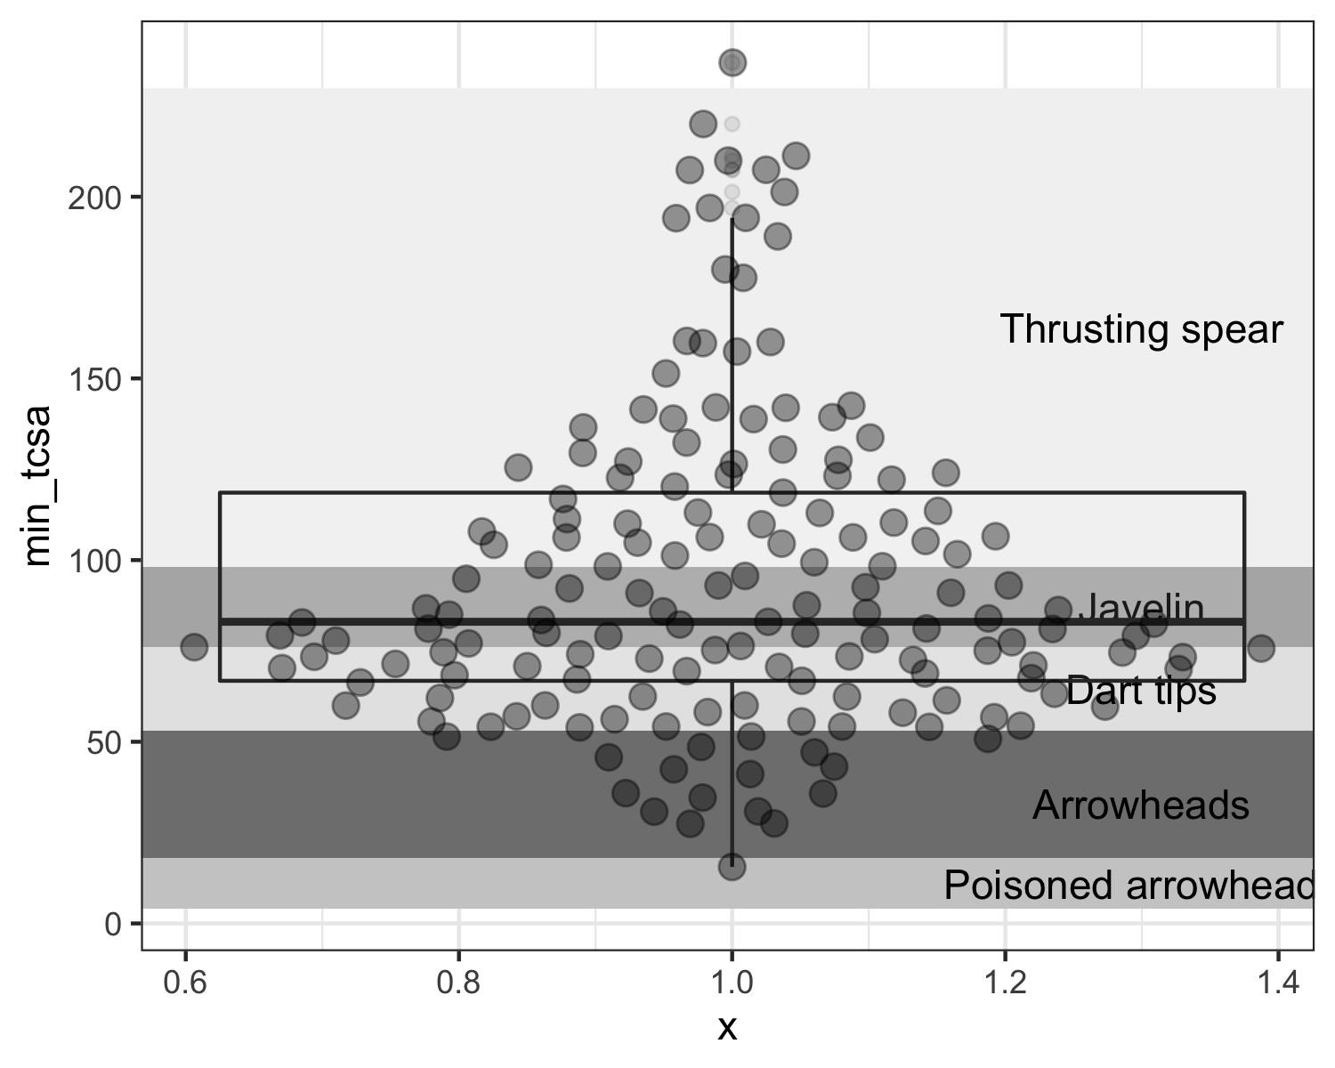

## 4.1 Raw materials

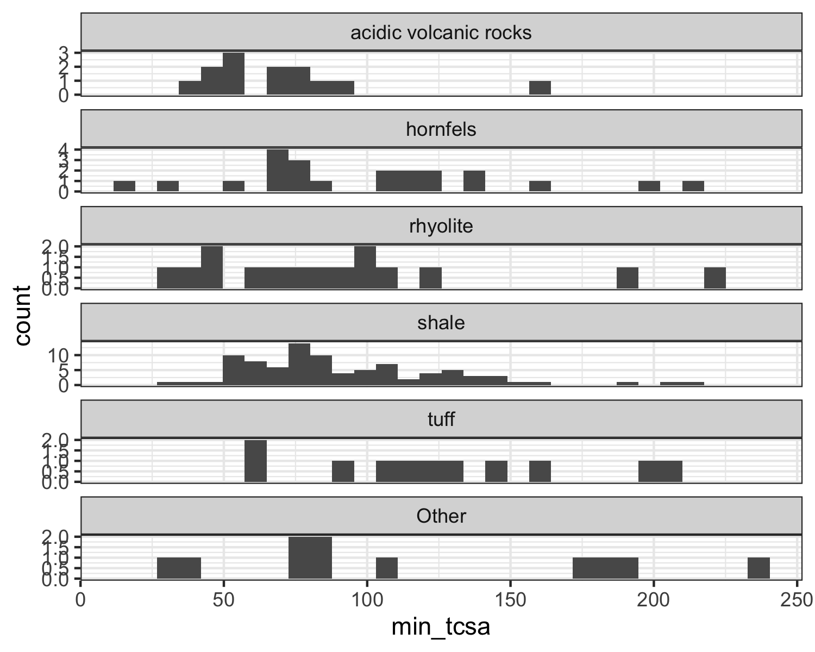

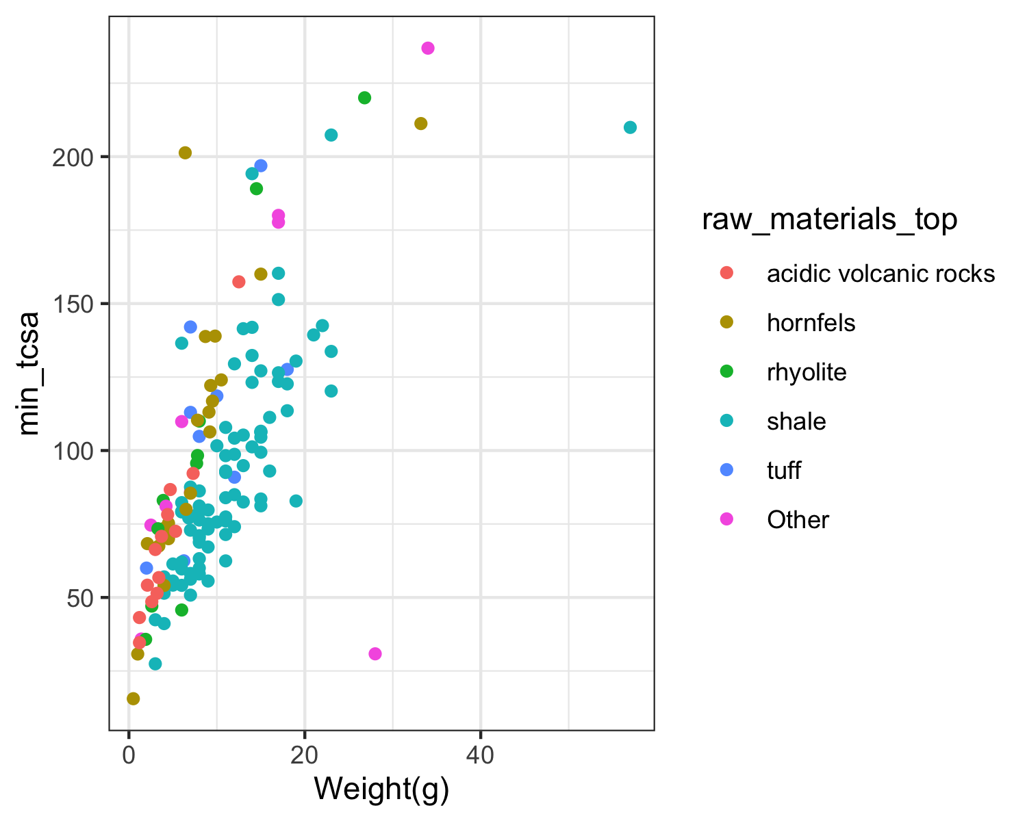

## 4.2 Variation by site

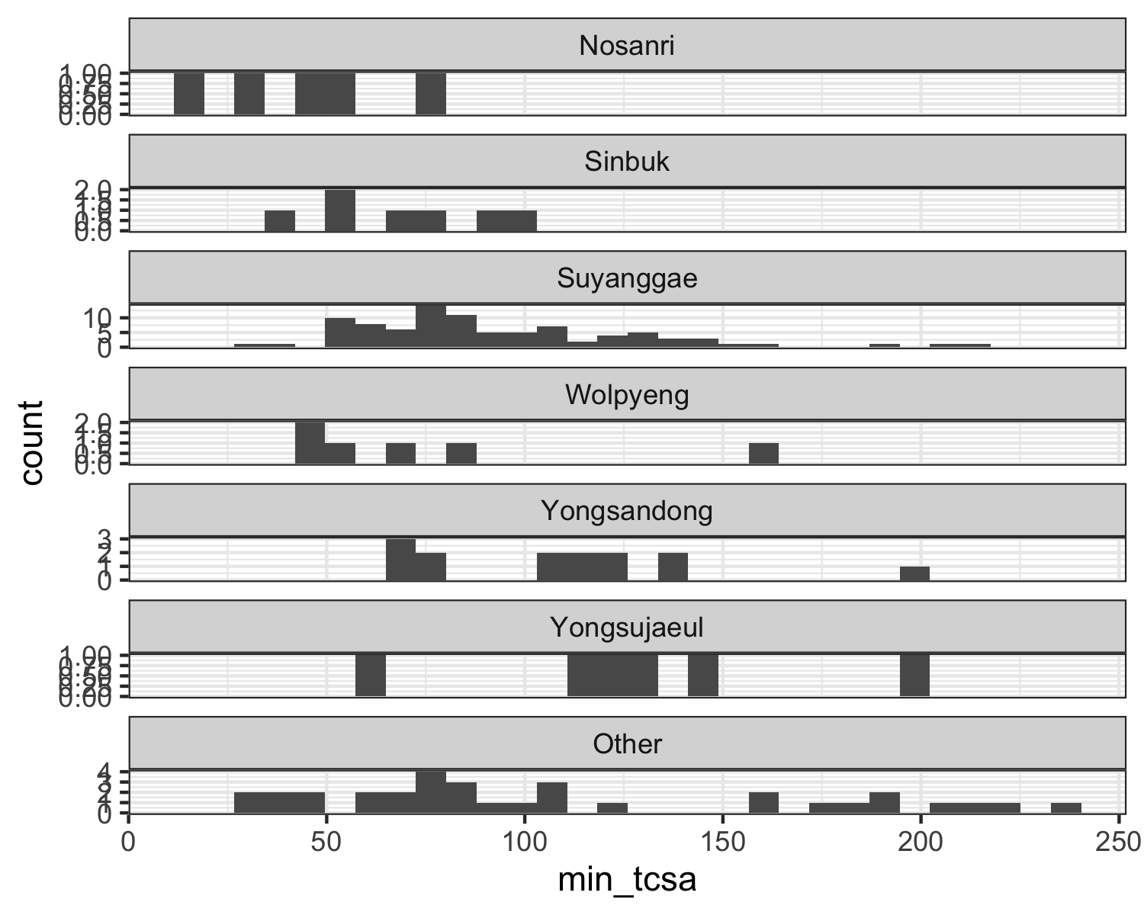

## 4.3 Variation by artefact size

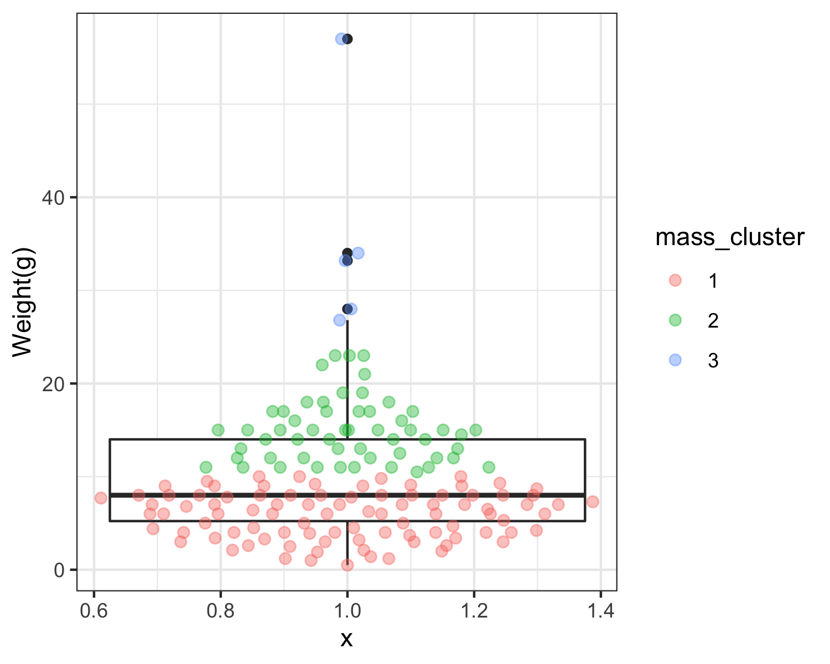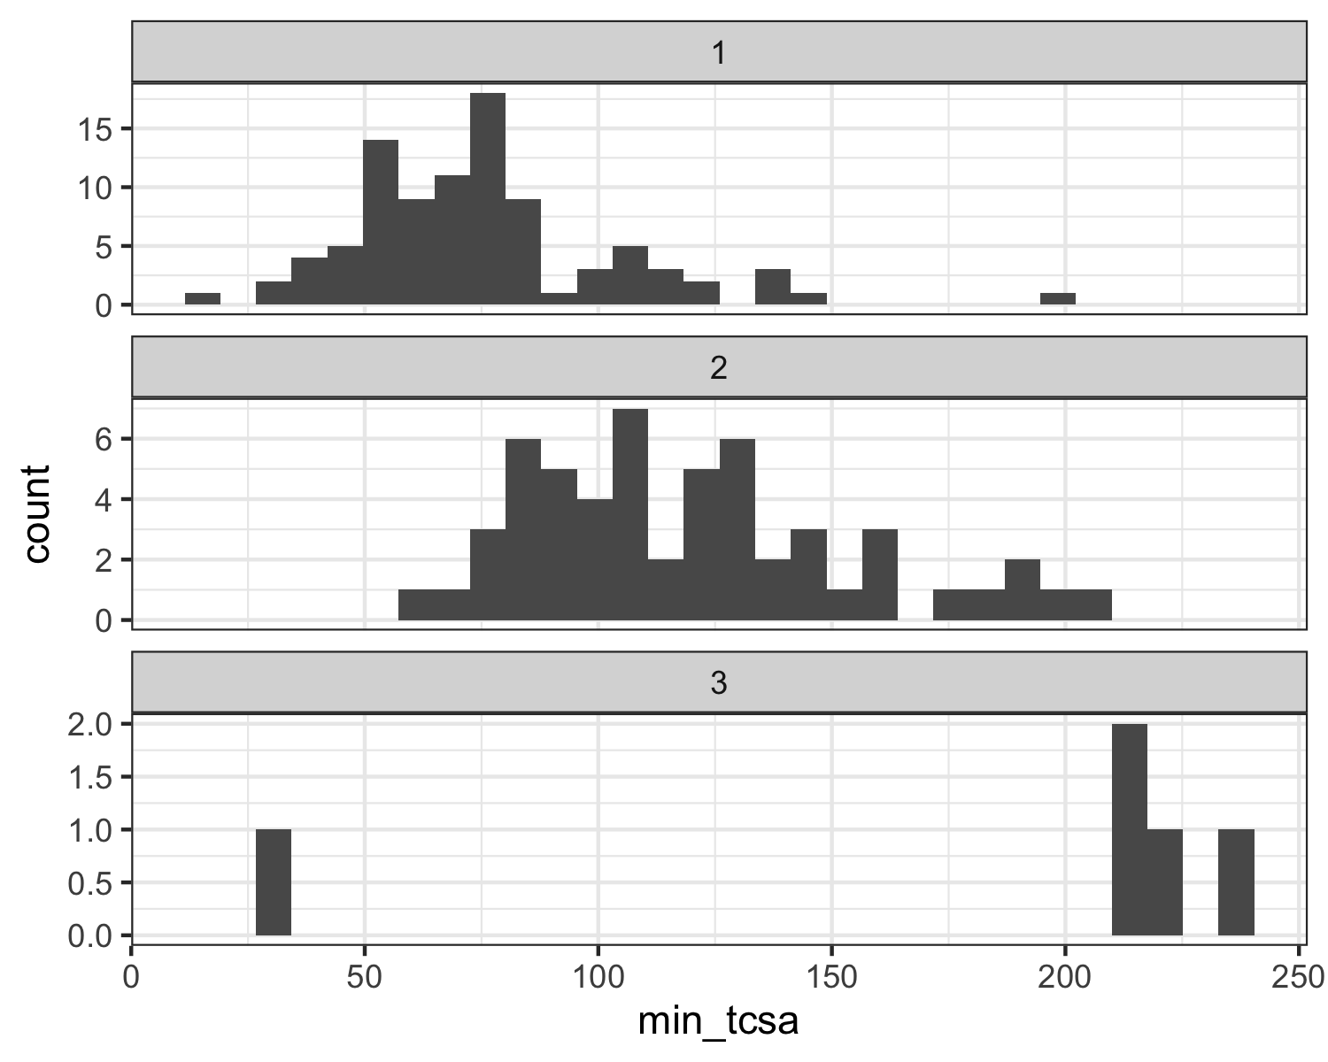

# 5 Discussion

# 6 Conclusion

# 7 Acknowledgements

# 8 References

### 8.0.1 Colophon

This report was generated on 2022-03-21 09:09:26 using the following computational environment and dependencies:

#> ─ Session info ───────────────────────────────────────────────────────────────  
#> setting value  
#> version R version 4.1.2 (2021-11-01)  
#> os macOS Catalina 10.15.7  
#> system x86_64, darwin17.0  
#> ui X11  
#> language (EN)  
#> collate en_US.UTF-8  
#> ctype en_US.UTF-8  
#> tz America/Los_Angeles  
#> date 2022-03-21  
#> pandoc 2.14.0.3 @ /Applications/RStudio.app/Contents/MacOS/pandoc/ (via rmarkdown)  
#>   
#> ─ Packages ───────────────────────────────────────────────────────────────────  
#> package * version date (UTC) lib source  
#> assertthat 0.2.1 2019-03-21 [1] CRAN (R 4.1.0)  
#> backports 1.4.1 2021-12-13 [1] CRAN (R 4.1.0)  
#> beeswarm 0.4.0 2021-06-01 [1] CRAN (R 4.1.0)  
#> bookdown 0.24 2021-09-02 [1] CRAN (R 4.1.0)  
#> brio 1.1.3 2021-11-30 [1] CRAN (R 4.1.0)  
#> broom 0.7.12 2022-01-28 [1] CRAN (R 4.1.2)  
#> cachem 1.0.6 2021-08-19 [1] CRAN (R 4.1.0)  
#> callr 3.7.0 2021-04-20 [1] CRAN (R 4.1.0)  
#> cellranger 1.1.0 2016-07-27 [1] CRAN (R 4.1.0)  
#> Ckmeans.1d.dp * 4.3.4 2022-01-31 [1] CRAN (R 4.1.2)  
#> cli 3.2.0 2022-02-14 [1] CRAN (R 4.1.2)  
#> colorspace 2.0-3 2022-02-21 [1] CRAN (R 4.1.2)  
#> crayon 1.5.0 2022-02-14 [1] CRAN (R 4.1.2)  
#> DBI 1.1.2 2021-12-20 [1] CRAN (R 4.1.0)  
#> dbplyr 2.1.1 2021-04-06 [1] CRAN (R 4.1.0)  
#> desc 1.4.1 2022-03-06 [1] CRAN (R 4.1.2)  
#> devtools 2.4.3 2021-11-30 [1] CRAN (R 4.1.0)  
#> digest 0.6.29 2021-12-01 [1] CRAN (R 4.1.0)  
#> dplyr * 1.0.8 2022-02-08 [1] CRAN (R 4.1.2)  
#> ellipsis 0.3.2 2021-04-29 [1] CRAN (R 4.1.0)  
#> evaluate 0.15 2022-02-18 [1] CRAN (R 4.1.2)  
#> fansi 1.0.2 2022-01-14 [1] CRAN (R 4.1.2)  
#> farver 2.1.0 2021-02-28 [1] CRAN (R 4.1.0)  
#> fastmap 1.1.0 2021-01-25 [1] CRAN (R 4.1.0)  
#> forcats * 0.5.1 2021-01-27 [1] CRAN (R 4.1.0)  
#> fs 1.5.2 2021-12-08 [1] CRAN (R 4.1.0)  
#> generics 0.1.2 2022-01-31 [1] CRAN (R 4.1.2)  
#> ggbeeswarm * 0.6.0 2017-08-07 [1] CRAN (R 4.1.0)  
#> ggplot2 * 3.3.5 2021-06-25 [1] CRAN (R 4.1.0)  
#> glue 1.6.2 2022-02-24 [1] CRAN (R 4.1.2)  
#> gtable 0.3.0 2019-03-25 [1] CRAN (R 4.1.0)  
#> haven 2.4.3 2021-08-04 [1] CRAN (R 4.1.0)  
#> here * 1.0.1 2020-12-13 [1] CRAN (R 4.1.0)  
#> highr 0.9 2021-04-16 [1] CRAN (R 4.1.0)  
#> hms 1.1.1 2021-09-26 [1] CRAN (R 4.1.0)  
#> htmltools 0.5.2 2021-08-25 [1] CRAN (R 4.1.0)  
#> httr 1.4.2 2020-07-20 [1] CRAN (R 4.1.0)  
#> jsonlite 1.8.0 2022-02-22 [1] CRAN (R 4.1.2)  
#> knitr 1.37.4 2022-01-29 [1] https://yihui.r-universe.dev (R 4.1.2)  
#> labeling 0.4.2 2020-10-20 [1] CRAN (R 4.1.0)  
#> lifecycle 1.0.1 2021-09-24 [1] CRAN (R 4.1.0)  
#> lubridate 1.8.0 2021-10-07 [1] CRAN (R 4.1.0)  
#> magrittr 2.0.2 2022-01-26 [1] CRAN (R 4.1.2)  
#> memoise 2.0.1 2021-11-26 [1] CRAN (R 4.1.0)  
#> modelr 0.1.8 2020-05-19 [1] CRAN (R 4.1.0)  
#> munsell 0.5.0 2018-06-12 [1] CRAN (R 4.1.0)  
#> pillar 1.7.0 2022-02-01 [1] CRAN (R 4.1.2)  
#> pkgbuild 1.3.1 2021-12-20 [1] CRAN (R 4.1.0)  
#> pkgconfig 2.0.3 2019-09-22 [1] CRAN (R 4.1.0)  
#> pkgload 1.2.4 2021-11-30 [1] CRAN (R 4.1.0)  
#> prettyunits 1.1.1 2020-01-24 [1] CRAN (R 4.1.0)  
#> processx 3.5.2 2021-04-30 [1] CRAN (R 4.1.0)  
#> ps 1.6.0 2021-02-28 [1] CRAN (R 4.1.0)  
#> purrr * 0.3.4 2020-04-17 [1] CRAN (R 4.1.0)  
#> R6 2.5.1 2021-08-19 [1] CRAN (R 4.1.0)  
#> rbibutils 2.2.7 2021-12-07 [1] CRAN (R 4.1.0)  
#> Rcpp 1.0.8 2022-01-13 [1] CRAN (R 4.1.2)  
#> Rdpack 2.1.4 2022-02-18 [1] CRAN (R 4.1.2)  
#> readr * 2.1.2 2022-01-30 [1] CRAN (R 4.1.2)  
#> readxl * 1.3.1 2019-03-13 [1] CRAN (R 4.1.0)  
#> remotes 2.4.2 2021-11-30 [1] CRAN (R 4.1.0)  
#> reprex 2.0.1 2021-08-05 [1] CRAN (R 4.1.0)  
#> rlang 1.0.2 2022-03-04 [1] CRAN (R 4.1.2)  
#> rmarkdown 2.12 2022-03-02 [1] CRAN (R 4.1.2)  
#> rprojroot 2.0.2 2020-11-15 [1] CRAN (R 4.1.0)  
#> rstudioapi 0.13 2020-11-12 [1] CRAN (R 4.1.0)  
#> rvest 1.0.2 2021-10-16 [1] CRAN (R 4.1.0)  
#> scales 1.1.1 2020-05-11 [1] CRAN (R 4.1.0)  
#> sessioninfo 1.2.2 2021-12-06 [1] CRAN (R 4.1.0)  
#> stringi 1.7.6 2021-11-29 [1] CRAN (R 4.1.0)  
#> stringr * 1.4.0 2019-02-10 [1] CRAN (R 4.1.0)  
#> testthat 3.1.2 2022-01-20 [1] CRAN (R 4.1.2)  
#> tibble * 3.1.6 2021-11-07 [1] CRAN (R 4.1.0)  
#> tidyr * 1.2.0 2022-02-01 [1] CRAN (R 4.1.2)  
#> tidyselect 1.1.2 2022-02-21 [1] CRAN (R 4.1.2)  
#> tidyverse * 1.3.1 2021-04-15 [1] CRAN (R 4.1.0)  
#> tzdb 0.2.0 2021-10-27 [1] CRAN (R 4.1.0)  
#> usethis 2.1.5 2021-12-09 [1] CRAN (R 4.1.0)  
#> utf8 1.2.2 2021-07-24 [1] CRAN (R 4.1.0)  
#> vctrs 0.3.8 2021-04-29 [1] CRAN (R 4.1.0)  
#> vipor 0.4.5 2017-03-22 [1] CRAN (R 4.1.0)  
#> withr 2.5.0 2022-03-03 [1] CRAN (R 4.1.2)  
#> xfun 0.30 2022-03-02 [1] CRAN (R 4.1.2)  
#> xml2 1.3.3 2021-11-30 [1] CRAN (R 4.1.0)  
#> yaml 2.3.5 2022-02-21 [1] CRAN (R 4.1.2)  
#>   
#> [1] /Library/Frameworks/R.framework/Versions/4.1/Resources/library  
#>   
#> ──────────────────────────────────────────────────────────────────────────────

The current Git commit details are:

#> Local: master /Users/bmarwick/Desktop/tcsakoreanpaleolithic  
#> Remote: master @ origin (https://github.com/parkgayoung/tcsakoreanpaleolithic)  
#> Head: [967531f] 2022-03-14: Some basic exploration of the data, move code to Rmd