**PROBLEM STATEMENT**

**Project: Timetable Management**

Create a project where when you send any faculty’s details you would the timetable of that faculty and you would therefore get to know weather he or she is free or not.

**FEATURE**

In this project we tried to solve the problem many faculties and student might have faced when they want to contact any faculty or any faculty wants to contact any student,

here one will have to enter the faculty details which include his or her name course id and section in which the faculty teaches, or as an alternate method one can enter faculty ID

after entering one part of these details the user will get the output where he or she will see the timetable of the faculty and would get to know whether he is free at that time or not

**MODULE AND CODE**

import java.awt.event.ActionEvent;

import java.awt.event.ActionListener;

import java.sql.*;

import java.util.Vector;

import javax.swing.JOptionPane;

import javax.swing.table.DefaultTableModel;

public class project extends javax.swing.JFrame implements ActionListener {

public project() {

initComponents();

jButton1.addActionListener(this);

jButton2.addActionListener(this);

}

private void initComponents() {

jDesktopPane1 = new javax.swing.JDesktopPane();

jPanel1 = new javax.swing.JPanel();

jFrame1 = new javax.swing.JFrame();

jTextField1 = new javax.swing.JTextField();

jTextField2 = new javax.swing.JTextField();

jTextField3 = new javax.swing.JTextField();

jTextField4 = new javax.swing.JTextField();

jButton1 = new javax.swing.JButton();

jButton2 = new javax.swing.JButton();

jLabel1 = new javax.swing.JLabel();

jLabel2 = new javax.swing.JLabel();

jLabel3 = new javax.swing.JLabel();

jLabel4 = new javax.swing.JLabel();

jLabel5 = new javax.swing.JLabel();

javax.swing.GroupLayout jDesktopPane1Layout = new javax.swing.GroupLayout(jDesktopPane1);

jDesktopPane1.setLayout(jDesktopPane1Layout);

jDesktopPane1Layout.setHorizontalGroup(

jDesktopPane1Layout.createParallelGroup(javax.swing.GroupLayout.Alignment.LEADING)

.addGap(0, 100, Short.MAX_VALUE)

);

jDesktopPane1Layout.setVerticalGroup(

jDesktopPane1Layout.createParallelGroup(javax.swing.GroupLayout.Alignment.LEADING)

.addGap(0, 100, Short.MAX_VALUE)

);

javax.swing.GroupLayout jPanel1Layout = new javax.swing.GroupLayout(jPanel1);

jPanel1.setLayout(jPanel1Layout);

jPanel1Layout.setHorizontalGroup(

jPanel1Layout.createParallelGroup(javax.swing.GroupLayout.Alignment.LEADING)

.addGap(0, 100, Short.MAX_VALUE)

);

jPanel1Layout.setVerticalGroup(

jPanel1Layout.createParallelGroup(javax.swing.GroupLayout.Alignment.LEADING)

.addGap(0, 100, Short.MAX_VALUE)

);

javax.swing.GroupLayout jFrame1Layout = new javax.swing.GroupLayout(jFrame1.getContentPane());

jFrame1.getContentPane().setLayout(jFrame1Layout);

jFrame1Layout.setHorizontalGroup(

jFrame1Layout.createParallelGroup(javax.swing.GroupLayout.Alignment.LEADING)

.addGap(0, 400, Short.MAX_VALUE)

);

jFrame1Layout.setVerticalGroup(

jFrame1Layout.createParallelGroup(javax.swing.GroupLayout.Alignment.LEADING)

.addGap(0, 300, Short.MAX_VALUE)

);

setDefaultCloseOperation(javax.swing.WindowConstants.EXIT_ON_CLOSE);

setMinimumSize(new java.awt.Dimension(510, 420));

setPreferredSize(new java.awt.Dimension(510, 420));

setResizable(false);

jButton1.setText("SUBMIT");

jButton2.setText("SUBMIT");

jLabel1.setHorizontalAlignment(javax.swing.SwingConstants.CENTER);

jLabel1.setText("OR");

jLabel1.setInheritsPopupMenu(false);

jLabel1.setMaximumSize(new java.awt.Dimension(20, 20));

jLabel1.setMinimumSize(new java.awt.Dimension(20, 20));

jLabel1.setPreferredSize(new java.awt.Dimension(20, 20));

jLabel2.setText("Faculty's Name");

jLabel3.setText("Couse ID");

jLabel4.setText("Your section");

jLabel5.setText("Faculty ID");

javax.swing.GroupLayout layout = new javax.swing.GroupLayout(getContentPane());

getContentPane().setLayout(layout);

layout.setHorizontalGroup(

layout.createParallelGroup(javax.swing.GroupLayout.Alignment.LEADING)

.addGroup(layout.createSequentialGroup()

.addGroup(layout.createParallelGroup(javax.swing.GroupLayout.Alignment.LEADING)

.addGroup(layout.createSequentialGroup()

.addGroup(layout.createParallelGroup(javax.swing.GroupLayout.Alignment.LEADING)

.addGroup(layout.createSequentialGroup()

.addGap(149, 149, 149)

.addComponent(jLabel1, javax.swing.GroupLayout.PREFERRED_SIZE, 126, javax.swing.GroupLayout.PREFERRED_SIZE))

.addGroup(layout.createSequentialGroup()

.addGap(32, 32, 32)

.addGroup(layout.createParallelGroup(javax.swing.GroupLayout.Alignment.LEADING, false)

.addGroup(layout.createSequentialGroup()

.addComponent(jLabel5, javax.swing.GroupLayout.PREFERRED_SIZE, 77, javax.swing.GroupLayout.PREFERRED_SIZE)

.addGap(18, 18, 18)

.addComponent(jTextField4))

.addGroup(layout.createSequentialGroup()

.addGroup(layout.createParallelGroup(javax.swing.GroupLayout.Alignment.LEADING)

.addComponent(jLabel2)

.addComponent(jLabel3, javax.swing.GroupLayout.PREFERRED_SIZE, 63, javax.swing.GroupLayout.PREFERRED_SIZE)

.addComponent(jLabel4, javax.swing.GroupLayout.PREFERRED_SIZE, 81, javax.swing.GroupLayout.PREFERRED_SIZE))

.addGap(18, 18, 18)

.addGroup(layout.createParallelGroup(javax.swing.GroupLayout.Alignment.LEADING, false)

.addComponent(jTextField1)

.addComponent(jTextField2)

.addComponent(jTextField3, javax.swing.GroupLayout.PREFERRED_SIZE, 180, javax.swing.GroupLayout.PREFERRED_SIZE))))))

.addGap(45, 45, 45))

.addGroup(javax.swing.GroupLayout.Alignment.TRAILING, layout.createSequentialGroup()

.addContainerGap()

.addGroup(layout.createParallelGroup(javax.swing.GroupLayout.Alignment.LEADING)

.addComponent(jButton1, javax.swing.GroupLayout.Alignment.TRAILING, javax.swing.GroupLayout.PREFERRED_SIZE, 87, javax.swing.GroupLayout.PREFERRED_SIZE)

.addComponent(jButton2, javax.swing.GroupLayout.Alignment.TRAILING, javax.swing.GroupLayout.PREFERRED_SIZE, 84, javax.swing.GroupLayout.PREFERRED_SIZE))

.addGap(97, 97, 97)))

.addContainerGap(javax.swing.GroupLayout.DEFAULT_SIZE, Short.MAX_VALUE))

);

layout.setVerticalGroup(

layout.createParallelGroup(javax.swing.GroupLayout.Alignment.LEADING)

.addGroup(layout.createSequentialGroup()

.addGap(77, 77, 77)

.addGroup(layout.createParallelGroup(javax.swing.GroupLayout.Alignment.LEADING)

.addComponent(jTextField1, javax.swing.GroupLayout.PREFERRED_SIZE, 34, javax.swing.GroupLayout.PREFERRED_SIZE)

.addGroup(layout.createSequentialGroup()

.addGap(1, 1, 1)

.addComponent(jLabel2, javax.swing.GroupLayout.PREFERRED_SIZE, 36, javax.swing.GroupLayout.PREFERRED_SIZE)))

.addPreferredGap(javax.swing.LayoutStyle.ComponentPlacement.UNRELATED)

.addGroup(layout.createParallelGroup(javax.swing.GroupLayout.Alignment.BASELINE)

.addComponent(jTextField2, javax.swing.GroupLayout.PREFERRED_SIZE, 34, javax.swing.GroupLayout.PREFERRED_SIZE)

.addComponent(jLabel3, javax.swing.GroupLayout.PREFERRED_SIZE, 36, javax.swing.GroupLayout.PREFERRED_SIZE))

.addPreferredGap(javax.swing.LayoutStyle.ComponentPlacement.RELATED)

.addGroup(layout.createParallelGroup(javax.swing.GroupLayout.Alignment.BASELINE)

.addComponent(jTextField3, javax.swing.GroupLayout.PREFERRED_SIZE, 37, javax.swing.GroupLayout.PREFERRED_SIZE)

.addComponent(jLabel4, javax.swing.GroupLayout.PREFERRED_SIZE, 40, javax.swing.GroupLayout.PREFERRED_SIZE))

.addPreferredGap(javax.swing.LayoutStyle.ComponentPlacement.UNRELATED)

.addComponent(jButton1, javax.swing.GroupLayout.PREFERRED_SIZE, 31, javax.swing.GroupLayout.PREFERRED_SIZE)

.addGap(5, 5, 5)

.addComponent(jLabel1, javax.swing.GroupLayout.PREFERRED_SIZE, 28, javax.swing.GroupLayout.PREFERRED_SIZE)

.addPreferredGap(javax.swing.LayoutStyle.ComponentPlacement.RELATED)

.addGroup(layout.createParallelGroup(javax.swing.GroupLayout.Alignment.TRAILING)

.addComponent(jLabel5, javax.swing.GroupLayout.PREFERRED_SIZE, 33, javax.swing.GroupLayout.PREFERRED_SIZE)

.addGroup(layout.createSequentialGroup()

.addComponent(jTextField4, javax.swing.GroupLayout.PREFERRED_SIZE, 32, javax.swing.GroupLayout.PREFERRED_SIZE)

.addGap(1, 1, 1)))

.addPreferredGap(javax.swing.LayoutStyle.ComponentPlacement.UNRELATED)

.addComponent(jButton2, javax.swing.GroupLayout.PREFERRED_SIZE, 35, javax.swing.GroupLayout.PREFERRED_SIZE)

.addGap(119, 119, 119))

);

}

static Connection con=null;

//For connection to sql database

public static void connectsql(){

try{

con = DriverManager.getConnection("jdbc:mysql://127.0.0.1:3306/project", "root", "kshitij426");

System.out.println("connection is established");

}

catch(Exception e){

JOptionPane.showMessageDialog(null, e);

}

}

//For Executing queries

public void query(String f_name, String c_id, String section){

String f_id = null;

Statement statement = null;

try {

statement = con.createStatement();

} catch (SQLException ex) {

JOptionPane.showMessageDialog(null, ex);

}

// Create and execute a SELECT SQL statement.

try {

//Using SQL SELECT Query

PreparedStatement preparedStatement=con.prepareStatement("select Faculty_ID from Faculty_info where Faculty_name = ? AND Course_ID = ? AND Section = ? ");

preparedStatement.setString(1, f_name);

preparedStatement.setString(2, c_id);

preparedStatement.setString(3, section);

//Creating Java ResultSet object

ResultSet resultSet=preparedStatement.executeQuery();

while(resultSet.next()){

f_id=resultSet.getString("Faculty_ID");

}

} catch (SQLException e) {

JOptionPane.showMessageDialog(null, e);

}

displayquery(f_id);

}

public void query(String f_id){

displayquery(f_id);

}

public void displayquery(String fID){

project2 pro2 = new project2();

pro2.setVisible(true);

int i=0;

String t = "";

try {

//Using SQL SELECT Query

PreparedStatement preparedStatement=con.prepareStatement("select Faculty_ID, Faculty_name, Course_ID, Section, Room_no from Faculty_info where Faculty_ID = ?");

preparedStatement.setString(1, fID);

//Creating Java ResultSet object

ResultSet resultSet=preparedStatement.executeQuery();

while(resultSet.next()){

if(i>=1){

t = ",";

}

String f_name=resultSet.getString("Faculty_name");

String c_id=resultSet.getString("Course_ID");

String sec=resultSet.getString("Section");

pro2.jLabel1.setText(f_name);

pro2.jLabel2.setText(c_id + t);

pro2.jLabel3.setText(sec + t);

i++;

}

pro2.jLabel4.setText(fID);

} catch (SQLException e) {

JOptionPane.showMessageDialog(null, e);

}

String temp = "f";

fID = temp + fID;

String[] columnNames = {"Day", "09-10:00", "10-11:00", "11-12:00", "12-1:00", "1-2:00", "2-3:00", "3-4:00", "4-5:00", "5-6:00"};

DefaultTableModel model = new DefaultTableModel(columnNames, 0);

String sql = "select * from " + fID;

try{

PreparedStatement prepareStatement=con.prepareStatement(sql);

ResultSet rs = prepareStatement.executeQuery();

while (rs.next()){

Vector row = new Vector();

for (int j = 1; j <= 10; j++){

row.addElement(rs.getObject(j));

}

model.addRow( row );

}

pro2.jTable1.setModel(model);

} catch(Exception e){

JOptionPane.showMessageDialog(null, e);

}

}

public void actionPerformed(ActionEvent e) {

String fname = jTextField1.getText();

String cid = jTextField2.getText();

String sec = jTextField3.getText();

String fid = jTextField4.getText();

if (e.getSource() == jButton1) {

query(fname, cid, sec);

} else if (e.getSource() == jButton2) {

query(fid);

}

}

public static void main(String args[]) {

try {

for (javax.swing.UIManager.LookAndFeelInfo info : javax.swing.UIManager.getInstalledLookAndFeels()) {

if ("Nimbus".equals(info.getName())) {

javax.swing.UIManager.setLookAndFeel(info.getClassName());

break;

}

}

} catch (ClassNotFoundException ex) {

java.util.logging.Logger.getLogger(project.class.getName()).log(java.util.logging.Level.SEVERE, null, ex);

} catch (InstantiationException ex) {

java.util.logging.Logger.getLogger(project.class.getName()).log(java.util.logging.Level.SEVERE, null, ex);

} catch (IllegalAccessException ex) {

java.util.logging.Logger.getLogger(project.class.getName()).log(java.util.logging.Level.SEVERE, null, ex);

} catch (javax.swing.UnsupportedLookAndFeelException ex) {

java.util.logging.Logger.getLogger(project.class.getName()).log(java.util.logging.Level.SEVERE, null, ex);

}

/* Create and display the form */

java.awt.EventQueue.invokeLater(new Runnable() {

public void run() {

new project().setVisible(true);

}

});

connectsql();

}

// Variables declaration

private javax.swing.JButton jButton1;

private javax.swing.JButton jButton2;

private javax.swing.JDesktopPane jDesktopPane1;

private javax.swing.JFrame jFrame1;

private javax.swing.JLabel jLabel1;

private javax.swing.JLabel jLabel2;

private javax.swing.JLabel jLabel3;

private javax.swing.JLabel jLabel4;

private javax.swing.JLabel jLabel5;

private javax.swing.JPanel jPanel1;

private javax.swing.JTextField jTextField1;

private javax.swing.JTextField jTextField2;

private javax.swing.JTextField jTextField3;

private javax.swing.JTextField jTextField4;

}

public class project2 extends javax.swing.JFrame {

/**

* Creates new form project2

*/

public project2() {

initComponents();

}

/**

* This method is called from within the constructor to initialize the form.

* WARNING: Do NOT modify this code. The content of this method is always

* regenerated by the Form Editor.

*/

@SuppressWarnings("unchecked")

// <editor-fold defaultstate="collapsed" desc="Generated Code">

private void initComponents() {

jScrollPane1 = new javax.swing.JScrollPane();

jTable1 = new javax.swing.JTable();

jLabel1 = new javax.swing.JLabel();

jLabel2 = new javax.swing.JLabel();

jLabel3 = new javax.swing.JLabel();

jLabel4 = new javax.swing.JLabel();

jLabel5 = new javax.swing.JLabel();

jLabel6 = new javax.swing.JLabel();

jLabel7 = new javax.swing.JLabel();

jLabel8 = new javax.swing.JLabel();

setDefaultCloseOperation(javax.swing.WindowConstants.DISPOSE_ON_CLOSE);

jTable1.setModel(new javax.swing.table.DefaultTableModel(

new Object [][] {

{null, null, null, null, null, null, null, null, null, null},

{null, null, null, null, null, null, null, null, null, null},

{null, null, null, null, null, null, null, null, null, null},

{null, null, null, null, null, null, null, null, null, null},

{null, null, null, null, null, null, null, null, null, null},

{null, null, null, null, null, null, null, null, null, null}

},

new String [] {

"DAY / TIME", "09 - 10:00 AM", "10 - 11:00 AM", "11 - 12:00 PM", "12 - 01:00 PM", "01 - 02:00 PM", "02 - 03:00 PM", "03 - 04:00 PM", "04 - 05:00 PM", "05 - 06:00 PM"

}

) {

boolean[] canEdit = new boolean [] {

false, false, false, false, false, false, false, false, false, false

};

public boolean isCellEditable(int rowIndex, int columnIndex) {

return canEdit [columnIndex];

}

});

jScrollPane1.setViewportView(jTable1);

jLabel5.setText("Faculty's Name");

jLabel6.setText("Subject Code");

jLabel7.setText("Faculty's ID");

jLabel8.setText("Room No.");

javax.swing.GroupLayout layout = new javax.swing.GroupLayout(getContentPane());

getContentPane().setLayout(layout);

layout.setHorizontalGroup(

layout.createParallelGroup(javax.swing.GroupLayout.Alignment.LEADING)

.addGroup(layout.createSequentialGroup()

.addGap(26, 26, 26)

.addGroup(layout.createParallelGroup(javax.swing.GroupLayout.Alignment.LEADING)

.addGroup(layout.createSequentialGroup()

.addComponent(jScrollPane1, javax.swing.GroupLayout.PREFERRED_SIZE, 966, javax.swing.GroupLayout.PREFERRED_SIZE)

.addContainerGap(70, Short.MAX_VALUE))

.addGroup(layout.createSequentialGroup()

.addGroup(layout.createParallelGroup(javax.swing.GroupLayout.Alignment.LEADING, false)

.addComponent(jLabel5, javax.swing.GroupLayout.DEFAULT_SIZE, 101, Short.MAX_VALUE)

.addComponent(jLabel6, javax.swing.GroupLayout.DEFAULT_SIZE, javax.swing.GroupLayout.DEFAULT_SIZE, Short.MAX_VALUE))

.addGap(18, 18, 18)

.addGroup(layout.createParallelGroup(javax.swing.GroupLayout.Alignment.LEADING, false)

.addComponent(jLabel1, javax.swing.GroupLayout.DEFAULT_SIZE, javax.swing.GroupLayout.DEFAULT_SIZE, Short.MAX_VALUE)

.addComponent(jLabel2, javax.swing.GroupLayout.DEFAULT_SIZE, 150, Short.MAX_VALUE))

.addGap(417, 417, 417)

.addGroup(layout.createParallelGroup(javax.swing.GroupLayout.Alignment.LEADING)

.addComponent(jLabel7, javax.swing.GroupLayout.DEFAULT_SIZE, javax.swing.GroupLayout.DEFAULT_SIZE, Short.MAX_VALUE)

.addComponent(jLabel8, javax.swing.GroupLayout.DEFAULT_SIZE, javax.swing.GroupLayout.DEFAULT_SIZE, Short.MAX_VALUE))

.addPreferredGap(javax.swing.LayoutStyle.ComponentPlacement.RELATED)

.addGroup(layout.createParallelGroup(javax.swing.GroupLayout.Alignment.LEADING, false)

.addComponent(jLabel3, javax.swing.GroupLayout.DEFAULT_SIZE, javax.swing.GroupLayout.DEFAULT_SIZE, Short.MAX_VALUE)

.addComponent(jLabel4, javax.swing.GroupLayout.DEFAULT_SIZE, 140, Short.MAX_VALUE))

.addGap(84, 84, 84))))

);

layout.setVerticalGroup(

layout.createParallelGroup(javax.swing.GroupLayout.Alignment.LEADING)

.addGroup(javax.swing.GroupLayout.Alignment.TRAILING, layout.createSequentialGroup()

.addContainerGap(70, Short.MAX_VALUE)

.addGroup(layout.createParallelGroup(javax.swing.GroupLayout.Alignment.LEADING, false)

.addGroup(javax.swing.GroupLayout.Alignment.TRAILING, layout.createParallelGroup(javax.swing.GroupLayout.Alignment.BASELINE)

.addComponent(jLabel1, javax.swing.GroupLayout.DEFAULT_SIZE, javax.swing.GroupLayout.DEFAULT_SIZE, Short.MAX_VALUE)

.addComponent(jLabel5))

.addGroup(layout.createParallelGroup(javax.swing.GroupLayout.Alignment.BASELINE)

.addComponent(jLabel3, javax.swing.GroupLayout.DEFAULT_SIZE, javax.swing.GroupLayout.DEFAULT_SIZE, Short.MAX_VALUE)

.addComponent(jLabel7, javax.swing.GroupLayout.PREFERRED_SIZE, 20, javax.swing.GroupLayout.PREFERRED_SIZE)))

.addGap(33, 33, 33)

.addGroup(layout.createParallelGroup(javax.swing.GroupLayout.Alignment.LEADING)

.addGroup(layout.createSequentialGroup()

.addGroup(layout.createParallelGroup(javax.swing.GroupLayout.Alignment.BASELINE)

.addComponent(jLabel2, javax.swing.GroupLayout.PREFERRED_SIZE, 20, javax.swing.GroupLayout.PREFERRED_SIZE)

.addComponent(jLabel6, javax.swing.GroupLayout.PREFERRED_SIZE, 20, javax.swing.GroupLayout.PREFERRED_SIZE))

.addPreferredGap(javax.swing.LayoutStyle.ComponentPlacement.RELATED, 46, Short.MAX_VALUE))

.addGroup(javax.swing.GroupLayout.Alignment.TRAILING, layout.createSequentialGroup()

.addGroup(layout.createParallelGroup(javax.swing.GroupLayout.Alignment.BASELINE)

.addComponent(jLabel4, javax.swing.GroupLayout.PREFERRED_SIZE, 20, javax.swing.GroupLayout.PREFERRED_SIZE)

.addComponent(jLabel8, javax.swing.GroupLayout.PREFERRED_SIZE, 20, javax.swing.GroupLayout.PREFERRED_SIZE))

.addGap(44, 44, 44)))

.addComponent(jScrollPane1, javax.swing.GroupLayout.PREFERRED_SIZE, 125, javax.swing.GroupLayout.PREFERRED_SIZE)

.addGap(213, 213, 213))

);

pack();

}

public static void main(String args[]) {

try {

for (javax.swing.UIManager.LookAndFeelInfo info : javax.swing.UIManager.getInstalledLookAndFeels()) {

if ("Nimbus".equals(info.getName())) {

javax.swing.UIManager.setLookAndFeel(info.getClassName());

break;

}

}

} catch (ClassNotFoundException ex) {

java.util.logging.Logger.getLogger(project2.class.getName()).log(java.util.logging.Level.SEVERE, null, ex);

} catch (InstantiationException ex) {

java.util.logging.Logger.getLogger(project2.class.getName()).log(java.util.logging.Level.SEVERE, null, ex);

} catch (IllegalAccessException ex) {

java.util.logging.Logger.getLogger(project2.class.getName()).log(java.util.logging.Level.SEVERE, null, ex);

} catch (javax.swing.UnsupportedLookAndFeelException ex) {

java.util.logging.Logger.getLogger(project2.class.getName()).log(java.util.logging.Level.SEVERE, null, ex);

}

/* Create and display the form */

java.awt.EventQueue.invokeLater(new Runnable() {

public void run() {

new project2().setVisible(true);

}

});

}

// Variables declaration - do not modify

public javax.swing.JLabel jLabel1;

public javax.swing.JLabel jLabel2;

public javax.swing.JLabel jLabel3;

public javax.swing.JLabel jLabel4;

private javax.swing.JLabel jLabel5;

private javax.swing.JLabel jLabel6;

private javax.swing.JLabel jLabel7;

private javax.swing.JLabel jLabel8;

private javax.swing.JScrollPane jScrollPane1;

public javax.swing.JTable jTable1;

}

**MODULE AND SCREENSHOTS**

**First pag you would see on your screen**

(Here you either need to fill the 1st part or the other)

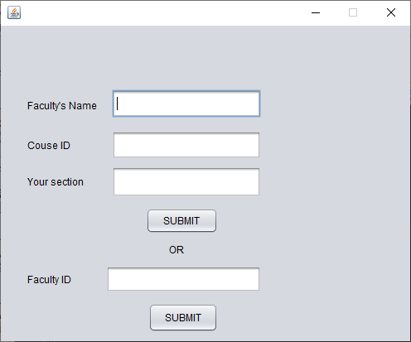

filling in the details of faculty

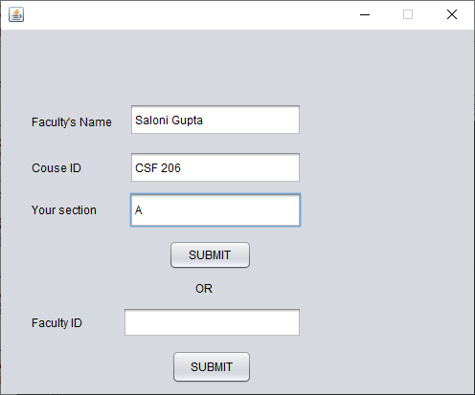

Timetable we see on the other screen

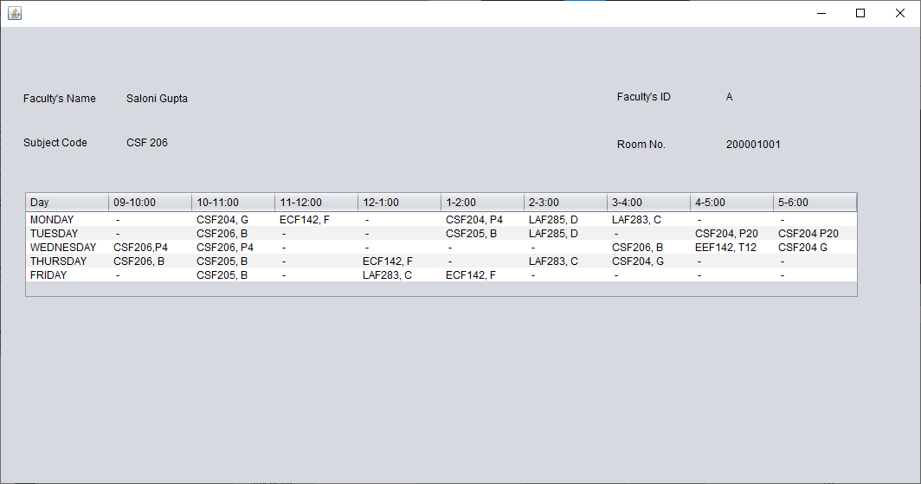

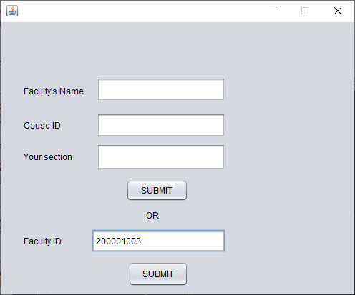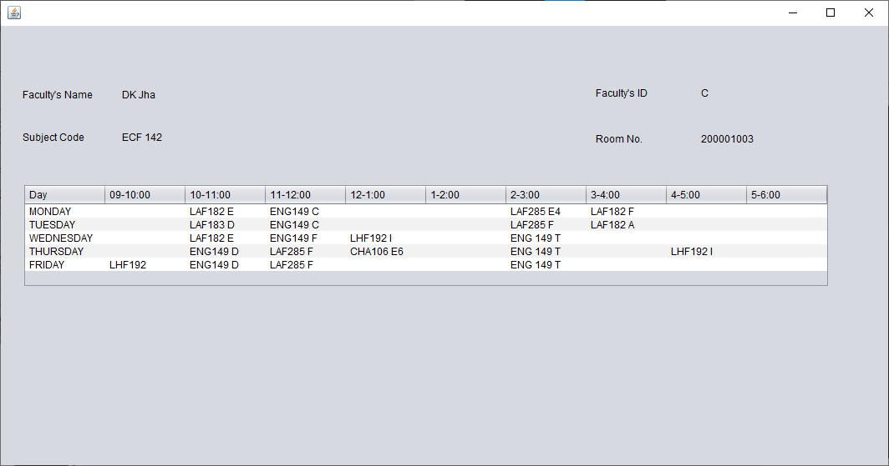

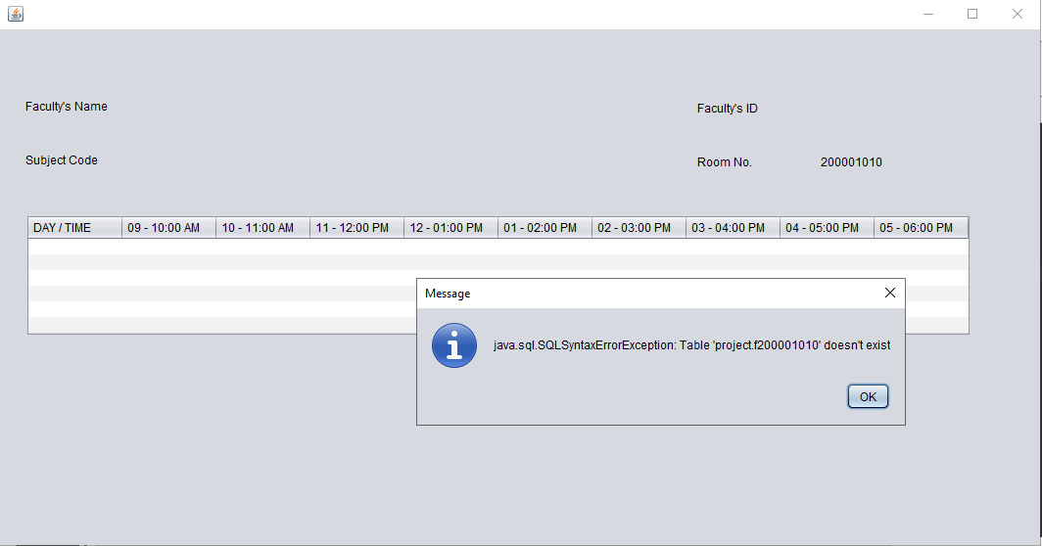

Error we would get if the user will fill the wrong details

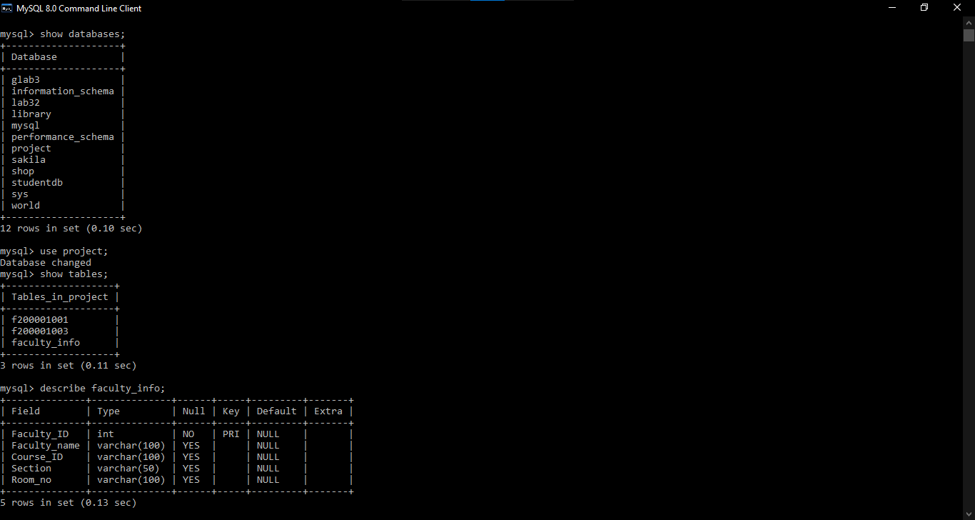 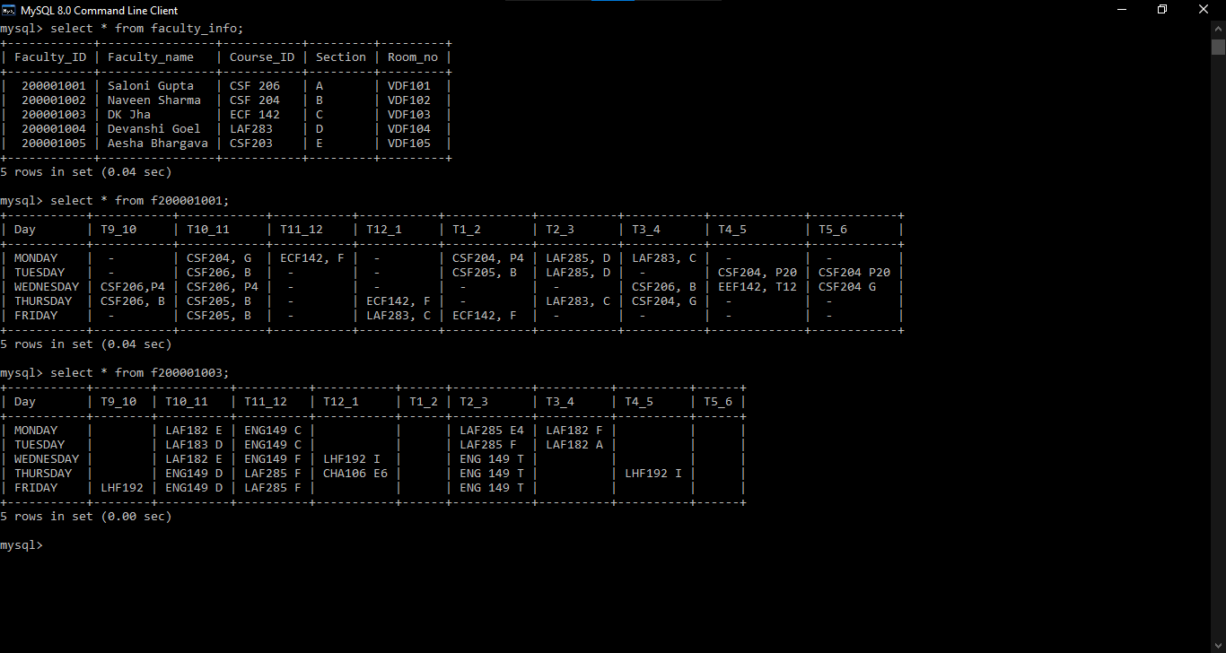

**CONCLUSIONS**

In conclusion, a database is a far more efficient mechanism to store and organize data than spreadsheets; it allows for a centralized facility that can easily be modified and quickly shared among multiple users. Having a web based front end removes the requirement of users having to understand and use a database directly, and allows users to connect from anywhere with an internet connection and a basic web browser. It also allows the possibility of queries to obtain information for various surveys. Due to the number of users reading and modifying student data in the department, it is an ideal use for such a system.

**FUTURE SCOPE**

DBMS simply defined as, “Database Management System is software which allows the users to CREATE, UPDATE, DELETE and RETRIEVE the data or the records stored”. It not only allows users to manipulate data but to create databases as per their requirements. All users may or may not know how to play with the data directly from and/or into the database, but DBMS software provides the users with an interface, which helps them to access and modify the data more easily and efficiently. DBMS also provides some special features like Data Security and Data Protection, which a regular data storage facility or an old data storage system cannot provide. Today there are many Database Management Systems available in the market.

With our project we want to lessen the burden of our respected faculty by letting student faculty interact in a systematic manner, and make academic interactions easier.

**BIBLIOGRAPHY**

Database System Concepts- by Henry F. Korth and Abraham Silberschatz

Fundamentals of Database System- by Ramez Elmsari and Shamkant B. Navathe

Java The Complete Reference-by Herbert Schildt

www.google.com