Jong Park
CS 312 – System Administration
HW1
April 08, 2019

1. What does the clock generator on a motherboard do? What is the resonant circuit in the
generator usually made from? (4 points)
A clock generator is an electronic oscillator (circuit) that produces a timing signal (known as a clock signal and behaves as such) for use in synchronizing a circuit's operation. The resonant circuit is usually made from a quartz (mineral composed of silicon-oxygen tetrahedra – SiO2). However, a simple LC circuit (inductor-capacitor) or RC circuit (resistor-capacitor) circuits may be also used instead. [1]

2. What is an anti-static wrist strap for? Why is it important to be grounded when working inside a PC? (4 points)
The highly conductive threads on the wrist strap leads to ground conductor to discharge the static electricity safely. When working with circuit board(s) such as PC, it is essential to be grounded or it could cause accidental shortage (or over loading of voltage in an electronics) which has the potential to damage the machine permanently. [2]

3. What is the commonly-given maximum resolution of the ubiquitous VGA connector at 85 HZ?
Does it surprise you that it reaches that resolution? Why or why not? (4 points)
Depending on the capability of the graphics card and monitor, VGA connector can reach up to 2048×1536px (QXGA) @85 Hz (388 MHz). [3] It does not surprise me that it can reach that high resolution since it is still used widely today. What does surprise me is how the newer formats, specifically DVI, which has a lower resolution despite it being a digital replacement for VGA and HDMI, which is the “standard” that every TV has adopted has such a fragile cord that breaks more often than it should.

4. Discuss the term “Wintel”, and its dominance in the PC marketplace. (6 points)
Wintel is a hybrid word of “Windows” and “Intel” the two most dominant manufacture company of PC in terms of OS (Microsoft Windows) and processors (Intel). Microsoft and Intel gave the PC industry the “standard” for PC in early 90’s when there was no industry standard for OS-processor combo. [4]

5. A customer of yours wants to replace the CPU in their custom PC (i.e. it’s built from off-the-
shelf parts, not made by a big vendor like HP, Dell, etc.). Write up a brief set of instructions,
walking the user through how to do it (this will probably be easier to answer after you complete
Lab 1). (8 points)
Step 1. Back up everything in case your computer won’t boot up again.
Step 2. Turn off your computer and unplug everything from the PC.
Step 3. Switch off the power supply unit (PSU) and press the power button couple times to clear off the leftover charge in the computer.
Step 4. open up the computer case and ground yourself.
Step 5. unscrew the fan / CPU cooler and place it on the side after cleaning off the thermal paste using isopropyl alcohol and a clean paper towel.
Step 6. Unlatch the CPU from the motherboard and put it on the side. Also, clean the thermal paste.
Step 7. Place the new CPU into the slot and latch it down.
Step 8. Apply a ½ dime sized thermal paste on the center of the CPU.
Step 9. Replace (or place a new) fan or cooler on top of the CPU and mount it using the 4 screws, make sure to screw them in a zigzag order so the fan/cooler would be mounted evenly.
Step 10. Boot up the computer and go into BIOS/UEFI. Make sure the system recognizes the new CPU and nothing is broken.
Step 11. Close the computer case and plug the rest of the peripheral.
Step 12. Boot into the installed Operating System (likely Windows) and hope that your computer doesn’t freak out.

6. What is a motherboard beep code? Why are they important? (4 points)
Motherboard beep codes are part of the POST (Power-on self-test) during boot process. The beep code indicate if there are errors during the boot process and depending on the number of beeps it gives out, it indicates different hardware problems. Or it could be trivial as a key being pressed and held during boot process. [5]

7. What is USB-C, and how is it an improvement? (4 points)
USB-C is the newest standard for charging android phones and Macbooks. On top of delivering power, it also has USB 3.1 and USB 3.2 specification, which allows data transfer rate up to 10 or 20 GBits (1250 and 2500 MB/s). USB-C replaces many of USB-A and USB-B connector as well as HDMI and 3.5 mm audio cables. [6] The best part of it is that plugs are reversible, meaning you don’t have to flip it 3 times to plug it in like you normally do with USB-A plugs. The ports are designed so that all outside pins are ground and top and bottom pins are mirrored in a way that it will deliver same input/output whichever way it is plugged.

8. Draw the following video jacks: (6 points)
(I tried.)

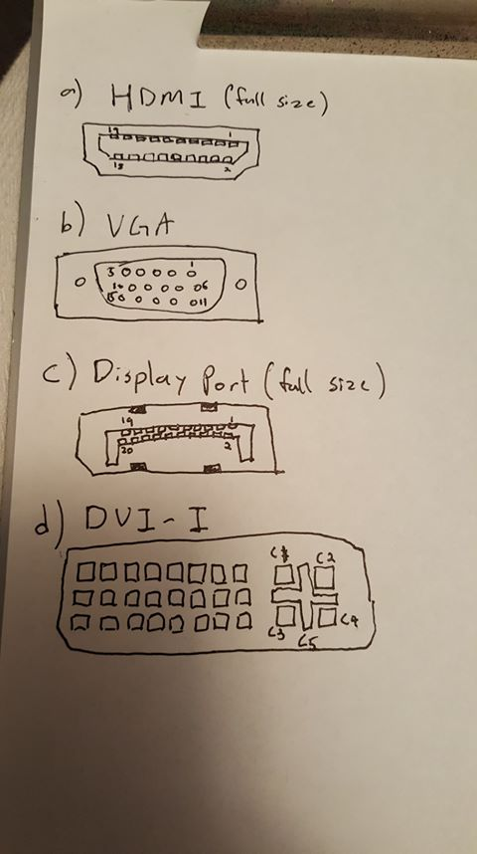

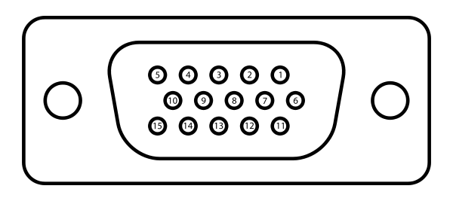
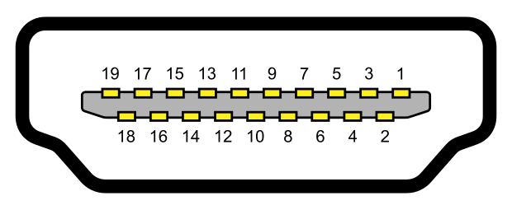
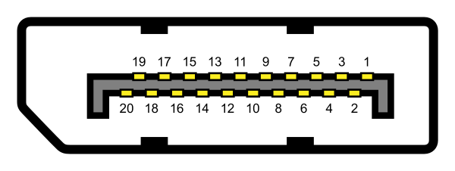
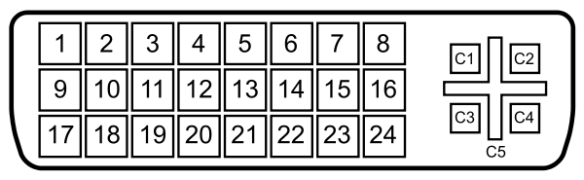
Sources:
1. https://www.wikiwand.com/en/Clock_generator
2. https://www.techopedia.com/definition/27301/anti-static-wrist-strap
3. https://www.wikiwand.com/en/VGA_connector
4. https://searchwindowsserver.techtarget.com/definition/Wintel
5. https://www.computerhope.com/beep.htm
6. https://www.wikiwand.com/en/USB-C
7. HDMI (full-size)
https://upload.wikimedia.org/wikipedia/commons/thumb/4/48/HDMI_Connector_Pinout.svg/620px-HDMI_Connector_Pinout.svg.png
8. VGA
https://upload.wikimedia.org/wikipedia/commons/thumb/3/30/DE15_Connector_Pinout.svg/600px-DE15_Connector_Pinout.svg.png
9. DisplayPort (full-size)
https://upload.wikimedia.org/wikipedia/commons/thumb/f/f1/DisplayPort_Connector.svg/600px-DisplayPort_Connector.svg.png
10. DVI-I
https://upload.wikimedia.org/wikipedia/commons/thumb/5/5b/DVI_Connector_Pinout.svg/600px-DVI_Connector_Pinout.svg.png

