Jong Park
CS 312 – System Architecture
HW 3
April 22, 2019

1. VM Windows 10 install
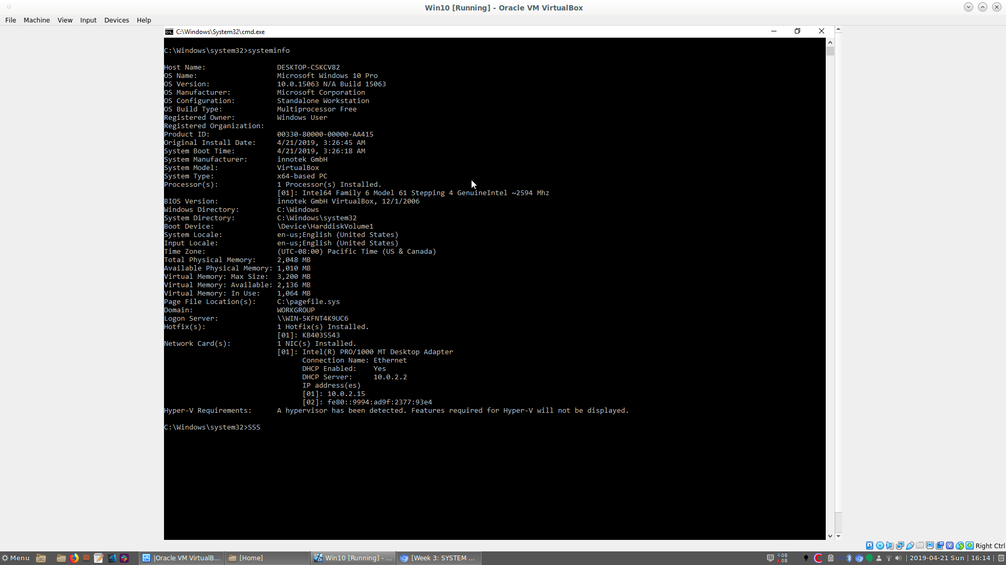
2. VM CentOS install
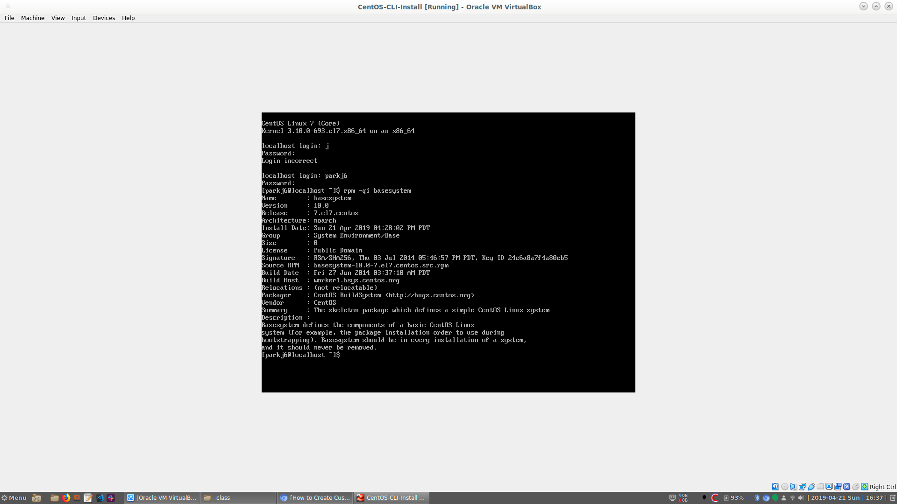
3. List the folder path where all user directories are stored in CentOS7, Windows 10, and macOS High Sierra (you can use our three reference VMs to get these paths, for example). (6 points: 2 for each)
CentOS: /home/$USERNAME
Windows: C:\Users\$USERNAME
MacOS: /users/$USERNAME

4. What does the name of the Linux folder /usr mean? Is USR an abbreviation for something?
USR stands for Unix System Resources. It contains the largest share of data on system. This is the most important directories in the system as it contains all the user binaries, their documentations, libraries, header files and etc. [1]

5. Explain, in your own words, the difference between the Linux directories /bin, /usr/bin, /sbin, and /usr/sbin. Name a common program located in each. (6 points)
/bin:
Standard binaries needed for basic shell operations of the OS. Used by both root and non-root users.[2]
examples: cat, ls, echo, bash, kill, ps, mv, rm, ping
/usr/bin:
Standard binaries not needed for booting or repairing the system beyond the basic binaries used in operation of shell, located in /bin. [3]
examples: awk, clear, diff, gcc, tail, find, free, sudo
/sbin:
Superuser binaries, basic binaries in order for basic shell operation of the OS but only can be used in root level. [4]
examples: mkfs, reboot, fsck, fdisk, grub, halt, ifconfig
/usr/sbin:
This folder contains non-vital utilities used for administrating a system. It also contains daemons to be run in the background by some programs. [5]
examples: chroot, useradd, pppconfig, groupadd, crond

6. On either the reference CentOS VM, or the one you created above, install the Lynx CLI web browser. Using it, browse to www.slashdot.org, then take a screenshot of some part of that page and attach it with your submission. (6 points)
Shown on next page.

Reference:
1. https://www.tldp.org/LDP/Linux-Filesystem-Hierarchy/html/usr.html
2. http://www.linfo.org/bin.html
3. http://www.linfo.org/usr_bin.html
4. http://www.linfo.org/sbin.html
5. http://www.linfo.org/usr_sbin.html
