Jong Park
Feb 27, 2018
Math 351 – Numerical Analysis
Prof. Higdon
HW 3

1. Let
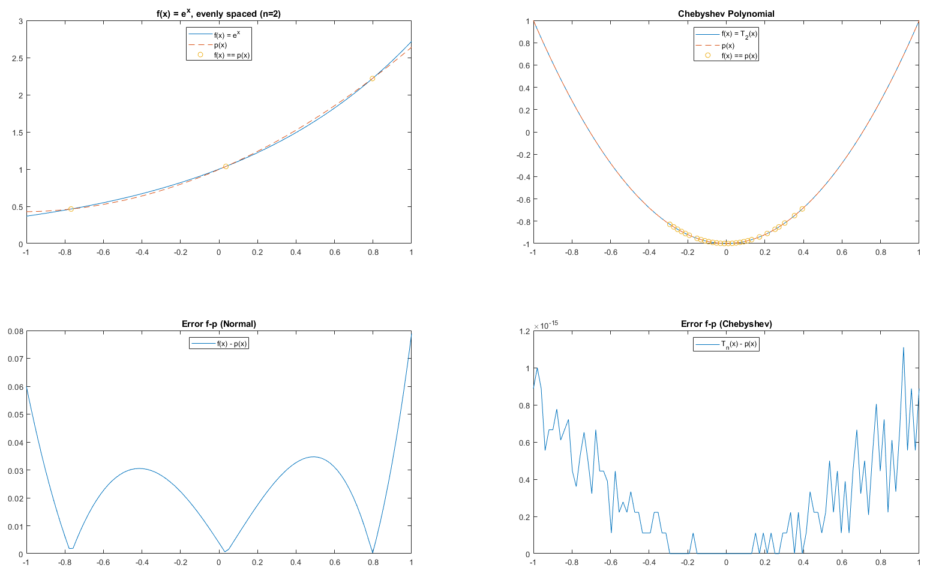
Number of roots (f(x)) = 3
Number of roots (T_{n}(x)) = 28
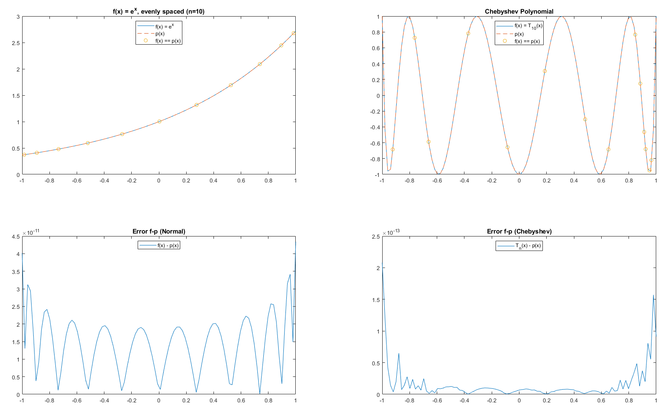
Number of roots (f(x)) = 11
Number of roots (T_{n}(x)) = 14
2.
print n = 10

Instructions:
Matlab program that interpolates f at n+1 points with polynomial p degree n or less for cases:

i) n+1 evenly spaced in [-1, 1]. These interpolation points includes the endpoints -1 and 1.

ii) The n+1 Chebyshev points, which are roots of the Chebyshev polynomial T_{n+1} of degree n+1.
- Use subplot to create 2x2
  - Upper left plot, plot f as a solid curve.
    - Plot interpolating polynomial, p, with evenly-spaced points as dashed curve.
    - Plot plot small circle at each points on the graph of f where p interpolates f.
  - upper right frame: same thing with Chebyshev points.
- Lower row of plots, plot the errors f-p
  - lower left plot corresponds to evenly spaced points
  - lower right corresponds to Chebyshev points.

- Execute codes for values n = 2, n = 10 (2 pages of plots)
- For each value of n, discuss which choice of interpolation points yields an error which comes closest to “equioscillation property”
  - Include a count of the number of extrema of f-p in the interval [-1,1].

