Jong Park
Jan 18, 2018
Math 351 – Numerical Analysis
Prof. Higdon
HW 1

Solve where f(x)and B = 1, 5, 10, 25, 50
For a given value of B, the equation has exactly one real root between (-1,0)

a) Graphs of f for B = 1, 5, 10, 25, 50, x-window: -2 ≤ x ≤ 2, Include horizontal axis y = 0
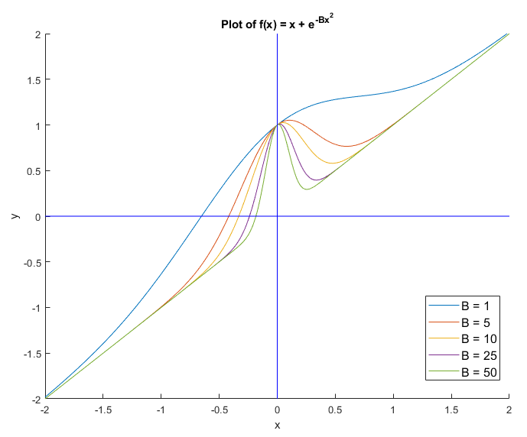
%% Initial Plot
x = -2: 0.01: 2;
y = -2: 0.01: 2;
plot(x, zeros(size(x)), 'b', zeros(size(y)),y,'b');
axis([-2, 2, -2, 2]);
title("Plot of f(x) = x + e^{-Bx^2}");
xlabel('x');
ylabel('y');
hold on; % to what you got

%% Part a
B = [1, 5, 10, 25, 50]; % Initial input
x = -2: 0.01: 2; % Used for making pretty graphs

for k = 1 : length(B)
bval = B(k);
y = x + exp(-bval .* (x .^ 2));
plot (x,y);
end
b) Use Newton’s method to compute root of.

%% Part b
x = [-0.60, -0.40, -0.30, -0.25, -0.20]; % These are actually x0
max_iter = 20;
f = 'x + exp(-B .* (x .^ 2))';
fprime = '1 + 2.*(-B) .* exp(-B .* (x .^ 2)) .* x';
iters = [0,x]; % Start at iteration 0
for j = 1 : max_iter % Max 20 iterations
xnew = x - eval(f) ./ eval(fprime);
iters = [iters; j, xnew]; % Added iteration #
test = abs(xnew -x) ./ (abs(xnew)+eps);
if max(test) < 10*eps, break, end
x = xnew;
end

format long; % Changing the Format to long;
iters % Display iterations.

iters =
0 | 0.600000000000000 | 0.400000000000000 | 0.300000000000000 | 0.250000000000000 | 0.200000000000000
1 | 0.653165528964849 | 0.417634391912929 | 0.330984794819419 | 0.238843363309377 | 0.182554666430992
2 | 0.652918643575563 | 0.417795150802284 | 0.332038020615977 | 0.239202061410311 | 0.183990474213253
3 | 0.652918640419205 | 0.417795165450810 | 0.332039401125263 | 0.239202432177130 | 0.184000818492285
4 | 0.652918640419205 | 0.417795165450810 | 0.332039401127642 | 0.239202432177527 | 0.184000819027798
5 | 0.652918640419205 | 0.417795165450810 | 0.332039401127642 | 0.239202432177527 | 0.184000819027798

Far left number on the table represent iteration #, iteration 0 being the initial guess for the root.
c) Repeat b) but with x0 = 0 for each B. Explain each behavior of iterations.
Draw diagram (tangent line) with explanations
%% Part c
for k = 1 : length(B)
figure % Used to make individual charts
x = -2: 0.01: 2;
y = -2: 0.01: 2;
plot(x, zeros(size(x)), 'b', zeros(size(y)),y,'b')
axis([-2, 2, -2, 2])
title(sprintf("Plot of f(x) = x + e^{- %d x^2}",B(k)))
xlabel('x')
ylabel('y')
hold on

y = x + exp(-B(k) .* (x .^ 2)); % Individual graphs
plot (x,y);

x = -2: 0.01: 2;
m = 1 + 2.*(-B(k)) .* exp(-B(k) .* (xgood(k) .^ 2)) .* xgood(k); % slope
y = m .* x - m .* xgood(k); % Graph of the new slope
plot (x,y)
hold off
end

x = [0 0 0 0 0]; % All x0 = 0;
max_iter = 20;
f = 'x + exp(-B .* (x .^ 2))';
fprime = '1 + 2.*(-B) .* exp(-B .* (x .^ 2)) .* x';
iters = [0,x]; % Start at iteration 0
for j = 1 : max_iter % Max 20 iterations
xbad = x - eval(f) ./ eval(fprime);
iters = [iters; j, xbad]; % Added iteration #
test = abs(xbad -x) ./ (abs(xbad)+eps);
if max(test) < 10*eps, break, end
x = xbad;
end

%% Changing the Format to short;
format short
iters

iters =
0 | 0 | 0 | 0 | 0 | 0
1.0000 | -1.0000 | -1.0000 | -1.0000 | -1.0000 | -1.0000
2.0000 | -0.6358 | -0.0694 | -0.0010 | -0.0000 | 0
3.0000 | -0.6529 | -0.6099 | -0.9813 | -1.0000 | -1.0000
4.0000 | -0.6529 | -0.3769 | -0.0013 | -0.0000 | 0
5.0000 | -0.6529 | -0.4171 | -0.9741 | -1.0000 | -1.0000
6.0000 | -0.6529 | -0.4178 | -0.0015 | -0.0000 | 0
7.0000 | -0.6529 | -0.4178 | -0.9707 | -1.0000 | -1.0000
8.0000 | -0.6529 | -0.4178 | -0.0016 | -0.0000 | 0
9.0000 | -0.6529 | -0.4178 | -0.9690 | -1.0000 | -1.0000
10.0000 | -0.6529 | -0.4178 | -0.0017 | -0.0000 | 0
11.0000 | -0.6529 | -0.4178 | -0.9681 | -1.0000 | -1.0000
12.0000 | -0.6529 | -0.4178 | -0.0017 | -0.0000 | 0
13.0000 | -0.6529 | -0.4178 | -0.9676 | -1.0000 | -1.0000
14.0000 | -0.6529 | -0.4178 | -0.0017 | -0.0000 | 0
15.0000 | -0.6529 | -0.4178 | -0.9673 | -1.0000 | -1.0000
16.0000 | -0.6529 | -0.4178 | -0.0017 | -0.0000 | 0
17.0000 | -0.6529 | -0.4178 | -0.9671 | -1.0000 | -1.0000
18.0000 | -0.6529 | -0.4178 | -0.0017 | -0.0000 | 0
19.0000 | -0.6529 | -0.4178 | -0.9671 | -1.0000 | -1.0000
20.0000 | -0.6529 | -0.4178 | -0.0017 | -0.0000 | 0

