Jong Park

Mar 8, 2019

Math 351 – Numerical Analysis

Prof. Higdon

HW 4 – Data Fitting

1. Fit this data with function of the form

, (c1, c2 = constants TBD)

%% Given

y = [1, 0.5, 0.4, 0.25, 0.1, 0.1, 0.05, 0.02, 0.01];

m = length(y);

x = 1:m;

%% 1. p(x) = c_1e^(-0.5x) + c_2e^(-x); c1, c2 are constants.

%% a) Use appx relation to derive an overdetermined system

u = exp(-0.5.*x(:)); % e^(-0.5x)

v = exp(-x(:)); % e^(-x)

%% b) Find least-square solution

A = [u,v];

b = y(:);

c = A\b % Ac = b;

%% c) Plot p(x) with c1, c2.

%x = graphable x from 0:10

xp = linspace(0,10);

%p(x) = c_1e^(-0.5x) + c_2e^(-x)

yp = c(1).*exp(-0.5.*xp) + c(2).*exp(-xp);

plot (xp, yp, x, y, 'o');

title(sprintf("Approximation relation p(x) = c_1e^{-0.5x} + c_2e^{-x}"))

legend('p(x)','Initial Data','location','best')

A =

0.6065 0.3679

0.3679 0.1353

0.2231 0.0498

0.1353 0.0183

0.0821 0.0067

0.0498 0.0025

0.0302 0.0009

0.0183 0.0003

0.0111 0.0001

b =

1.0000

0.5000

0.4000

0.2500

0.1000

0.1000

0.0500

0.0200

0.0100

c1 =

1.5086

c2 =

0.1771

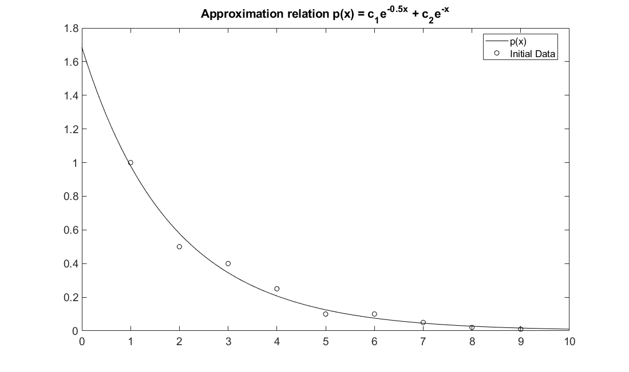

1. Fit the data with function of the form

$p\left(x\right)={re}^{sx}$, (r, s = constants TBD)

%% 2. p(x) = re^(sx); r, s are constants.

%% a) Use log to break re^(sx_i) and use the result to derive overdetermined system.

u = ones(m,1);

v = x(:);

A = [u,v]

b

%% b) Find least-square solution

c = A\log(b) %Ac = b;

r = exp(c(1))

s = c(2)

%% c) Plot

figure

yp = r.*exp(s.*xp);

plot (xp,yp,'k', x,y,'ok')

title(sprintf("Approximation relation p(x) = re^{sx}"))

legend('p(x)','Initial Data','location','best')

A =

1 1

1 2

1 3

1 4

1 5

1 6

1 7

1 8

1 9

b =

1.0000

0.5000

0.4000

0.2500

0.1000

0.1000

0.0500

0.0200

0.0100

c =

0.6389

-0.5525

r =

1.8945

s =

-0.5525

