MGDI Participant Instruction
Review the required posture for each condition and what to do if the HoloLens system Start menu appears.

1. If the HoloLens Start Menu Appears
Important If the blue HoloLens Start menu shown below appears during the study, tap the Start icon on your wrist again to close it and notify the experimenter.

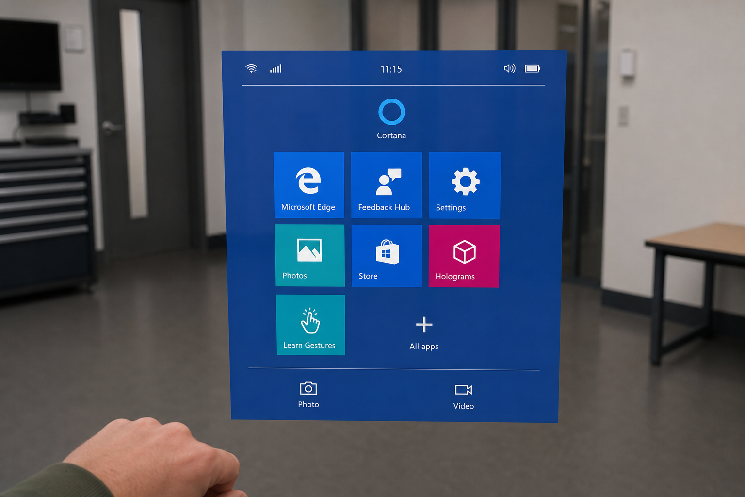
Example: the blue HoloLens Start menu that can appear after tapping the wrist Start icon

Instruction to Participant
If this blue menu appears: pause the task, tap the Start icon on your wrist again to close the menu, and notify the experimenter if it does not close.

2. Postures by Condition
At the start of each condition, look at the posture example shown on the screen, match the hand position, and hold it briefly. The condition order may differ by Participant ID.

Macro - Near Head
- Use large arm and hand movements to control the system.
- Keep your hand near your head.
- After matching the target, use triple tap when you are ready to submit.
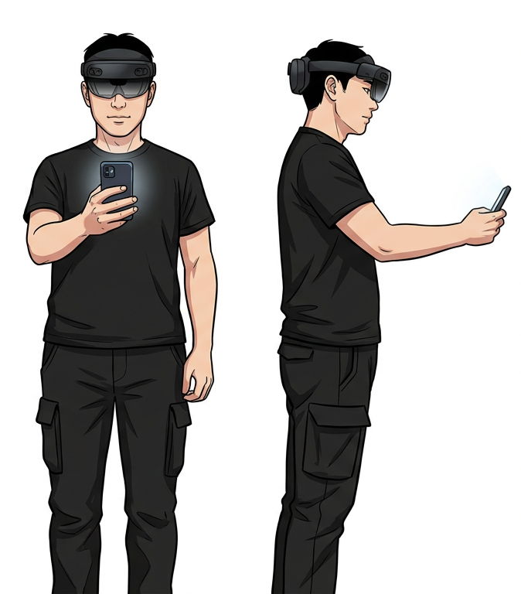
Posture example: Macro - Near Head

Macro - Side Of Body
- Use large arm and hand movements to control the system.
- Keep your hand at the side of your body.
- In this condition, up/down movement and forward/back movement are remapped.
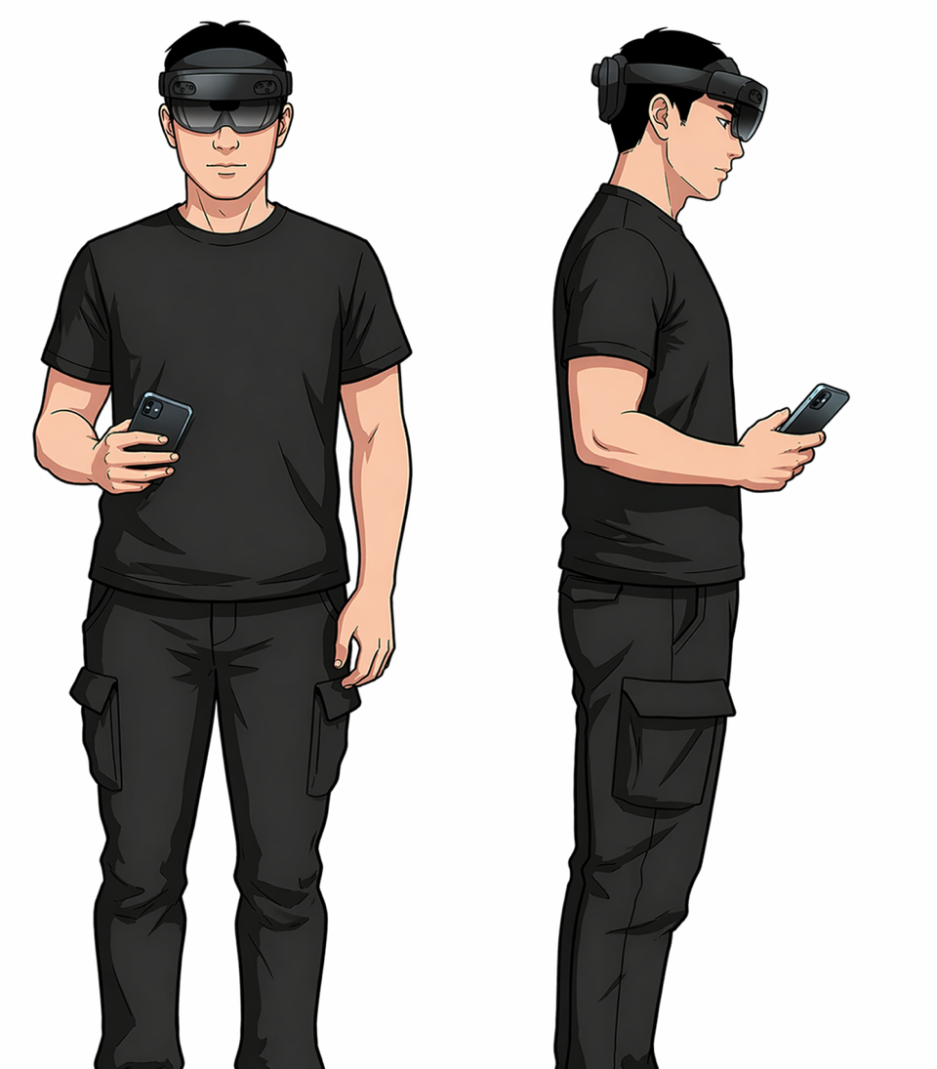
Posture example: Macro - Side Of Body

Micro - Near Head
- Keep your hand near your head.
- Use phone-screen swipes for fine control.
- In Micro conditions, tap once to grab an object and tap again to release it.

Posture example: Micro - Near Head

Micro - Side Of Body
- Keep your hand at the side of your body.
- Use phone-screen swipes for fine control.
- After matching the target, use triple tap when you are ready to submit.
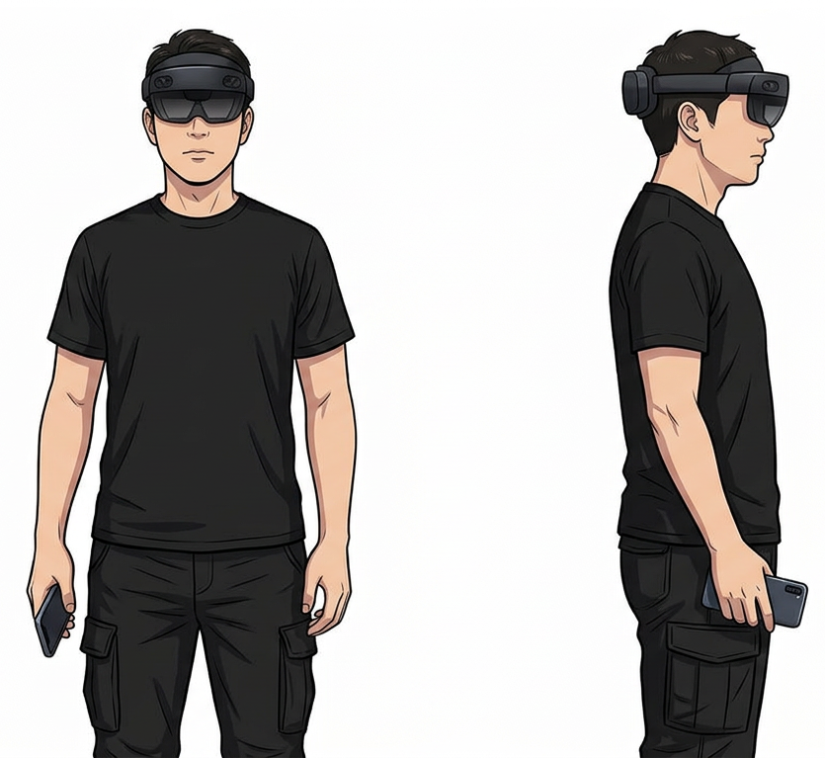
Posture example: Micro - Side Of Body

3. Condition Start Flow
1 | Open or restart the phone app.
2 | Scan the QR code with the phone and wait for the HoloLens message: 'Phone QR detected.'
3 | Match the posture example shown on the screen and hold the posture briefly.
4 | When the countdown ends, the task starts automatically.
5 | After matching the target, use triple tap when you are ready to submit.

